

EI 2018

ASSESSMENT HANDBOOK

Front cover image credits:

Biologic cell (colourful), iStock.com/ © dreaming2004

Blue ink, iStock.com/ © Pathathai Chungyam

Top view of inside a green plant, iStock.com/ © Zaharov

Deep blue silky smoke background, iStock.com/ © Storman

ISBN 978-0-6481723-6-9

© Commonwealth of Australia 2018

Creative Commons License

All material presented in this publication is provided under a CC Attribution-NonCommercial-NoDerivatives 4.0 International (CC BY-NC-ND 4.0) licence [www.creativecommons.org](http://www.creativecommons.org) > Licenses > [by-nc-nd/4.0](https://creativecommons.org/licenses/by-nc-nd/4.0/) with the exception of the Commonwealth Coat of Arms, the Australian Research Council (ARC) logo, images, signatures and where otherwise stated.

The details of the relevant licence conditions are available on the Creative Commons website as is the full legal code for the CC Attribution BY-NC-ND 4.0 licence, [www.creativecommons.org](https://creativecommons.org/licenses/by-nc-nd/4.0/legalcode) > licenses > [by-nc-nd 4.0 legal code](https://creativecommons.org/licenses/by-nc-nd/4.0/). Requests and enquiries regarding this licence should be addressed to ARC Legal Services on +61 2 6287 6600.

**Table of Contents**

[1. Engagement and Impact Assessment 2018 overview 5](#_Toc13643998)

[1.1 Introduction 5](#_Toc13643999)

[1.2 Objectives 5](#_Toc13644000)

[1.3 Definitions 5](#_Toc13644001)

[1.4 Unit of Assessment (UoA) 6](#_Toc13644002)

[1.5 Assessments 8](#_Toc13644003)

[1.6 Reference periods 8](#_Toc13644004)

[1.7 Documentation 9](#_Toc13644005)

[1.8 Use of EI 2018 information (reporting) 9](#_Toc13644006)

[1.9 Further assistance 9](#_Toc13644007)

[2. Responsibilities of assessment panels 10](#_Toc13644008)

[2.1 Expert review 10](#_Toc13644009)

[2.2 Responsibilities of the assessment panel 12](#_Toc13644010)

[2.3 Responsibilities of assessment panel members 12](#_Toc13644011)

[2.4 Responsibilities of assessment panel chairs 12](#_Toc13644012)

[2.5 Assignment outside area of expertise 13](#_Toc13644013)

[2.6 Review of EI processes and feedback 13](#_Toc13644014)

[2.7 Confidentiality 13](#_Toc13644015)

[2.8 Material Personal Interest (MPI) 13](#_Toc13644016)

[2.9 Research integrity and research misconduct 14](#_Toc13644017)

[2.10 Submission integrity 14](#_Toc13644018)

[2.11 Security and sensitivity 15](#_Toc13644019)

[2.12 Copyright 16](#_Toc13644020)

[3. The EI 2018 assessment process 17](#_Toc13644021)

[3.1 The EI phases 17](#_Toc13644022)

[4. Engagement assessment 20](#_Toc13644023)

[4.1 Rating scale for engagement 20](#_Toc13644024)

[4.2 Assessment of engagement 21](#_Toc13644025)

[4.3 Engagement narrative 21](#_Toc13644026)

[4.4 Engagement indicator explanatory statement 22](#_Toc13644027)

[4.5 Engagement indicators—overview 22](#_Toc13644028)

[4.6 Engagement Indicators—details 25](#_Toc13644029)

[4.7 How to rate engagement 30](#_Toc13644030)

[5. Impact assessment 31](#_Toc13644031)

[5.1 Rating scales for impact and approach to impact 32](#_Toc13644032)

[5.2 Assessment of impact 33](#_Toc13644033)

[5.3 Assessment of approach to impact 36](#_Toc13644034)

[5.4 Other components of the impact study template 37](#_Toc13644035)

[6. Appendices 39](#_Toc13644036)

[Appendix A—Glossary 39](#_Toc13644037)

[Appendix B—Abbreviations 41](#_Toc13644038)

[Appendix C—ANZSRC, SEO codes, ANZSIC and Science and Research Priorities 43](#_Toc13644039)

[Appendix D—FoR 11 division 46](#_Toc13644040)

[Appendix E—Eligible institutions 47](#_Toc13644041)

[Appendix F—Engagement assessment data requirements 49](#_Toc13644042)

[Appendix G—Examples of additional quantitative information for the engagement narrative 52](#_Toc13644043)

[Appendix H—Specified HERDC Category 1 grants 54](#_Toc13644044)

[Appendix I—Impact studies 63](#_Toc13644045)

[Appendix J—Working notes for assessment 70](#_Toc13644046)

# Engagement and Impact Assessment 2018 overview

## 1.1 Introduction

In December 2015, as part of its National Innovation and Science Agenda (NISA), the Government announced the development of an Engagement and Impact (EI) assessment. The EI assessment examines how universities[[1]](#footnote-2) are translating their research into economic, environmental, social and other benefits.

EI 2018 aims to encourage greater collaboration between universities and research end-users, such as industry, by assessing engagement and impact.

EI 2018 is a companion exercise to Excellence in Research for Australia (ERA) 2018, and data collected for ERA 2018 forms part of the EI 2018 assessment[[2]](#footnote-3).

## 1.2 Objectives

The objectives of the EI assessment are to:

* provide clarity to the Government and the Australian public about how their investments in university research translate into tangible benefits beyond academia
* identify institutional processes and infrastructure that enable research engagement
* promote greater support for the translation of research impact within institutions for the benefit of Australia beyond academia
* identify the ways in which institutions currently translate research into impact.

## 1.3 Definitions

EI 2018 has a number of definitions specific to it. It is essential that panel members understand, and apply, these definitions when assessing and rating submissions.

**Research**

Research is the creation of new knowledge and/or the use of existing knowledge in a new and creative way to generate new concepts, methodologies, inventions and understandings. This could include the synthesis and analysis of previous research to the extent that it is new and creative.

This is the same definition used for ERA. It is consistent with a broad notion of research and experimental development comprising “creative and systematic work undertaken in order to increase the stock of knowledge—including knowledge of humankind, culture and society—and to devise new applications of available knowledge” as defined in the ARC funding rules.

**Aboriginal and Torres Strait Islander research**

Aboriginal and Torres Strait Islander research means that the research (as defined above) significantly:

* relates to Aboriginal and Torres Strait Islander peoples, nations, communities, language, place, culture or knowledges, and/or
* is undertaken with Aboriginal and Torres Strait Islander peoples, nations, or communities.

**Engagement**

Research engagement is the interaction between researchers and research end-users outside of academia for the mutually beneficial transfer of knowledge, technologies, methods or resources.

**Impact**

Research impact is the contribution that research makes to the economy, society, environment or culture, beyond the contribution to academic research.

**Research end-user**

A research end-user is an individual, community or organisation external to academia that will directly use or directly benefit from the output, outcome or result of the research.

Examples of research end-users include governments, businesses, non-governmental organisations, communities, and community organisations.

Specific exclusions of research end-users are:

* publicly funded research organisations (CSIRO, AIMS, ANSTO, NMI, DSTO, etc.)
* other higher education providers (including international universities)
* organisations that are affiliates, controlled entities or subsidiaries (such as Medical Research Institutes) of a higher education provider
* equivalents (international or domestic) of the above exclusions.

## 1.4 Unit of Assessment (UoA)

EI assesses the engagement and impact arising from research undertaken in Australian institutions by unit of assessment (UoA).

EI defines the UoA as the two-digit Fields of Research (FoRs), as identified in the Australian and New Zealand Standard Research Classification (ANZSRC) [www.abs.gov.au](http://www.abs.gov.au/) > Statistics > Classifications > [Australian and New Zealand Standard Research Classification (ANZSRC)](https://www.abs.gov.au/ausstats/abs@.nsf/0/4AE1B46AE2048A28CA25741800044242), at each institution, with three exceptions.

* FoR 11 Medical and Health Sciences is divided into two groups—the Biomedical and Clinical Sciences (BCS), and the Public and Allied Health Sciences (PHS)—due to the diversity and high volume of research covered by this FoR. The allocation of the four-digit FoRs to BCS and PHS is at [Appendix D](#_Appendix_D—FoR_11).
* Aboriginal and Torres Strait Islander research is treated as a separate, optional UoA for impact only.
* There is also an optional, impact-only interdisciplinary UoA.

In summary, there are three *types* of UoA:

* two-digit FoR
* interdisciplinary *(impact only, optional)*
* Aboriginal and Torres Strait Islander research *(impact only, optional)*

Note: Two-digit FoR UoAs correspond to FoR codes and do not necessarily correspond to departments or research groups within an institution.

| **What is ANZSRC?**  ANZSRC stands for the Australian and New Zealand Standard Research Classification developed by the Australian Bureau of Statistics and Statistics New Zealand.  The ANZSRC is a hierarchical classification system with three levels. The two-digit Fields of Research (FoR) is the highest level, followed by the four-digit and then six-digit codes.  There are 22 divisions (the two-digit FoR): | |
| --- | --- |
| * 01 Mathematical Sciences * 02 Physical Sciences * 03 Chemical Sciences * 04 Earth Sciences * 05 Environmental Sciences * 06 Biological Sciences * 07 Agricultural and Veterinary Sciences * 08 Information and Computing Sciences * 09 Engineering * 10 Technology * 11 Medical and Health Sciences * 12 Built Environment and Design | * 13 Education * 14 Economics * 15 Commerce, Management, Tourism and Services * 16 Studies in Human Society * 17 Psychology and Cognitive Sciences * 18 Law and Legal Studies * 19 Studies in Creative Arts and Writing * 20 Language, Communication and Culture * 21 History and Archaeology * 22 Philosophy and Religious Studies |

### 1.4.1 Low-volume threshold

In general, EI assesses two-digit FoR UoAs where there is sufficient data for assessment. For this reason, a low-volume threshold is applied.

In EI 2018, the low-volume threshold is 150 weighted apportioned outputs (1 book counts as 5) based on an institution’s relevant two-digit FoR submission to ERA 2018. EI 2018 will assess UoAs that meet the low-volume threshold for both engagement and impact. If an institution considers that a UoA falling below the low-volume threshold has sufficient evidence for assessment of engagement or impact, it can choose to opt-in to assessments of either or both.

The ARC acknowledges that for some UoAs there may be no impact, or insufficient impact, to report. If an institution meets the low-volume threshold in a UoA but

* the majority of the research outputs are primarily basic or fundamental research OR
* the research area at the institution is too new then an institution may request that the UoA not be assessed for impact.

To request not to be assessed, the institution must indicate which criterion is relevant to the UoA and submit a statement, which includes:

* a description of the strategy the institution will put in place for the UoA to participate in future rounds of the impact assessment
* the timeframe in which the institution expects the UoA to participate in future impact assessment rounds.

Where the ARC determines that the request not to be assessed meets one of the above criteria, the UoA will not be assessed for impact and the ARC will publicly report this as ‘requested not to be assessed’.

There is no option to request not be assessed for engagement.

The low-volume threshold does not apply to the interdisciplinary nor the Aboriginal and Torres Strait Islander research impact studies. Institutions may opt-in for either or both.

## 1.5 Assessments

In EI 2018, assessment panels comprise researchers and research end‑users. The panels assess and rate UoAs. There are two broad categories of assessments:

* Engagement

Panels assess research engagement activity based on an engagement narrative, a small suite of quantitative indicators, and an indicator explanatory statement. Each UoA receives a rating for engagement.

* Impact studies

Panels assess research impact and the institution's approach to impact based on qualitative impact studies that detail the impact, the research associated with the impact, and the approach to impact for each UoA. Each UoA receives two impact ratings—one for the impact and one for approach to impact.

## 1.6 Reference periods

The ARC collects submission data for EI 2018 for the following reference periods (Table 1).

Table 1: EI 2018 reference periods

| **Data type** | **Reference period** | **Years** |
| --- | --- | --- |
| Impact | 1 January 2011–31 December 2016 | 6 |
| Associated research | 1 January 2002–31 December 2016 | 15 |
| Engagement | 1 January 2014–31 December 2016 | 3 |

While a reference period is not specified for approach to impact, the approach must be retrospective and within the context of the impact study.

## 1.7 Documentation

This handbook is the key source of information for panel members. A number of other documents related to the submission phase are also available on the ARC website: [www.arc.gov.au](http://www.arc.gov.au/) > Engagement and Impact > [EI Key Documents](https://www.arc.gov.au/engagement-and-impact-assessment/ei-key-documents). These are:

* EI 2018 Framework
* EI 2018 Submission Guidelines—provide guidance to institutions on how to complete submissions.
* EI 2018 Technical Specifications—provide additional technical guidance on the submission process to institutions.
* The EI 2018 Discipline Matrix—provides information on the indicator applicability for each discipline.

The ARC will also give panel members the EI 2018 SEER Assessment Guide. This document gives guidance to panel members on using the System to Evaluate Excellence of Research (SEER)[[3]](#footnote-4). Panel chairs use SEER to assign UoAs to their panel members and all panel members use the system to record their assessments.

## 1.8 Use of EI 2018 information (reporting)

The ARC will publish ratings for EI assessments and selected EI submission information.

The ARC will publish ratings as part of the EI 2018 National Report, as well as aggregated, summary, and de-identified information from submission.

## 1.9 Further assistance

Further information about EI is available on the ARC website: [www.arc.gov.au](http://www.arc.gov.au).

Please direct queries regarding EI 2018 to the EI helpdesk by phone during Canberra business hours at (02) 6287 6755 or via email: ARC-EI@arc.gov.au.

# Responsibilities of assessment panels

## 2.1 Expert review

Central to the EI 2018 assessment is expert review which can only be informed by:

Engagement

* evidence provided in the engagement narrative
* engagement indicators and the engagement indicator explanatory statement

Impact

* evidence provided of impact—Part A of the impact study

Approach to impact

* evidence provided of approach to impact—Part B of the impact study

There are five panels for EI 2018:

* Social Sciences (SS)
* Science and Technology (ST)
* Creative Arts and Humanities (CAH)
* Health and Life Sciences (HLS)
* Aboriginal and Torres Strait Islander research (IN).

Each panel will assess engagement, impact and approach to impact except for the Aboriginal and Torres Strait Islander research panel which only assesses impact studies (impact and approach to impact). The SS, ST, CAH or HLS panels will assess interdisciplinary impact studies, depending on the assigned two-digit FoRs. [Table 2](#Table_2) lists the FoRs for each panel.

Each panel has one panel member (or assessor) appointed as chair. At least three panel members will assess each UoA submitted. One of these panel members will be the principal assessor. For more details on the assessment, see Sections [3](#_The_EI_2018), [4](#_Engagement_Assessment) and [5](#_Impact_assessment_1).

Table 2: The allocation of FoRs to panels

| **Social Sciences (SS)** | **Health and Life Sciences (HLS)** | **Creative Arts and Humanities (CAH)** | **Science and Technology (ST)** | **Aboriginal and Torres Strait Islander research** |
| --- | --- | --- | --- | --- |
| * 13 Education * 14 Economics * 15 Commerce, Management, Tourism and Services * 16 Studies in Human Society * Interdisciplinary | * 05 Environmental Sciences * 06 Biological Sciences * 07 Agricultural and Veterinary Sciences * 11 Biomedical and Clinical Sciences * 11 Public and Allied Health Sciences * 17 Psychology and Cognitive Sciences * Interdisciplinary | * 12 Built Environment and Design * 18 Law and Legal Studies * 19 Studies in Creative Arts and Writing * 20 Language, Communication and Culture * 21 History and Archaeology * 22 Philosophy and Religious Studies * Interdisciplinary | * 01 Mathematical Sciences * 02 Physical Sciences * 03 Chemical Sciences * 04 Earth Sciences * 08 Information and Computing Sciences * 09 Engineering * 10 Technology * Interdisciplinary | * Aboriginal and Torres Strait Islander research |

## 2.2 Responsibilities of the assessment panel

The responsibilities of a panel, as a whole, are to:

* assign agreed ratings for all allocated UoAs
* consistently apply the rating standards and assessment procedures
* provide feedback and advice as requested to the ARC, on any aspects of the assessment process, then report the results to the ARC.

## 2.3 Responsibilities of assessment panel members

The responsibilities of individual panel members are to:

* participate fully in the assessment process within their panel
* abide by the confidentiality agreement and material personal interest (MPI) requirements
* maintain confidentiality of both deliberations and decisions of the panel
* identify all instances where they may have an MPI or other sensitivity and raise these with the ARC prior to the conflict occurring
* ensure they adequately prepare for meetings to avoid unnecessary additional costs and inconvenience to other panel members
* be diligent in completing tasks allocated to them by the panel chair
* assess assigned material and allocate preliminary ratings to each UoA
* contribute fully, constructively and dispassionately to all panel processes and, within the capacity of their expertise, take ownership of the collective decisions of the panel
* exercise due skill and care in the performance of their responsibilities.

### 2.3.1 Principal assessor

The responsibilities of a principal assessor are the same as a panel member. In addition, a principal assessor:

* takes the lead role during the assessment meeting in the discussions of the UoAs for which they are the principal assessor.

## 2.4 Responsibilities of assessment panel chairs

The responsibilities of a panel chair are the same as the responsibilities of panel members ([2.3](#_2.3_Responsibilities_of)). In addition, panel chairs are to:

* ensure that the panel operates within the policies, guidelines and procedures established by the ARC
* ensure that confidentiality is maintained for the deliberations and decisions of the panel
* assign material to panel members for assessment
* ensure that assessments are completed within agreed timeframes
* chair the panel meeting to review preliminary ratings, and guide the panel to provide final ratings for each UoA
* ensure that panel members have an opportunity to contribute fully to the process and panel activities
* ensure that panel decisions are documented
* participate in a review at the conclusion of the panel meeting and report to the ARC on the assessment processes undertaken by the panel
* provide advice or feedback directly to the ARC, as requested.

In the event that a panel chair is unable to perform some or all of these responsibilities, the ARC will appoint an acting chair from within the panel for all, or part, of the responsibilities of a panel chair.

## 2.5 Assignment outside area of expertise

Panel members may be assigned to assess UoAs that do not appear to correspond directly with their expertise. It is important to note that panel members’ overall expertise, judgment and views are extremely valuable in the assessment of these UoAs.

## 2.6 Review of EI processes and feedback

The ARC encourages panel members to provide feedback on all EI processes. After the assessment meeting the ARC will invite panel members and chairs to provide feedback on the EI process, however, panel members can provide feedback to the ARC at any time.

## 2.7 Confidentiality

Panel members must sign a confidentiality agreement with the ARC prior to their participation in EI 2018. The agreement covers all aspects of their work for EI 2018, and survives the conclusion of their commitment to EI 2018.

Panel members must not contact researchers, institutions or research end-users, under any circumstances, in relation to material submitted for assessment or seek additional information from any sources. Panel members must not reveal details about any assessment, deliberations or conclusions, at any time.

## 2.8 Material Personal Interest (MPI)

All panel members must make a Material Personal Interest (MPI) Declaration and have an ongoing responsibility to declare any further material personal interests that may arise. All panel members must adhere to the decisions made by the ARC in relation to any material personal interests.

A material personal interest is an interest of a type that may give rise to a real or perceived conflict of interest that could be perceived by an external observer as having inappropriate influence over a panel member’s decisions in relation to assessing a UoA. Once a material personal interest is declared, the ARC will assess and determine whether the interest amounts to a conflict of interest or may be perceived to be a conflict of interest, and if so, how this will affect the panel member’s involvement. The ARC will assess each instance on a case-by-case basis, and typically, where a conflict or perceived conflict exists, the ARC will assign or reassign (as appropriate) the material to another panel member, or appoint an acting panel chair.

Some examples of material personal interests panel members must declare are:

* being employed by, or holding an adjunct or honorary appointment at, the institution that has made the submission being assigned.
* being employed by, or holding an appointment with, an end-user referred to in the UoA submission.
* having a close personal relationship with someone whose work is significantly incorporated in the UoA being assigned for assessment. This could include a partner, spouse, family member or close friend. Enmity is included in this category.
* being a close associate with a person or organisation whose work is significantly incorporated into the UoA. One example of an MPI is where a panel member is a close associate with researcher/s in the two–digit FoR at a particular institution. A close association is considered to be when there are joint publications, joint research projects and/or joint commercial arrangements.
* having a close association with the outcomes of the research reported in the UoA. One example of an MPI is having a financial interest in the research outcomes.
* owning shares in, being a member of a board, or exercising control in a company or other organisation which is referred to in the UoA.
* other conflicts that panel members will need to raise and have clarified include financial interests (for example holding a company directorship, stock ownership or options, patents, royalties, consultancy or grant) which could lead to financial gain for a panel member in circumstances where they have access to information or are able to influence decision-making.

## 2.9 Research integrity and research misconduct

As specified within the ARC Research Integrity and Research Misconduct Policy, the ARC requires anyone engaged on ARC business, such as EI panel members, to report alleged breaches of research integrity or research misconduct issues identified in relation to ARC-funded business to the ARC Research Integrity Officer. The policy and contact details for the Research Integrity Officer are available on the ARC website ([www.arc.gov.au](http://www.arc.gov.au/) > Policies and Strategies > Policy > [ARC Research Integrity and Research Misconduct Policy](http://www.arc.gov.au/arc-research-integrity-and-research-misconduct-policy)).

Should you identify a potential breach of research integrity or a research misconduct issue as part of your assessments, please notify the ARC Research Integrity Officer.

The ARC Research Integrity Officer will refer the allegation to the relevant institution for investigation, in accordance with the requirements of the Australian Code for the Responsible Conduct of Research available on the NHMRC website: [NHMRC](https://www.nhmrc.gov.au/) > About us > Publications > [Australian Code for the Responsible Conduct of Research](https://www.nhmrc.gov.au/about-us/publications/australian-code-responsible-conduct-research-2007). Sufficient information should be provided to enable the institution to progress an investigation into the allegation (if required).

## 2.10 Submission integrity

If the ARC considers that any information provided by an institution as part of its submission is incomplete or inaccurate, or contains false or misleading information, the ARC will in the first instance contact the institution to resolve the issue prior to taking further action. If the ARC identified any issues prior to submission closing, institutions were required to explain and/or correct any data anomalies in their submission.

The ARC may in its absolute discretion take any action it considers necessary to maintain the integrity of the EI assessment process. This includes but is not limited to:

* withholding this information from panels
* removing part or all of a submission from assessment after the panels have received the information
* investigating the matter with a view to prosecution under Commonwealth law.

If the ARC withholds such information from a panel, it will advise the institution of this action and provide a statement of reasons. If the ARC deems any part of a UoA to be incomplete, inaccurate, false or misleading as described above, the ARC may remove the entire UoA.

The ARC reserves the right to audit a submission if it considers that any information provided by an institution as part of its submission is incomplete or inaccurate, or contains false or misleading information. See section 5.6 *EI 2018 Submission Guidelines* available on the ARC website: [www.arc.gov.au](http://www.arc.gov.au/) > Engagement and Impact > [EI Key Documents](https://www.arc.gov.au/engagement-and-impact-assessment/ei-key-documents).

## 2.11 Security and sensitivity

If any submission material causes offence or serious sensitivity to panel members, they should raise their concern with the ARC as soon as possible. Depending on the nature of the issues, the ARC may reassign the UoA, or take other action.

Institutions are responsible for indicating the conditions under which it is appropriate or inappropriate for ARC staff and panel members to view sensitive information.

The ARC will treat the information in accordance with the type of sensitivity assigned to the UoA by institutions.

Sensitive information may be:

* commercially sensitive and/or
* culturally sensitive.

### 2.11.1 Commercially sensitive submissions

Some information submitted in UoAs may be commercially sensitive.

Institutions may include commercially sensitive items in their submission, as long as they specifically identify and advise the ARC of the commercial sensitivity of the UoA and provide instructions for handling, as required.

### 2.11.2 Culturally sensitive submissions

Some information submitted in UoAs may be culturally sensitive.

Institutions may include culturally sensitive items in their submission, as long as they specifically identify and advise the ARC of the cultural sensitivity of the submission and provide instructions for handling, as required.

As a panel member, you may receive culturally sensitive material. If you do not wish to assess this material or have concerns about assessing this material, please notify the ARC as soon as possible.

### 2.11.3 Australian Government security classified submissions

Information classified in line with the Australian Protective Security Framework as either ‘In-Confidence’ or greater, or ‘Restricted’ or greater, **must not be included.**

## 2.12 Copyright

Panel members have access to submissions, and use of relevant UoAs for the purposes of conducting the EI 2018 assessment. In accordance with an authorisation granted by the Commonwealth of Australia to panel members under section 183(1) of the Copyright Act 1968 (Cth), panel members may copy, distribute, or reproduce the relevant material where that use is necessary or convenient to enable their participation in EI 2018. The authorisation granted to panel members for this purpose is strictly limited to their participation in EI 2018 and will not extend to use for any purpose unrelated to participation in EI 2018. To ensure appropriate protection of copyright material in submissions, panel members must at all times comply with the authorisation.

# The EI 2018 assessment process

## 3.1 The EI phases

EI 2018 comprises four phases—submission, assignment, assessment and reporting. Each of these phases comprises a number of smaller stages. Table 3 outlines the EI phases and the assessment schedule in more detail.

Table 3: The detailed EI 2018 phases

| PHASE |  | ACTIVITY | |
| --- | --- | --- | --- |
| Submission |  | Submission of data by eligible institutions to the ARC—closed 18 July 2018 | |
| Assignment |  | EI panel chairs assign panel members to UoAs and appoint principal assessors—**15 August 2018** | |
| Assessment | **Remote and Individual** | **Stage 1** | **10 September 2018 to 5 October 2018**  Preliminary individual assessment of assigned UoAs by panel members. This is done independently online through SEER. |
| **Stage 2** | **9 October 2018 to 25 October 2018**  Panel members’ moderation of assessments. This is done independently online through SEER. |
| **Stage 3** | **26 October 2018 to 4 November 2018**  Read-only phase in which panel members prepare for the meeting, including downloading meeting run-sheets. |
| **Face-to-face** | **Stage 4** | **5 November to 8 November 2018**  All panel members attend the Stage 4 meeting in person. At this meeting the panels agree on final assessment outcomes. The ARC facilitates this meeting. |
| Reporting |  | Publication of ratings and select data from EI 2018 | |

### 3.1.1 Assignment and assessment

Following the submission phase of EI, the EI chairs and panel members will be involved in assignment and assessment.

### 3.1.2 Assignment of assessment panel members

The ARC assigns UoAs to panels. Panel chairs, or acting chairs in cases of conflict, assign panel members, including principal assessors, to each UoA for which they are responsible.

In general, each UoA has three panel members, one of whom is appointed by the chair as the principal assessor. The principal assessor takes a lead role in discussions of the UoA at the Stage 4 assessment meeting.

#### Cross-panel review

On occasion, panel members may have UoAs to assess from outside their panel. This cross-panel review may occur where a chair considers the content of a UoA would benefit from the expertise of another panel. The assigned cross-panel member will provide a rating and comments, along with other assessors assigned to the UoA, during stages 1 to 4. At the stage 4 meeting, all panels will meet concurrently which will also enable cross-panel expertise to contribute to finalised ratings.

### 3.1.3 Assessment and moderation

Stages 1 to 3 of the assessment in EI 2018 occur online with access to the relevant information for each assigned UoA. Stage 4—the assessment meeting—occurs face-to-face ([Table 3](#Table_3_Title)).

**Stage 1**

Panel members undertake stage 1 of the assessment ([Table 3](#Table_3_Title)) individually, online in SEER. You must not contact other panel members to discuss the assessment. If you have any queries during this stage, including any data integrity concerns, you must speak with ARC staff.

During stage 1, all panel members record their preliminary ratings and provide reasoning for their preliminary ratings. A key point, when providing information on your reasoning for the rating, is to consider what would be useful to other panel members reading your preliminary assessment in stage 2—moderation. Some tips include:

* clearly explain your reasoning for your preliminary rating
* provide your expert opinion on a UoA’s engagement, and/or impact and approach to impact rather than repeat what is in the submission
* do not seek information on the content of a UoA’s submission from any additional or outside source during the assessment. The content, upon which you base your ratings, is contained solely within the submission and your expert knowledge of the FoR
* do not compare the UoAs against each other. EI 2018 is a rating not a ranking.
* if URLs are included in a submission, do not click on the links.

**Stage 2**

In Stage 2, panel members moderate preliminary ratings. In SEER, you have access to the assessments and preliminary ratings of panel members co-assigned to your UoAs. During this stage, you consider your preliminary assessments in light of other panel members’ comments and have the option to change your ratings based on this review. You must record any changes to ratings and reasons in SEER. This is still an independent activity, do not contact other panel members, institutions, or conduct your own external investigations.

Moderation is an important process in EI—it ensures that each assessment occurs as an exchange of views between experts. The process promotes the standard application of the EI methodology across disciplines. When considering other panel members’ assessment and preliminary ratings, and writing your moderation report, some tips are:

* highlight significant points of agreement and/or disagreement
* report significant evidence from other co-assigned members’ reports which influences your ‘moderation’ considerations
* clarify your rating for the UoA, provide reasons if you change your rating, or say that you are maintaining your preliminary rating.

**Stage 3**

In Stage 3, you will have **read-only** access to your assigned assessments in SEER. You cannot make any changes or edits to your assessments at this stage, but you will be able to view your own, as well as your co-assigned panel members’ ratings and assessment reports. During this stage, you must download your meeting run-sheet for the final meeting. Your own personal run-sheet will include the order of UoAs to be assessed, excluding any you are conflicted with, and your comments and ratings against each UoA. Remember to keep this confidential.

For those UoAs assigned to you as the principal assessor, you will lead discussions at the Stage 4 assessment meeting. At the meeting you will be expected to summarise the UoA and note any particular points of agreement/disagreement. You must prepare your working notes for this purpose. The working notes are your guide for leading discussions at the meeting and you must not enter them into SEER. Sections [4](#_Toc518650574) and [5](#_Impact_assessment_1) of this handbook and [Appendix J](#_Appendix_I—Specified_HERDC) provide questions to guide your working notes which must be followed.

**Stage 4**

Stage 4 of assessment is the panel meeting. Panel members meet as a panel to decide final ratings for their assigned UoAs. In this meeting, the principal assessors introduce UoAs they are responsible for to panel members by stating the preliminary ratings, and describing the UoA along with key reasons for each of the assessors’ ratings. The panel then discusses the UoA with the goal of deciding a final rating for each UoA. The panel decides each rating through consensus.

The panels provide their agreed final ratings to the ARC.

# Engagement assessment

Engagement submissions each comprise three components:

* an engagement narrative
* an engagement indicator explanatory statement
* four compulsory engagement indicators.

Sections [1.4](#_1.4_Unit_of) and [3.1.3](#_3.1.3_Assessment_and) outline the engagement assessment process for all UoAs.

## 4.1 Rating scale for engagement

Panels assess research engagement for each UoA using a three-point scale. The ratings for the engagement assessment are—High, Medium and Low.

*Figure 1: The engagement rating scale*

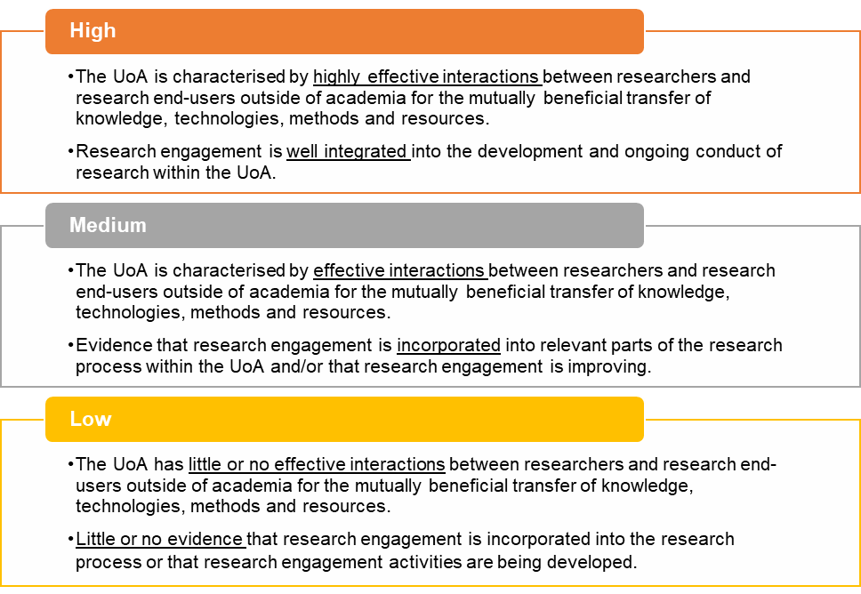

## 4.2 Assessment of engagement

The panel determines the rating for engagement by:

* reviewing the evidence provided by the institution in their engagement submission
* considering this evidence against the rating scale.

Note—There is no weighting applied to the different parts of the submission. Panel members consider the evidence as a whole before deciding the UoA’s rating. The content of the submission wholly determines the rating. Panel members must not seek information outside of the engagement submission to verify information.

Note—the assessment of a UoA results is a rating, not a ranking. There is no quota for each rating and panel members should assess UoAs against the standard set out in the rating scale, not in comparison with other UoAs.

## 4.3 Engagement narrative

In the engagement narrative ([Appendix F1](#_Appendix_G1—Engagement_narrative)), institutions describe the overall engagement activity, strategies and objectives for the UoA and may include:

* the purpose of the engagement
* how the UoA engaged with research end-users for mutual benefit
* the duration and extent of the engagement activities.

Institutions may use examples of engagement in their narrative that involve collaborations with other institutions, but they must make their role clear. Similarly, researchers need not have been present for the entirety of a project, or at its conclusion, in order for institutions to detail their involvement in activities described in the engagement narrative.

While the ARC directed institutions not to include links to external references, such as URLs, some narratives may include them. If this is the case, panel members must not view the external information. Nor can panel members of their own volition seek information outside of the narrative to verify claims made.

Additional quantitative evidence, including indicators that are not a part of the 2018 engagement indicator suite, can be included in the engagement narrative. Institutions may draw on any qualitative or quantitative information for their narrative that provides evidence of their engagement activities within a UoA. [Appendix G](#_Appendix_F—Examples_of) gives examples of some additional quantitative information that institutions may have included in their submission.

Key questions to keep in mind during consideration of the narrative are:

* Whom did the institution engage with outside academia within the reference period?
* Was the engagement mutually beneficial?
* What was the purpose of the engagement?
* How long were the engagement activities undertaken for and what was their extent?
* Are engagement activities well integrated into the research processes within the UoA?
* What evidence of engagement does the UoA provide?
* Is there anything significant to note?
* If additional indicators are given, how are they defined? Is this a reasonable measure of engagement?
* Have they explained how the additional indicator contributes to the engagement that they have already described in the narrative?

[Appendix J](#_Appendix_I—Specified_HERDC) also lists these questions.

## 4.4 Engagement indicator explanatory statement

In the engagement indicator explanatory statement ([Appendix F3](#_Appendix_F3—Engagement_indicator)) institutions provide context for the four engagement indicators including any anomalies in the data. For EI 2018, the ARC has asked institutions to provide further information about the relationship between the indicator data and a UoA’s engagement with research end-users. The ARC has also asked institutions to ensure the additional context provides a clear explanation of the link between the engagement indicator and the engagement activity of the UoA.

## 4.5 Engagement indicators—overview

In considering the engagement performance of a UoA, panels must make a holistic judgment based on the engagement narrative, the indicator explanatory statement and the income indicators. Panel members should start with the engagement narrative and consider if there is evidence in the indicator explanatory statement and indicators that support, enhance or otherwise moderate the claims in the engagement narrative.

For all engagement indicators, panels should consider the indicators in the context of the engagement narrative and indicator explanatory statement when deciding on a rating.

EI 2018 has four compulsory indicators of research engagement with research end-users:

* cash support from research end-users
  + given as a dollar value and as a proportion of total Higher Education Research Data Collection (HERDC) income for specified HERDC Category 1 and HERDC Categories 2, 3 (i, ii, iii), and 4 (see section [4.5.1](#_4.5.1_Provision_of) for more detail)
* total HERDC income per FTE
  + for specified HERDC Category 1 and Categories 2, 3 (i, ii, iii), and 4
* proportion of specified Category 1 grants to all HERDC Category 1 grants
  + two proportions are provided—one for income ($) provided by the grants and the other for counts of grants
* research commercialisation income.

***Note—Specified HERDC Category 1* grants** are grants within the HERDC Category 1 that the ARC identified as having an end-user funded component or end-user partnership focus. This list of specified grants is at [Appendix H](#_Appendix_H—Specified_HERDC).

Each compulsory indicator provides some evidence of engagement with research end-users. The first three engagement indicators are an analysis of research income associated with end-user partnerships. The fourth indicator is further evidence of a commitment to the research project. It is important to consider all four indicators as well as the descriptions of engagement related to these indicators provided by the institution in the indicator explanatory statement.

Not all disciplines are assessed against all indicators. Both 11 Public and Allied Health, and 18 Law and Legal Studies are excluded from reporting research commercialisation income.

Note**—**The ARC is also collecting data on co-supervision of HDR students[[4]](#footnote-5) by research end-users, with the view that this may become a compulsory indicator in future rounds. In EI 2018, this data is not assessed and will not be provided to panels.

### 4.5.1 Provision of data

Institutions are required to provide the value of cash support from research end-users against grants within the specified HERDC Category 1 and HERDC Categories 2, 3 (i, ii, iii), and 4. All other data for the compulsory indicators comes from ERA 2018 submissions. [Appendix F2](#_Appendix_G2—Data_items) individually lists the data requirements. The ARC performs all the calculations necessary.

#### HERDC Income

The Department of Education maintains the HERDC as part of their process for determining annual allocation of research block grants by the Australian Government. The data collection consists of research income data submitted by universities to the Department of Education each year. The ARC uses the same reporting categories as HERDC for reporting income in ERA and EI. EI 2018 includes the following HERDC categories of income:

* Category 1: Australian competitive grants
* Category 2: Other public sector research income
* Category 3: Total industry and other research income
  + 3 (i): Australian
  + 3 (ii): International A (competitive, peer reviewed)
  + 3 (iii): International B (other international income)
* Category 4: Cooperative Research Centre (CRC) research income.

Note—ERA and EI do not include all types of funding reported under Category 3. The following subcategories are excluded:

* HERDC Category 3 (i)—subcategory of ‘Australian’ income: HDR fees for domestic students are not considered to be research income or end-user funding for the purpose of EI 2018.
* HERDC Category 3— subcategory ‘International C: HDR fees for international students’ are not considered to be research income or end-user funding for the purpose of EI 2018.

#### Specified HERDC income as presented in the indicators

The first three indicators must be considered together as they look at the specified HERDC income from different viewpoints. It is important to understand how the income components are related to each other. [Figure 2](#Figure_2) schematically illustrates the link.

Figure 1: Specified HERDC income and the first three indictors

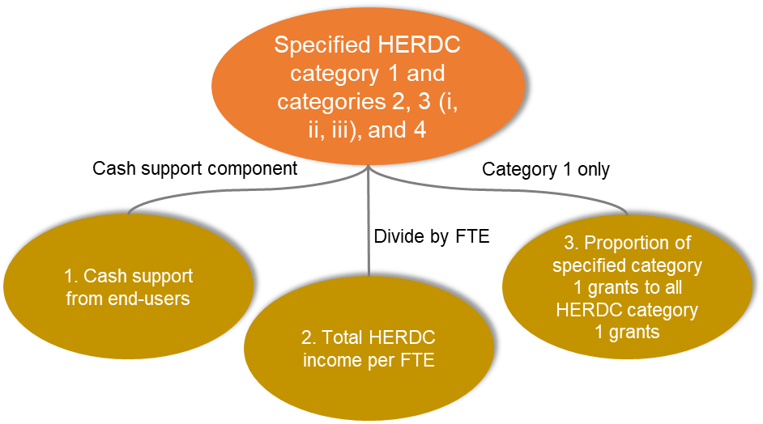

The first indicator is the end-user component of this income. Institutions were asked to isolate the end-user cash component from the total amount from specified Category 1 and Categories 2 and 3 (i, ii, iii) and 4. Institutions determined the end-user amount based on the definition of end-user provided in the EI 2018 Submission Guidelines. End-user income may vary based on the type of grant and the specific purpose of each grant. Please note—in the case of Category 4 CRC income, for EI 2018, the ARC has allowed the institutions to claim 100 percent of the CRC income as end-user income.

The second and third engagement indicators are created from the data institutions have provided to the ARC in their ERA submission. This data has been collected through ERA since 2010. End-user income is a new data collection and is reported separately by institutions, not as part of their ERA submission.

The second indicator is the income per FTE. This indicator looks at the same total HERDC income (specified Category 1 and 2, 3 (i, ii, iii), 4) amount as indicator 1 but normalised by size of the UoA, in this case the FTE. Note that the number of FTE from research staff excludes teaching only appointments.

The third engagement indicator focusses on the specified Category 1 income, in relation to the total Category 1 income. This indicator provides a comparison of grants with an integrated end-user component against the funding from grants that are less likely to, or are not required to, have an end-user component.

The third engagement indicator has two parts. Part 1 shows the percentage of specified HERDC Category 1 to total of all HERDC Category 1 income. The second part of the third indicator is looking at the same grants but instead of dollars, the focus is the number of grants won by this UoA. It is important to look at dollars and number of grants, as it is possible to win more grants with less expensive research projects and vice versa. The two parts of this indicator reveal the success in dollars and the success in winning grants.

### 4.5.2 Presentation of indicators within an FoR

The compulsory indicators are shown as a distribution of the UoAs within the corresponding discipline, or FoR, to provide a comparison between the UoA being considered and all other UoAs within their specific FoR.

This presentation shows the spread of these indicators in each FoR. It should not be used to rank UoAs. The distribution may assist panel members to answer questions such as:

* Is this indicator value high or low for the discipline?
* Is this one of a few key players, or are most UoAs very similar in this indicator?

Each indicator is presented as a distribution (see for example [Figure 3](#Figure_3) below) which gives the number of institutions that fall into equal bands between zero and the rounded maximum value for the indicator observed in the specific FoR. In addition, the first band shows zero percent or a less than one dollar amount, which represents no or negligible income. To assist visualisation, the bars of the histogram constitute small stacked circles with each circle representing one institution. The banding within which the assessed UoA falls is identified by a darker colour.

The expectations regarding income will vary across different disciplines, for example, the amount of income considered to be high in 21 (CAH), may be considered low in 11 (BCS).

## 4.6 Engagement Indicators—details

### 4.6.1 Indicator 1—Cash support from research end-users (specified HERDC Category 1 and HERDC Categories 2, 3 (i, ii, iii) and 4)

This indicator focuses on the amount of cash support that research end-users have provided to institutions for research. It captures cash contributions from research end-users as per the definition of research end-user ([1.3](#_1.3_Definitions)). Funding of this type may point to engagement with research end-users as it indicates interaction of researchers with end-users for a mutually beneficial exchange of knowledge and resources. Note that for some disciplines cash support from end-users may not normally be expected or only expected in small amounts, therefore the indicator should not be compared across disciplines.

Institutions report cash contributions from research end-users against a specified list of HERDC Category 1 grants and any relevant funding in HERDC Categories 2, 3 (i, ii, iii), and 4 by FoR code. The cash support from research end-users is reported as the amount specific to the FoR code and within the engagement reference period ([1.6](#_1.7_Reference_periods)).

The focus of assessment is on the total amount of cash not individual categories, so panels see a total overall value for the reference period. Again, it is important to note that there are differences between disciplines so you must not compare one discipline to another.

Cash support from end-users appears as a dollar value and as a proportion of the total HERDC income. Higher dollar values show greater monetary support by research end-users. Higher proportions of cash support show that end-users are providing a larger portion of the financial research support. Since the reported cash support is included in the reported HERDC income it is expected that the proportion of cash support will be less than or equal to 100% (see Table 4 for example).

Table 4: Example UoA showing tabulated cash support from end-users

| **Type of Income** | **Amount** |
| --- | --- |
| Total HERDC Income (specified Category 1, and 2, 3 (i, ii, iii) and 4) | $15,409,241.10 |
| **Cash support from research end-users** | **$1,551,760.00** |
| Proportion of cash support reported to total HERDC (specified, as above) | 10% |

In addition to the tabulated results, the cash support as a dollar value and as a proportion of the total HERDC income for that UoA is identified on a distribution of the cash support across the specific FoR. [Figure 3](#Figure_3) and [Figure 4](#Figure_4) illustrate the form of the distribution, with an example UoA marked. The horizontal axes give the upper band (exclusive) of each of the 21 bandings. The first band represents negligible cash support (less than $1), and the remaining bandings are 20 equal divisions between zero and a rounded value above the maximum value any institution received. In this example, there are no institutions with negligible cash support. It is important to realise that the cash support as a dollar value and as a proportion are different distributions, since each institution will have a different total HERDC income. The institution’s position in each distribution can therefore vary.

Figure 3: The distribution of cash support as a dollar value with an example UoA identified.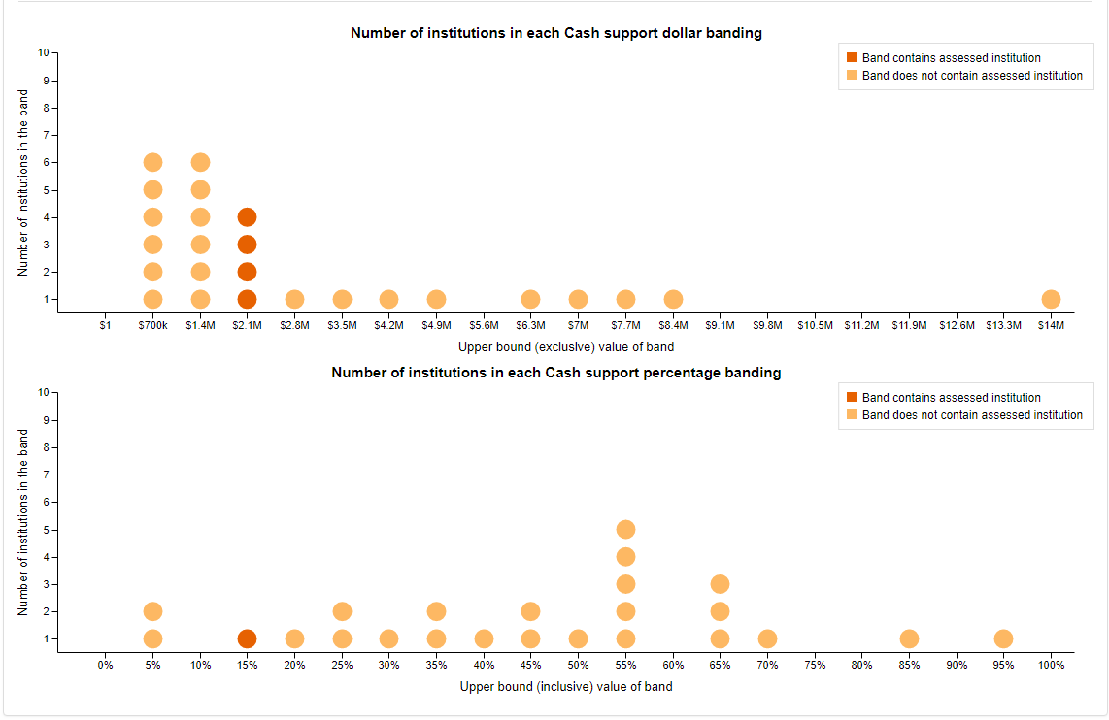

Figure 4: The distribution of cash support as a proportion value with an example UoA identified.



### 4.6.2 Indicator 2—Total HERDC income (specified HERDC Category 1 and Categories 2, 3 (i, ii, iii), and 4) per FTE

This indicator is broader than cash support from research end-users. It includes total funding (not just cash from research end-users) from the specified category 1 and categories 2, 3 (i, ii, iii) and 4. For comparative purposes, the ARC divides funding by FTE to account for varying size of institutions.

Panel members will see a table showing the total HERDC income, the total FTE and the total HERDC Income per FTE. The total income per FTE is the indicator and the distribution for the FoR with the UoA identified is shown as a chart. See [Table 5](#Table_5_Title) and [Figure 5](#Figure_5) respectively.

Table 5: Example UoA showing total HERDC income per FTE

| **Type of Income** | **Amount** |
| --- | --- |
| Total HERDC Income (specified Category 1 and 2, 3 (i, ii, iii) and 4) | $15,409,241.10 |
| Total FTE | 99.66 |
| **Total HERDC Income per FTE** | **$154,618** |

Note—The total FTE given here only includes staff that have a research component to their employment, i.e. a function of either “Research only” or “Teaching and Research”.

Figure 5: The distribution of the Total HERDC income per FTE with the example UoA identified.

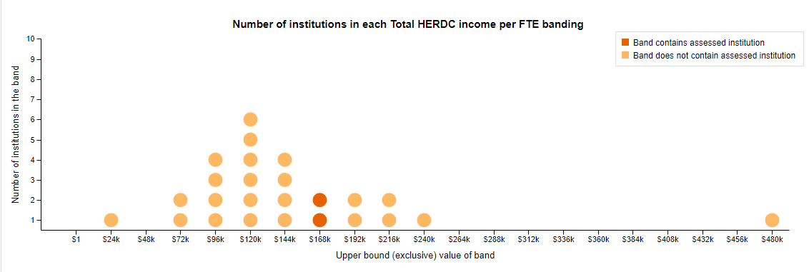

The horizontal axis in [Figure 5](#Figure_5) gives the upper band (exclusive) of each of the 21 bandings. The first band represents negligible income (less than $1), and the remaining bandings are 20 equal divisions between zero and a rounded value above the maximum value any institution received. In this example, there are no institutions with negligible HERDC income. You can see that this UoA is in the top eight UoAs, and has around a third of the income per FTE of the top UoA.

### 4.6.3 Indicator 3—Proportion of specified HERDC Category 1 grants to all HERDC Category 1 grants

This indicator focuses on the proportion of HERDC Category 1 funding arising from specified HERDC Category 1 grants (end-user sponsored) compared to all HERDC Category 1 grants. Research end‑user sponsored grants indicate a cooperative approach to research. Identifying the proportion of these grants from the total HERDC Category 1 grants gives an indication of research engagement. The proportions are calculated based on the portion of the Category 1 grants received within the reference period.

This indicator includes two separate calculations:

* the proportion of the **number** of specified HERDC Category 1 grants to the **number** of all HERDC Category 1 grants
* the proportion of the **income** from specified HERDC Category 1 grants to the **income** of all HERDC Category 1 grants

Both calculations are proportions, and so have a maximum value of 100%; this means that both proportions can be presented on the same graph. By presenting the two proportions on the same graph, panel members can more easily see if the institution is winning larger grants, larger numbers of grants, or is fairly consistent in both.

Comparing the two proportions helps interpret the depth of engagement (dollars—organisations providing the grants are more invested financially) and breadth of engagement (counts—more projects with investment from organisations). If the proportion of the number of grants is greater than the proportion of the income, this shows engagement that is broader rather than deeper, suggesting smaller investments from more end-users. If the proportion of the income is greater than the proportion of the number of grants, this shows engagement that is deeper rather than broader, suggesting that fewer organisations are making larger investments. The actual values of both counts and income proportions suggest the relative level of support by organisations. It is important to interpret this indicator in light of the indicator explanatory statement to understand the nature of the engagements.

SEER presents this indicator in tabular and graphical form. See [Table 6](#Table_6_title) and [Figure 6](#Figure_6_title) examples.

Table 6: Example UoA showing proportions of specific category 1 grants to all category 1 grants

|  | **Income** | **Number of grants** |
| --- | --- | --- |
| Income from specified HERDC Category 1 | 2,849,662 | 2.24 |
| Income from all HERDC Category 1 | 4,577,144 | 9.25 |
| **Proportion of specified Category 1 grants to all HERDC Category 1 grants** | **62%** | **24%** |

*Figure 6: The distribution of the proportions of specific category 1 grants to all category 1 grants with an example UoA identified*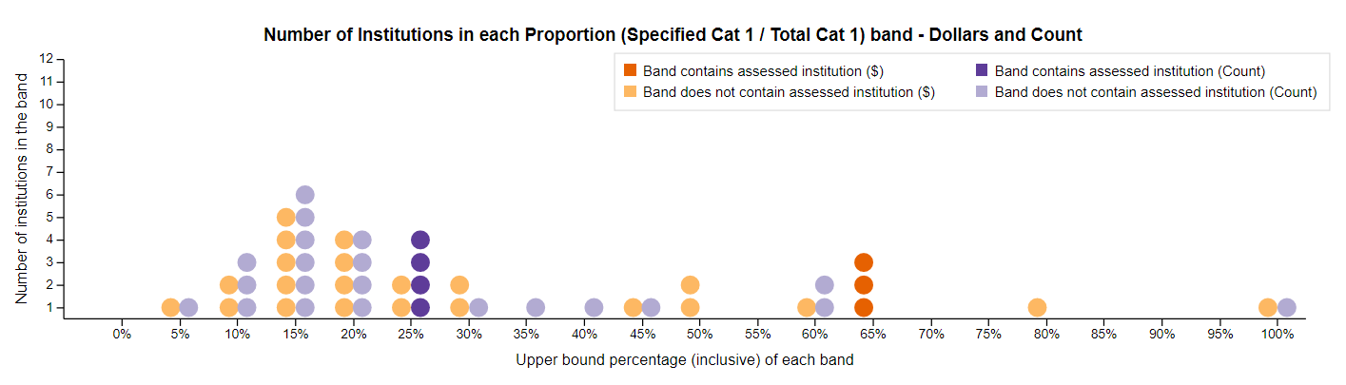

The horizontal axis gives the top percentage (inclusive) of each banding. The first band is zero percent, and the last is 100%. In [Figure 6](#Figure_6_title), there are no institutions with zero income from specified HERDC category 1 grants. For this indicator, the example UoA has quite different proportions of numbers of grants and income from grants, with the proportion of the income from grants significantly higher than the counts. This is evidence of greater depth than breadth in relation to engagement income.

### 4.6.4 Indicator 4—Research commercialisation income

Research commercialisation income is indicative of a mutually beneficial arrangement between an institution and a research end-user. Data for this indicator comes from an institution's ERA 2018 submission. ERA collects research commercialisation income at the four-digit FoR level. This data is rolled up to the two-digit level for EI 2018.

As in ERA 2018, research commercialisation income is defined as income from:

* institution-owned subsidiaries
* spinoff companies
* licences, options and assignments (LOA).

LOA for inclusion must be negotiated on full commercial terms, granting access to institutional intellectual property (patents, designs, PBR and trademarks) in return for royalties or licence fees.

LOA include:

* running royalties
* cashed in equity.

LOA do not include:

* material transfer agreements (MTA), including income received to cover costs of making and transferring materials under MTA
* patent expense reimbursement from licensees
* research funding
* a valuation of equity not cashed in
* trademark licensing royalties from university insignia.

Research commercialisation income does not include:

* commercial income from research contracts and consultancies, commissioned works, student fees, rents or any other source
* Cooperative Research Centre (CRC) research income.

Research commercialisation income is not used as an indicator for:

* 11—Public and Allied Health Sciences
* 18—Law and Legal Studies.

This indicator shows the total research commercialisation income for the UoA. Panel members will see a table showing the research commercialisation income presented in tabular form, and then a distribution is given with the UoA identified (Table 7 and Figure 7).

Table 7: Example UoA showing research commercialisation income

| **Income** | **Amount** |
| --- | --- |
| **Total research commercialisation income over reference period** | **$50,437** |
| Contribution to total research commercialisation income in the FoR | 0% |

*Figure 7: The distribution of research commercialisation income with UoA identified.*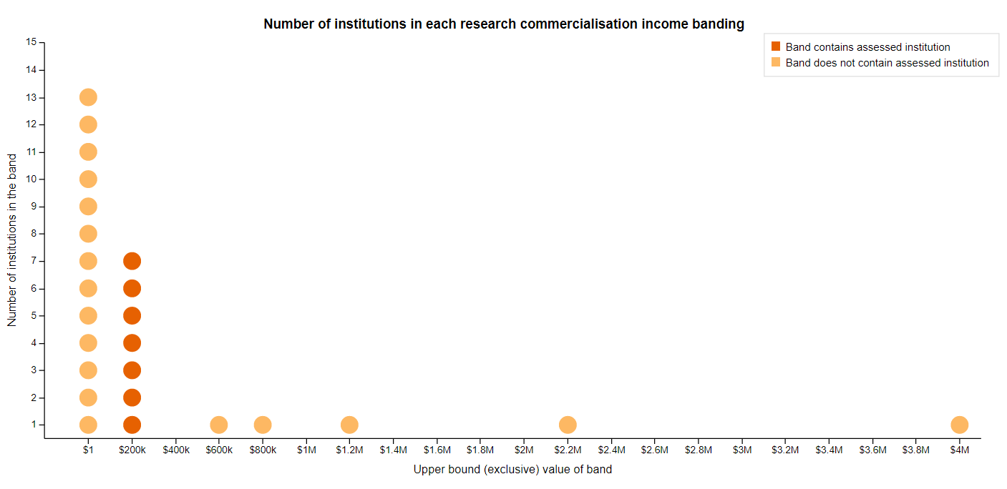

In this example, 13 institutions had negligible research commercialisation income (less than $1), with a scattering of higher incomes. This UoA has some commercialisation income, but the value is considerably smaller than the top five institutions. This is evidence of some research commercialisation, compared to many institutions in the FoR which have limited commercialisation income.

Key questions to keep in mind in considering the engagement indicators and explanatory statement are:

* Do the income indicators align with the information in the engagement narrative?
* Where in the distribution does the UoA fall?
* Is this what you would expect based on the type of engagement described in the narrative?
* Are the indicator values what you would expect for the two-digit FoR?
* What reasons does the explanatory statement give for the values of the indicators? Does it explain or support the values of the indicators?

[Appendix J](#_Appendix_I—Specified_HERDC) also lists these questions.

## 4.7 How to rate engagement

* How effective are the interactions between researchers and research end-users?
* Is there a mutually beneficial transfer of knowledge, methods and/or resources?
* How well is the engagement integrated (or incorporated) into the development of research within the UoA?

[Appendix J](#_Appendix_I—Specified_HERDC) also lists these questions.

# Impact assessment

An impact submission comprises two components:

* the impact of the research and the associated research
* the approach to impact

Both are assessed and rated separately.

Impact and approach to impact are assessed in all UoAs as outlined in [3.1.3](#_3.1.3_Assessment_and). Corresponding to the three types of UoA ([1.4](#_1.3_Disciplines)), there are three impact templates:

* two-digit FoR impact study ([Appendix I1](#_Appendix_G1_Two-digit))
* interdisciplinary impact study ([Appendix I2](#_Appendix_G2_interdisciplinary))
* Aboriginal and Torres Strait Islander research impact study ([Appendix I3](#_Appendix_H3—Aboriginal_and))

The templates set out the information institutions are required to submit for each type of impact study.

**Two-digit FoR impact study**

This impact study is assessed by one of the four discipline-specific panels (SS, ST, CAH or HLS) depending on the FoR code which is identified as the primary FoR on the template ([Table 2](#Table_2)).

**Interdisciplinary impact study**

Institutions may choose to submit one interdisciplinary impact study. The ARC has advised institutions that they should use interdisciplinary impact studies where the impact is so broad that one primary FoR code cannot describe it. Institutions can assign up to three FoR codes to describe the content of the interdisciplinary impact study.

**Aboriginal and Torres Strait Islander research impact studies**

Institutions may choose to submit an impact study on Aboriginal and Torres Strait Islander research. Where relevant, the impact study should demonstrate the ways in which Aboriginal and Torres Strait Islander leadership and governance arrangements were integrated into the activities and processes throughout all stages from the initial research, through translation, to the impact itself. A key element of this is demonstrating Indigenous-led principles which embody the right to self-determination as articulated in the *United Nations Declaration on the Rights of Indigenous Peoples* (of particular note are articles 3, 4, 19 and 31).

The Aboriginal and Torres Strait Islander research impact study does not have to be associated with any particular FoR, although institutions may identify additional FoRs associated with the impact study. Additional FoR codes assigned to studies assist in the assignment of appropriate panel members.

## 5.1 Rating scales for impact and approach to impact

Panels assess impact and approach to impact for each UoA using a three-point scale. The ratings for the impact and approach to impact are—High, Medium and Low. While using the same scale for both assessments, the description of what constitutes the ratings differs. The separate descriptors for each point on the rating scales are set out below.

### Impact

*Figure 8: The impact rating scale*

*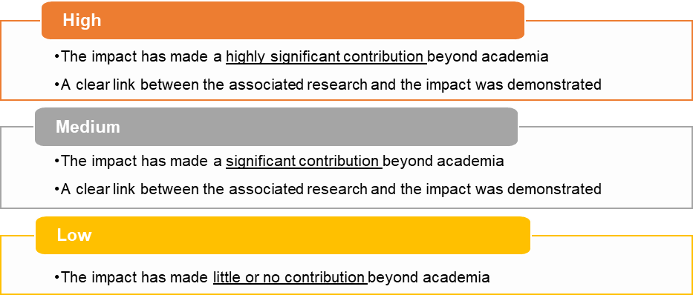*

### Approach to impact

*Figure 9: The approach to impact rating scale*

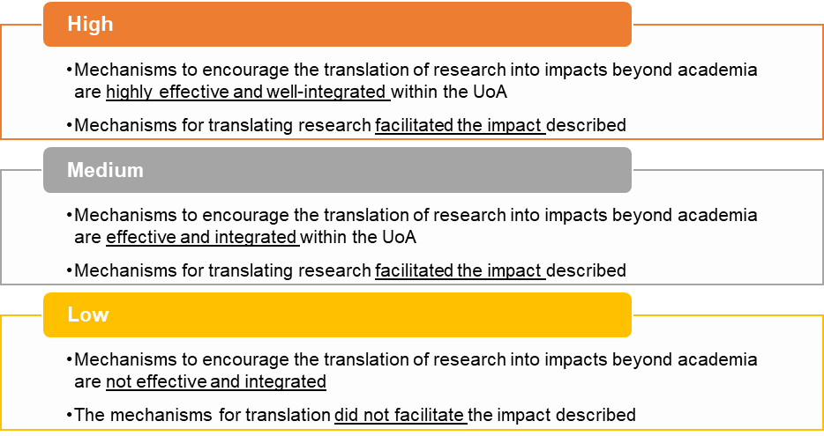

## 5.2 Assessment of impact

The panel determines the ratings for impact by:

* reviewing the evidence provided by the institution in Part A of the template
* considering this evidence against the rating scale.

Note—The content of the template wholly determines the rating. Panel members must not seek information outside of the impact study. This includes clicking on any URLs within the template. The ARC directed institutions not to include links to external references (URLs); however, some submissions may incorrectly include them.

The assessment of a UoA results in a rating, not a ranking. There is no quota for each rating and panel members should assess UoAs against the standard set out in the rating scale, not in comparison with other UoAs.

While the information provided in Part A and Part B of the impact study is related, the ratings a UoA receives for impact and approach to impact depend on different evidence and are assessed using different rating descriptors. Therefore, it is entirely possible that a UoA receives different ratings for impact and approach to impact.

### 5.2.1 Part A—Impact

Part A of the impact studies template is comprised of a number of sub-sections described in more detail below.

**1. Summary of impact**

In this section of the template, institutions summarise the impact described in the template. They should use simple, clear English such that the general public could understand the impact of the research. This section of the template is mandatory in SEER and the content should reflect the information provided in Section 4 of the template which has details of the impact.

**2. Beneficiaries**

Institutions may list up to 10 beneficiaries related to the impact. Institutions must list at least one beneficiary and at least one of the listed beneficiaries must be an end-user according to the EI 2018 definition of end-user.

**3. Countries in which the impact occurred**

Institutions may list as many countries as related to the location of the impact.

It is important to note that geographical spread is **not** an indicator of the standard of impact that occurred.

This section does not appear in the Aboriginal and Torres Strait Islander research impact study template as the impact would be expected to have occurred within Australia.

**4.** **Details of the impact**

This section contains the key information that forms the basis of the rating for impact. The narrative should clearly outline the research impact. The narrative should explain the relationship between the associated research and the impact. It should also identify the contribution the research has made beyond academia, including:

* who or what has benefitted from the results of the research (this should identify relevant research end-users, or beneficiaries from industry, the community, government, wider public etc.)
* the nature or type of the impact and how the research made a social, economic, cultural and/or environmental impact
* the extent of the impact (with specific references to appropriate evidence, such as cost-benefit analysis, quantity of those affected, reported benefits etc.)
* the dates and time period in which the impact occurred
* a clear link between the impact and the associated research.

The narrative describes impact that occurred within the six-year reference period, 1 January 2011–31 December 2016. However, the impact study can refer to, or include, external evidence that verifies the claims made. For example, an auditor’s report on return on investment can be included, even if this was published after the impact reference period, if it relates to impact within the reference period.

**Note**—some impact studies include information about impact that occurred outside of the reference period, typically where impacts arising from research were iterative. The focus of the assessment, however, is on the impact that occurred within the reference period only. Panel members’ judgements about the quality of the impact should only be based on the impacts occurring within the impact reference period.

The ARC directed institutions to focus on an example of impact within the two-digit FoR rather than attempting to report on all impact arising from the FoR.

Institutions were able to select impact examples that involved collaboration with other institutions. In such cases, institutions were instructed to articulate clearly the role of their institution in relation to the impact. Similarly, institutions were able to select impact examples that involved researchers who may not have been present at the institution for the entirety of a project. In such cases, institutions were instructed to articulate clearly the role of the researchers at the institution and in relation to the impact.

Key questions to keep in mind when considering the impact are:

* What was the impact?
* When did the impact occur?
* Is it research impact? Did the impact arise from research, or from another kind of activity at the institution? Consider the associated research section of the template.
* Does the impact study describe who or what benefited from the results of the research? Is it outside of academia?
* How did the research make a social, economic, cultural and/or environmental impact?
* What was the extent of the impact and has suitable evidence been provided?

For the Aboriginal and Torres Strait Islander impact study, a key question to consider is:

* Where relevant, does the impact study demonstrate the ways in which Aboriginal and Torres Strait Islander leadership and governance arrangements were integrated into the activities and processes throughout all stages from the initial research, through translation, to the impact itself? A key element of this is demonstrating Indigenous-led principles, which embody the right to self-determination.
* Where relevant, is evidence of how Aboriginal and Torres Strait Islander ethical research guidelines were integrated into the research activities and process detailed in the impact study?

[Appendix J](#_Appendix_I—Specified_HERDC) also lists these questions.

**5. Associated research**

In this section of the template, institutions provide a description of the research associated with the impact described in [4.](#Section_4_Details_of_Impact) above. The research must meet the definition of research ([1.3](#_1.3_Definitions)). The description should include details of:

* what was researched
* when the research occurred
* who conducted the research and what was the association with the institution.

The research described must have occurred within the reference period for associated research—1 January 2002 to 31 December 2016.

The rating scale for impact states that there must be a clear link between associated research and impact. Therefore, a panel member’s assessment of the connection between the associated research and the impact comes into the panel member’s judgement about the rating. Panels do not rate the quality of the research, and need only to be satisfied that the research underpins the impact described.

**6. FoR of associated research**

In this section of the template, institutions may list up to three two-digit FoR codes that best describe the associated research. The FoR codes listed do not have to be identical to the FoRs listed for the impact study.

The FoRs for associated research recognise that the research and the impact may occur in different fields of research. For example, research in 01 Mathematical Sciences such as geometric methods for image processing may lead to an impact in aeronautical engineering (09 Engineering) through improvements to autopilot systems or improvements to medical imaging systems (11 Medical and Health Sciences). The discipline in which the research was produced is not being rated, only the impact of the research is rated in the relevant FoR.

**7. References (up to 10 references)**

The institution must provide at least one reference, and may list up to 10 of the most relevant references associated with the research. References must be within the reference period for associated research 1 January 2002–31 December 2016.

Key questions to keep in mind in considering the associated research are:

* Is the research described relevant to the impact described?
* What is the institution’s link to the research? Is there an association to the institution claiming the impact?

[Appendix J](#_Appendix_I—Specified_HERDC) also lists these questions.

**Additional quantitative indicators**

In this optional section, institutions may provide information about any quantitative indicators (up to a maximum of four) not captured in Part A that are relevant to the impact study. For example, information on return on investment, jobs created, improvements in quality of life years (QALYs), number of visitors to an exhibition. Institutions must include for each indicator:

* name of the indicator
* data for the indicator
* brief description of the indicator and how it is calculated.

The data provided may be useful as context when considering impact but the additional quantitative indicators are optional and so their absence must not disadvantage a UoA.

Key questions to keep in mind in considering any additional quantitative indicators are:

* What are the indicators? How do they align with the information provided in the impact section?
* Are they supportive of other information provided in the submission?
* Is the data provided for the indicator within the reference period?

[Appendix J](#_Appendix_I—Specified_HERDC) also lists these questions.

### 5.2.2 How to rate impact

* What was the impact of the research? How did it contribute to the economy, society, environment or culture, beyond the contribution to academic research?
* How significant was the contribution beyond academia?
* Did the impact described arise from research? Is it research impact, or is it impact arising from another activity at that institution?

[Appendix J](#_Appendix_I—Specified_HERDC) also lists these questions.

## 5.3 Assessment of approach to impact

The panel determines the ratings for approach to impact by:

* reviewing the evidence provided by the institution in Part B of the template
* considering this evidence against the rating scale.

Note—The content of the template wholly determines the rating. Panel members must not seek information outside of the impact study. This includes clicking on any URLs within the template. The ARC directed institutions not to include links to external references (URLs); however, some submissions may incorrectly include them.

The assessment of a UoA results in a rating, not a ranking. There is no quota for each rating and UoAs are assessed against the standard set out in the rating scale, not in comparison with other UoAs.

While the information provided in Part A and Part B of the impact study is related, the ratings a UoA receives for impact and approach to impact depend on different evidence and are assessed using different rating descriptors. Therefore, it is entirely possible that a UoA receives different ratings for impact and approach to impact.

### 5.3.1 Part B—Approach to impact

Part B of the impact studies template comprises two sub-sections described in more detail below.

**1. Summary of the approaches to impact**

This section should summarise the strategies, detailed in 2. Approach to impact, implemented by the institution, its colleges, faculties, groups, departments, and/or centres that facilitated the delivery of the impact described in Part A of the template.

**2. Approach to impact**

This section of the template contains the information on which the rating for approach to impact is based. Institutions have been instructed to explain their role in facilitating the delivery of impact. Descriptions about institution support may include general information, but should also include information about the mechanisms that relate to the specific impact example in Part A, and to the UoA more broadly.

Institutions can include a range of information including:

* support provided by the institution, its faculties, colleges, groups, departments, and/or centres for researchers to affect positive impact
* how that support was implemented by the research area
* how researchers interacted and engaged with research end-users or beneficiaries
* evidence of review of impact processes and outcomes during the period
* evidence of how mechanisms of translation were integrated into research practices
* human resources policies, initiatives and strategies
* financial or other resources made available to facilitate the realisation of the impact
* other strategies used in relation to this UoA that aided in the realisation of impact.

Key questions to keep in mind when considering the approach to impact are:

* How did the institution, faculties, colleges, groups, departments, and/or centres facilitate the impact described in Part A?
* What are the mechanisms described? Are they well-integrated within the UoA?
* How effective were the mechanisms in facilitating the delivery of the impact?

For the Aboriginal and Torres Strait Islander impact study, a key question to consider is:

* Were there any targeted efforts to engage with Aboriginal and Torres Strait Islander communities, groups or people?

[Appendix J](#_Appendix_I—Specified_HERDC) also lists these questions.

### 5.3.2 How to rate approach to impact

* How effective and integrated are the mechanisms to encourage translation of research into impacts beyond academia?
* Did the described mechanisms for translating research facilitate the impact described?

[Appendix J](#_Appendix_I—Specified_HERDC) also lists these questions.

## 5.4 Other components of the impact study template

The impact study templates require institutions to provide information that will be used by the ARC for administrative and reporting purposes. This information includes:

* **Australian and New Zealand Standard Research Classification (ANZSRC) FoR codes**—Institutions select the fields of research that are relevant to the impact study, and the fields of research relevant to the associated research.
* **Socio-Economic Objective (SEO) codes**— SEO codes enable research and development (R&D) to be categorised according to the purpose or outcome of the R&D. The codes consists of discrete economic, social, technological or scientific domains for identifying the principal purposes of the R&D. The SEO codes have a hierarchical structure comprising four levels—section, division, group and objective ([Appendix C](#_Appendix_C—ANZSRC,_SEO)). Institutions select the most relevant SEO code from the division level.
* **Australian and New Zealand Standard Industrial Classification (ANZSIC) codes**— ANZSIC was developed for use in the compilation and analysis of industry statistics in Australia and New Zealand. It is a hierarchical classification with four levels—division, subdivision, group and class ([Appendix C](#_Appendix_C—ANZSRC,_SEO)). Institutions select the most relevant ANZSIC codes from the subdivision level.
* **Commercial or cultural sensitivities**—institutions indicate where material in an impact study may be commercially or culturally sensitive, including instructions for handling such material.
* **Science and Research Priorities**— The Science and Research Priorities ensure that appropriate levels of public funding are allocated to research that addresses the most immediate problems facing the nation ([Appendix C](#_Appendix_C—ANZSRC,_SEO)). Institutions select the priorities that are most relevant.
* **Aboriginal and Torres Strait Islander content flag**—the two-digit FoR impact study and the interdisciplinary impact study templates have an Aboriginal and Torres Strait Islander content flag. Institutions may use this flag to identify impact studies where the impact, associated research and/or approach to impact, relates to Aboriginal and Torres Strait Islander peoples, nations, communities, language, culture and knowledges and/or is undertaken with Aboriginal and Torres Strait Islander peoples, nations and/or communities.

# Appendices

## Appendix A—Glossary

| **Term** | **Description** |
| --- | --- |
| Aboriginal and Torres Strait Islander research | Aboriginal and Torres Strait Islander research means that the research (as per the definition for EI) significantly:   * relates to Aboriginal and Torres Strait Islander peoples, nations, communities, language, place, culture or knowledges and/or * is undertaken with Aboriginal and Torres Strait Islander peoples, nations, or communities. |
| ANZSIC | The Australian and New Zealand Standard Industrial Classification (ANZSIC) was developed for use in the compilation and analysis of industry statistics in Australia and New Zealand. It is a hierarchical classification with four levels – Division, Subdivision, Group and Class. |
| ANZSRC | The Australian and New Zealand Standard research classification (ANZSRC) developed by the Australian Bureau of Statistics and Statistics New Zealand.  The ANZSRC is a hierarchical classification system with three levels. The two-digit Field of research is the highest, followed by the four-digit and then six-digit. |
| Engagement | Research engagement is the interaction between researchers and research end-users outside of academia, for the mutually beneficial transfer of knowledge, technologies, methods or resources. |
| Fields of Research (FoR) | A hierarchical classification of fields of research set out in the ANZSRC. In this handbook, the term ‘Fields of Research’ or ‘FoR’ applies to the two-digit Field of Research level. |
| Higher Degree by Research | An HDR is a Research Doctorate or Research Masters. A Research Doctorate means a Level 10 Doctoral Degree (Research) qualification as described in the Australian Qualifications Framework and a Research Masters means a Level 9 Master’s Degree (Research) qualification as described in the Australian Qualifications Framework. Professional Doctorates may be included but only where at least two-thirds of the qualification is research. |
| Higher Education Research Data Collection (HERDC) | The annual research data collection exercise undertaken by the Department of Education. |
| Impact | Research impact is the contribution that research makes to the economy, society, environment or culture, beyond the contribution to academic research. |
| Institution | Australian higher education providers eligible to participate in EI, defined as Table A and Table B providers listed in the *Higher Education Support Act 2003.* A list of institutions is provided at [Appendix E](#_Appendix_E—Eligible_institutions). |
| Low volume threshold | The threshold for assessment of a UoA in EI is 150 weighted research outputs submitted to ERA (1 book = 5 outputs) |
| Principal assessor | Panel member who is appointed to lead discussions of preliminary assessments of a UoA at the Stage 4 finalisation meeting. Each assessment UoA is assigned a principal assessor. |
| Research | Research is the creation of new knowledge and/or the use of existing knowledge in a new and creative way to generate new concepts, methodologies, inventions and understandings. This could include the synthesis and analysis of previous research to the extent that it is new and creative. |
| Research end-user | A research end-user is an individual, community or organisation external to academia that will directly use or directly benefit from the output, outcome or result of the research.  Examples of research end-users include governments, businesses, non-governmental organisations, communities and community organisations. |
| Unit of Assessment (UoA) | A discipline for a specific institution defined as:   * two-digit FoR * Interdisciplinary * Aboriginal and Torres Strait Islander research |

## Appendix B—Abbreviations

| **Abbreviation** | **Description** |  |
| --- | --- | --- |
| AIMS | Australian Institute of Medical Sciences |  |
| ANSTO | Australian Nuclear Science and Technology Organisation |  |
| ANZSIC | Australian and New Zealand Standard Industrial Classification |  |
| ANZSRC | Australian and New Zealand Standard Research Classification |  |
| BCS | Biomedical and Clinical Sciences |  |
| CAH | Creative Arts and Humanities assessment panel |  |
| CRC | Cooperative Research Centres |  |
| DSTO | Defence Science and Technology Group |  |
| EI | Engagement and Impact |  |
| ERA | Excellence in Research for Australia |  |
| FOI | Freedom of Information |  |
| FoR | Fields of Research |  |
| FTE | Full-time equivalent |  |
| HDR | Higher Degree by Research |  |
| HERDC | Higher Education Research Data Collection |  |
| HLS | Health and Life Sciences assessment panel |  |
| IN | Aboriginal and Torres Strait Islander research assessment panel (IN is abbreviation used in SEER) |  |
| LOA | Licences, options and assignments |  |
| MPI | Material personal interest |  |
| MTA | Material transfer agreements |  |
| NHMRC | National Health and Medical Research Council |  |
| NISA | National Innovation and Science Agenda |  |
| PHS | Public and Allied Health Sciences |  |
| QALY | Quality-adjusted life year |  |
| SEER | System to Evaluate Excellence in Research |  |
| SEO | Socio-Economic Objectives |  |
| SS | Social Sciences assessment panel |  |
| ST | Sciences and Technologies assessment panel |  |
| UoA | Unit of Assessment |  |

## Appendix C—ANZSRC, SEO codes, ANZSIC and Science and Research Priorities

**Australian and New Zealand Sta****ndard Research Classification**

The Australian and New Zealand Standard research classification (ANZSRC) was developed by the Australian Bureau of Statistics and Statistics New Zealand.

The ANZSRC is a hierarchical classification system with three levels. The two-digit Field of Research is the highest, followed by the four-digit and then six-digit.

There are 22 divisions (the two-digit FoR) and 157 groups (four-digit FoR). The 22 divisions are:

* 01 Mathematical Sciences
* 02 Physical Sciences
* 03 Chemical Sciences
* 04 Earth Sciences
* 05 Environmental Sciences
* 06 Biological Sciences
* 07 Agricultural and Veterinary Sciences
* 08 Information and Computing Sciences
* 09 Engineering
* 10 Technology
* 11 Medical and Health Sciences
* 12 Built Environment and Design
* 13 Education
* 14 Economics
* 15 Commerce, Management, Tourism and Services
* 16 Studies in Human Society
* 17 Psychology and Cognitive Sciences
* 18 Law and Legal Studies
* 19 Studies in Creative Arts and Writing
* 20 Language, Communication and Culture
* 21 History and Archaeology
* 22 Philosophy and Religious Studies

**ANZSRC—Hierarchical structure of the FoR**

Figure 10: The hierarchical structure of ANZSRC

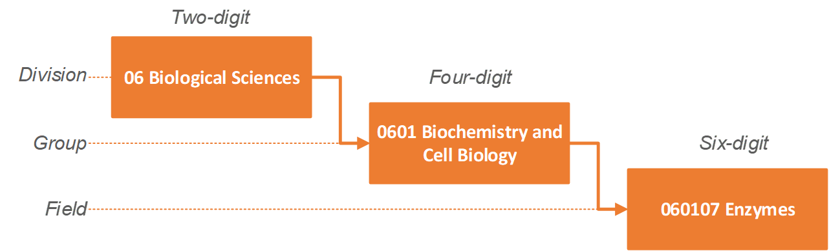

**Socio-Economic (SEO) Codes**

The Socio-Economic Objective (SEO) codes enable research to be categorised according to the intended purpose or outcome of the research. For example, the impact of research in ANZSRC 09 Engineering, may have impacts in SEO Code Sector A Defence.

It consists of discrete economic, social, technological or scientific domains for identifying the principal purposes of the R&D. The SEO codes have a hierarchical structure comprising four levels—section, division, group and objective. The top level comprises sectors A to E:

* Sector A Defence
* Sector B Economic Development
* Sector C Society
* Sector D Environment
* Sector E Expanding Knowledge

Institutions select the most relevant SEO code from the second level (division). The second level is shown in the hierarchical structure in Figure 11.

Figure 11: The SEO code hierarchy

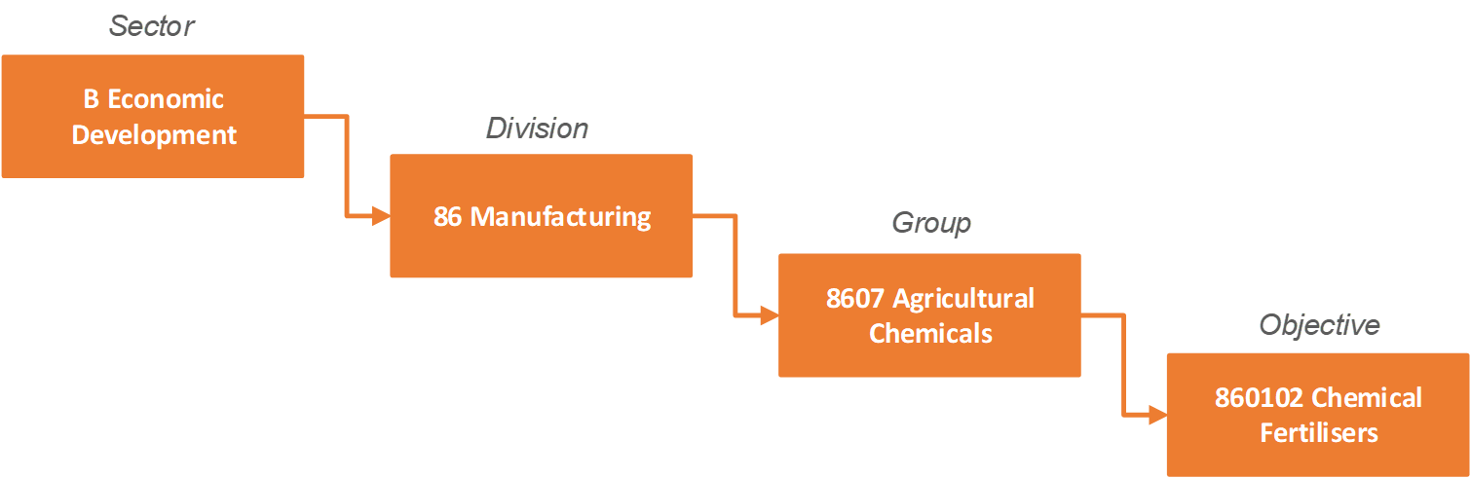

**Australian and New Zealand Standard Industrial Classification (ANZSIC)**

ANZSIC was developed for use in the compilation and analysis of industry statistics in Australia and New Zealand. It is a hierarchical classification with four levels—division, subdivision, group and class. The top level comprises divisions A to S:

* A Agricultural, Forestry and Fishing
* B Mining
* C Manufacturing
* D Electricity, Gas, Water and Waste Services
* E Construction
* F Wholesale Trade
* G Retail Trade
* H Accommodation and Food Services
* I Transport, Post and Warehousing
* J Information Media and Telecommunications
* K Financial and Insurance Services
* L Rental, Hiring and Real Estate Services
* M Professional, Scientific and Technical Services
* N Administrative and Support Services
* O Public Administration and Safety
* P Education and Training
* Q Health Care and Social Assistance
* R Arts and Recreation Services
* S Other Services

Institutions select the most relevant ANZSIC code from the second level (subdivision). The second level is shown in the hierarchical structure in Figure 12.

Figure 12: The ANZSIC hierarchy

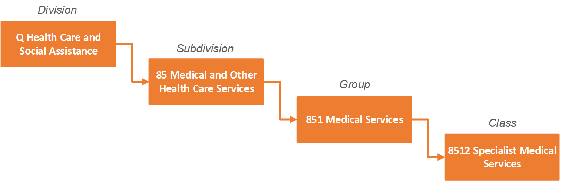

**Science and Research Priorities**

The Science and Research Priorities ensure that appropriate levels of public funding are allocated to research that addresses the most immediate problems facing the nation.

These are:

* Food
* Soil and Water
* Transport
* Cybersecurity
* Energy
* Resources
* Advanced Manufacturing
* Environmental Change, and
* Health.

## Appendix D—FoR 11 division

FoR 11 Medical and Health Sciences has been divided into two UoAs for EI:

| **Biomedical and Clinical Sciences (BCS)** | **Public and Allied Health Sciences (PHS)** |
| --- | --- |
| * + - 1101 Medical Biochemistry and Metabolomics     - 1102 Cardiovascular Medicine and Haematology     - 1103 Clinical Sciences     - 1105 Dentistry     - 1107 Immunology     - 1108 Medical Microbiology     - 1109 Neurosciences     - 1112 Oncology and Carcinogenesis     - 1113 Ophthalmology and Optometry     - 1114 Paediatrics and Reproductive Medicine     - 1115 Pharmacology and Pharmaceutical Sciences     - 1116 Medical Physiology | * + - 1104 Complementary and Alternative Medicine     - 1106 Human Movement and Sports Science     - 1110 Nursing     - 1111 Nutrition and Dietetics     - 1117 Public Health and Health Services     - 1199 Other Medical and Health Sciences |

## Appendix E—Eligible institutions

In EI 2018, an eligible institution is one that meets the criteria for a “Higher Education Provider” under the *Higher Education Support Act 2003* and is listed as a Table A or B provider. A list of eligible institutions is given below.

| **Institution** | **Abbreviation** |
| --- | --- |
| Australian Catholic University | ACU |
| Batchelor Institute of Indigenous Tertiary Education | BAT |
| Bond University | BON |
| Central Queensland University | CQU |
| Charles Darwin University | CDU |
| Charles Sturt University | CSU |
| Curtin University of Technology[1] | CUT |
| Deakin University | DKN |
| Edith Cowan University | ECU |
| Federation University Australia | FED |
| Griffith University | GRF |
| James Cook University | JCU |
| La Trobe University | LTU |
| Macquarie University | MQU |
| MCD University of Divinity[2] | DIV |
| Monash University | MON |
| Murdoch University | MUR |
| Queensland University of Technology | QUT |
| Royal Melbourne Institute of Technology[3] | RMT |
| Southern Cross University | SCU |
| Swinburne University of Technology | SWN |
| The Australian National University | ANU |
| The Flinders University of South Australia | FLN |
| The University of Adelaide | ADE |
| The University of Melbourne | MEL |
| The University of Notre Dame Australia | NDA |
| The University of Queensland | QLD |
| The University of Sydney | SYD |
| The University of Western Australia | UWA |
| Torrens University Australia | TOR |
| University of Canberra | CAN |
| University of New England | UNE |
| University of New South Wales | NSW |
| University of Newcastle | NEW |
| University of South Australia | USA |
| University of Southern Queensland | USQ |
| University of Tasmania | TAS |
| University of Technology, Sydney | UTS |
| University of the Sunshine Coast | USC |
| University Western Sydney[4] | WSU |
| University of Wollongong | WOL |
| Victoria University | VIC |
| [[1]](https://dataportal.arc.gov.au/ERA/NationalReport/2018/pages/abbreviations_glossary_appendices/appendix-1eligible-institutions/" \l "_ftnref1) Currently known as Curtin University  [2] Currently known as University of Divinity  [[3]](https://dataportal.arc.gov.au/ERA/NationalReport/2018/pages/abbreviations_glossary_appendices/appendix-1eligible-institutions/" \l "_ftnref2) Currently known as RMIT University  [[4]](https://dataportal.arc.gov.au/ERA/NationalReport/2018/pages/abbreviations_glossary_appendices/appendix-1eligible-institutions/" \l "_ftnref3) Currently known as Western Sydney University |  |

## Appendix F—Engagement assessment data requirements

### Appendix F1—Engagement narrative template

Institutions use the engagement narrative template to describe the engagement activities of the UoA. Institutions may also provide additional quantitative information in the engagement narrative where they consider the engagement indicators do not fully describe the engagement activity of the UoA. Institutions include any qualitative or quantitative information in their narrative. References to specific external media or publications are allowed where appropriate.

[Appendix G](#_Appendix_F—Examples_of) provides a list of examples of quantitative information that may be included. Institutions are not limited to the examples in the list.

|  |
| --- |
| **Submitting Institution (pre populated):** |
| **Unit of Assessment (pre populated):** |
| **Sensitivities**   * commercially sensitive; and/or * culturally sensitive. |
| **Sensitivities description(1500 character maximum):** |
| **Engagement narrative (7000 character maximum)**  **Institutions should use this template to describe:**   * How the UoA engaged with parties, outside of academia, during the reference period for the mutual benefit of the institution researchers and research end-users * The purpose of engagement, describing what the institution was trying to achieve through the engagement * The duration and extent of the engagement activities. |
| **Institutions can provide additional indicator information** (can be added up to 4 times)  Provide information about any additional quantitative indicators **not** captured elsewhere in this narrative that are relevant to the engagement narrative and have specific data to support them.   * name of indicator (100 characters) * data for indicator (200 characters) * brief description of indicator and how it is calculated (300 characters). |

### Appendix F2—Data items for engagement indicators

| **Data item** | **Data requirement** |
| --- | --- |
| **Cash support from research end-users (specified HERDC Category 1 and Categories 2, 3 (i, ii, iii) and 4)\*** |  |
| Cash amount from research end-users for the UoA for specified HERDC Category 1 schemes, Category 2, 3 (i, ii, iii), and 4 income | New data from institutions |
| **Total HERDC income per FTE\*** |  |
| HERDC Category 1 income from specified Category 1 schemes/total Category 2, 3 (i, ii, iii), and 4 income | ERA 2018 submission data |
| FTE | ERA 2018 submission data |
| **Proportion of specified HERDC Category 1 grants to all HERDC Category 1 grants\*** |  |
| Number of specified HERDC Category 1 grants for the UoA | ERA 2018 submission data |
| Number of HERDC Category 1 grants for the UoA | ERA 2018 submission data |
| Income from specified HERDC Category 1 grants for the UoA | ERA 2018 submission data |
| Income from HERDC Category 1 grants for the UoA | ERA 2018 submission data |
| **Research commercialisation income** |  |
| Total research commercialisation income for the UoA | ERA 2018 submission data |
| **HDR co-supervision (optional)** |  |
| Number of co-supervised HDR students for the UoA | New data from institutions |

\*See [Appendix H](#Appendix_H_Specified_HERDC_Cat_1) for a list of the specified HERDC Category 1 grants. All Income from HERDC Categories 2, 3 (i, ii, iii), and 4 with the following exceptions:

* HERDC Category 3 (i)—subcategory of ‘Australian’ income—HDR fees for domestic students are not considered to be research income or research end-user funding for the EI assessment.
* HERDC Category 3—subcategory ‘International C—HDR fees for international students’ are not considered to be research income or research end-user funding for the EI assessment.

### Appendix F3—Engagement indicator explanatory statement template

Institutions should use the engagement indicator explanatory statement template to provide context for the indicators.

| **Unit of Assessment (pre populated):** |
| --- |
| **Engagement indicator explanatory statement (4500 character maximum)**  **Institutions should use this template to provide context for the following indicators:**   * Cash support from research end-users (specified HERDC Category 1 and Categories 2, 3 (i, ii, iii), and 4) * Total HERDC income per FTE * Proportion of specified HERDC Category 1 grants to all HERDC Category 1 grants * Research commercialisation income |

## Appendix G—Examples of additional quantitative information for the engagement narrative

Note—This is **NOT** an exhaustive list. This list includes examples which may not be relevant for all disciplines. Institutions may provide other additional quantitative information where relevant. It is **NOT** compulsory to include additional quantitative information in the engagement narrative.

* Mobility of researchers (i.e. researchers employed or placed outside academia, and/or research end-user employees that are employed or placed within academia)
* Patents granted, PCT applications, triadic patents
* Citations in patents to traditional research outputs
* HDR students in internships/placements
* HDR student employment destinations
* Repeat business with industry
* Start-up/spin-out companies
* Co-authorship of research outputs with research end-users
* Co-funding of research outputs with research end-users
* In-kind support from research end-users
* Licencing agreements
* Confidentiality agreements
* Number of contracts for research, consulting, expert witness and testing
* Number of licences, assignments and options
* Established networks and relationships with research users
* Number of different clients with contracts worth greater than a threshold value
* Evidence of significant institutional partnerships—e.g. Sydney Health Partners; various global research consortia, OECD, World Bank, World Health Organisation, UN, UNESCO
* Philanthropy linked to research support and in-kind support
* Book sales
* Serving on external advisory boards
* Consultations with community groups, professional/practice organisations, government bodies
* Consultation with/advice to Government
* Expert witness in court cases
* Contributions/submissions to public enquiries on industry-research related issues
* Public lectures, seminars, open days, school visits
* Presentations to practitioner communities
* Connections to cultural institutions, seminars/workshops, internships and engagement with the public
* Support for cultural events/institutions—e.g. Writers’ Festivals, Film Festivals, Vivid Sydney, etc.
* Co-designing and collaborating on performances and exhibitions
* Mentoring external research partners
* Involving users at all stages of the research, including working with user stakeholder and participatory groups
* Memoranda of Understanding (MOU)/Agreements
* Data collected around performance and the different types of public activities in which researchers generally report their work to the community or use their research capacity to further the work of community organisations
* Event participation statistics (public lectures, cultural events, exhibitions, etc.)
* Outreach activities (public lectures, policy engagements, media engagements, community events)
* Media coverage of exhibitions and new works
* Modification of traditional 'commercialisation' metrics such as 'spin-offs' to capture arts entrepreneurship such as setting up galleries, ensembles, groups and other professional practice entities
* Metrics which capture social media activity
* Any other indicator.

## Appendix H—Specified HERDC Category 1 grants

Specified HERDC Category 1 grants were selected if they had an end-user funded component and/or directly benefited an end-user.

| **Code** | **Scheme** | **Funding organisation** |
| --- | --- | --- |
| FND2014\_024 | National Taxonomy Research Grant Program (research grants only) | Australian Biological Resources Study |
| FND2015\_022 | National Taxonomy Research Grant Program (research grants only) | Australian Biological Resources Study |
| FND2016\_021 | National Taxonomy Research Grant Program (research grants only) | Australian Biological Resources Study |
| FND2014\_095 | Australian Coal Association Research Program | Australian Coal Research Limited |
| FND2015\_100 | Australian Coal Association Research Program | Australian Coal Research Limited |
| FND2016\_105 | Australian Coal Association Research Program | Australian Coal Research Limited |
| FND2014\_071 | Innovation and Efficiency RD&E Open Call | Australian Egg Corporation Limited |
| FND2015\_076 | Innovation and Efficiency RD&E Open Call | Australian Egg Corporation Limited |
| FND2016\_080 | Innovation and Efficiency RD&E Open Call | Australian Egg Corporation Limited |
| FND2014\_072 | Research and Development Call for Applications | Australian Grape and Wine Authority |
| FND2015\_077 | Research and Development Call for Applications | Australian Grape and Wine Authority |
| FND2016\_081 | Research and Development Call for Applications | Australian Grape and Wine Authority |
| FND2014\_098 | Alternatives & Fundamentals Program | Australian National Low Emissions Coal Research and Development Limited |
| FND2015\_103 | Alternatives & Fundamentals Program | Australian National Low Emissions Coal Research and Development Limited |
| FND2016\_108 | Alternatives & Fundamentals Program—EXPIRED | Australian National Low Emissions Coal Research and Development Limited |
| FND2014\_099 | ANZCA Research Grants Program | Australian and New Zealand College of Anaesthetists |
| FND2015\_104 | ANZCA Research Grants Program | Australian and New Zealand College of Anaesthetists |
| FND2016\_109 | ANZCA Research Grants Program | Australian and New Zealand College of Anaesthetists |
| FND2014\_073 | Research and Innovation Open Tenders | Australian Pork Limited |
| FND2015\_078 | Research and Innovation Open Tenders | Australian Pork Limited |
| FND2016\_082 | Research and Innovation Open Tenders | Australian Pork Limited |
| FND2014\_011 | Linkage Projects | Australian Research Council |
| FND2015\_011 | Linkage Projects | Australian Research Council |
| FND2016\_011 | Linkage Projects | Australian Research Council |
| FND2014\_009 | ARC Centres of Excellence | Australian Research Council |
| FND2015\_009 | ARC Centres of Excellence | Australian Research Council |
| FND2016\_009 | ARC Centres of Excellence | Australian Research Council |
| FND2014\_014 | Industrial Transformation Research Hubs | Australian Research Council |
| FND2015\_014 | Industrial Transformation Research Hubs | Australian Research Council |
| FND2016\_014 | Industrial Transformation Research Hubs | Australian Research Council |
| FND2014\_015 | Industrial Transformation Training Centres | Australian Research Council |
| FND2015\_015 | Industrial Transformation Training Centres | Australian Research Council |
| FND2016\_015 | Industrial Transformation Training Centres | Australian Research Council |
| FND2014\_074 | Call for Proposals On-Farm R&D, Off-Farm R&D | Australian Wool Innovation Ltd |
| FND2015\_079 | Call for Proposals On-Farm R&D, Off-Farm R&D | Australian Wool Innovation Ltd |
| FND2016\_083 | Call for Proposals On-Farm R&D, Off-Farm R&D | Australian Wool Innovation Ltd |
| FND2014\_102 | R&D Project Funding Rounds | Brown Coal Innovation Australia |
| FND2015\_107 | R&D Project Funding Rounds | Brown Coal Innovation Australia |
| FND2014\_030 | Priority-driven Collaborative Cancer Research Scheme | Cancer Australia |
| FND2015\_028 | Priority-driven Collaborative Cancer Research Scheme | Cancer Australia |
| FND2016\_029 | Priority-driven Collaborative Cancer Research Scheme | Cancer Australia |
| FND2014\_031 | Support for Cancer Clinical Trials—Existing National Cooperative Oncology Groups | Cancer Australia |
| FND2015\_029 | Support for Cancer Clinical Trials—Existing National Cooperative Oncology Groups | Cancer Australia |
| FND2016\_030 | Support for Cancer Clinical Trials—Existing National Cooperative Oncology Groups | Cancer Australia |
| FND2014\_075 | Open Call Research and Development Projects | Cotton Research and Development Corporation |
| FND2015\_080 | Open Call Research and Development Projects | Cotton Research and Development Corporation |
| FND2016\_084 | Open Call Research and Development Projects | Cotton Research and Development Corporation |
| FND2014\_076 | Research and Development Grants | Dairy Australia |
| FND2015\_081 | Research and Development Grants | Dairy Australia |
| FND2016\_085 | Research and Development Grants | Dairy Australia |
| FND2014\_104 | Dairy Innovation Research Grants | Dairy Innovation Australia Limited |
| FND2015\_109 | Dairy Innovation Research Grants—EXPIRED | Dairy Innovation Australia Limited |
| FND2016\_115 | Dairy Innovation Research Grants—EXPIRED | Dairy Innovation Australia Limited |
| FND2014\_001 | Carbon Farming Futures—Filling the Research Gap | Department of Agriculture |
| FND2015\_001 | Carbon Farming Futures—Filling the Research Gap | Department of Agriculture |
| FND2016\_001 | Carbon Farming Futures - Filling the Research Gap—EXPIRED | Department of Agriculture |
| FND2014\_002 | Centre of Excellence for Biosecurity Risk Analysis (CEBRA) | Department of Agriculture |
| FND2015\_002 | Centre of Excellence for Biosecurity Risk Analysis (CEBRA) | Department of Agriculture |
| FND2016\_002 | Centre of Excellence for Biosecurity Risk Analysis (CEBRA) | Department of Agriculture |
| FND2014\_018 | Marine and Tropical Sciences Research Facility (MTSRF)—EXPIRED | Department of the Environment |
| FND2014\_019 | Commonwealth Environment Research Facilities (CERF) —EXPIRED | Department of the Environment |
| FND2014\_020 | National Environmental Research Program (NERP) | Department of the Environment |
| FND2015\_018 | National Environmental Research Program (NERP) —EXPIRED | Department of the Environment |
| FND2014\_021 | National Environmental Science Programme (NESP) (excluding Emerging Priorities) | Department of the Environment |
| FND2015\_019 | National Environmental Science Programme (NESP) (excluding Emerging Priorities) | Department of the Environment |
| FND2016\_018 | National Environmental Science Programme (NESP) (excluding Emerging Priorities) | Department of the Environment |
| FND2014\_027 | Australian Development Research Awards | Department of Foreign Affairs and Trade |
| FND2015\_025 | Australian Development Research Awards—EXPIRED | Department of Foreign Affairs and Trade |
| FND2014\_029 | Preventative Health Research Grants Program (formerly under the Australian National Preventative Health Agency) | Department of Health - National Drug Law Enforcement Research Fund (NDLERF) |
| FND2015\_027 | Preventative Health Research Grants Program (formerly under the Australian National Preventative Health Agency) | Department of Health, National Drug Law Enforcement Research Fund (NDLERF) |
| FND2014\_061 | Australia-India Strategic Research Fund (AISRF) | Department of Industry and Science |
| FND2015\_067 | Australia-India Strategic Research Fund (AISRF) | Department of Industry and Science |
| FND2016\_070 | Australia-India Strategic Research Fund (AISRF) | Department of Industry, Innovation and Science |
| FND2014\_062 | Australia-China Science and Research Fund (ACSRF) | Department of Industry and Science |
| FND2015\_068 | Australia-China Science and Research Fund (ACSRF) | Department of Industry and Science |
| FND2016\_071 | Australia-China Science and Research Fund (ACSRF) | Department of Industry, Innovation and Science |
| FND2016\_072 | Global Innovation Linkages (GIL) | Department of Industry, Innovation and Science |
| FND2014\_068 | Homelessness Research Partnership Agreements – EXPIRED | Department of Social Services |
| FND2014\_079 | Industry Partnership Agreement Programme | Fisheries Research and Development Corporation |
| FND2015\_084 | Industry Partnership Agreement Programme | Fisheries Research and Development Corporation |
| FND2016\_088 | Industry Partnership Agreement Programme | Fisheries Research and Development Corporation |
| FND2016\_086 | Open Call Funding Round (formerly Annual Open Call Funding Round)—EXPIRED | Fisheries Research and Development Corporation |
| FND2014\_078 | Tactical Research Fund | Fisheries Research and Development Corporation |
| FND2015\_083 | Tactical Research Fund | Fisheries Research and Development Corporation |
| FND2016\_087 | Tactical Research Fund—EXPIRED | Fisheries Research and Development Corporation |
| FND2014\_077 | Annual Open Call Funding Round | Fisheries Research and Development Corporation |
| FND2015\_082 | Annual Open Call Funding Round | Fisheries Research and Development Corporation |
| FND2014\_080 | Research and Development Scheme | Forest and Wood Products Australia Ltd |
| FND2015\_085 | Research and Development Scheme | Forest and Wood Products Australia Ltd |
| FND2016\_089 | Research and Development Funding Program (formerly Research and Development Scheme) | Forest and Wood Products Australia Ltd |
| FND2014\_106 | Innovation Program | Gardiner Foundation |
| FND2015\_111 | Innovation Program | Gardiner Foundation |
| FND2016\_117 | Innovation Program—EXPIRED | Gardiner Foundation |
| FND2014\_081 | Meeting Market Requirements | Grains Research and Development Corporation (GRDC) |
| FND2014\_082 | Protecting Your Crop (excluding Integrating Crop Protection Training Project) | Grains Research and Development Corporation (GRDC) |
| FND2014\_083 | Improving Crop Yields | Grains Research and Development Corporation (GRDC) |
| FND2015\_086 | Research and Development Programs: R&D Open Tender, Multi-stage Tenders and Expressions of Interest (research projects only) | Grains Research and Development Corporation (GRDC) |
| FND2016\_090 | Research and Development Programs: R&D Open Tender, Multi-stage Tenders and Expressions of Interest (research and development projects only) | Grains Research and Development Corporation (GRDC) |
| FND2014\_108 | Health Services Research Grants Program | HCF Research Foundation |
| FND2015\_113 | Health Services Research Grants Program | HCF Research Foundation |
| FND2016\_119 | Health Services Research Grants Program | HCF Research Foundation |
| FND2014\_084 | Industry Call | Horticulture Innovation Australia Limited (formerly Horticulture Australia Limited) |
| FND2015\_087 | Industry Call | Horticulture Innovation Australia Limited (formerly Horticulture Australia Limited) |
| FND2016\_091 | Industry Call—EXPIRED | Horticulture Innovation Australia Limited (formerly Horticulture Australia Limited) |
| FND2014\_085 | General Call | Horticulture Innovation Australia Limited (formerly Horticulture Australia Limited) |
| FND2015\_088 | General Call | Horticulture Innovation Australia Limited (formerly Horticulture Australia Limited) |
| FND2016\_092 | General Call—EXPIRED | Horticulture Innovation Australia Limited (formerly Horticulture Australia Limited) |
| FND2014\_086 | Horticultural Transformational Funding Call | Horticulture Innovation Australia Limited (formerly Horticulture Australia Limited) |
| FND2015\_089 | Horticultural Transformational Funding Call | Horticulture Innovation Australia Limited (formerly Horticulture Australia Limited) |
| FND2016\_093 | Horticultural Transformational Funding Call | Horticulture Innovation Australia Limited (formerly Horticulture Australia Limited) |
| FND2014\_087 | R&D Strategic Investment Funding Call | Horticulture Innovation Australia Limited (formerly Horticulture Australia Limited) |
| FND2015\_090 | R&D Strategic Investment Funding Call | Horticulture Innovation Australia Limited (formerly Horticulture Australia Limited) |
| FND2016\_094 | R&D Strategic Investment Funding Call | Horticulture Innovation Australia Limited (formerly Horticulture Australia Limited) |
| FND2014\_088 | Sweeter Citrus Program | Horticulture Innovation Australia Limited (formerly Horticulture Australia Limited) |
| FND2015\_091 | Sweeter Citrus Program | Horticulture Innovation Australia Limited (formerly Horticulture Australia Limited) |
| FND2016\_095 | Sweeter Citrus Program | Horticulture Innovation Australia Limited (formerly Horticulture Australia Limited) |
| FND2015\_092 | Matched Levy Funded Investment Pool and Strategic Co-investment Pool open procurements only (excluding expression of interest procurements) | Horticulture Innovation Australia Limited (formerly Horticulture Australia Limited) |
| FND2016\_096 | Matched Levy Funded Investment Pool and Strategic Co-investment Pool open procurements only (excluding expression of interest procurements) | Horticulture Innovation Australia Limited (formerly Horticulture Australia Limited) |
| FND2014\_089 | MLA Research Program, Human Nutrition Research Program Strategic and Applied Research Funding (Producer Demonstration Sites and Research Organisation Funding only) | Meat and Livestock Australia |
| FND2015\_093 | MLA Research Program, Human Nutrition Research Program Strategic and Applied Research Funding (Producer Demonstration Sites and Research Organisation Funding only) | Meat and Livestock Australia |
| FND2016\_097 | MLA Research Program Annual Call for research and development projects only | Meat and Livestock Australia |
| FND2016\_098 | MLA Research Program Open Tenders/Expression of Interest for research and development projects only | Meat and Livestock Australia |
| FND2014\_069 | National Vocational Education and Training Research (NVETR) Program (formerly National Vocational Education and Training Research and Evaluation Program (NVETRE)) | National Centre for Vocational Education Research |
| FND2015\_074 | National Vocational Education and Training Research (NVETR) Program (formerly National Vocational Education and Training Research and Evaluation Program (NVETRE)) | National Centre for Vocational Education Research |
| FND2016\_078 | National Vocational Education and Training Research (NVETR) Program (formerly National Vocational Education and Training Research and Evaluation Program (NVETRE))—EXPIRED | National Centre for Vocational Education Research |
| FND2014\_036 | Partnership Projects | National Health and Medical Research Council |
| FND2015\_034 | Partnership Projects | National Health and Medical Research Council |
| FND2016\_035 | Partnership Projects | National Health and Medical Research Council |
| FND2014\_060 | Development Grants | National Health and Medical Research Council |
| FND2015\_058 | Development Grants | National Health and Medical Research Council |
| FND2016\_055 | Development Grants | National Health and Medical Research Council |
| FND2014\_126 | Environmental Research Program | New South Wales Office of Environment and Heritage, New South Wales Environment Trust |
| FND2015\_132 | Environmental Research Program | New South Wales Office of Environment and Heritage, New South Wales Environment Trust |
| FND2016\_139 | New South Wales Environment Trust - Environmental Research Program | New South Wales Office of Environment and Heritage, New South Wales Environment Trust |
| FND2014\_016 | OLT Fellowships | Office for Learning and Teaching (OLT) |
| FND2015\_016 | OLT Fellowships | Office for Learning and Teaching (OLT) |
| FND2016\_016 | OLT Fellowships | Office for Learning and Teaching (OLT) |
| FND2014\_017 | OLT Grants (including Innovation and Development, Seed Projects, and Strategic Priority Projects) | Office for Learning and Teaching (OLT) |
| FND2015\_017 | OLT Grants (including Innovation and Development, Seed Projects, and Strategic Priority Projects) | Office for Learning and Teaching (OLT) |
| FND2016\_017 | OLT Grants (including Innovation and Development, Seed Projects, and Strategic Priority Projects) | Office for Learning and Teaching (OLT) |
| FND2014\_127 | Pfizer Australia Research Fellowships—EXPIRED | Pfizer Australia |
| FND2014\_090 | Open Call Research and Development Projects | Rural Industries R&D Corporation |
| FND2015\_094 | Open Call Research and Development Projects | Rural Industries R&D Corporation |
| FND2016\_099 | Open Call Research and Development Projects | Rural Industries R&D Corporation |
| FND2014\_091 | Open Call Research and Development Projects | Sugar Research Australia |
| FND2015\_095 | Open Call Research and Development Projects | Sugar Research Australia |
| FND2016\_100 | Open Call Research and Development Projects | Sugar Research Australia |
| FND2014\_136 | Project Grants | The Garnett Passe & Rodney Williams Memorial Foundation |
| FND2015\_141 | Project Grants | The Garnett Passe & Rodney Williams Memorial Foundation |
| FND2016\_148 | Project Grants—EXPIRED | The Garnett Passe & Rodney Williams Memorial Foundation |
| FND2014\_137 | Conjoint Grant | The Garnett Passe & Rodney Williams Memorial Foundation |
| FND2015\_142 | Conjoint Grant | The Garnett Passe & Rodney Williams Memorial Foundation |
| FND2016\_149 | Conjoint Grant | The Garnett Passe & Rodney Williams Memorial Foundation |
| FND2014\_070 | Centre of Excellence for International Finance and Regulation (One-off open tender) | The Treasury |
| FND2015\_075 | Centre of Excellence for International Finance and Regulation (One-off open tender) | The Treasury |
| FND2016\_079 | Centre of Excellence for International Finance and Regulation (One-off open tender) —EXPIRED | The Treasury |

## Appendix I—Impact studies

Part A should focus on the specific impact and the evidence of its benefits, while Part B should clearly demonstrate how the institutions facilitated the realisation of the impact. References to specific external media or publications are allowed where appropriate.

### Appendix I1—Two-digit FoR impact study template

|  |
| --- |
| **Title:** |
| **Unit of Assessment:**  This is the primary FoR code that relates to the overall content of the impact study. |
| **Additional FoR codes:**  Identify up to two additional two-digit FoRs that relate to the overall content of the impact study. |
| **Socio-Economic Objective (SEO) Codes:**  Choose from the list of two-digit SEO codes any that are relevant to the impact study. |
| **Australian and New Zealand Standard Industrial Classification (ANZSIC) Codes:**  Choose from the list of two-digit ANZSIC codes that are relevant to the impact study. |
| **Keywords:**  List up to 10 keywords related to the impact described in Part A. |
| **Sensitivities**   * commercially sensitive; and/or * culturally sensitive. |
| **Sensitivities description:**  Please describe any sensitivities in relation to the impact study that need to be considered, including any particular instructions for ARC staff or assessors, or for the impact study to be made publicly available after EI 2018. |
| **Aboriginal and Torres Strait Islander research flag:**  Is this impact study associated with Aboriginal and Torres Strait Islander content?  **NOTE**—institutions may identify impact studies where the impact, associated research and/or approach to impact relates to Aboriginal and Torres Strait Islander peoples, nations, communities, language, place, culture and knowledges and/or is undertaken with Aboriginal and Torres Strait Islander peoples, nations, and/or communities. |
| **Science and Research Priorities:**  Identify whether the impact study is related to the [Science and Research Priorities](https://www.industry.gov.au/data-and-publications/science-and-research-priorities). If so, choose from the lists provided in SEER. |
| **PART A—IMPACT** |
| **1. Summary of the impact** (maximum 800 characters)  Briefly describe the specific impact in simple, clear English. This will enable the general community to understand the impact of the research. |
| **2. Beneficiaries**  List up to 10 beneficiaries related to the impact study. |
| **3. Countries in which the impact occurred**  Choose from the ABS list of countries as many as relate to the location of impact. |
| **4. Details of the impact** (maximum 6000 characters)  Provide a narrative that clearly outlines the research impact. The narrative should explain the relationship between the associated research and the impact. It should also identify the contribution the research has made beyond academia, including:   * who or what has benefited from the results of the research (this should identify relevant research end-users, or beneficiaries from industry, the community, government, wider public etc.) * the nature or type of impact and how the research made a social, economic, cultural, and/or environmental impact * the extent of the impact (with specific references to appropriate evidence, such as cost-benefit-analysis, quantity of those affected, reported benefits etc.) * the dates and time period in which the impact occurred.   **NOTE*—***the narrative must describe only impact that has occurred within the reference period, and must not make aspirational claims. |
| **5. Associated research** (maximum 1500 characters)  Briefly describe the research that led to the impact presented for the UoA. The research must meet the definition of research ([1.3](#_1.3_Definitions)). The description should include details of:   * what was researched * when the research occurred * who conducted the research and what is their association with the institution. |
| **6. FoR of associated research**  Up to three two-digit FoRs that best describe the associated research. |
| **7. References** (up to 10 references, 350 characters per reference)  This section should include a list of up to 10 of the most relevant research outputs associated with the impact. |
| **ADDITIONAL IMPACT INDICATOR INFORMATION** |
| (can be added up to 4 times)  Provide information about any indicators not captured above that are relevant to the impact study, for example return on investment, jobs created, or improvements in quality of life years (QALYs). Additional indicators should be quantitative in nature and include:   * name of indicator (100 characters) * data for indicator (200 characters) * brief description of indicator and how it is calculated (300 characters). |
| **PART B—APPROACH TO IMPACT** |
| **1**. **Summary of the approaches to impact** (maximum 800 characters)  This section should summarise the strategies (detailed in section 2 below) implemented by the institution, its colleges, faculties, groups, departments, and/or centres for achieving the impact described in Part A. |
| **2. Approach to impact** (maximum 6000 characters)  This section should provide a narrative that explains how the institution facilitated the realisation of the impact described in Part A. The information provided must be from the period between the research and the impact. Evidence throughout the narrative should relate to the impact described in Part A.  It can include details of:   * support provided by the institution, its faculties, colleges, groups, departments, and/or centres for researchers to affect positive impact * how that support was implemented by the research area * how researchers interacted and engaged with research end-users or beneficiaries * evidence of reviewing impact processes and outcomes during the period * evidence of how mechanisms of translation were integrated into research practices * human resources policies, initiatives and strategies * financial or other resources made available to facilitate the realisation of the impact * other strategies used in relation to this UoA that aided in the realisation of the impact. |

### Appendix I2—Interdisciplinary impact study template

|  |
| --- |
| **Title:** |
| **Unit of Assessment:** Interdisciplinary |
| **FoR codes:**  Identify up to three two-digit FoRs that relate to the overall content of the impact study. |
| **Socio-Economic Objective (SEO) Codes:**  Choose from the list of two-digit SEO codes any that are relevant to the impact study. |
| **Australian and New Zealand Standard Industrial Classification (ANZSIC) Codes:**  Choose from the list of two-digit ANZSIC codes that are relevant to the impact study. |
| **Keywords:**  List up to 10 keywords related to the impact described in Part A. |
| **Sensitivities:**   * commercially sensitive; and/or * culturally sensitive. |
| **Sensitivities:**  Please describe any sensitivities in relation to the impact study that need to be considered, including any particular instructions for ARC staff or assessors. |
| **Aboriginal and Torres Strait Islander research flag:**  Is this impact study associated with Aboriginal and Torres Strait Islander research?  **NOTE**—institutions may identify impact studies where the impact, associated research and/or approach to impact relates to Aboriginal and Torres Strait Islander peoples, nations, communities, language, place, culture and knowledges and/or is undertaken with Aboriginal and Torres Strait Islander peoples, nations, and/or communities.. |
| **Science and Research Priorities:**  Identify whether the impact study is related to the [Science and Research Priorities](https://www.industry.gov.au/data-and-publications/science-and-research-priorities). If so, choose from the lists provided in SEER. |
| **PART A—IMPACT** |
| **1. Summary of the impact** (maximum 800 characters)  Briefly describe the specific impact in simple, clear, plain English. This will enable the general community to understand the impact of the research. |
| **2. Beneficiaries**  List up to 10 beneficiaries related to the impact study. |
| **3.** **Countries in which the impact occurred**  Choose from the ABS list of countries as many as relate to the location of impact. |
| **4. Details of the impact** (maximum 6000 characters)  Provide a narrative that clearly illustrates the relationship between the associated research and the positive effects it brought about. The narrative should identify the contribution the research has made beyond academia, including:   * who or what has benefited from the results of the research (this should identify relevant research end-users, or beneficiaries from industry, the community, government, wider public etc.) * the nature or type of impact and how the research made a social, economic, cultural, and/or environmental impact * the extent of the impact (with specific references to appropriate evidence, such as cost-benefit-analysis, quantity of those affected, reported benefits etc.) * the dates and time period in which the impact occurred * the ways in which the impact relates to the identified FoR codes.   **NOTE*—***the narrative must describe only impact that has occurred within the reference period, and must not make aspirational claims. |
| **5. Associated research** (maximum 1500 characters)  Briefly describe the research that led to the impact presented for the UoA. The research must meet the definition of research ([1.3](#_1.3_Definitions)). The description should include details of:   * what was researched * when the research occurred * who conducted the research and what is their association with the institution. |
| **6. FoR of associated research**  Up to three two-digit FoRs that best describe the associated research. |
| **7. References** (up to 10 references, 350 characters per reference)  This section should include a list of up to 10 of the most relevant research outputs associated with the impact. |
| **ADDITIONAL IMPACT INDICATOR INFORMATION** |
| (can be added up to 4 times)  Provide information about any indicators not captured above that are relevant to the impact study, for example return on investment, jobs created, or improvements in quality of life years (QALYs). Additional indicators should be quantitative in nature and include:   * name of indicator (100 characters) * data for indicator (200 characters) * brief description of indicator and how it is calculated (300 characters). |
| **PART B—APPROACH TO IMPACT** |
| **1. Summary of the approaches to impact** (maximum 800 characters)  This section should summarise the strategies (detailed in section 2 below) implemented by the institution, its colleges, faculties, groups, departments, and/or centres described in Part A. |
| **2. Approach to impact** (maximum 6000 characters)  This section should provide a narrative that explains how the institutions facilitated the realisation of the impact described in Part A. The information provided must be from the period between the research and the impact. Evidence throughout the narrative should relate to the impact described in Part A.  It can include details of:   * support provided by the institution, its faculties, colleges, groups, departments, and/or centres for researchers to affect positive impact * how that support was implemented by the research area * how researchers interacted and engaged with research end-users or beneficiaries * evidence of reviewing impact processes and outcomes during the period * evidence of how mechanisms of translation were integrated into research practices * human resources policies, initiatives and strategies * financial or other resources made available to facilitate the realisation of the impact * other strategies used in relation to this UoA that aided in the realisation of the impact. |

### Appendix I3—Aboriginal and Torres Strait Islander research impact study template

Where relevant, the submission should include specific evidence of how Aboriginal and Torres Strait Islander leadership and governance arrangements were integrated into the activities and processes detailed in all aspects of the impact study. Where relevant, the impact study should reference key documents and policies such as ethics standards and guidelines (e.g., *NHMRC Values and Ethics: Guidelines for Ethical Conduct in Aboriginal and Torres Strait Islander Health Research; Australian Institute of Aboriginal and Torres Strait Islander Studies Guidelines for Ethical Research in Australian Indigenous Studies; and The Australia Council for the Arts, Indigenous Cultural Protocols for Producing Indigenous Australian Music, Writing, Visual Arts, Media Arts and Performing Arts*.)

|  |
| --- |
| **Title:** |
| **Unit of Assessment:** Aboriginal and Torres Strait Islander research |
| **FoR codes:** (optional)  Identify up to three two-digit FoRs that relate to the overall content of the impact study. |
| **Socio-Economic Objective (SEO) Codes:**  Choose from the list of two-digit SEO codes any that are relevant to the impact study. |
| **Australian and New Zealand Standard Industrial Classification (ANZSIC) Codes:**  Choose from the list of two-digit ANZSIC codes that are relevant to the impact study. |
| **Keywords:**  List up to 10 keywords related to the impact described in Part A. |
| **Sensitivities:**   * commercially sensitive; and/or * culturally sensitive. |
| **Sensitivities description:**  Please describe any sensitivities in relation to the impact study that need to be considered, including any particular instructions for ARC staff or assessors. |
| **Science and Research Priorities:**  Identify whether the impact study is related to the [Science and Research Priorities](http://www.science.gov.au/scienceGov/ScienceAndResearchPriorities/Pages/default.aspx). If so, choose from the lists provided in SEER. |
| **PART A—IMPACT** |
| **1. Summary of the impact** (maximum 800 characters)  Briefly describe the specific impact in simple, clear, plain English. This will enable the general community to understand the impact of the research. |
| **2. Beneficiaries**  List up to 10 beneficiaries related to the impact study. (E.g. communities, schools etc.) |
| **3. Details of the impact** (maximum 6000 characters)  Provide a narrative that clearly illustrates the relationship between the associated research and the positive effects it brought about. The narrative should identify the contribution the research has made beyond academia, including:   * who or what has benefited from the results of the research (this should identify relevant research end-users, or beneficiaries from industry, the community, government, wider public etc.) * the nature or type of impact and how the research made a social, economic, cultural, and/or environmental impact * the extent of the impact (with specific references to appropriate evidence, such as cost-benefit-analysis, quantity of those affected, reported benefits etc.) * the dates and time period in which the impact occurred * where relevant, evidence of how Aboriginal and Torres Strait Islander ethical research guidelines were integrated into the research activities and processes detailed in the impact study   **NOTE*—***the narrative must describe only impact that has occurred within the reference period, and must not make aspirational claims. |
| **4. Associated research** (maximum 1500 characters)  Briefly describe the research that led to the impact presented for the UoA. The research must meet the definition of research ([1.3](#_1.3_Definitions)). The description should include details of:   * what was researched * when the research occurred * who conducted the research and what is their association with the institution * details of any Aboriginal and Torres Strait Islander people or communities who were consulted throughout the research. |
| **5. FoR of associated research**  Up to three two-digit FoRs that best describe the associated research. |
| **6. References** (up to 10 references, 350 characters per reference)  This section should include a list of up to 10 of the most relevant research outputs associated with the impact. |
| **ADDITIONAL IMPACT INDICATOR INFORMATION** |
| (can be added up to 4 times)  Provide information about any indicators not captured above that are relevant to the impact study, for example return on investment, jobs created, or improvements in quality of life years (QALYs). Additional indicators should be quantitative in nature and include:   * name of indicator (100 characters) * data for indicator (200 characters) * brief description of indicator and how it is calculated (300 characters). |
| **PART B—APPROACH TO IMPACT** |
| **1. Summary of the approaches to impact** (maximum 800 characters)  This section should summarise the strategies (detailed in section 2 below) implemented by the institution, its colleges, faculties, groups, departments, and/or centres for achieving the impact described in Part A. |
| **2. Approach to impact** (maximum 6000 characters)  This section should provide a narrative that explains how the institutions facilitated the realisation of the impact described in Part A. The information provided must be from the period between the research and the impact. Evidence throughout the narrative should relate to the impact described in Part A and should connect the institution’s Aboriginal and Torres Strait Islander policies with the impact.  It can include details of:   * support provided by the institution, its faculties, colleges, groups, departments, and/or centres for researchers to affect positive impact * how that support was implemented by the research area * how researchers interacted and engaged with research end-users or beneficiaries * evidence of reviewing impact processes and outcomes during the period * evidence of how mechanisms of translation were integrated into research practices * human resources policies, initiatives and strategies * financial or other resources made available to facilitate the realisation of the impact * other strategies used in relation to this UoA that aided in the realisation of the impact * any targeted efforts to engage with Aboriginal and Torres Strait Islander communities, groups, or people. |

## Appendix J—Working notes for assessment

Below are a series of questions to keep in mind as you go through assessing submissions.

### Engagement Assessment

#### ****Engagement Narrative****

* Whom did the institution engage with outside academia within the reference period?
* Was the engagement mutually beneficial?
* What was the purpose of the engagement?
* How long were the engagement activities undertaken and what was their extent?
* Are engagement activities well-integrated into the research processes within the UoA?
* What evidence of engagement does the UoA provide?
* Is there anything significant to note?
* If additional indicators are given, how are they defined? Is this a reasonable measure of engagement?
* Have they explained how the additional indicator contributes to the engagement that they have already described in the narrative?

#### ****Engagement indicators and engagement indicator explanatory statement****

* Do the income indicators align with the information in the engagement narrative?
* Where in the distribution does the UoA fall?
* Is this what you would expect based on the type of engagement described in the narrative?
* Are the indicator values what you would expect for the two-digit FoR?
* What reasons does the explanatory statement give for the values of the indicators? Does it explain or support the values of the indicators?

#### How to rate engagement

* How effective are the interactions between researchers and research end-users?
* Is there a mutually beneficial transfer of knowledge, methods and/or resources?
* How well in is the engagement integrated (or incorporated) into the development of research within the UoA?

### Impact Assessment

#### Impact

* What was the impact?
* When did the impact occur?
* Is it research impact? Did the impact arise from research, or from another kind of activity at the institution? Consider the associated research section of the template.
* Does the impact study describe who or what benefited from the results of the research? Is it outside of academia?
* How did the research make a social, economic, cultural and/or environmental impact?
* What was the extent of the impact and has suitable evidence been provided?

For the Aboriginal and Torres Strait Islander impact study, a key question to consider is:

* Where relevant, does the impact study demonstrate the ways in which Aboriginal and Torres Strait Islander leadership and governance arrangements were integrated into the activities and processes throughout all stages; from the initial research, through translation, to the impact itself? A key element of this is demonstrating Indigenous-led principles which embody the right to self-determination.
* Where relevant, is there evidence of how Aboriginal and Torres Strait Islander ethical research guidelines were integrated into the research activities and process detailed in the impact study?

#### Associated ****research****

* Is the research described relevant to the impact described in [Section 4: Details of Impact](#Section_4_Details_of_Impact)?’
* What is the UoA’s link to the research? Is there an association to the institution claiming the impact?

#### Additional ****indicator information****

* What are the indicators? How do they align with the information provided in the impact section?
* Are they supportive of other information provided in the submission?
* Is the data provided for the indicator within the reference period?

#### How to rate impact

* What was the impact of the research? How did it contribute to the economy, society, environment or culture, beyond the contribution to academic research?
* How significant was the contribution beyond academia?
* Did the impact described arise from research? Is it research impact, or is it impact arising from another activity at that institution?

### Approach to Impact Assessment

#### Approach to impact

* How did the institution, faculties, colleges, groups, departments, and/or centres facilitate the impact described in Part A?
* What are the mechanisms described? Are they well-integrated within the UoA?
* How effective were the mechanisms in facilitating the delivery of the impact?

For the Aboriginal and Torres Strait Islander impact study, a key question to consider is:

* Were there any targeted efforts to engage with Aboriginal and Torres Strait Islander communities, groups or people?

#### How to rate approach to impact

* How effective and integrated are the mechanisms to encourage translation of research into impacts beyond academia?
* Did the described mechanisms for translating research facilitate the impact described?

1. In this document, universities are also referred to as institutions. When the term ‘institution’ or ‘institutional’ are used, the term is referring to Australian higher education providers as defined by the *Higher Education Support Act 2003* (Table A and Table B). For more information, see [Appendix E](#_Appendix_E—Eligible_EI). [↑](#footnote-ref-2)
2. ERA (Excellence in Research for Australia) is Australia’s national research evaluation framework. ERA identifies and promotes excellence across the full spectrum of research activity in Australia’s higher education institutions. There have been four full rounds of ERA—ERA 2010, ERA 2012, ERA 2015 and ERA 2018. [↑](#footnote-ref-3)
3. SEER is the ARC’s web-based application for EI’s submission and assessment processes. [↑](#footnote-ref-4)
4. A HDR student is someone who is completing a Research Doctorate or Research Masters. A Research Doctorate means a Level 10 Doctoral Degree (Research) qualification as described in the Australian Qualifications Framework and a Research Master’s means a Level 9 Master’s Degree (Research) qualification as described in the Australian Qualifications Framework. Professional Doctorates may be included but only where at least two-thirds of the qualification is research. [↑](#footnote-ref-5)