24 April 2023

Report to

Australian Research Council

Impact assessment of   
ARC-funded research

Final report

**About ACIL Allen**

ACIL Allen is a leading independent economics, policy and strategy advisory firm, dedicated to helping clients solve complex issues.

Our purpose is to help clients make informed decisions about complex economic and public policy issues.

Our vision is to be Australia’s most trusted economics, policy and strategy advisory firm. We are committed and passionate about providing rigorous independent advice that contributes to a better world.

Suggested citation for this report: ACIL Allen (2023). *Impact assessment of ARC-funded research summary report*. A report for the Australian Research Council.

Reliance and disclaimer: The professional analysis and advice in this report has been prepared by ACIL Allen for the exclusive use of the party or parties to whom it is addressed (the addressee) and for the purposes specified in it. This report is supplied in good faith and reflects the knowledge, expertise and experience of the consultants involved. The report must not be published, quoted or disseminated to any other party without ACIL Allen’s prior written consent. ACIL Allen accepts no responsibility whatsoever for any loss occasioned by any person acting or refraining from action as a result of reliance on the report, other than the addressee.

In conducting the analysis in this report ACIL Allen has endeavoured to use what it considers is the best information available at the date of publication, including information supplied by the addressee. ACIL Allen has relied upon the information provided by the addressee and has not sought to verify the accuracy of the information supplied. If the information is subsequently determined to be false, inaccurate or incomplete then it is possible that our observations and conclusions as expressed in this report may change. The passage of time, manifestation of latent conditions or impacts of future events may require further examination of the project and subsequent data analysis, and re-evaluation of the data, findings, observations and conclusions expressed in this report. Unless stated otherwise, ACIL Allen does not warrant the accuracy of any forecast or projection in the report. Although ACIL Allen exercises reasonable care when making forecasts or projections, factors in the process, such as future market behaviour, are inherently uncertain and cannot be forecast or projected reliably.

This report does not constitute a personal recommendation of ACIL Allen or take into account the particular investment objectives, financial situations, or needs of the addressee in relation to any transaction that the addressee is contemplating. Investors should consider whether the content of this report is suitable for their particular circumstances and, if appropriate, seek their own professional advice and carry out any further necessary investigations before deciding whether or not to proceed with a transaction. ACIL Allen shall not be liable in respect of any claim arising out of the failure of a client investment to perform to the advantage of the client or to the advantage of the client to the degree suggested or assumed in any advice or forecast given by ACIL Allen.

ACIL Allen acknowledges Aboriginal and Torres Strait Islander peoples as the Traditional Custodians of the land and its waters. We pay our respects to Elders, past and present, and to the youth, for the future. We extend this to all Aboriginal and Torres Strait Islander peoples reading this report.



Goomup, by Jarni McGuire

1. Introduction
   1. The Australian Research Council (ARC) has a key role in Australia’s innovation and research system in supporting Australia's universities to produce high-quality and impactful research through the delivery of the National Competitive Grants Program (NCGP). It achieves this by allocating funding on a competitive basis to universities undertaking world-class research.
   2. The ARC also has the national responsibility for assessing the quality, engagement and impact of university research and working in partnership with the sector to safeguard research integrity.
   3. The National Competitive Grants Program

This evaluation is focused on the NCGP, which allocates research grant funding via a competitive peer review process through the Discovery Program and the Linkage Program. The Discovery Program plays a crucial role in funding blue-sky research in Australia, while the Linkage Program focuses on collaborative research that links universities, industry and other research users.

Under these programs, the ARC funds a range of complementary schemes. The aim is to support researchers at different stages of their careers, build Australia’s research capability, expand and enhance research networks and collaborations, and develop centres of excellence. ARC funding ensures Australia can maximise the benefits of having a strong and vibrant research sector.

The intended outcome of the Programs is to contribute to the growth of Australia’s research and innovation capacity, which generates new knowledge and results in the development of new technologies, products and ideas, the creation of jobs, economic growth, and an enhanced quality of life in Australia.

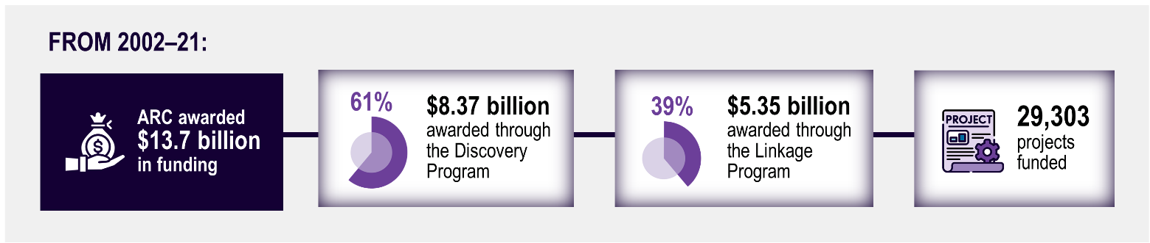

Source: ACIL Allen

* 1. This evaluation

The ARC commissioned ACIL Allen to independently evaluate the outcomes and impacts of NCGP-funded research over the past 2 decades and consider the potential future benefits delivered from the funding. In addition, ACIL Allen was asked to assess the effectiveness with which the ARC supports, monitors, and reports on research impact and identify opportunities for improvement.

In assessing the outcomes and impact of NCGP-funded research, ACIL Allen has drawn on data provided by the ARC from 2002-2021. This includes funding data for 29,303 projects, 22,352 grant final reports, a survey of 3,361 researchers, and consultation with system leaders in Australia and international funding agencies. The evidence was analysed and synthesised using whole of economy modelling, impact case studies and qualitative and quantitative analysis.

There are several challenges in assessing the impact of a research program such as the NCGP. These challenges include the large number of projects funded, the time lags to impact, the diverse range of research activities supported and impacts delivered, and the attribution of impact when there is more than one source of funding.

* 1. Key findings

This report demonstrates that ARC-funded research has delivered significant and diverse benefits to a broad range of end-users and beneficiaries in Australia and internationally that will continue into the future.

Key findings:
$1 generated $3.32 or $184.3b in additional economic output (GDP) - significant value for money.
$152.5b cumulative increase in Australian’s real income.
6,570 jobs created per year across Australia
Research has delivered broad and substantial social, cultural, & environmental benefits.
82% of surveyed researchers reported their research impacts would have been unlikely without ARC.
$1.23 leveraged per $1 ARC funding.
Opportunities to develop a NCGP impact evaluation framework; strengthen NCGP impact data collection practices; explore data-driven approaches to impact assessment; enhance communication and understanding of research impact


* + 1. Economic benefits of the NCGP

The economic modelling undertaken for this study suggests that the NCGP **generates $3.32 in additional economic output** (Gross Domestic Product) for **every $1 of funding** (2002-21). This return on investment is comparable to a 2021 CSIRO analysis that estimated $1 of research and development investment creates an average of $3.50 in benefits for Australia.

NCGP funding awarded between 2002 and 2021 is projected **to boost Australia’s economic output** (GDP) **by $184.3 billion** over the life of benefits generated from 20 years of research funding. Over the same period, ARC funding will increase total employment, **creating** around **6,570 FTE jobs per year** across Australia (page 4).

These economic benefits are additional to a range of other non-economic impacts and social goods, which are highly valuable but more challenging to quantify in monetary terms.

**Improved research capacity**

ARC-funded research has built Australia’s research capacity and capability. It has contributed to the stock of knowledge, enabled new research directions, supported training in world-class environments and promoted new and ongoing collaborations between Australian universities and national and international partners (page 6).

**Social, cultural and environmental benefits**

ARC-funded research has produced **broad and substantial social, cultural, and environmental benefits**, as highlighted in the case studies developed for this evaluation. These benefits include research that has helped improve critical technology and communications, environmental sustainability, food supply chains, social policy and outcomes for First Nations peoples (pages 7-15). Many of the benefits identified align with Government’s strategic priorities.

The ARC supports the effective delivery of research outcomes and impacts through a variety of mechanisms. Most researchers surveyed (82%) considered that the impacts delivered by their research would be unlikely to have occurred without the ARC’s support, highlighting the essential and unique role of ARC funding in supporting the delivery of impact from Australia’s innovation system.

**Opportunities for future improvements**

The ARC has systems for supporting, monitoring and communicating impact in place, but there are opportunities to improve these approaches in consultation with the research sector. While there is no ‘silver bullet’ solution to enhancing and assessing research impact, the ARC could consider developing a NCGP impact evaluation framework, strengthening NCGP impact data collection practices, exploring data-driven approaches to impact assessment and enhancing the communication and understanding of research impact (page 16-17).

1. Economic impacts of NCGP-funded research

**The impact of ARC-funded research from 2002-21 was estimated using a model of the Australian economy (Tasman Global). This model is a high-level representation of the Australian economy that enables measurement of the wider effects of changes in economic activity in key industries and regions due to ARC-funded research. Economy-wide models like Tasman Global are widely known and have been used by the Productivity Commission, the Commonwealth Treasury and other government agencies to evaluate economy-wide impacts of industry and policy changes.**

Research funded by the ARC is varied and has a range of **economic, social, environmental, cultural and research capacity impacts**. Some of these impacts are very difficult to quantify and monetise. The economic analysis only captures the direct and indirect economic impacts of ARC-funded research. Research capacity, social, environmental and cultural impacts associated with research projects funded by the ARC have been qualitatively assessed. Once these (and other) non-quantified impacts of ARC-funded research are considered, **the value of the NCGP is likely much higher than the estimates provided in this section**.

The key findings of the economic modelling are shown below and more details of the methodology used to estimate the impact of ARC-funded research are provided at the back of this document.

**ARC-FUNDED RESEARCH: LARGE GAINS FOR THE AUSTRALIAN ECONOMY**

**$1 generated $3.32 in additional economic output (GDP) for funding awarded through the NCGP from 2002-21. 
The NCGP provides significant value for money and benefits to the Australian economy. 
GENERATES SUBSTANTIAL ECONOMIC ACTIVITY: $184.3 billion higher economic output (GDP) for Australia (from NCGP funding awarded 2002-21) - equivalent to $33.6 billion increase in present value and ~1.5% of Australia’s current GDP.
RAISES AUSTRALIA’S ECONOMIC WELFARE:  $152.5 billion cumulative increase in the real income of Australians (from NCGP funding awarded 2002-21) - the value of this impact is equivalent to a one-time increase in the average income of Australians by approximately $1,171 per person.
GENERATES SIGNIFICANT EMPLOYMENT OPPORTUNITIES:  6,570 FTE jobs created per year across Australia (from NCGP funding awarded 2002-21) - It is projected that a total of 295,673 employee years of direct and indirect jobs will be created in Australia by the NCGP.
Leveraged co-contributions total $7.9 billion cash and $9 billion in-kind ($1.23 per $1 of ARC funding).
**

**RESEARCHER PERSPECTIVES ON ECONOMIC IMPACT**

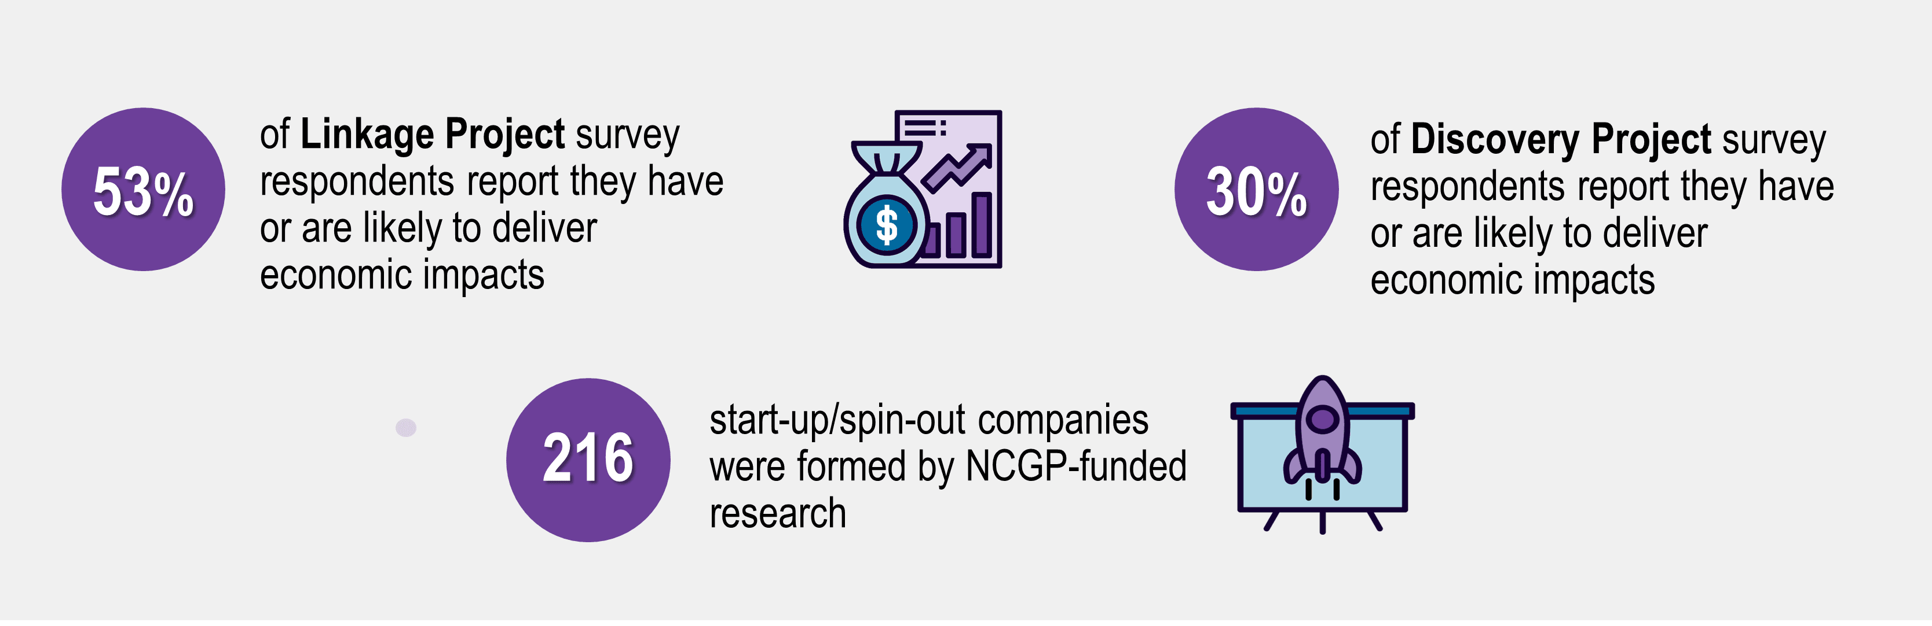

1. Building research capacity and capability

**Contribution to the stock of knowledge and the longer-term research capability of Australia are core purposes of the NCGP. This evaluation found that the Discovery and Linkage Programs have improved research capacity by enabling new research directions, research training (e.g. researchers and graduates) and new partnerships (in Australia and internationally), which in turn leads to improved understanding and new knowledge. NCGP-funded research projects across a number of publication types produced almost 400,000 outputs. This is exemplified by the case studies in terms of publications, monitoring indicators and training materials.**

NCGP-funded research has increased Australia’s research capacity and capability by enabling **new research directions, research training** (e.g. researchers and graduates) and **new partnerships** (in Australia and internationally). This is helping to inform further excellent research, support a strong and sustainable research workforce and promote the adoption and translation of research by industry and others.

ARC grants increase research capacity by **supporting students and researchers** to participate in excellent projects with world-class research leaders. These researchers go on to be employed in different sectors, boosting the capacity of Australia's innovation system. The Quantum Computation and Communication Technology case study (page 9) shows that hundreds of students and researchers have gained important skills for emerging industries through participation in ARC-supported quantum Centres of Excellence.

The case studies (pages 7-15) highlight examples of ARC grants promoting collaboration between universities, industry and other research users, thus supporting the delivery of impact. The Return, reconcile, renew (RRR): Indigenous remains repatriation case study involved major multi-sector global partnerships between researchers, institutions, governments and community that expedited repatriation activities.

**NCGP DELIVERS STRONG RESEARCH CAPACITY AND CAPABILITY**

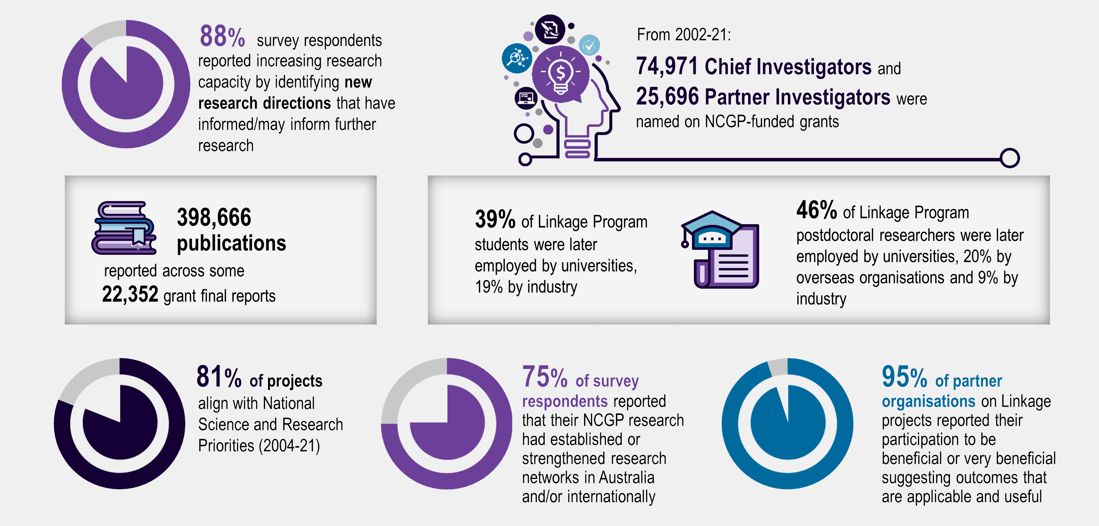

1. Social, cultural and environmental impacts

**Contribution to society, culture and the environment is a core purpose of the NCGP and aligns with the intended outcome of enhancing the quality of life in Australia. NCGP-funded research has produced a broad range of impacts that have benefited many across Australia, including government, academic, industry, business and non-profit sectors as well as the general public, schools, hospitals and others.**

* 1. Data on social, cultural and environmental impact

It is challenging to quantify the aggregate social, cultural, environmental and other impacts of ARC-funded research, which have been delivered to a wide range of beneficiaries and end-users. However, the data collected in this evaluation illustrates the **important role of** **ARC funding in the innovation ecosystem** in terms of delivering impact. Over 80% of survey respondents considered that the impacts delivered by their research would be unlikely or very unlikely to have occurred without the ARC’s support. The proportion of researchers surveyed for this evaluation who report delivering social, cultural and environmental impact is shown below.

Impacts that have been/are likely to be delivered (proportion of survey respondents): 
Linkage - 79% social, 50% cultural, 54% environmental
Discovery - 72% social, 52% cultural, 44% environmental

Both Discovery and Linkage Program projects commonly reported social impacts, including contributing to improved health and wellbeing, informed decision-making, improved safety and security, and reduced social problems.

NCGP-funded research has also improved cultural understanding and preservation, leading to improved social cohesion within and beyond Australia.

Environmental impacts included contributing to better natural resource management and reduced environmental damage.

Information on the broader impacts of ARC-funded research is more meaningful at the individual project level, as evidenced by the insights from the case studies on the following pages.

**Case studies of impact**

To illustrate the diverse nature of the impact delivered by NCGP-funded research, 7 examples of exceptional impact were chosen for deeper analysis in the form of case studies. These case studies show major benefits for Australia, including for:

— critical technology and communications (see the quantum computing case study)

— environmental sustainability (see the aquifer reinjection and automated irrigation case studies)

— food supply chains (see the onshore lobster aquaculture case study)

— social policy (see the protecting survivors of domestic and family violence case study)

— First Nations peoples (see the Indigenous persistence in formal learning and Indigenous remains repatriation case studies).

The case studies demonstrate how the **NCGP's support for curiosity-led**, excellent research, across the spectrum of basic to applied research, can generate new knowledge that over time delivers substantial impacts. The case studies highlight how researchers have used different ARC schemes across their careers to progress research and deliver impact to a broad range of end-users and beneficiaries. They also exemplify excellent research that delivers on Australia’s Science and Research Priorities and other government priorities such as ending domestic and family violence and Closing the Gap.

Where possible and appropriate, the economic impact of the case studies has been assessed by calculating the costs and benefits (present value, PV), along with the net present and anticipated economic impacts (NPV) and benefit cost-ratio (BCR).

The***Quantum Computation and Communication******Technology*** case study shows how Australia is delivering world-leading quantum research to develop full-scale quantum systems – encompassing ultra-fast computation and secure communication. Quantum technologies work by controlling the world at its smallest scale using principles of quantum mechanics. While the ARC has funded several quantum programs, this study focuses on the Centre of Excellence for Quantum Computation and Communications Technology (CQC2T). This has fundamentally shaped quantum research in Australia and internationally and will continue to deliver broad impacts across most economic sectors.

|  |
| --- |
| Case study: Quantum computation and communication technology |
| **$97.8 million** invested by ARC (8 grants) and **$218.3 million** by participating organisations (2003-24) |
| **ECONOMIC IMPACT:**  **$637.7 million** in PV costs from ARC-funded research  **$2.9 billion** in PV benefits from CSIRO estimates of Australia’s quantum opportunity attributed to ARC-funded research: **$2.2b NPV, BCR of 4.50** |
| **KEY OUTCOMES AND IMPACTS** |
| * **7** Australian universities and **25** international partner organisations * More than **2,203** refereed papers produced since 2000, including **200** papers in prestigious Nature and Science suite of journals * **951** jobs created, including training for **569** postgraduate/final year Honours students and **382** University roles * **122** industry full time equivalent jobs created through spin-out companies * Developed **4** Australian quantum information companies * Produced **more than 100** granted patents with 50 patent applications underway * Investors in the Centre include IBM, Hewlett Packard, NASA, Commonwealth Bank of Australia, and Telstra |
| The Centre has demonstrated the following key outcomes:   * **Invented and pioneered** the manufacturing of atom-based silicon quantum computing processors, with **world** **records** for the **highest quality qubits** in the solid state * **Demonstrated world’s first** single atom transistor, single electron spin and single nuclear spin qubits in silicon, and **world’s first** atomic-scale integrated circuit * **Invented and pioneered** the first practical schemes to realise optical quantum processors, demonstrating small-scale quantum algorithms and integrated optical platforms for distributed processing and communications * **Pioneered secure**, long distance quantum communication technologies * Provided the **world’s most popular & powerful** online random number generator * **Established global leadership** in silicon and optical quantum computing, cyber-security, cryptography, and quantum information processing. |

*The* ***Aquifer Reinjection*** project led to Australia’s first full-scale groundwater replenishment scheme. The project demonstrated that treated wastewater can be reinjected into Perth’s aquifers (underground layers of groundwater-bearing, permeable rock). This water can then be extracted further downstream, creating additional safe water supplies that are essential for Perth’s communities, wetlands and lakes.

|  |
| --- |
| Case study: Aquifer Reinjection, Australia’s first full-scale groundwater replenishment scheme |
| **$1.3 million** in cash support from the ARC (3 grants) and **$3.65 million** by participating organisations (2006-18) |
| **ECONOMIC IMPACT:**  **$13.6 million** in PV costs from ARC-funded research  **78.1 million** in PV benefits from costs avoided by Water Corporation from using aquifer reinjection instead of desalination: **$64.5m NPV, BCR of 5.76** |
| **KEY OUTCOMES AND IMPACTS** |
| * Demonstrated the feasibility of groundwater reinjection of wastewater and led to the construction of a plant that annually reinjects **28GL of treated wastewater** * Built collaboration between Curtin and WA Water Corporation * Engaged with **7,300 community** members to build acceptance of groundwater replenishment * Enabled ongoing monitoring * Better **protected Perth’s wetlands and lakes** * Concluded a **successful trial** of groundwater replenishment, which created **>180 jobs** * Supported a **framework and guidelines** for water utilities reusing wastewater in Australia * Enabled **more energy-efficient supply** of Perth’s water needs * Has enabled up to **28 gigalitres** per year to be recharged into Perth’s aquifers * Water Corporation can source **~100 gigalitres** of groundwater from Perth’s aquifers |

The***Irrigation automation***case study focuses on a partnership developed between Rubicon Water Ltd and the University of Melbourne over 20 years, which involves research on irrigation automation and the efficiency of large-scale gravity-fed irrigation systems. This research has enabled the delivery of significant annual water savings to Victoria through the Goulburn-Murray Irrigation District Connections Project.

|  |
| --- |
| Case study: Irrigation automation |
| **$2.8 million** invested by ARC (5 grants) and **$6.8 million** by participating organisations (2003-24) |
| **ECONOMIC IMPACT:**  **$4.9 billion** (not attributed*) in PV costs from ARC-funded research, and Golden Murray Water Connections Project capital expenditure to upgrade the irrigation network (Victorian and Australian Government funded)  **$14.6 billion** (not attributed*) in PV benefits from the value of the water savings and reduced operational expenditure for the water distributor from automating a previously manual system, **$9.7b (not attributed*), BCR of 2.94** |
| **KEY OUTCOMES AND IMPACTS** |
| * Contributed to the development of Rubicon Water’s automated irrigation system, Total Channel Control, which has addressed many issues with manual systems and proved valuable * **20** **students** trained and **218 patents** * **Rubicon Water debuted on the Australian Stock Exchange** in 2021, aiming to raise $42.6 million at a market capitalisation of $171.9 million * TCC **adopted by Goulburn-Murray Irrigation District Connections** Project, and the Karnataka irrigation modernisation project in India * Created **10** **FTE jobs** at University of Melbourne   Goulburn Murray Water Connections:   * **279 gigalitres** recovered for the environment * supported a water **commitment to irrigators, the environment**, Melbourne **retail water** corporations, and **Traditional Owners** (the first time that Traditional Owners in northern Victoria received a water entitlement) * Will **return over 3,000 gigalitres to the environment from 2021-31** * **Improved farmer wellbeing and quality of life** by improving farmer’s capability and capacity   Impacts have not been attributed due to commercial sensitivities. However, Rubicon Water has stated that the ARC funding has supported the development of the TCC algorithm, part of the system responsible for delivering the benefits. |

The ***Onshore Lobster Aquaculture*** research project demonstrated that it was possible to close the complex and protracted life cycle of spiny lobsters in captivity. The lobster aquaculture project developed and demonstrated the technology for hatching, raising and growing out lobsters in captivity. This technology is being commercialised through a start-up company to create a new and more sustainable onshore lobster aquaculture industry.

|  |
| --- |
| Case study: Onshore lobster aquaculture |
| **$10 million** in cash support from the ARC (2 grants) and **$33 million** by participating organisations  (2012-24) |
| **ECONOMIC IMPACT:**  **$96.7 million** in PV costs from ARC-funded research, Ornatas’ capital and operational expenditure involved in lobster production  **$297.7 million** in PV benefits from the value of future lobster production, **$201.1m NPV,  BCR of 3.08** |
| **KEY OUTCOMES AND IMPACTS** |
| * Trained **26 PhD** students * Developed **commercial hatchery technology** * Publications and conference presentations * Secured **large ongoing private investment** to commercialise the technology * **Piloted a lobster hatchery** in North Queensland, with a **commercial scale hatchery commissioned** * **Supported collaboration** between Universities of Tasmania, Sunshine Coast and Auckland and industry partners Ornatas and PFG to commercialise the technology * **4 provisional patents** for larval and juvenile feeds and culture systems * Led to the **start-up of Ornatas**, which has **licensed the technology**   Expected to:   * generate **1,000 jobs by 2032** * generate lobster **export earnings** up to **$100 million per year by 2032** * create a **more sustainable lobster industry** |

***The following case study presents a body of research focused on domestic and family violence (DFV). Some information may be sensitive and confronting to some readers, caution is advised.***

The***Changing the law to protect survivors of DFV*** case study focuses on women experiencing DFV and the legal and justice system responses to DFV. The research has significantly influenced state laws and culture around DFV across Australia, which aims to improve legal system responsiveness and efficiency, and outcomes for women.

|  |
| --- |
| Case study: Changing the law to protect survivors of DFV |
| **$2.15 million** invested by ARC (4 grants) and **$1.93 million** by participating organisations (2012-29) |
| **ECONOMIC IMPACT:**  **1 life** would need to be saved for the benefits to offset the research costs |
| **KEY OUTCOMES AND IMPACTS** |
| * **2** books, **14** papers, **3** conversation pieces, media and public engagements * **3 PhD** and **24 honours students** trained * National Domestic and Family Violence Bench Book (**60K users**) – Queensland judges better recognise the dangers of NFS and highlight these in their judgments * Training materials for **240** judiciary, magistrates and tribunal members, and law students * Developed a **robust evidence base** on DFV, leading to **improved policy making** * Informed the introduction of **2 state-based laws on non-fatal strangulation** – which is used by law and justice agencies * Cited in **state and national policies, strategies and reports** * May **increase accuracy, responsiveness and efficiency of the legal system**, and **improve outcomes for women and communities.** |

The ***Indigenous persistence in formal learning*** case studyfocuses on better understanding how Indigenous students persist in higher education and developing models to support retention and graduation rates. This has had a profound impact on student engagement and completion rates at selected universities, which has the potential to be scaled across Australian universities, schools and other student cohorts.

|  |
| --- |
| Case study: Indigenous persistence in formal learning |
| **$693,000** invested by ARC (1 grant) (2012-17), with 6 other supporting ARC grants |
| **ECONOMIC IMPACT:**  **$71.3 million** in PV costs from ARC-funded research and the higher education expenses of the Indigenous students supported by the program  **$176.5 million** in PV benefits from additional income generated by the Indigenous students who graduated as a result of the program and experienced higher income: – **$105.3m NPV, BCR of 2.48** |
| **KEY OUTCOMES AND IMPACTS** |
| * **Developed Transitional Academic Pastoral Support (TAPS)** * Indigenous learning model and **WillowSoft** commercial application software * **5** journal articles, **3** conference presentations, **2** case studies, **1** book on *Supporting Indigenous Students to Succeed at University* * TAPS wrap around support is used for Indigenous students at **Edith Cowan University, Griffith University, James Cook University** and **UNSW**   TAPS has impacted **~6,000** Indigenous students and:   * Improved **graduation and completion rates** * Improved Indigenous student **satisfaction** * Reduced failure of pre-requisite diplomas * Shown promising evidence for **use in high schools and other priority cohorts** |

***First Nations readers should be aware that the following case study contains information about the theft and return of ancestral remains that can be confronting and distressing.***

The ***Return, reconcile, renew (RRR): Indigenous remains repatriation*** case study focuses on developing and implementing a centralised archive of repatriation information to support repatriation of Indigenous remains. Repatriation is a declaration of respect for ancestors and cultural beliefs. This research has benefited Australian Indigenous Communities, First Nations Peoples in other countries, and supported a global network of repatriation practitioners and researchers.

|  |
| --- |
| Case study: Return, reconcile, renew (RRR): Indigenous remains repatriation |
| **$2.98 million** invested by ARC (4 grants) and **$5.96 million** by participating organisations (2013-23)  While the search, research and administrative costs associated with repatriation were reduced, these were not quantifiable due to the unique nature of each repatriation. |
| **KEY OUTCOMES AND IMPACTS** |
| * Trained **8 PhD** students, **32 Masters** students and 108 participants in professional development courses over 6 years * Empirically mapped Indigenous ancestral remains around the world * Produced the **RRR website, Digital Archive** and **global network** * Created an **international community** of practitioners, researchers and government officials * Repatriation is integral to healing and wellbeing, nation building, cultural governance, identity and knowledge building * Masters course and professional and practitioner training courses and micro-credentials * **World first Graduate Certificate** in Repatriation and Restitution planned for delivery at ANU in 2023 * **Deep and continued collaboration** with Indigenous communities * Provided **critical support** for the proposed **development of a National Resting Place** for poorly provenanced ancestral remains * Avoided years of pain and suffering by communities involved in the repatriation of ancestral remains |

1. Future considerations
   1. Our analysis shows there is no ‘silver bullet’ solution to research impact analysis, as many countries around the world struggle to systematically understand all impacts generated by their research funding programs. However, international practices for supporting, monitoring and reporting on research impact could be explored, noting that consultation with the Australian sector to determine appropriateness is critical.
   2. Stakeholders consulted for this evaluation have expressed a desire for improved communication of impact, noting this is a shared responsibility across the sector (including ARC, universities and researchers). Further, most survey respondents reported that it was somewhat or very important that the ARC monitor and communicate the impact of funded research (71%), with a view to justifying the use of public funds and promoting the value of the investment.

**Opportunities to better support and assess the impact of NCGP-funded research**

As part of this evaluation, ACIL Allen was asked to assess the effectiveness with which the ARC is supporting, monitoring and reporting on NCGP research impact and identify opportunities for how these activities could be improved in the future.

The ARC’s approach to improving NCGP impact assessment and communication needs to be carefully considered and tailored to **reflect the purpose** of the impact assessment, **reduce the burden** on the sector and **employ the best available tools and techniques** to capture an understanding of the breadth of impact. Given **there is no one-size-fits-all solution** to impact assessment, ACIL Allen has identified a range of opportunities to enhance how the ARC supports, monitors and reports on the impact of the research it funds, which are summarised below. These opportunities are based on stakeholder feedback gained through this evaluation that there is a benefit in improving the assessment of impact in the future and an appetite to capture this benefit.

The opportunities provide flexibility for ARC to design an NCGP impact assessment framework in consultation with the research community. They will need to be considered within the broader contextof the independent review of the ARC and its enabling legislation, refresh of the National Science and Research Priorities and National Science Statement, the policy review of NCGP programs, the Excellence in Research for Australia (ERA) transition plan, and data analytics capability building within the ARC.

|  |  |
| --- | --- |
| **Opportunity** | **Potential benefits** |
| **1.**  **Develop an NCGP impact evaluation framework**   * Develop agreed metrics with stakeholders, drawing on existing research and innovation metrics * Align with the national research evaluations (such as ERA and Engagement and Impact) | * Greater clarity and consistency on impact reporting requirements for the research sector |
| **2. Strengthen NCGP impact data collection and reporting**   * Capture case-studies of the impact of major projects * Capture impact data that can highlight trends for the ARC, researchers and the sector | * Improved evidence base that can better support the delivery of impact across the spectrum of basic to applied research * Improved data and narratives for communicating research impact * Greater ability for universities and government to demonstrate the value of research funding for both basic and applied research |
| **3. Explore data-driven approaches to impact assessment**   * Connect to external data sources and metrics to supplement ARC impact data collection * Adapt approaches over time as metrics and data sources improve | * Improved capabilities to develop deep insights into the impact delivered by ARC-funded research * Reduced burden on the research sector of manual data assembly associated with impact assessment |
| **4. Enhance the communication and understanding of research impact**   * Regularly communicate the impact of research in an engaging, and targeted way for audiences using data and case studies | * Improved understanding of the value of research among all stakeholders, increasing social license for government investment * Improved early-stage extension, translation and adoption of excellent research, leading to increased collaboration and impact |

Source: ACIL Allen

1. Economic modelling

**The economic impact of ARC-funded research from 2002-21 includes:**

**— Direct impacts of ARC-funded research, which refer to changes directly attributed to the research outputs.**

**— Economy-wide impacts, which refer to the indirect impacts of ARC-funded research on the economy. As the direct impacts flow through the economy, this stimulates investment, jobs and economic growth.**

**The analytical framework used to assess the impact of ARC-funded research on the Australian economy is summarised below. This shows the main channels through which ARC-funded projects impact the Australian economy. It has been successfully used in many similar studies of research impact undertaken by ACIL Allen over the past decades.**

Economy-wide impacts were estimated using ACIL Allen’s Computable General Equilibrium (CGE) model of the Australian economy, *Tasman Global*. This compares the *Base Case scenario* (where it is assumed that the NCGP does not exist) with the *NCGP scenario* (where the NCGP has been established and ARC grants and co-contributions have been awarded from 2002-21) to demonstrate these direct and indirect impacts.

FUNDING:  Australian Government funding plus other contributions (in-kind, cash and co-contributions) equals the total funding available through NCGP.
DIRECT IMPACTS: Research and knowledge impacts – increased economic activity (sales, revenue, contract income, spin-offs, employment etc.); increased productivity and efficiency; cost saved/avoided; human capital development; license/patent income.
INDIRECT IMPACTS:  Computable General Equilibrium (CGE) modelling.
TOTAL ECONOMIC IMPACTS:  (direct and indirect) output, income, government revenue. Other impacts: environmental impacts and social impacts.


Key parameters and assumptions underpinning the modelling are summarised in the table below. These are based on a combination of relevant literature, survey results, consultations with key stakeholders undertaken for the evaluation and discussions with the ARC.

**Key modelling parameters and assumptions**

|  |  |
| --- | --- |
| Parameter | Assumption |
| Level and source of investment in R&D activities that generate a market return | Proportion of ARC projects assumed to generate a quantifiable economic return was based on the survey results (responses where projects ‘have produced’, are ‘likely to’ and ‘may’ result in economic impact, by Field of Research (FOR)). 72% of ARC funds invested from 2002-21 and corresponding co-contributions are assumed to generate a market return and are included in the modelling |
| Assumed rate of return on research investments | Based on literature search and assumptions developed with ARC |
| Industry sectors that benefit from research outputs | Benefits were allocated to Australian and New Zealand Standard Industrial Classification divisions based on project Socio-Economic Objective (SEO) and FOR codes |
| Time lags involved in accrual of returns on investments | Assumed to be 6 years for Discovery and 4 years for Linkage based on survey results and consultation with sector leaders |
| Useful life of research | Assumed to be 15 years. Previous evaluations of research institutes conducted by ACIL Allen used the 20‑year standard for patent life generally recognised in patent legislation as the indicator of the useful economic life of research. However, not all the ARC-funded research projects produce commercial outputs and some research outcomes have a period of impact longer than 20-years. Given this, an assumption of 15-years was considered a reasonable average life for the outcomes from ARC-funded research. |
| Geographic boundaries of returns from research | Given the national nature of the ARC, the modelling assumes that all benefits are national. |

Source: ACIL Allen various

The figure below illustrates how the benefits of a research project funded in one year are calculated over time.

**NCGP funding/payment timeframes**

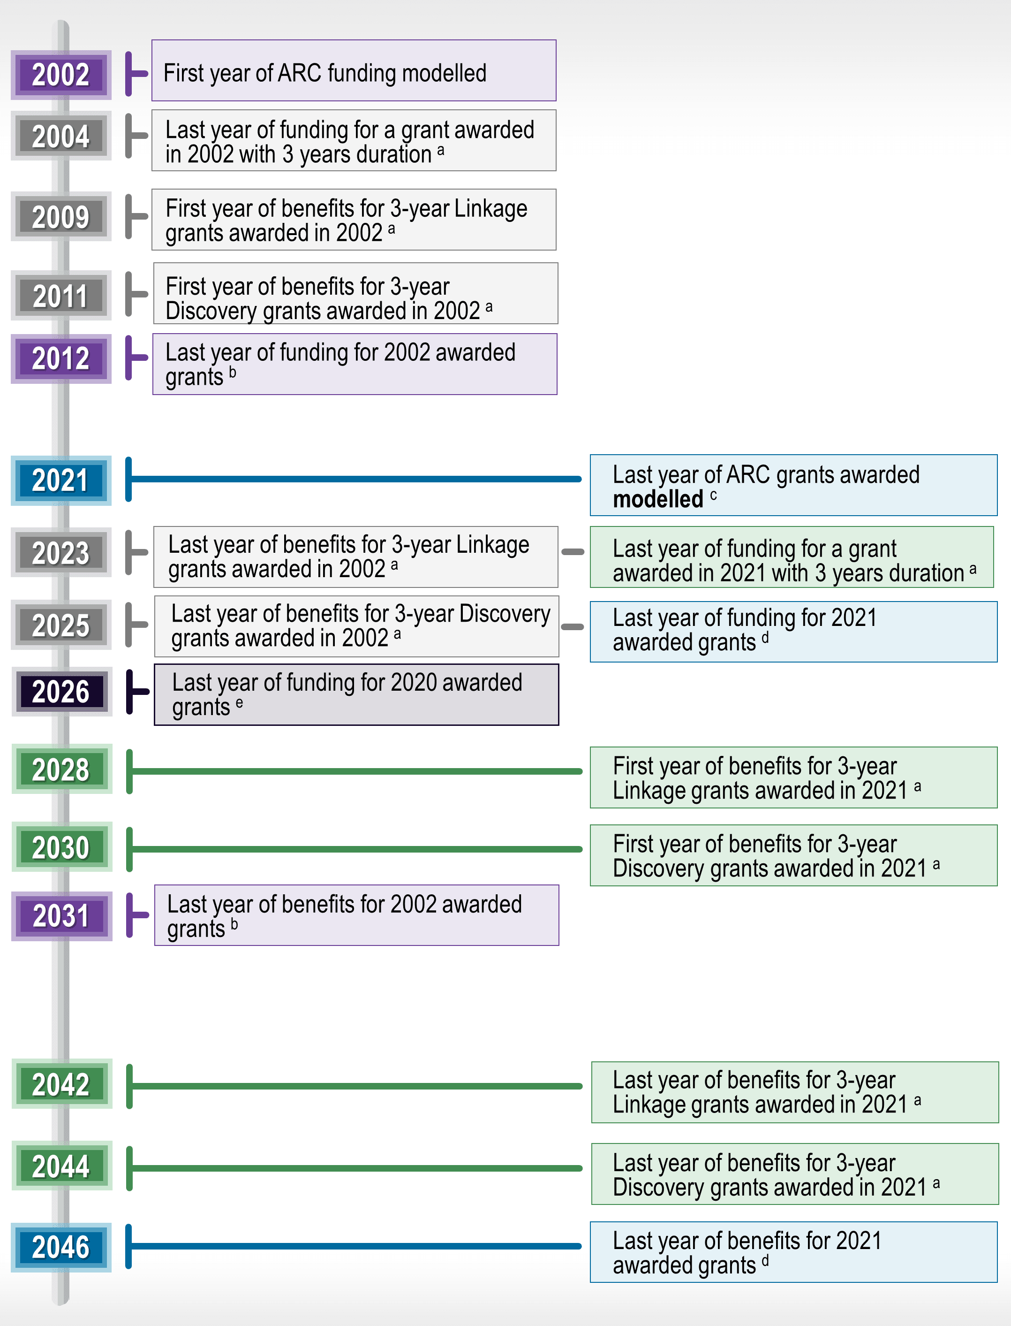

|  |  |  |
| --- | --- | --- |
|  |  |  |
| Melbourne  Suite 4, Level 19; North Tower  80 Collins Street  Melbourne VIC 3000 Australia  +61 3 8650 6000  Canberra  Level 6, 54 Marcus Clarke Street  Canberra ACT 2601 Australia  +61 2 6103 8200 | Sydney  Suite 603, Level 6  309 Kent Street  Sydney NSW 2000 Australia  +61 2 8272 5100  Perth  Level 12, 28 The Esplanade  Perth WA 6000 Australia  +61 8 9449 9600 | Brisbane  Level 15, 127 Creek Street  Brisbane QLD 4000 Australia  +61 7 3009 8700  Adelaide  167 Flinders Street  Adelaide SA 5000 Australia  +61 8 8122 4965 |
| ACIL Allen Pty Ltd  ABN 68 102 652 148 |  |  |
| acilallen.com.au |  |  |