21 April 2023
Report to
Australian Research Council

Impact assessment of ARC-funded research
Final technical supplement

Contents
1 Introduction 1
2 ROR on research: literature review 2
2.1 Glossary of key terms 2
2.2 Literature review methodology 4
2.3 The role of R&D in an economy 5
2.4 The economic impact of R&D 6
3 CGE modelling approach 16
3.1 Why use a CGE model to evaluate economic impact? 16
3.2 Modelled scenarios 16
3.3 Model inputs 17
3.4 Opportunity cost of investment 22
3.5 Rate of return on investment 23
3.6 Time lags and useful life of research 26
3.7 Industry sectors receiving the benefits 26
3.8 Geographic boundaries of returns from research 29
3.9 Modelling inputs 29
4 Tasman Global 32
4.1 A dynamic model 32
4.2 The database 33
4.3 Model structure 34
4.4 Population growth and labour supply 37
4.5 The Australian labour market 38
4.6 Labour market model structure 40
5 Stakeholder consultation methodology 43
5.1 Stakeholders consulted 43
6 Domestic stakeholder consultation themes 44
6.1 Stakeholder perception about the outcomes and impacts of ARC-funded research 44
6.2 Alignment with priorities 46
6.3 Value of NCGP funding 48
6.4 Improving the delivery of research impacts and ongoing impact assessment 51
7 International stakeholder consultation themes 56
7.1 The ARC’s international comparators 56
7.2 Overview of comparator funding programs 57
7.3 Overview of international comparators 61
7.4 Outcomes and impacts from funded research 66
7.5 Monitoring, analysing and reporting on outcomes and impacts 68
8 Stakeholder survey methodology and additional information 75
8.1 Survey approach and timing 75
8.2 Survey qualitative analysis methodology 75
8.3 Survey demographics 77
8.4 Impact by scheme 82
8.5 Sentiment analysis 85

Introduction
The Australian Research Council (ARC) engaged ACIL Allen to independently assess the outcomes and impact of NCGP-funded research over the past 2 decades, which includes an assessment of the potential future benefits of the Linkage and Discovery Programs. The terms of reference for this evaluation are provided in Box 1.1.
Box 1.1 Terms of reference
The evaluation is required to:
- assess the outcomes of NCGP-funded research, including those relevant to the Government’s broad strategic priorities
- assess the economic impact of NCGP-funded research
- assess the broader impacts of NCGP-funded research, including environmental, social and other impacts
- assess the effectiveness with which the ARC is supporting, monitoring and reporting on NCGP research impact
- identify lessons and recommendations on how the impact of ARC-funded research could be better supported, monitored and communicated in the future.
Source: ARC’s 2022 RFQ
This technical report is a supplement to the main report. It contains more detailed information and analysis on:
- return on investment literature that has underpinned the modelling assumptions presented in the main report
- domestic stakeholder consultation themes
- international stakeholder consultation themes
- analysis of the survey of ARC-funded researchers and partners
- analysis of funding and program data.

ROR on research: literature review
This chapter examines the literature on the rate of return (ROR) to public R&D. This review has drawn on Australian literature as well as literature from the United States, United Kingdom, European Union and other Organisation for Economic Co-operation and Development (OECD) countries to ensure a holistic examination of R&D ROR.

Glossary of key terms
Consumer surplus | Consumer surplus is a measure of economic welfare, and it is defined as the difference between what a consumer would be willing to pay for a good or service and what they actually have to pay.
Econometric vector error correction model (VECM) | The error correction model (ECM) is a time series regression model based on the behavioural assumption that two or more time series exhibit an equilibrium relationship that determines both short-run and long-run behaviour. A vector error correction model (VECM) adds additional error correction features to the ECM approach through a multi-factor model known as vector autoregression. An autoregressive model uses observations from previous time steps as input to regression equations to predict the value at the next step.
Economic surplus approach | Economic surplus considers both consumer surplus and producer surplus. The producer surplus is the difference between the actual price of a good or service–the market price–and the lowest price a producer would be willing to accept for a good. The sum of consumer and producer surplus results in the total economic surplus.
Employee years | An employee year is employment of one full time equivalent (FTE) person for one year or one 0.5 FTE person for two years.
Employment | An indicator of job numbers in the economy.
Jones and Summers (2020) approach | The Jones and Summers approach is a macro-level approach that draws on modern innovation-based growth theory to show how average returns to innovation can be calculated by linking the total cost of innovation investments to economy-wide gains in GDP.
Macro-economic modelling approach | A macroeconomic model is an analytical tool designed to replicate the operation of the global or individual country's economy. It examines the dynamics of important economic indicators like output, inflation and unemployment. Benefits are calculated by examining increases in the economy’s output.
Present value | The value of a future stream of income (or expenses) converted into current terms by an assumed annual discount rate. The underlying premise is that receiving, say, $100 in 10 years is not ‘worth’ the same (i.e. is less desirable) than receiving $100 today.
Production function approach | The production function depicts the relation between physical outputs of a production process and physical inputs, i.e. factors of production. The practical application of production functions is obtained by valuing the physical outputs and inputs by their prices. The economic value of physical outputs minus the economic value of physical inputs is the income generated by the production process.
Real discount rate | An interest rate that has been adjusted to remove the effects of inflation.
Real Economic Output and Real Income | Real economic output is a measure of the aggregate output generated by an economy over a period of time (typically a year). At a national level, real economic output refers to Gross Domestic Product (GDP).  Although changes in real economic output are useful measures for estimating how much the output of the economy may change due to the ARC-funded research activities, changes in the real income of a region are more important as they provide an indication of the change in economic welfare of the residents of a region. Indeed, it is possible that real economic output can increase with no, or possibly negative, changes in real income. The changes in real income at the national level reported in this analysis are synonymous with real gross national disposable income (RGNDI).  Changes in real income are equivalent to the changes in real economic output, plus the change in net foreign income transfers, plus the change in terms of trade (which measure changes in the purchasing power of a region’s exports relative to its imports).  In summary:  - Economic output (GDP) is one of the primary indicators used to gauge the health of the economy as it measures the amount of economic activity happening in a country/state/region. It represents the total dollar value of all goods and services produced over a specific time period — it can be thought of it as the size of the economy.  - Real income measures the income available to the nation/state/region for final consumption and saving. It equals GDP:  - plus the trading gain or loss resulting from changes in the terms of trade  - plus real primary incomes receivable from abroad; minus real primary incomes payable abroad  - plus real current transfers receivable from abroad; minus real current transfers payable abroad.
Real Wages | Wages refer to money that is paid or received for work or services.  Real wages refer to wages adjusted for the effect of consumer prices (inflation).
Total factor productivity approach | The total factor productivity approach describes the relationship between output in real terms and the inputs involved in its production. It is a commonly used device for explaining the economic output and development of national economies.

Literature review methodology

Overview of the approach
A 4-step process was used to perform the systematic literature search:
- Identify parameters of the literature review: ensuring the review is targeted appropriately and will answer key research questions posed.
- Identify relevant search terms and databases: including the identification of leading researchers, journals, authorities and other information sources, aligned with relevant research questions.
- Define inclusion and exclusion criteria: for example, the eligible time period of publications, type of publication (e.g. journal article and newspaper article), and the origin of the publication or its source.
- Assess the quality and weight of evidence: this step ensures that only reliable and robust evidence is reported.
This process is detailed below.

Search strategy
      - Parameters of the literature review
The systematic literature search drew on a range of resources to collate the most contemporary evidence on rates of return to R&D. The literature review categorised research by the industry/subject focus (see list below).
      - Search terms and databases
The search terms will include:
- public funding / private funding
- rate of return / return on investment
- research areas:
  - academic science research
  - basic research
  - chemical research
  - mining research
  - agricultural research
  - industrial research
  - manufacturing research
  - medical research
  - social science research
  - humanities research
  - environmental research
  - chemical research.
Appropriate variations were used to account for word variations and plurals.
The literature review required a mix of database and purposive/ targeted searches, as well as the ‘Snowballing’ technique. Snowballing involves identifying further resources from resources identified through the database and purposive/ targeted searches (for example, in reference lists).
The search was conducted across the ProQuest ABI/INFORM (ProQuest 2022) electronic database using combinations of the search terms outlined above.
This work expanded on ACIL Allen’s rates of return of R&D repository, which summarises published estimates of rates of return to publicly funded R&D.
      - Inclusion and exclusion criteria
The following parameters were included in the search process:
- Australian literature preferred, but literature from other OECD countries also be examined
- literature published in English
- peer reviewed literature and grey literature.
      - Quality and weight of evidence
The evidence was assessed, taking into consideration the weight of evidence according to 3 factors:
- Topic relevance: the alignment of the focus of the research with ARC-funded research
- Methodological quality: The trustworthiness of the results judged by the quality of the study within the accepted norms for undertaking the particular type of research design used in the study.
- Methodological relevance: The appropriateness of the use of that study design for informing the rate of return analysis.
      - Documentation from the Department
Documentation supplied by the ARC for the purpose of this ARC evaluation was also examined as part of the literature review and included in the reference list.

The role of R&D in an economy
Research and innovation lead to the development of new and efficient processes, technologies and products, which improve living standards when deployed across the economy. Indeed, Australia’s national wellbeing, as reflected in the health and lifestyle of the population and the security and sustainability of the environment in which Australians live, is dependent on research and innovation.
Publicly funded research can enhance health and living standards, improve economic, social and environmental outcomes, and create national wealth. It can also raise national productivity, increase national competitiveness, create new jobs and increase tax revenues. Publicly funded research contributes to a valuable innovation cycle that ultimately permits further investment in research. This cycle is illustrated in Figure 2.1.
Figure 2.1 The cycle of publicly funded research
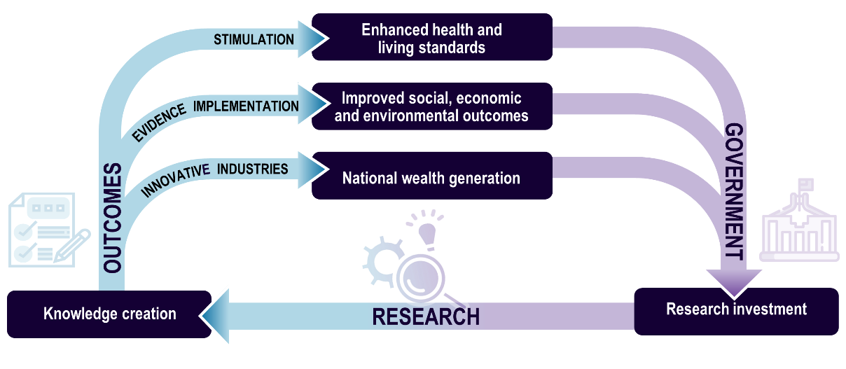
Source: ACIL Allen based on NHMRC 2010.

The range of economic benefits generated from research is extensive. Martin and Salter (2001) have suggested the main benefits of publicly funded research that led to economic growth are:
- increasing the stock of useful knowledge
- training skilled graduates
- creating new scientific instrumentation and methodologies
- forming networks and stimulating social interaction
- increasing the capacity for scientific and technological problem solving
- creating new firms.
In addition to economic benefits, R&D investments are crucial to address key societal challenges and improve well-being as they contribute to enhancing health outcomes, fighting against climate change and building more inclusive and resilient societies.
At a business level, the benefits of innovation (which includes R&D activities) have been demonstrated by decades of economic research. Indeed, innovation has been demonstrated to drive productivity growth and the competitive advantage of businesses, with innovative businesses out-competing other businesses by achieving higher rates of business survival and growth in employment and profits.

The economic impact of R&D
While it is widely acknowledged that research leads to a wide range of benefits, it is also well-documented that the impact of research is difficult to measure. More specifically, the creation, transfer and subsequent application of knowledge and the success and effect of this are difficult to measure. This is because the relationship between research, knowledge transfer, application and the economic, social and other outcomes these can produce is complex.
Numerous studies have addressed the ROR on public and private investments in research, and while there are variations in the methodologies used across studies, the strong consensus is that the ROR is high. Indeed, according to most studies, the overall value generated by public research is between 3 and 8 times the initial investment over the entire life cycle of the effects. When calculated in terms of annual ROR, private ROR to R&D investments are estimated at around 10-30% and social ROR on publicly funded research in the order of 20-50% a year (in fact, the former Australian Department of Industry, Science, Energy and Resources suggest that ROR are more than 40% for social return).
The section below reviews and summarises a selection of studies available in the academic literature on the economic impacts of publicly funded R&D.
Empirical studies conducted in the 1980s and 1990s have often indicated a ROR typically of between 20% and 50% for public R&D.
The Productivity Commission (2007) suggests that even when uncertainty about the parameters is considered, the social ROR of publicly supported R&D is mostly above 35% and below 100%.
An analysis conducted by the Allen Consulting Group for the ARC in 2003 estimated an overall social ROR (SROR) of 25% for the decade 1990-00 using a top-down approach. This was done by first determining the increase in GDP for the period, estimating the proportion of the increase in GDP that could be directly attributed to the increase in total factor productivity (previously known as multi-factor productivity) growth, then determining what proportion of the total factor productivity growth could be attributed to public R&D. The report then translates this dollar figure increase in GDP due to public R&D activities into the social ROR on public research funding, by dividing the dollar value of the increase in GDP due to Public R&D by the total Public R&D funding amount for the period (more details on this methodology is presented in the main report).
There are several ways to estimate ROR figures, each with various benefits and shortfalls. A description of the methods that appear in this literature review is provided in Box 2.1.
Box 2.1 Economic modelling approaches used to estimate the returns to research investments
This box describes the economic modelling approaches that have been used to estimate the returns to research investments in the literature included in this review.
Case study approach: An extremely common approach for estimating returns on investment (especially to innovation) are case studies of specific projects and programs, as they are a relatively simple way to demonstrate the benefits and need for funding of the project or program. In general, these studies calculate the present value of the total benefits to the present value of the total costs involved, both privately and for the broader economy. The benefit of the approach is that it can provide a more holistic picture of the activities and benefits of the program (rather than the economics alone). A limitation of this approach is that it is difficult to apply if there are a large number of projects/programs.
Macro-economic modelling approach: The macro-economic modelling approach assumes various (often complex) macroeconomic functional forms and their parametric values to calculate the returns to investment and provides the basis for studies that use computable general equilibrium (CGE) modelling. CGE models treat economic benefits (e.g. additional revenue based on an R&D innovation) as a positive “productivity shock” to derive estimated GDP impacts. A benefit of this approach is that it provides a way to analyse the impacts of policies and programs on an entire economy, including interactions between different sectors and households. A limitation of this method is that it is complex and often needs specialist skills and software to conduct.
The Jones and Summers (2020) approach: This approach is a novel, yet simple, macro-level approach developed by Jones and Summers in 2020. It draws on modern innovation-based growth theory to show how average returns to innovation can be calculated by linking the total cost of innovation investments to economy-wide gains in GDP. The approach's key advantages are that it examines the aggregate path of GDP as a result of R&D expenditure and estimates average returns; and applies individual “adjustments” to recalculate the baseline results and emphasise particular features of innovation activity (e.g., delays in benefits realisation or the role of capital expenditure). A limitation is that it excludes non-monetary, societal and environmental benefits.
Production Function approach: The production function approach models the relationship between the quantities of productive factors (such as labour and capital) used and the amount of product obtained. The production function can answer a variety of questions, for example, it can measure the marginal productivity of a particular factor of production (i.e., the change in output from one additional unit of that factor). It can also be used to determine the cheapest combination of productive factors that can be used to produce a given output. A benefit of this approach is that it provides a framework for understanding the relationship between inputs and outputs in the production process. Limitations of this approach depend on the type of production function used. For example, the Cobb-Douglas production function shows constant returns to scale, which are not an actuality.
Total factor productivity approach: Total factor productivity (TFP) is a measure of the efficiency with which inputs are used in production. As both output and inputs are expressed in term of volume indices, the indicator measures TFP growth. To aggregate the different output (and input) volume indices, the production (and input) values are used as weights. This allows capturing the relative importance between outputs, or inputs. An increase in TFP reflects a gain in output quantity which does not originate from an increase of inputs. A benefit of this approach (particularly for innovation) is that it can help identify sources of productivity growth, such as technological progress. A limitation is that it does not account for externalities or other factors that may affect productivity, such as improvement of air or water quality.
Economic surplus approach: The economic surplus approach is based on the concept of economic surplus, which is the difference between the maximum amount that consumers are willing to pay for a good or service and the minimum amount that producers are willing to accept as payment for supplying that good or service. A benefit of this approach is that it can be used to consider net welfare effects of policies or programs, by comparing the economic surplus before and after the policy or program is implemented. A limitation of this method is that it can be difficult to collect accurate data on what consumers are willing to pay for a good or service.
Cost-benefit analysis approach: Cost-benefit analysis (CBA) is an economic modelling approach which involves comparing the total costs of implementing a policy or project to the total benefits generated by it, and determining whether the benefits outweigh the costs. Costs and benefits are adjusted to present day dollars so that projects from different time periods can be compared. A benefit of this approach is that it provides a systematic framework for evaluating the economic feasibility of policies or projects and is relatively simple to conduct. A limitation is that the approach may not fully account for intangible or intangible benefits or costs, such as changes in quality of life or environmental impacts.
The Vector Error Correction Model: The Vector Error Correction Model (VECM) is a statistical model used in econometrics to analyse the dynamic relationships between multiple time series variables. The VECM approach assumes that economic variables are co-integrated. Co-integration occurs when there is a relationship between two or more time-related series. The VECM model estimates short-run behaviour, long-run cointegrating relationship as well as short-run adjustment coefficients. The short-run deviations from long-run equilibrium are corrected and the speed of this correction is shown by the adjustment coefficients. A benefit of the method is that it considers both short-term and long-term relationships of variables. A limitation is that a large dataset is needed to model the long-term relationships accurately.
Source: ACIL Allen 2023; Wynn, 2022, Quantifying the economy-wide returns to innovations for Australia; and European Commission, 2014, The Production Function Methodology for Calculating Potential Growth Rates & Output Gaps.; CSIRO, 2021, Quantifying Australia’s returns to innovation; Diewert, E., n.d., The Challenge of Total Factor Productivity Measurement; University of Texas at Dallas, n.d., The Production Function Approach, sand VAR: Theory; https://spureconomics.com/vector-error-correction-vecm-theory/.
Table 2.1 summarises published estimates of ROR to publicly funded R&D. It shows that ROR on publicly funded research vary greatly depending on the methodology used and the subject of the study. On the whole, it may be concluded that R&D ROR in developed economies during the past half century have been strongly positive and may be as high as 75%, although they are more likely to be in the 20% to 50% range.
Table 2.1 Selection of published estimates of the ROR to publicly funded R&D
Author(s) | Subject/industry focus |  |  |  | Methodology/Framework |  |  |  |  | Annual ROR to public R&D (%)
Agricultural research
Griliches (1958) | Hybrid corn |  |  |  | Economic surplus approach |  |  |  |  | 21-40
Griliches (1964) | Aggregate agricultural research |  |  |  | Production function approach |  |  |  |  | 35-40
Peterson (1967) | Poultry |  |  |  | Production function approach |  |  |  |  | 21-25
Evenson (1968) | Aggregate agricultural research |  |  |  | Production function approach |  |  |  |  | 28-47
Schmitz and Seckler (1970) | Tomato harvester |  |  |  | Economic surplus approach |  |  |  |  | 16-46
Cline (1975) | Aggregate agricultural research |  |  |  | Production function approach |  |  |  |  | 41-50
Bredahl and Peterson (1976) | Cash Grain  Poultry  Dairy  Livestock |  |  |  | Production function approach |  |  |  |  | 36  37  43  47
Knutson and Tweeten (1979) | Aggregate agricultural research |  |  |  | Production function approach |  |  |  |  | 28-47
Davis (1979) | Aggregate agricultural research |  |  |  | Production function approach |  |  |  |  | 37
Evenson (1979) | Aggregate agricultural research |  |  |  | Production function approach |  |  |  |  | 45
Davis and Peterson (1981) | Aggregate agricultural research |  |  |  | Production function approach |  |  |  |  | 37
Norton (1981) | Poultry  Dairy  Livestock  Cash grain |  |  |  | Production function approach |  |  |  |  | 27-33  56-66  30  44
Scobie and Everleens (1986) | Aggregate agricultural research |  |  |  | Total factor productivity approach |  |  |  |  | 30
Huffman and Evenson (1993) | Aggregate agricultural research |  |  |  | Production function approach |  |  |  |  | 43-67
Mullen and Cox (1995) | Agricultural research: broadacre (Australia) |  |  |  | Total factor productivity approach |  |  |  |  | 15-40
Frontier Economics (2014) | Aggregate agricultural research (UK) |  |  |  | Production function approach |  |  |  |  | 30-40
Manufacturing/industrial research
Mansfield (1980) | Industrial R&D |  |  |  | Total factor productivity approach |  |  |  |  | 12
Goodridge et al (2015) | Industrial R&D |  |  |  | Production function approach |  |  |  |  | 20
Frontier Economics (2014) | Aggregate industrial sectors research (UK) |  |  |  | Production function approach |  |  |  |  | 20-28
Mining research
Productivity Commission (2007) | Longwall mining automation |  |  |  | Cost benefit analysis/IRR |  |  |  |  | 69 ª
University of South Australia (2018) | Return on AMIRA’s P260 Project to the minerals industry |  |  |  | Cost benefit analysis/IRR |  |  |  |  | 110 ^{b}
Australia Parliament House of Representatives, 2003 | CSIRO’s robotic mining project  Return on seven minerals and energy R&D projects from CSIRO |  |  |  | Cost benefit analysis/IRR  Cost benefit analysis/IRR |  |  |  |  | 720  22.5- 292.5 ^{c}
ACIL Allen Consulting (2019) | Public R&D in mining geology |  |  |  | Economic surplus approach |  |  |  |  | 1-90
Health/medical research
Cockburn and Henderson (2000) | Pharmaceuticals |  |  |  | N/A – study presents a literature review |  |  |  |  | 30
OECD (2008) | United States National Institute of Health funded research |  |  |  | N/A – study presents a literature review |  |  |  |  | 15
Sussex et al (2016) | Biomedical and health research in the UK (includes spillover effects) |  |  |  | Econometric vector error correction model (VECM) |  |  |  |  | 15-18
Grant and Buxton (2018) | Musculoskeletal disease research (UK)  Cancer research (UK)  Cardiovascular disease research (UK) |  |  |  | ROR measured in terms of the additional health gain |  |  |  |  | 10  7-10  9
Grant and Buxton (2018) | Aggregate medical research (UK) |  |  |  | Impact on GDP |  |  |  |  | 15-18
ACIL Allen Consulting (2018) | Public R&D in medical research |  |  |  | Economy-wide approach |  |  |  |  | 12-80
Overall public R&D
Allen Consulting Group (2003) | Australian Research Council funded research. This considered all six ARC research areas at the time, which includes humanities and creative arts. |  |  |  | Total factor productivity approach |  |  |  |  | 25
Productivity Commission (2007) | Public sector agencies. Covers physical, biological, mathematical, and HASS. While the study discusses the impacts of research across these sectors including HASS, no specific estimates for HASS research were provided |  |  |  | Total factor productivity approach |  |  |  |  | 35-100
Hall et. Al (2009) | Various (industry and firm data, sector not specified) |  |  |  | N/A – study presents a literature review |  |  |  |  | 20-30
Salter and Martin (2001) cited in Bornman (2012) | R&D programs in the UK (basic research, does not include research in HASS) |  |  |  | Survey |  |  |  |  | 21-67
CSIRO (2021) | Average annual return of R&D to Australia (aggregate of public and private funding sources), lower bound is adjusted for additional time and costs associated with integrating R&D into the economy. Upper bound is unadjusted. Does not include HASS research. |  |  |  | Jones and Summers (2020) approach |  |  |  |  | 10-104
European Commission (2017) | Horizon 2020 (European research and innovation Framework Programme). Figure is for 2030. While the study discusses the impacts of research across a wide range of sectors including HASS, no specific estimates for HASS research were provided |  |  |  | Macro-economic modelling approach |  |  |  |  | 30
European Commission (2017) | FP7 (Seventh Framework Programme, European Union R&I funding programme) and Horizon 2020. Does not discuss individual sectors, only public R&I overall. |  |  |  | Case study approach |  |  |  |  | 32
Basic (academic science) research in scientific fields ^{d}
Mansfield (1991, 1995, 1998) | All academic science research. Based on aggregated figures from scientific fields, including information processing, electrical equipment, chemicals, instruments, drugs, metals, and oil. |  |  |  | Return on investment approach |  |  |  |  | 28
Georghiou (2015) | All academic science research. Based on research on the agriculture and biomedical fields. |  |  |  | Presents a literature review |  |  |  |  | 20-50
Hines (2017) | All academic science research ^{e} |  |  |  | Presents a literature review |  |  |  |  | 20
ª This ROR has been estimated from a benefit cost ratio (BCR) provided in Table I.9 (automated mining new estimate) of the Productivity Commission’s Research Report. As noted in this report, a rough translation of the BCR to the internal ROR is i times the BCR, where i is the discount rate (Alston et al. 2000, cited in Productivity Commission 2007, p. 146).
^{b} ROR has been approximated from a BCR of 22:1 and assuming a discount rate of 5%.
^{c} ROR has been approximated from BCRs of between 3 and 39 and a discount rate of 7.5%.
^{d} Basic (academic science) research, also called pure research or fundamental research, is a type of scientific research with the aim of improving scientific theories for better understanding and prediction of natural or other phenomena.
^{e} This study drew on Mansfield (1991;1998) and Georghiou (2015), in addition to Frontier economics (2014) which focused on agricultural research, Buxton (2009) which focused on biomedical research, Beise and Stahl (1999) which focused on industrial innovation, and European Commission (2017), which focused on technologies and innovation R&I (digital, biotechnologies, energy and the environment, and advanced materials).
Source: ACIL Allen based on noted sources.

There is some evidence to suggest public R&D has a lower ROR compared to private R&D, both at a private and social level. Gudgiev and others even report that public R&D contributes virtually nothing to productivity. This analysis can be misleading. Primarily, it does not consider the many spillover benefits associated with public R&D, such as innovation and increasing the capacity for scientific and technological problem-solving. Dagg (2007) concludes that when this is considered, the long-term impact of public R&D may be higher than that of business sector R&D.
An extensive literature review conducted by Frontier Economics (2014) concluded that social returns to R&D (based on spillover benefits from R&D conducted by one agent to the productivity or output of other agents) are typically 2 to 3 times larger than private returns. Further, a US-based study by Lucking, Bloom, and Van Reenen (2018) used 3 decades of firm-level data and a production function–based approach to document evidence of substantial positive net knowledge spillovers of R&D. The authors estimate that social returns are about 60% compared with private returns of around 15%. Sveikauskas (2007) states that spillovers account for roughly three-fifths of the social return to R&D.
It should be noted that Elk et al (2019) found that in their analysis of R&D investments in 22 OECD countries, publicly performed R&D investments did not automatically foster GDP and multi-factor productivity growth in production function models. This study included assumptions on knowledge spillovers between different countries. The estimates suggest that economic returns to publicly performed R&D appeared to depend on the specific national context. That being said, Table 2.1 shows that a range of sectors have experienced significant returns from publicly funded R&D in Australia and comparable western nations.
In addition to the studies cited in Table 2.1, Gudgiev’s and Elk’s findings differ from several other studies investigating the impact of R&D on productivity. A study by Guellec and van Pottelsberge (2001), for example, concluded that a country’s public R&D did make a positive contribution to productivity growth (and hence on social ROR) — on average a 1% increase in public R&D resulted in a 0.17% increase in productivity growth. This study assessed the impact of domestic public, domestic business and foreign R&D multifactor productivity growth using a panel of 16 Organisation for Economic Cooperation and Development (OECD) countries from 1980 to 1998.
Studies have also found that the benefits of R&D can accrue to other nations. A widely cited study by Coe and Helpman (1995) examined macroeconomic data from 22 developed economies and found that roughly 25% of R&D spending benefits in G7 economies accrue to trading partners.
However, there has been much debate and criticism on the validity of the historic ROR numbers and on the econometric models used to derive these numbers. Martin (2007) argues that past studies often have major conceptual and methodological problems. Due to the heterogeneity in the relationship between basic research and innovation and commercialisation, the time-lags involved in the realisation of benefits from R&D, as well as the difficulty in quantitatively measuring other supposed spillover benefits, he claims that no simple model of the nature of the economic and social benefits is possible. The Productivity Commission (2007) similarly acknowledges that given a host of unquantifiable economic, social and environmental benefits associated with public R&D, the social ROR on R&D estimates can be unreliable.
The use of such a wide array of analytical techniques, such as general equilibrium models, data linkages and sciento-metric methods, has made comparing different studies difficult. A recent study by the CSIRO on quantifying the economy-wide returns to innovation for Australia provides a summary of several methods for quantifying the returns to innovation. The methods described in this paper include the case study approach, the firm/industry-specific regression approach, the national-level regression approach, the model-driven macroeconomic approach, and the Jones and Summers (2020) approach. These approaches, in addition to the other methods described in Box 2.1 above, exemplify the broad range of approaches available to measure returns on innovation. To our knowledge, no common framework for developing and using these analytical techniques has been agreed upon.
Although comparisons between public sector research investments are difficult due to methodological inconsistencies, there is still evidence to show that the ROR for publicly funded research is substantial, particularly when compared to other public investments. In a study of economic returns to medical research funding in the UK, Grant and Buxton (2018) noted that the ROR figures for publicly funded medical research were well in excess of the yields of 6-8% that governments typically expect from public investments in aggregate (i.e. it is not specific to value adding investments). This is also in excess of the 3.5% real annual ROR required by the UK government to make public investments generally. Indeed, most of the ROR figures in Table 2.1 are above these thresholds.
Further, the literature review conducted by Frontier Economics (2014) noted that ‘There is some evidence that, at least in terms of their impact on private sector productivity, public R&D channelled through the research councils leads to higher social returns than R&D conducted by government departments (civil and defence) or channelled through higher education’. This suggests that research councils like the ARC may experience greater ROR than the average R&D return figures.

Research on Humanities and Social Sciences
No robust estimates of ROR on research in HASS fields were found in the literature.
- Frontier Economics argues that their research found ‘Evidence that (…) all forms of research council spending (including non-scientific spending on social sciences and humanities) yield positive social returns.’ However, the report does not provide a suitable reference of the size of these returns.
- The Allen Consulting Group’s economic evaluation of the ARC in 2003 noted that ‘Research in the humanities could be expected to contribute substantial cultural and social benefits, such as better equipping society to embrace and adapt to change. There could also be significant economic benefits from research in the social sciences - one element of which (the contribution to better policy outcomes in the area of economics) was considered [in the measured economic impacts of the ARC]’. In terms of the measured benefits from better-informed policy, this study found an estimated average of 6% social ROR from ARC funding with an 8-year time lag.
Key Finding ROR on R&D: literature review
Despite differences in methodologies, an overwhelming number of empirical studies indicate that investments in R&D have significant payoffs in terms of productivity, economic growth and living standards. Continued advances in R&D and technology are therefore crucial to ensuring and increasing economic growth.
Generally, studies place the economy-wide social ROR on overall publicly funded research between 20% and 50% a year, while private ROR to R&D investments tend to produce estimates of return of around 30% on average.

CGE modelling approach
The economy-wide impacts of the NCGP to the Australian economy was estimated using a Computable General Equilibrium (CGE) model of the Australian economy, the Tasman Global model.
To evaluate the NCGP’s economic impact on the Australian economy, Tasman Global was first used to project a business as usual scenario where the NCGP was assumed to not have been created. This provides the counterfactual against which to judge the impact that the NCGP has had on the economy. Then an alternative simulation was conducted based on assumptions regarding the direct benefits of ARC-funded research projects. The sections below provide more details about these assumptions, the simulation design and the inputs used for the economic modelling. Additional details about Tasman Global are provided in the technical supplement to this report.

Why use a CGE model to evaluate economic impact?
An ex-post impact evaluation of research investments requires an understanding of what would have happened in the absence of the program outputs that are attributed to the R&D funding under examination. This ‘without R&D’ scenario (the ‘counterfactual’) cannot, of course, be observed, so it must be inferred.
Establishing the ‘without R&D’ baseline is fundamental to assess the extent to which the aims of a research program like the NCGP are being achieved. A CGE model is capable of providing an accurate reflection of the world without policy intervention (that is, without the R&D investments being assessed, in this case, without the NCGP). In that sense, it is a much more useful tool than a comparative cost-benefit analysis approach. Furthermore, a CGE model can estimate the impacts of research investments on key macroeconomic aggregates such as GDP, exports, imports, consumption and investment and can provide valid measures of changes in consumer welfare or living standards so that the NCGP impacts can be correctly evaluated in terms of public interest.
The use of CGE models in policy and program analysis also imposes a discipline in which model structures can be easily compared and contrasted, and model results can be interpreted using a well-understood and rigorously developed theoretical framework. In addition, the use of a CGE framework allows capturing both the direct and indirect impacts of the NCGP. A CGE model is a high-level representation of the Australian economy that allows measuring the wider effects of changes in economic activity in key industries and regions. To the extent that economic activity is interlinked, a CGE model will capture any flow-on effects that arise from ARC-funded research outcomes, including upstream and downstream impacts.
CGE models are widely used by government, industry and academics to evaluate the worth of policy actions, programs and projects. This means that CGE modelling results are well understood and accepted by a wide range of stakeholders.

Modelled scenarios
This report analyses the economic impact of grants awarded by the ARC over the period 2002 to 2021 (i.e. it illustrates the economic impact that the NCGP has had in Australia over its whole life). To estimate this impact, the following scenarios were simulated in the Tasman Global model:
- Base Case scenario — this scenario projects a business-as-usual base case where it is assumed that the NCGP does not exist. The Base Case was used as a benchmark with which to compare the results of simulating the NCGP scenario.
- NCGP scenario — this scenario refers to a case where the NCGP has been established and grants have been awarded by the ARC over the period 2002 to 2021. This scenario includes the funding provided by ARC and the co-contributions from different parties. In practice, the historical period (2002-2021) reflects the actual historical path of the Australian economy in terms of changes in GDP, population, employment, trade, etc. while the Base Case scenario estimates what the Australian economy could have looked like if the NCGP had not been established.
Differences in economic outcomes between the NCGP scenario and the Base Case scenario are calculated to determine the economic benefits stemming from the NCGP over its lifetime.
The inputs used to model the NCGP scenario are discussed in more detail below.

Information and assumptions used to derive modelling inputs
There are two sets of shocks that were applied to Tasman Global in the NCGP simulation. One set of shocks is related to the direct benefits of the ARC-funded research activity, and the other to its costs.
The direct benefits of ARC-funded research were estimated using ARC project data, rates of return on public research investments obtained from the national and international literature, and a number of assumptions and parameters. In particular, the following parameters and assumptions were determined to estimate the direct benefits of ARC-funded research:
- the level and source of investment in R&D activities
- the opportunity cost of investment
- the assumed rate of return on research investments
- the industry sectors that benefit from research outputs
- the time lags involved in accrual of returns on investments
- the useful life of research
- the geographic boundaries of returns from research.
Each of these matters are discussed in the following sections. The direct benefits estimated using this information were applied to Tasman Global as output productivity gains (which are input neutral) across the industries identified as likely beneficiaries of ARC-funded research.
In terms of the costs of the NCGP, it has been assumed that, if the Government had not funded the NCGP, the grant funding would have been allocated across other Government expenditures (potentially having positive impacts elsewhere). An alternative counterfactual assumption could be that taxes could have been lowered by the amount of NCGP funding. However, given the scale of NCGP funding in the overall Australian Government budget, it is more likely that the funds would have just been differently allocated out of consolidated government revenue.

Level and source of research investment
For studies of economic benefit to be credible, it is essential that they are based on a clearly argued case for ‘additionality’ of the research’s economic contribution. To determine the net benefit of ARC-funded research, a necessary condition is to show that certain streams of economic benefits can be identified and associated with the NCGP funding. However, this by itself is not sufficient. It is also necessary to show that the identified streams of economic benefits (or a substantial part of them) are ‘additional’ in the sense that without the presence of the NCGP, the economic benefits would not have occurred or occurred to the extent they did.
Assessing additionality requires two separate questions to be answered:
  - Would specific research projects have proceeded in the form they did in the absence of NCGP funding?
  - To what extent would the resources invested by other parties in research projects funded by the NCGP have been invested elsewhere within the science and innovation system?
Judgements in relation to these two questions are necessarily subjective. Therefore, assessments of ‘additionality’ rates should be seen as estimates rather than as definitive figures.
The total funds awarded by ARC at the time of the Minister's announcement of the round outcomes from 2002 to 2021 and the co-contributions reported in grant applications (in current dollars) are outlined in Table 3.1. As shown in this table, over the last 20 years, ARC has funded $13.7 billion in research projects. This funding has been extended by $14.3 billion in co-contributions from other Australian sources and $2.6 billion in co-contributions from international sources.
Table 3.1 Funds awarded to research activities funded by the ARC by funding source (in current dollars)
Year | ARC funding | Other Australian | International
2002 | 344,813,934 | 303,749,910 | 12,664,942
2003 | 966,356,825 | 654,024,386 | 31,889,401
2004 | 467,026,153 | 535,504,907 | 23,172,994
2005 | 689,872,165 | 663,246,578 | 25,627,794
2006 | 476,219,475 | 499,403,330 | 16,279,745
2007 | 474,813,894 | 597,476,739 | 41,951,642
2008 | 506,709,914 | 653,434,076 | 23,817,744
2009 | 659,142,639 | 563,963,161 | 366,117,331
2010 | 746,484,976 | 813,991,111 | 43,878,712
2011 | 969,390,767 | 806,511,986 | 154,055,343
2012 | 745,969,491 | 671,104,425 | 112,319,593
2013 | 705,102,947 | 709,041,409 | 248,379,731
2014 | 1,036,699,181 | 983,128,094 | 125,761,566
2015 | 558,192,027 | 618,416,797 | 134,665,898
2016 | 583,989,558 | 617,219,588 | 91,904,311
2017 | 828,393,546 | 1,091,355,304 | 347,623,267
2018 | 573,502,577 | 661,614,623 | 102,001,042
2019 | 619,317,436 | 686,543,729 | 81,544,872
2020 | 1,069,847,718 | 1,283,169,787 | 215,452,085
2021 | 699,411,504 | 887,690,971 | 393,580,209
Total | 13,721,256,727 | 14,300,590,911 | 2,592,688,222
Note: Other Australian includes co-contributions from universities and other organisations in Australia.
Source: ACIL Allen based on ARC data.

Notably, the actual amount paid (invested in research activities) over the course of the grants may differ due to indexation and other factors (e.g. changes in financial commitments from partners). For modelling purposes, it has been assumed that the research funds invested each year of a grant are equal to the total amount of ARC funding awarded plus the total amount of reported co-contributions, divided by the project duration awarded at the time of the Minister's announcement of the round outcomes and assuming that funding actually commenced in the calendar year in which it was expected to commence at the time of funding announcement.
The profile of expenditure in ARC-funded research by year calculated using these assumptions is show in Figure 3.1. Importantly, while the modelling covers the ARC grants awarded over the period 2002 to 2021, the last year of expenditure on these research projects is 2026 (for grants awarded in 2020 which have a duration of 7 years). These timeframes are explained in more detail in Figure 3.2.
Figure 3.1 Estimated total ARC funding and co-contributions by year for grants awarded between 2002 and 2021, nominal dollars, 2002-2026
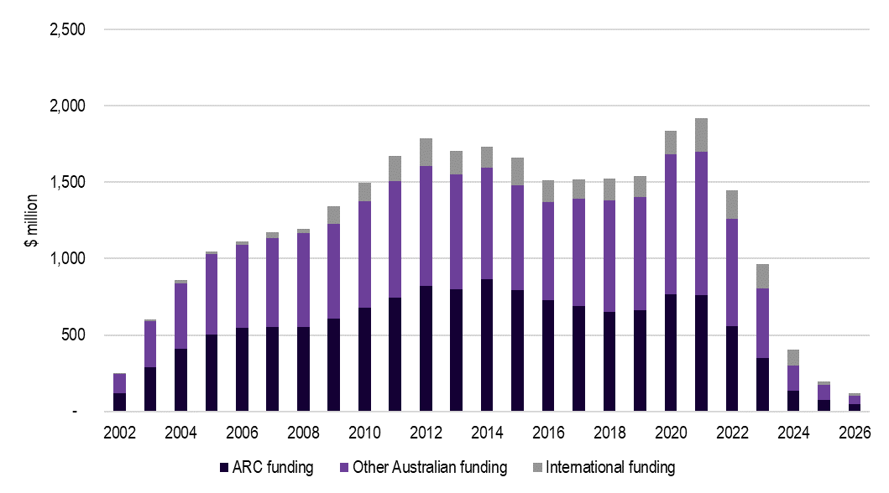
Note: Other Australian includes co-contributions from universities and other organisations in Australia. Figures reflect co-contributions reported in grant applications. ARC analysis of a sample of projects has shown that these reported contributions are close to the actual amount delivered throughout the projects.
Source: ACIL Allen estimates based on the ARC’s funding levels.

Figure 3.2 NCGP funding/payment timeframes
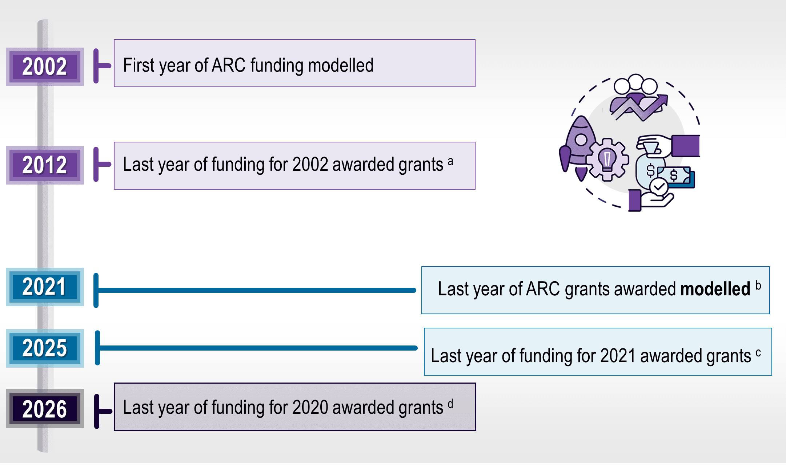
ª The maximum duration of grants awarded in 2002 is 11 years.
^{b} In reality, ARC grants have continued to be awarded after this date.
^{c} The maximum duration of grants awarded in 2021 is 5 years.
^{d} The maximum duration of grants awarded in 2020 is 7 years, so the last year of actual funding provided by ARC will be 2026 for these projects.
Source: ACIL Allen.
For modelling purposes, the nominal year on year expenditure in NCGP grants was converted into 2022 terms. This increases the total expenditure in the NCGP over the period 2002-2026 from $13.7 billion in nominal terms to $17.6 billion in 2022 dollars (see Table 3.2).
Table 3.2 Expenditure in NCGP grants over the period 2002-26, $ billion
 | In current dollars (nominal terms) |  | In 2022 dollars
 | Total (2002-2026) | NPV (7% discount) | Total (2002-2026) | NPV (7% discount)
ARC funding | 13.7 | 7.5 | 17.6 | 10.1
Co-contributions
From Australian sources | 14.3 | 7.5 | 18.2 | 10.0
From international sources | 2.6 | 1.2 | 3.1 | 1.5
Total | 30.6 | 16.1 | 38.9 | 21.6
Source: ACIL Allen.

All of the funds in Table 3.1 and Figure 3.1 have been considered as ‘additional’ for the purposes of the modelling.
- Commonwealth Government investment (i.e. ARC grants) has been considered to be ‘additional’ to that which would have occurred in the absence of the ARC because without ARC funding, this research is most unlikely to have taken place.
- Research funding provided by other Australian organisations (including universities) represents less mobile investment capital that was more likely to stay in Australia in the absence of the ARC and hence may be allocated a lower additionality rate. However, Australian universities are generally not likely to invest in research offshore and other Australian investors are likely to prefer to invest in research where they can closely monitor results.
- Investment in ARC-funded research projects made by international sources represents highly mobile investment capital that has come to Australia because of particular scientific infrastructure and expertise. Therefore, the ‘additionality rate’ of such leveraged investment was considered to be high.

Research investments that generate an economic return
ARC-funded projects generate a variety of important social, cultural and environmental impacts, which are not reflected in market returns. In this analysis, the social, cultural and environmental impacts associated with these research projects have not been monetised, and hence only the research investments that are likely to produce a market rate of return are included in the economic modelling. The social, cultural and environmental impacts generated by ARC-projects were captured via other evaluation data collection and analysis processes and presented in chapter 4.
The proportion of ARC projects that are assumed to generate a quantifiable economic return was based on survey responses. This includes responses reporting that projects ‘have produced’, are ‘likely to result in’ and ‘may result in’ economic impact by FoR and by project type — see Table 3.3.
Table 3.3 Proportion of survey responses indicating actual/anticipated impact by primary 2-digit FoR code
FoRs | Discovery projects | Linkage projects
Mathematical Sciences | 57% | 85%
Physical Sciences | 62% | 80%
Chemical Sciences | 80% | 87%
Earth Sciences | 44% | 82%
Environmental Sciences | 60% | 78%
Biological Sciences | 61% | 81%
Agricultural and Veterinary Sciences | 84% | 94%
Information and Computing Sciences | 83% | 84%
Engineering | 86% | 93%
Technology | 89% | 92%
Medical and Health Sciences | 73% | 77%
Built Environment and Design | 76% | 84%
Education | 51% | 65%
Economics | 78% | 89%
Commerce, Management, Tourism and Services | 83% | 95%
Studies in Human Society | 50% | 67%
Psychology and Cognitive Sciences | 58% | 72%
Law and Legal Studies | 52% | 68%
Studies in Creative Arts and Writing | 60% | 80%
Language, Communication and Culture | 41% | 67%
History and Archaeology | 38% | 58%
Philosophy and Religious Studies | 28% | 29%
Notes: Based on survey responses to the question ‘What (economic) impacts have been/are likely to be delivered by the project(s)?’. Percentages include responses reporting that projects ‘have produced’, are ‘likely to result in’ and ‘may result in’ economic impact.
Source: ACIL Allen.

Based on the figures in Table 3.3 and detailed project data provided by the ARC, around 72% of the ARC funds invested in the period 2002 2026 ($9.9 billion in nominal dollars) and their corresponding co contributions (approximately $12.9 billion in nominal dollars) were assumed to get an economic return (and hence were included in the modelling).
Of the ARC funds included in the modelling, 55% are from Discovery Program projects and 45% from Linkage Program projects. The distribution of funding included in the modelling by FoR is shown in Figure 3.3 and by year in Figure 3.4.
Figure 3.3 Distribution of funds included in modelling by FoR
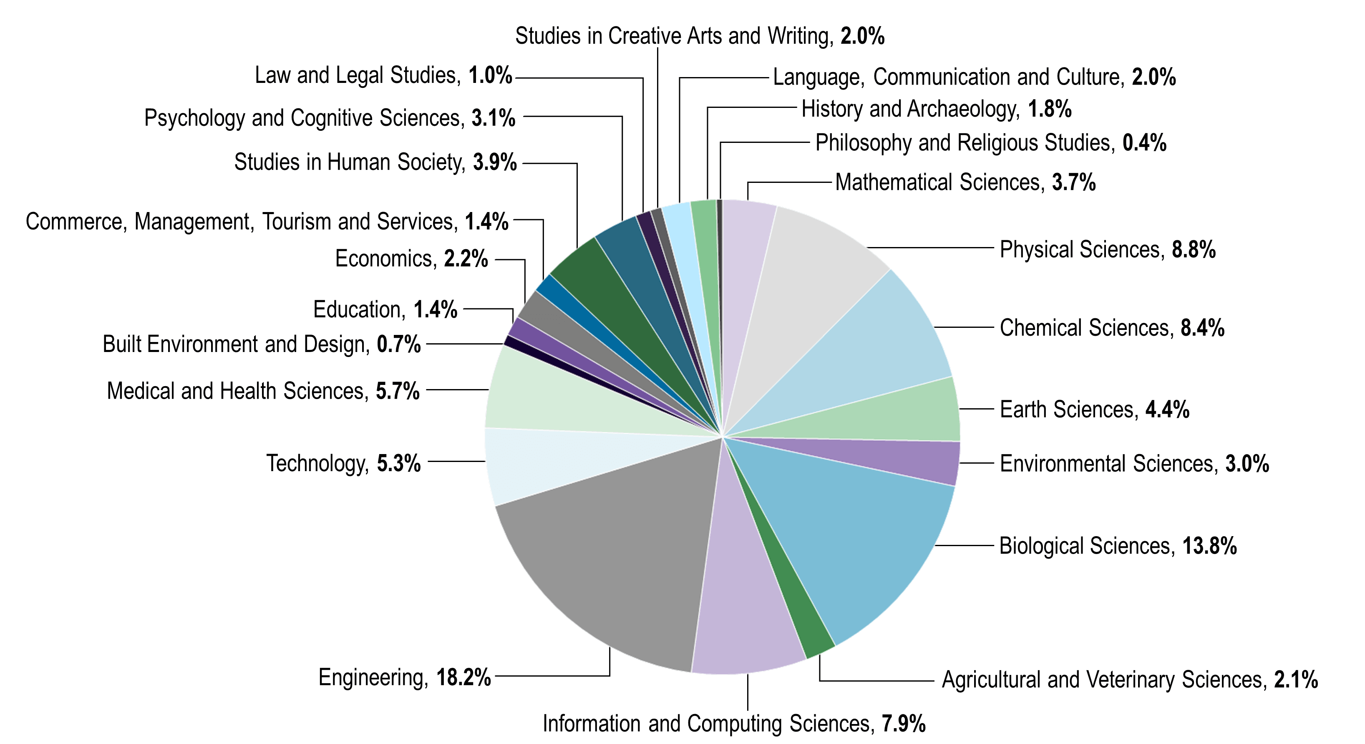
Source: ACIL Allen based on ARC data.

Figure 3.4 Distribution of funds included in modelling by year, nominal dollars, 2002-2026
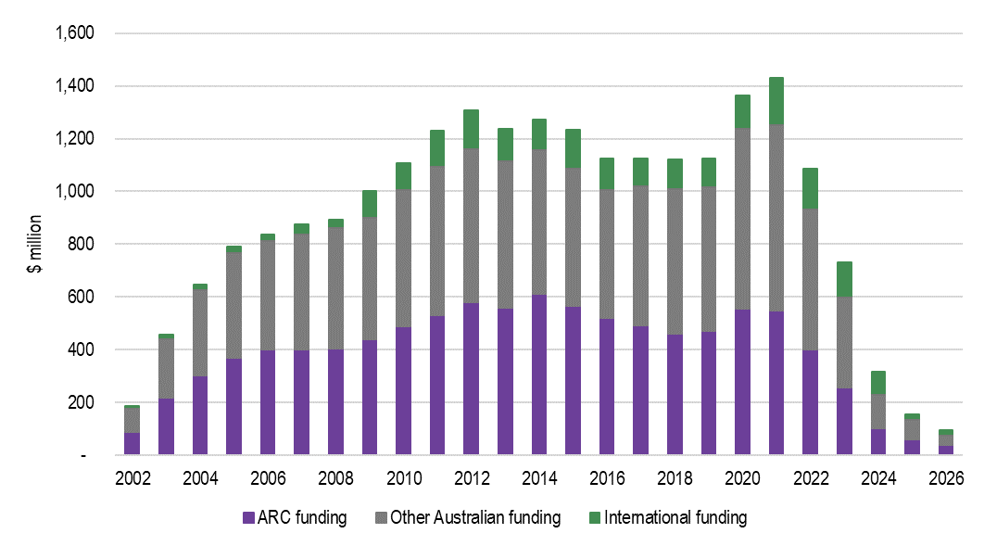
Source: ACIL Allen.

Opportunity cost of investment
For the modelling, it has been assumed that, in the absence of the NCGP, the funds currently allocated to the program would have been allocated to general government expenditure (potentially having positive impacts elsewhere). An alternative counterfactual assumption could be that the amount of NCGP funding could have lowered taxes. However, given the scale of NCGP funding in the overall Australian Government budget, it is more likely that the funds would have just been differently allocated out of consolidated government revenue.

Rate of return on investment
Research activities funded by the ARC can generate positive productivity and knowledge spillovers as knowledge generated through these activities improves the productivity or processes of organisations (e.g. the outcomes of a successful ARC-funded irrigation automation project described in Part II can be used to upgrade irrigation systems across Australia and deliver significant water savings and process efficiencies). There are many ways in which research enabled by the NCGP can induce such positive spillover effects. For example, spillovers from universities to businesses would be enabled through direct R&D collaborations between the universities and firms, the publication and dissemination of research findings, or through upskilling of the talent pool available in the labour market.
One way to quantify the direct benefits of ARC-funded research would be to identify the outputs, outcomes and impacts directly generated by each of the research projects undertaken with NCGP grants. However, given the scale of the program and the large number of projects funded during the period of analysis (a total of 29,306 projects), this approach is not feasible. Another way of quantifying these benefits would be to use estimates of the average rate of return to publicly funded research found in the literature and data on the ARC-funded research investments to estimate the potential direct benefits of research enabled by the NCGP. This is the approach used in this report.
A crucial variable to estimate the direct benefits of ARC-funded research using this approach is the assumed rate of return associated with the additional investment in ARC-funded research activities. A variety of metrics have been used in the R&D literature to describe/report the returns on research investment. These include:
- Return on Investment (ROI) — a simple indicator that shows the total percentage increase or decrease of an investment (the overall return of a research project from beginning to end). It is calculated by taking the change in value of the activity benefitting from the research from start to finish and dividing this amount by the initial research investment.
- Internal rate of return (IRR) — the IRR is a metric typically used in financial analysis to estimate the profitability of potential investments. The IRR is the discount rate that sets the net present value (NPV) of the change in value of the activity benefitting from the research over the assumed useful life of the research equal to zero in a discounted cash flow analysis. This approach normalises cashflows and produces a single annual rate of return for an investment.
- Benefit cost ratio (BCR) — a BCR is given by the ratio of the present value of a project’s benefits from the research to the present value of its costs and can be interpreted as every one dollar of research costs delivers ‘X’ dollars of benefits.
For the purposes of estimating the direct impacts of ARC-funded research, we have used estimates of the IRR on research investments in the literature. Hence, references to rate of return to research investments refer to IRR estimates.
Some studies in the R&D literature publish only a BCR. To expand the available dataset of estimates from the literature, we have estimated an approximate IRR from these studies by using a method previously used by the Productivity Commission which suggests that a rough translation of the BCR to the IRR is i times the BCR, where i is the discount rate (Alston et al. 2000, cited in Productivity Commission 2007, p. 146).
Estimates of rates of return in the R&D literature can reflect different types of impacts. For instance studies in the literature can:
- estimate the return on a R&D project that resulted in the workforce used in farms being more efficient (e.g. by increasing the skills of workers). The estimates of rates of return on this research project would reflect labour productivity improvements.
- estimate the return on a R&D project that reduces downtime or maintenance costs of manufacturing equipment. The estimates of rates of return on this research project would reflect improvements in capital productivity.
- assess a range of R&D projects which could result in a mix of labour productivity and capital productivity improvements, or in the creation of new technologies of products in specific industries (e.g. agriculture).
- assess an input productivity improvement associated with specific non-factor inputs (such as an energy efficiency improvement).
- assess an output productivity improvement associated with improving the total value of output for the same costs (such as through reducing wastage).
Given that it is not always clear what type of impacts the estimates of rates of return in the R&D literature are measuring (i.e. whether they are measuring labour, capital, multifactor, input or output productivity improvements), and that we do not have specific details about the nature/type of impacts produced by ARC-funded research projects, for modelling purposes the rates of return in the literature have been translated into improvements in output productivity in the industries that are assumed to benefit from ARC-funded research (i.e. the productivity gains are assumed to be input neutral). All else equal, assuming the research is improving output productivity will produce more conservative economic impacts compared to assuming all of the research generating economic returns result in factor productivity improvements.
The output productivity improvements from ARC-funded research were estimated by applying average rates of return to research investments based on their Socio Economic Objective (SEO). The rates of return by SEO used in the economic modelling are provided in Table 3.5. These were based on the following assumptions.
- The rates of return applied to research investments in scientific fields were sourced from national and international literature on rates of return on R&D investments.
  - A review of the economic literature on rates of return to R&D shows consistent findings of a significant and positive rate of return on publicly funded R&D investments (despite methodological differences in the way these estimates were produced). Details about the literature review on rates of return on publicly funded R&D in Australia are provided in the technical supplement to this report.
  - When a directly relevant rate of return for a research project was available, the more specific estimates in Table 3.4 were used. For instance, if a project’s SOE is Plant Production and Plant Primary Products, then the rate of return to agricultural research presented in Table 3.4 was used. When it was not possible to identify a particular type of R&D due to information restrictions, an overall rate of return on R&D in scientific fields of 35% was used.
Table 3.4 Literature estimates used to calculate the direct benefits of research investments in scientific fields
Type of R&D | Literature estimates | IRR used in this study
Overall public R&D in scientific fields (including basic & applied research) | Literature estimates vary considerably, but many studies place the rate of return on overall publicly funded research in the order of 20% to 50%. | 35%
Agricultural R&D | Literature estimates vary from 15%% to 67%, but many are around 40%. | 40%
Mining R&D | Literature estimates vary considerably, from 1% to 720%. | 70%
Manufacturing/industrial research | The most recent literature estimates indicate a rate of return of 20%. | 20%
Health/medical R&D | Studies in the literature report returns of between 7% and 80%. | 45%
Note: Additional detail about these estimates is provided in the technical supplement to the main report.
Source: ACIL Allen.

- No estimates of rates of return on research in social sciences, arts and humanities were found in the literature, and as such, rates of return were assumed instead.
Table 3.5 Assumed type of R&D for each modelled SOE
SEO | Assumed type of R&D | Rate of return
Defence | Public R&D (literature estimates) | 35%
Plant Production and Plant Primary Products | Agricultural R&D (literature estimates) | 40%
Animal Production and Animal Primary Products | Agricultural R&D (literature estimates) | 40%
Mineral Resources (excl. Energy Resources) | Mining R&D (literature estimates) | 70%
Energy | Public R&D (literature estimates) | 35%
Manufacturing | Manufacturing/industrial research (literature estimates) | 20%
Construction | Public R&D (literature estimates) | 35%
Transport | Public R&D (literature estimates) | 35%
Information and Communication Services | Public R&D (literature estimates) | 35%
Commercial Services and Tourism | Public R&D (literature estimates) | 35%
Economic Framework | Public R&D (assumption) | 10%
Health | Health/medical R&D | 45%
Education and Training | Public R&D (assumption) | 15%
Law, Politics and Community Services | Public R&D (assumption) | 10%
Cultural Understanding | Public R&D (assumption) | 5%
Environment | Public R&D (literature estimates) | 35%
Expanding Knowledge | Public R&D (literature estimates) | 35%
Notes: The category named ‘Public R&D (literature estimates)’ is based on estimated rates of return to overall public R&D in scientific fields (including basic & applied). No estimates of rates of return in non-scientific fields (research in social sciences, arts and humanities) were found in the literature and hence assumptions were made in discussions with the ARC about a potential rate of return to research in these areas (noted in the table above as ‘Public R&D (assumption)’).
Source: ACIL Allen and ARC.

Time lags and useful life of research
For the calculation of benefits, it was assumed that the returns on investment (i.e. the benefits) from ARC-funded research will be achieved on average:
- between four years after the investment is made for Linkage Program projects
- between six years after the investment is made for Discovery projects.
These time lags assumptions were based on survey results (see Table 3.6) and consultation with sector leaders.
Table 3.6 Time lags for the realisation of research benefits
 |  | Percentage of respondents that think economic impacts would be realised in the specified timeframe |  | Assumed midpoint for calculation of weighted average (years)
 |  | Discovery projects | Linkage projects
 | During the project | 10% | 15% | 0
 | Within 1 year of project completion | 6% | 14% | 1
 | 2-5 years from project completion | 35% | 38% | 3.5
 | 5-10 years from project completion | 34% | 25% | 7.5
 | Over 10 years from project completion | 16% | 8% | 11
 | Weighted average | 5.6 | 4.2
 | Source: ACIL Allen.
The economic modelling also assumes that the useful economic life of outcomes generated or enabled through ARC-funded research activities is, on average, 15 years (i.e. the economic modelling does not include any economic impacts from ARC-funded research beyond 15 years after the investment is made). Previous evaluations of research institutes conducted by ACIL Allen used the 20-year standard for patent life generally recognised in patent legislation as the indicator of the useful economic life of research. However, not all the ARC-funded research projects produce commercial outputs, so a 15-year period used is considered a reasonable average.

Industry sectors receiving the benefits
As part of our modelling approach, we identified the sectors of the economy that are most likely to benefit from the ARC-funded research, based on the research projects over 2002-21. Benefits from ARC-funded research were allocated between subdivisional structures of the Australian and New Zealand Standard Industrial Classification (ANZSIC). This allocation was made based on analysis of SEO codes and FOR codes of each of the research projects. Table 3.7 shows broadly how the industries that benefits were assigned.

Table 3.7 Broad mapping of industries that benefit from ARC-funded research based on SEO
SEO |  | ANZSIC Division
Defence | Public Administration and Safety
Plant Production and Plant Primary Products | Agriculture, Forestry and Fishing
Animal Production and Animal Primary Products | Agriculture, Forestry and Fishing
Mineral Resources (excl. Energy Resources) | Mining
Energy | Benefits divided equally between the following divisions/subdivisions:  - Oil and Gas Extraction  - Electricity Supply  - Gas Supply
Manufacturing | Manufacturing
Construction | Construction
Transport | Transport, Postal and Warehousing
Information and Communication Services | Information Media and Telecommunications
Commercial Services and Tourism | Benefits divided equally between the following divisions/subdivisions:  - Water Supply, Sewerage and Drainage Services  - Waste Collection, Treatment and Disposal Services  - Accommodation and Food Services  - Financial and Insurance Services  - Rental, Hiring and Real Estate Services  - Professional, Scientific and Technical Services  - Administrative and Support Services
Economic Framework | See approach in table below  If FoR is: Then industry that benefits:  Mathematical Sciences Benefits divided equally between across all industries  Physical Sciences Benefits divided equally between across all industries  Chemical Sciences Manufacturing  Earth Sciences Mining  Environmental Sciences Agriculture, Forestry and Fishing  Biological Sciences Agriculture, Forestry and Fishing  Agricultural and Veterinary Sciences Agriculture, Forestry and Fishing  Information and Computing Sciences Information Media and Telecommunications  Engineering Manufacturing  Technology Manufacturing  Medical and Health Sciences Health Care and Social Assistance  Built Environment and Design Construction  Education Education and Training  Economics Financial and Insurance Services  Commerce, Management, Tourism and Services Benefits divided equally between the following divisions/subdivisions: - Water Supply, Sewerage and Drainage Services - Waste Collection, Treatment and Disposal Services - Accommodation and Food Services - Financial and Insurance Services - Rental, Hiring and Real Estate Services - Professional, Scientific and Technical Services - Administrative and Support Services  Studies in Human Society Arts and Recreation Services  Psychology and Cognitive Sciences Professional, Scientific and Technical Services  Law and Legal Studies Public Administration and Safety  Studies in Creative Arts and Writing Arts and Recreation Services  Language, Communication and Culture Arts and Recreation Services  History and Archaeology Arts and Recreation Services  Philosophy and Religious Studies Arts and Recreation Services
Health | Health Care and Social Assistance
Education and Training | Education and Training
Law, Politics and Community Services | Administrative and Support Services
Cultural Understanding | Arts and Recreation Services
Environment | Agriculture
Expanding Knowledge | See approach in table below  If FoR is: Then industry that benefits:  Mathematical Sciences Benefits divided equally between across all industries  Physical Sciences Benefits divided equally between across all industries  Chemical Sciences Manufacturing  Earth Sciences Mining  Environmental Sciences Agriculture, Forestry and Fishing  Biological Sciences Agriculture, Forestry and Fishing  Agricultural and Veterinary Sciences Agriculture, Forestry and Fishing  Information and Computing Sciences Information Media and Telecommunications  Engineering Manufacturing  Technology Manufacturing  Medical and Health Sciences Health Care and Social Assistance  Built Environment and Design Construction  Education Education and Training  Economics Financial and Insurance Services  Commerce, Management, Tourism and Services Benefits divided equally between the following divisions/subdivisions: - Water Supply, Sewerage and Drainage Services - Waste Collection, Treatment and Disposal Services - Accommodation and Food Services - Financial and Insurance Services - Rental, Hiring and Real Estate Services - Professional, Scientific and Technical Services - Administrative and Support Services  Studies in Human Society Arts and Recreation Services  Psychology and Cognitive Sciences Professional, Scientific and Technical Services  Law and Legal Studies Public Administration and Safety  Studies in Creative Arts and Writing Arts and Recreation Services  Language, Communication and Culture Arts and Recreation Services  History and Archaeology Arts and Recreation Services  Philosophy and Religious Studies Arts and Recreation Services
Source: ACIL Allen

Geographic boundaries of returns from research
To model the impact of ARC-funded research activities, assumptions must be made about the geographic boundaries within which the returns from the research activity accrue. Given the national nature of the ARC, the modelling assumes that all research benefits stemming from ARC funding will flow to all Australians.

Modelling inputs
Using the data and assumptions outlined in the previous sections, a set of shocks were developed to apply to the Tasman Global model related to the benefits of the investment in ARC-funded research activities.
The investment associated with ARC-funded research activities is factored into the modelling in the years it occurs (as per Figure 3.4). Depending on the industry that benefits, a few years after the installation of the investment (according to the lags outlined in section 3.6), output productivity shocks (i.e. the estimated direct benefits of the research activities) are applied to the Australian industry sectors that benefit from ARC-funded research activities.
The Tasman Global model then simulates the effects of this investment and lagged productivity shocks for Australia as a whole.
The direct benefits of funds awarded through the NCGP over the period 2002-2021 estimated based on the inputs and assumptions described in the previous sections are outlined in Figure 3.5. Taking into consideration the lags and the duration of benefits, it is estimated that as a result of the $22.8 billion research spend between 2002 and 2026, the direct benefit to the Australian economy is a cumulative total of $109.6 billion in nominal terms between 2002 and 2046.
Figure 3.5 Total estimated direct benefits over the period 2002–2046 associated with ARC research investments made between 2002 and 2026, relative to the Base Case (nominal dollars)
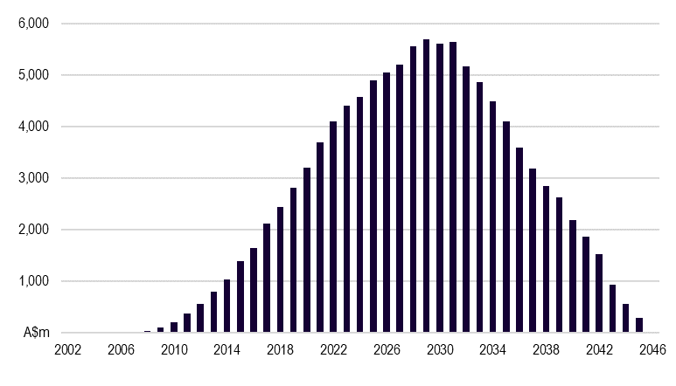
Source: ACIL Allen estimates.

The total estimated direct benefits by ANZSIC industry are summarised in Table 3.8. The agriculture, forestry and fisheries sector is expected to receive the highest benefits (23%), followed by the manufacturing sector (19%), health care and social assistance (16%) and information media and telecommunications (9%).
Table 3.8 Total estimated direct productivity benefits by ANZSIC sector 2002-2046
ANZSIC industry | Estimated benefits (A$m),  nominal prices | Percent of total benefits
Agriculture, Forestry and Fishing | 25,585 | 23.4%
Mining | 8,656 | 7.9%
Manufacturing | 20,545 | 18.8%
Electricity, Gas, Water and Waste Services | 6,769 | 6.2%
Construction | 4,087 | 3.7%
Wholesale Trade | 1,159 | 1.1%
Retail Trade | 966 | 0.9%
Accommodation and Food Services | 582 | 0.5%
Transport, Postal and Warehousing | 3,066 | 2.8%
Information Media and Telecommunications | 10,064 | 9.2%
Financial and Insurance Services | 1,205 | 1.1%
Rental, Hiring and Real Estate Services | 418 | 0.4%
Professional, Scientific and Technical Services | 461 | 0.4%
Administrative and Support Services | 418 | 0.4%
Public Administration and Safety | 2,574 | 2.3%
Education and Training | 2,499 | 2.3%
Health Care and Social Assistance | 17,446 | 15.9%
Arts and Recreation Services | 2,669 | 2.4%
Other Services | 386 | 0.4%
TOTAL | 109,556 | 100%
Source: ACIL Allen estimates.
The projected changes in real income associated with the ARC’s research investments are shown in the main report (section 2.1.3). Overall, the pattern of changes in income is similar to the pattern of changes in output, but income gains are slightly lower than the change in economic output. This is because the productivity improvements associated with the ARC research investments result in a fall in the prices of many key Australian export commodities while foreign prices are largely unaffected, thereby resulting in a reduction in Australia’s terms of trade relative to the Base Case (as shown in Table 3.6). This effect is to be expected, reflecting the transfer of benefits between producers and consumers, with some of the benefits going to foreign consumers.
Figure 3.6 Estimated change in cumulative real income over 2002–2046 associated with ARC grants awarded between 2002 and 2021, relative to the Base Case (2022$) by broad component
Is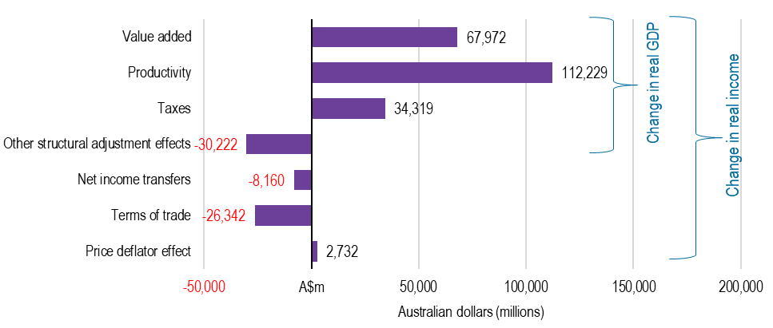
Source: ACIL Allen.

Tasman Global
Tasman Global is a dynamic, global CGE model that has been developed by ACIL Allen for the purpose of undertaking economic impact analysis at the regional, state, national and global level.
A CGE model captures the interlinkages between the markets of all commodities and factors, taking into account resource constraints, to find a simultaneous equilibrium in all markets. A global CGE model extends this interdependence of the markets across world regions and finds simultaneous equilibrium globally. A dynamic model adds onto this the interconnection of equilibrium economies across time periods. For example, investments made today are going to determine the capital stocks of tomorrow and hence future equilibrium outcomes depend on today’s equilibrium outcome, and so on.
A dynamic global CGE model, such as Tasman Global, has the capability of addressing total, sectoral, spatial and temporal efficiency of resource allocation as it connects markets globally and over time. Being a recursively dynamic model, however, its ability to address temporal issues is limited. In particular, Tasman Global cannot typically address issues requiring partial or perfect foresight. However, as documented in Jakeman et al (2001), it is possible to introduce partial or perfect foresight in certain markets using algorithmic approaches. Notwithstanding this, the model does have the capability to project the economic impacts over time of given changes in policies, tastes and technologies in any region of the world economy on all sectors and agents of all regions of the world economy.
Tasman Global was developed from the 2001 version of the Global Trade and Environment Model (GTEM) developed by ABARE (Pant 2007) and has been evolving ever since. In turn, GTEM was developed out of the MEGABARE model, which contained significant advancements over the Global Trade Analysis Project (GTAP) model of that time.

A dynamic model
Tasman Global is a model that estimates relationships between variables at different points in time. This is in contrast to comparative static models, which compare two equilibriums (one before an economic disturbance and one following). A dynamic model such as Tasman Global is beneficial when analysing issues for which both the timing of and the adjustment path that economies follow are relevant in the analysis.

The database
A key advantage of Tasman Global is the level of detail in the database underpinning the model. The database is derived from the GTAP database. This database is a fully documented, publicly available global data base which contains complete bilateral trade information, transport and protection linkages among regions for all GTAP commodities. It is the most detailed database of its type in the world.
Tasman Global builds on the GTAP database by adding the following important features:
- a detailed population and labour market database
- detailed technology representation within key industries (such as electricity generation and iron and steel production)
- disaggregation of a range of major commodities including iron ore, bauxite, alumina, primary aluminium, brown coal, black coal and LNG
- the ability to repatriate labour and capital income
- explicit representation of the states and territories of Australia
- the capacity to represent multiple regions within states and territories of Australia explicitly.
Nominally, version 10.1 of the Tasman Global database divides the world economy into 153 regions (145 international regions plus the 8 states and territories of Australia) although in reality the regions are frequently disaggregated further. ACIL Allen regularly models Australian or international projects or policies at the regional level including at the or at the state/territory/provincial level for various countries.
The Tasman Global database also contains a wealth of sectoral detail currently identifying up to 76 industries (Table 4.1). The foundation of this information is the input-output tables that underpin the database. The input-output tables account for the distribution of industry production to satisfy industry and final demands.
Industry demands, so-called intermediate usage, are the demands from each industry for inputs. For example, electricity is an input into the production of communications. In other words, the communications industry uses electricity as an intermediate input.
Final demands are those made by households, governments, investors and foreigners (export demand). These final demands, as the name suggests, represent the demand for finished goods and services. To continue the example, electricity is used by households – their consumption of electricity is a final demand.
Each sector in the economy is typically assumed to produce one commodity, although in Tasman Global, the electricity, transport and iron and steel sectors are modelled using a ‘technology bundle’ approach. With this approach, different known production methods are used to generate a homogeneous output for the ‘technology bundle’ industry. For example, electricity can be generated using brown coal, black coal, petroleum, base load gas, peak load gas, nuclear, hydro, geothermal, biomass, wind, solar or other renewable based technologies – each of which has its own cost structure.
The other key feature of the database is that the cost structure of each industry is also represented in detail. Each industry purchases intermediate inputs (from domestic and imported sources) primary factors (labour, capital, land and natural resources) as well as paying taxes or receiving subsidies.
Table 4.1 Standard sectors in the Tasman Global CGE model
no | Name | no | Name
1 | Paddy rice | 39 | Diesel (incl. nonconventional diesel)
2 | Wheat | 40 | Other petroleum, coal products
3 | Cereal grains nec | 41 | Chemical, rubber, plastic products
4 | Vegetables, fruit, nuts | 42 | Iron ore
5 | Oil seeds | 43 | Bauxite
6 | Sugar cane, sugar beet | 44 | Mineral products nec
7 | Plant- based fibres | 45 | Ferrous metals
8 | Crops nec | 46 | Alumina
9 | Bovine cattle, sheep, goats, horses | 47 | Primary aluminium
10 | Pigs | 48 | Metals nec
11 | Animal products nec | 49 | Metal products
12 | Raw milk | 50 | Motor vehicle and parts
13 | Wool, silk worm cocoons | 51 | Transport equipment nec
14 | Forestry | 52 | Electronic equipment
15 | Fishing | 53 | Machinery and equipment nec
16 | Brown coal | 54 | Manufactures nec
17 | Black coal | 55 | Electricity generation
18 | Oil | 56 | Electricity transmission and distribution
19 | LNG | 57 | Gas manufacture, distribution
20 | Other natural gas | 58 | Water
21 | Minerals nec | 59 | Construction
22 | Bovine meat products | 60 | Trade
23 | Pig meat products | 61 | Road transport
24 | Meat products nec | 62 | Rail and pipeline transport
25 | Vegetables oils and fats | 63 | Water transport
26 | Dairy products | 64 | Air transport
27 | Processed rice | 65 | Transport nec
28 | Sugar | 66 | Warehousing and support activities
29 | Food products nec | 67
30 | Wine | 68 | Communication
31 | Beer | 69 | Financial services nec
32 | Spirits and RTDs | 70 | Insurance
33 | Other beverages and tobacco products | 71 | Business services nec
34 | Textiles | 72 | Recreational and other services
35 | Wearing apparel | 73 | Public Administration and Defence
36 | Leather products | 74 | Education
37 | Wood products | 75 | Human health and social work activities
38 | Paper products, publishing | 76 | Dwellings
Note: nec = not elsewhere classified.
Source: ACIL Allen

Model structure
Given its heritage, the structure of the Tasman Global model closely follows that of the GTAP and GTEM models and interested readers are encouraged to refer to the documentation of these models for more detail. In summary:
- The model divides the world into a variety of regions and international waters.
  - Each region is fully represented with its own ‘bottom-up’ social accounting matrix and could be a local community, an LGA, state, country or a group of countries. The number of regions in a given simulation depends on the database aggregation. Each region consists of households, a government with a tax system, production sectors, investors, traders and finance brokers.
  - ‘International waters’ are a hypothetical region in which global traders operate and use international shipping services to ship goods from one region to the other. It also houses an international finance ‘clearing house’ that pools global savings and allocates the fund to investors located in every region.
  - Each region has a ‘regional household’112F that collects all factor payments, taxes, net foreign borrowings, net repatriation of factor incomes due to foreign ownership and any net income from trading of emission permits.
- The income of the regional household is allocated across private consumption, government consumption and savings according to a Cobb-Douglas utility function, which, in practice, means that the share of income going to each component is assumed to remain constant in nominal terms.
- Private consumption of each commodity is determined by maximising utility subject to a Constant Difference of Elasticities (CDE) function which includes both price and income elasticities.
- Government consumption of each commodity is determined by maximising utility subject to a Cobb-Douglas utility function.
- Each region has n production sectors, each producing single products using various production functions where they aim to maximise profits (or minimise costs) and take all prices as given. The nature of the production functions chosen in the model means that producers exhibit constant returns to scale.
  - In general, each producer supplies consumption goods by combining an aggregate energy-primary factor bundle with other intermediate inputs and according to a Leontief production function (which in practice means that the quantity shares remain in fixed proportions). Within the aggregate energy-primary factor bundle, the individual energy commodities and primary factors are combined using a nested Constant Elasticity of Substitution (CES) production function, in which energy and primary factor aggregates substitute according to a CES function with the individual energy commodities and individual primary factors substituting with their respective aggregates according to further CES production functions.
  - Exceptions to the above include the electricity generation, iron and steel and road transport sectors. These sectors employ the ‘technology bundle’ approach developed by ABARE in which non-homogenous technologies are employed to produce a homogenous output with the choice of technology governed by minimising costs according to a modified Constant Ratios of Elasticities of Substitution, Homothetic (CRESH) production function. For example, electricity may be generated from a variety of technologies (including brown coal, black coal, gas, nuclear, hydro, solar etc.), iron and steel may be produced from blast furnace or electric arc technologies while road transport services may be supplied using a range of different vehicle technologies. The ‘modified-CRESH’ function differs from the traditional CRESH function by also imposing the condition that the quantity units are homogenous.
- There are four primary factors (land, labour, mobile capital and fixed capital). While labour and mobile capital are used by all production sectors, land is only used by agricultural sectors while fixed capital is typically employed in industries with natural resources (such as fishing, forestry and mining) or in selected industries built by ACIL Allen.
  - Land supply in each region is typically assumed to remain fixed through time with the allocation of land between sectors occurring to maximise returns subject to a Constant Elasticity of Transformation (CET) utility function.
  - Mobile capital accumulates as a result of net investment. It is implicitly assumed in Tasman Global that it takes one year for capital to be installed. Hence, supply of capital in the current period depends on the last year’s capital stock and investments made during the previous year.
  - Labour supply in each year is determined by endogenous changes in population, given participation rates and a given unemployment rate. In policy scenarios, the supply of labour is positively influenced by movements in the real wage rate governed by the elasticity of supply. For countries where sub-regions have been specified (such as Australia), migration between regions is induced by changes in relative real wages with the constraint that net interregional migration equals zero. For regions where the labour market has been disaggregated to include occupations, there is limited substitution allowed between occupations by individuals supplying labour (according to a CET utility function) and by firms demanding labour (according to a CES production function) based on movements in relative real wages.
  - The supply of fixed capital is given for each sector in each region.
The model has the option for these assumptions to be changed at the time of model application if alternative factor supply behaviours are considered more relevant.
- It is assumed that labour (by occupation) and mobile capital are fully mobile across production sectors implying that, in equilibrium, wage rates (by occupation) and rental rates on capital are equalised across all sectors within each region. To a lesser extent, labour and capital are mobile between regions through international financial investment and migration, but this sort of mobility is sluggish and does not equalise rates of return across regions.
- For most international regions, for each consumer (private, government, industries and the local investment sector), consumption goods can be sourced either from domestic or imported sources. In any country that has disaggregated regions (such as Australia), consumption goods can also be sourced from other intrastate or interstate regions. In all cases, the source of non-domestically produced consumption goods is determined by minimising costs subject to a CRESH utility function. Like most other CGE models, a CES demand function is used to model the relative demand for domestically produced commodities versus non-domestically produced commodities. The elasticities chosen for the CES and CRESH demand functions mean that consumers in each region have a higher preference for domestically produced commodities than non-domestic commodities and a higher preference for intrastate- or interstate-produced commodities than foreign commodities.
- The capital account in Tasman Global is open. Domestic savers in each region purchase ‘bonds’ in the global financial market through local ‘brokers’ while investors in each region sell bonds to the global financial market to raise investible funds. A flexible global interest rate clears the global financial market.
- It is assumed that regions may differ in their risk characteristics and policy configurations. As a result, rates of return on money invested in physical capital may differ between regions and therefore may be different from the global cost of funds. Any difference between the local rates of return on capital and the global cost of borrowing is treated as the result of the existence of a risk premium and policy imperfections in the international capital market. It is maintained that the equilibrium allocation of investment requires the equalisation of changes in (as opposed to the absolute levels of) rates of return over the base year rates of return.
- Any excess of investment over domestic savings in a given region causes an increase in the net debt of that region. It is assumed that debtors service the debt at the interest rate that clears the global financial market. Similarly, regions that are net savers gives rise to interest receipts from the global financial market at the same interest rate.
- Investment in each region is used by the regional investor to purchase a suite of intermediate goods according to a Leontief production function to construct capital stock with the regional investor cost minimising by choosing between domestic, interstate and imported sources of each intermediate good via the CRESH production function. The regional cost of creating new capital stock versus the local rates of return on mobile capital is what determines the regional rate of return on new investment.
- In equilibrium, exports of a good from one region to the rest of world are equal to the import demand for that good in the remaining regions. Together with the merchandise trade balance, the net payments on foreign debt add up to the current account balance. Tasman Global does not require that the current account be in balance every year. It allows the capital account to move in a compensatory direction to maintain the balance of payments. The exchange rate provides the flexibility to keep the balance of payments in balance.
- Detailed bilateral transport margins for every commodity are specified in the starting database. By default, the bilateral transport mode shares are assumed to be constant, with the supply of international transportation services by each region solved by a cost-minimising international trader according to a Cobb-Douglas demand function.
- Emissions of six anthropogenic greenhouse gases (namely, carbon dioxide, methane, nitrous oxide, HFCs, PFCs and SF₆) associated with economic activity are tracked in the model. Almost all sources and sectors are represented; emissions from agricultural residues and land-use change and forestry activities are not explicitly modelled but can be accounted for externally. Prices can be applied to emissions which are converted to industry-specific production taxes or commodity-specific sales taxes that impact on demand. Abatement technologies similar to those adopted in a report released by the Commonwealth Government (2008) are available and emission quotas can be set globally or by region along with allocation schemes that enable emissions to be traded between regions.
More detail regarding specific elements of the model structure is discussed in the following sections.

Population growth and labour supply
Population growth is an important determinant of economic growth through the supply of labour and the demand for final goods and services. Population growth for each region represented in the Tasman Global database is projected using ACIL Allen’s in-house demographic model. The demographic model projects how the population in each region grows and how age and gender composition changes over time and is an important tool for determining the changes in regional labour supply and total population over the projected period.
For each of region, the model projects the changes in age-specific birth, mortality and net migration rates by gender for 101 age cohorts (0-99 and 100+). The demographic model also projects changes in participation rates by gender by age for each region, and, when combined with the age and gender composition of the population, endogenously projects the future supply of labour in each region. Changes in life expectancy are a function of income per person as well as assumed technical progress on lowering mortality rates for a given income (for example, reducing malaria-related mortality through better medicines, education, governance etc.). Participation rates are a function of life expectancy as well as expected changes in higher education rates, fertility rates and changes in the work force as a share of the total population.
Labour supply is derived from the combination of the projected regional population by age by gender and regional participation rates by age by gender. Over the projected period labour supply in most developed economies is projected to grow slower than total population because of ageing population effects.
For the Australian states and territories, the projected aggregate labour supply from ACIL Allen’s demographic module is used as the base level potential workforce for the detailed Australian labour market module, which is described in the next section.

The Australian labour market
Tasman Global has a detailed representation of the Australian labour market which has been designed to capture:
- different occupations
- changes to participation rates (or average hours worked) due to changes in real wages
- changes to unemployment rates due to changes in labour demand
- limited substitution between occupations by the firms demanding labour and by the individuals supplying labour, and
- limited labour mobility between states and regions within each state.
Tasman Global recognises 97 different occupations within Australia – although the exact number of occupations depends on the aggregation. The firms that hire labour are provided with some limited scope to change between these 97 labour types as the relative real wage between them changes. Similarly, the individuals supplying labour have a limited ability to change occupations in response to the changing relative real wage between occupations. Finally, as the real wage for a given occupation rises in one state relative to other states, workers are given some ability to respond by shifting their location. The model produces results at the 97 3-digit Australian New Zealand Standard Classification of Occupations (ANZSCO) level which are presented in Table 4.2.
The labour market structure of Tasman Global is thus designed to capture the reality of labour markets in Australia, where supply and demand at the occupational level do adjust, but within limits.
Labour supply in Tasman Global is presented as a three-stage process:
- labour makes itself available to the workforce based on movements in the real wage and the unemployment rate
- labour chooses between occupations in a state based on relative real wages within the state
- labour of a given occupation chooses in which state to locate based on movements in the relative real wage for that occupation between states.
By default, Tasman Global, like all CGE models, assumes that markets clear. Therefore, overall, supply and demand for different occupations will equate (as is the case in other markets in the model).

Table 4.2 Occupations in the Tasman Global database, ANZSCO 3-digit level (minor groups)
ANZSCO code, Description | ANZSCO code, Description | ANZSCO code, Description
1. MANAGERS  111 Chief Executives, General Managers and Legislators  121 Farmers and Farm Managers  131 Advertising and Sales Managers  132 Business Administration Managers  133 Construction, Distribution and Production Managers  134 Education, Health and Welfare Services Managers  135 ICT Managers  139 Miscellaneous Specialist Managers  141 Accommodation and Hospitality Managers  142 Retail Managers  149 Miscellaneous Hospitality, Retail and Service Managers  2. PROFESSIONALS  211 Arts Professionals  212 Media Professionals  221 Accountants, Auditors and Company Secretaries  222 Financial Brokers and Dealers, and Investment Advisers  223 Human Resource and Training Professionals  224 Information and Organisation Professionals  225 Sales, Marketing and Public Relations Professionals  231 Air and Marine Transport Professionals  232 Architects, Designers, Planners and Surveyors  233 Engineering Professionals  234 Natural and Physical Science Professionals  241 School Teachers  242 Tertiary Education Teachers  249 Miscellaneous Education Professionals  251 Health Diagnostic and Promotion Professionals  252 Health Therapy Professionals  253 Medical Practitioners  254 Midwifery and Nursing Professionals  261 Business and Systems Analysts, and Programmers  262 Database and Systems Administrators, and ICT Security Specialists  263 ICT Network and Support Professionals  271 Legal Professionals  272 Social and Welfare Professionals | 3. TECHNICIANS & TRADES WORKERS  311 Agricultural, Medical and Science Technicians  312 Building and Engineering Technicians  313 ICT and Telecommunications Technicians  321 Automotive Electricians and Mechanics  322 Fabrication Engineering Trades Workers  323 Mechanical Engineering Trades Workers  324 Panel beaters, and Vehicle Body Builders, Trimmers and Painters  331 Bricklayers, and Carpenters and Joiners  332 Floor Finishers and Painting Trades Workers  333 Glaziers, Plasterers and Tilers  334 Plumbers  341 Electricians  342 Electronics and Telecommunications Trades Workers  351 Food Trades Workers  361 Animal Attendants and Trainers, and Shearers  362 Horticultural Trades Workers  391 Hairdressers  392 Printing Trades Workers  393 Textile, Clothing and Footwear Trades Workers  394 Wood Trades Workers  399 Miscellaneous Technicians and Trades Workers  4. COMMUNITY & PERSONAL SERVICE  411 Health and Welfare Support Workers  421 Child Carers  422 Education Aides  423 Personal Carers and Assistants  431 Hospitality Workers  441 Defence Force Members, Fire Fighters and Police  442 Prison and Security Officers  451 Personal Service and Travel Workers  452 Sports and Fitness Workers | 5. CLERICAL & ADMINISTRATIVE  511 Contract, Program and Project Administrators  512 Office and Practice Managers  521 Personal Assistants and Secretaries  531 General Clerks  532 Keyboard Operators  541 Call or Contact Centre Information Clerks  542 Receptionists  551 Accounting Clerks and Bookkeepers  552 Financial and Insurance Clerks  561 Clerical and Office Support Workers  591 Logistics Clerks  599 Miscellaneous Clerical and Administrative Workers  6. SALES WORKERS  611 Insurance Agents and Sales Representatives  612 Real Estate Sales Agents  621 Sales Assistants and Salespersons  631 Checkout Operators and Office Cashiers  639 Miscellaneous Sales Support Workers  7. MACHINERY OPERATORS & DRIVERS  711 Machine Operators  712 Stationary Plant Operators  721 Mobile Plant Operators  731 Automobile, Bus and Rail Drivers  732 Delivery Drivers  733 Truck Drivers  741 Storepersons  8. LABOURERS  811 Cleaners and Laundry Workers  821 Construction and Mining Labourers  831 Food Process Workers  832 Packers and Product Assemblers  839 Miscellaneous Factory Process Workers  841 Farm, Forestry and Garden Workers  851 Food Preparation Assistants  891 Freight Handlers and Shelf Fillers  899 Miscellaneous Labourers
Source: ABS (2009), ANZSCO – Australian and New Zealand Standard Classifications Of Occupations, First edition, Revision 1, ABS catalogue no. 1220.0.

The Tasman Global database includes a detailed representation of the Australian labour market that has been designed to capture the supply and demand for different skills and occupations by industry. To achieve this, the Australian workforce is characterised by detailed supply and demand matrices.
On the supply side, the Australian population is characterised by a five-dimensional matrix consisting of:
- 7 post-school qualification levels
- 12 main qualification fields of highest educational attainment
- 97 occupations
- 101 age groups (namely 0 to 99 and 100+)
- 2 genders.
The data for this matrix is measured in persons and was sourced from the ABS 2011 Census. As the skills elements of the database and model structure have not been used for this project, it will be ignored in this discussion.
The 97 occupations are those specified at the 3-digit level (or Minor Groups) under the ANZSCO (see Table 4.2).
On the demand side, each industry demands a particular mix of occupations. This matrix is specified in units of FTE jobs where an FTE employee works an average of 37.5 hours per week. Consistent with the labour supply matrix, the data for FTE jobs by occupation by industry was also sourced from the ABS 2011 Census and updated using the latest labour force statistics.
Matching the demand and supply side matrices means that there is the implicit assumption that the average hours per worker are constant, but it is noted that mathematically changes in participation rates have the same effect as changes in average hours worked.

Labour market model structure
In the model, the underlying growth of each industry in the Australian economy results in a growth in demand for a particular set of skills and occupations. In contrast, the supply of each set of skills and occupations in a given year is primarily driven by the underlying demographics of the resident population. This creates a market for each skill by occupation that (unless specified otherwise) needs to clear at the start and end of each time period.113F The labour markets clear by a combination of different prices (i.e. wages) for each labour type and by allowing a range of demand and supply substitution possibilities, including:
- changes in firms’ demand for labour driven by changes in the underlying production technology
  - for technology bundle industries (electricity, iron and steel and road transportation) this occurs due to changes between explicitly identified alternative technologies
  - for non-technology bundle industries this includes substitution between factors (such as labour for capital) or energy for factors
- changes to participation rates (or average hours worked) due to changes in real wages
- changes in the occupations of a person due to changes in relative real wages
- substitution between occupations by the firms demanding labour due to changes in the relative costs
- changes to unemployment rates due to changes in labour demand, and
- limited labour mobility between states due to changes in relative real wages.
All of the labour supply substitution functions are modified-CET functions in which people supply their skills, occupation and rates of participation as a positive function of relative wages. However, unlike a standard CET (or CES) function, the functions are ‘modified’ to enforce an additional constraint that the number of people is maintained before and after substitution.
Although technically solved simultaneously, the labour market in Tasman Global can be thought of as a 5-stage process:
- labour makes itself available to the workforce based on movements in the real wage (that is, it actively participates with a certain number of average hours worked per week)
- the age, gender and occupations of the underlying population combined with the participation rate by gender by age implies a given supply of labour (the potentially available workforce)
- a portion of the potentially available workforce is unemployed, implying a given available labour force
- labour chooses to move between occupations based on relative real wages
- industries alter their demands for labour as a whole and for specific occupations based on the relative cost of labour to other inputs and the relative cost of each occupation.
By default, Tasman Global, like all CGE models, assumes that markets clear at the start and end of each period. Therefore, overall, supply and demand for different occupations will equate (as is the case in other markets in the model). In principle, (subject to zero starting values) people of any age and gender can move between any of the 97 occupations while industries can produce their output with any mix of occupations. However, in practice the combination of the initial database, the functional forms, low elasticities and moderate changes in relative prices for skills, occupations etc. means that there is only low to moderate change induced by these functions. The changes are sufficient to clear the markets, but not enough to radically change the structure of the workforce in the timeframe of this analysis.
Factor-factor substitution elasticities in non-technology bundle industries are industry specific and are the same as those specified in the GTAP database115F, while the fuel-factor and technology bundle elasticities are the same as those specified in GTEM.116F The detailed labour market elasticities are ACIL Allen assumptions, previously calibrated in the context of the model framework to replicate the historical change in the observed Australian labour market over a five year period117F. The unemployment rate function in the policy scenarios is a non-linear function of the change in the labour demand relative to the base case with the elasticity being a function of the unemployment rate (that is, the lower the unemployment rate the lower the elasticity and the higher the unemployment rate the higher the elasticity).

Stakeholder consultation methodology

Stakeholders consulted
Table 5.1 lists the stakeholders consulted for the evaluation. A total of 17 stakeholders were consulted. Notes were recorded during interviews to enable qualitative thematic analysis. Interviewees were provided with a discussion guide.
Table 5.1 Stakeholders consulted
Stakeholder group | Number of stakeholders
Domestic stakeholders
Australian Department of Education | 2
Australian Council of Learned Academies | 2
Australian Technology Network of Universities | 2
Group of Eight | 2
Regional Universities Network | 2
Universities Australia | 3
International stakeholders
Horizon Europe, European Commission (Horizon Europe) - Impact Monitoring, Research and Innovation | 1
Science Foundation Ireland (SFI) - Strategy and Transformation | 1
United Kingdom Research and Innovation (UKRI) - Evaluation and Performance | 1
New Zealand Ministry of Business, Innovation and Employment (MBIE) | 1
Source: ACIL Allen

Domestic stakeholder consultation themes
This chapter identifies the key themes from consultation with Australia’s university and research peak bodies (referred to as domestic stakeholders). Stakeholders were consulted from the following organisations:
- Australian Technology Network of Universities (ATN)
- Universities Australia (UA)
- Regional Universities Network (RUN)
- Group of Eight (Go8)
- Australian Council of Learned Academies (ACOLA)
- Australian Department of Education.
The themes below align with the discussion guide, which also aligns with the evaluation framework.

Stakeholder perception about the outcomes and impacts of ARC-funded research

Delivering outcomes and impacts
Domestic stakeholders were asked to comment on the extent to which NCGP-funded research is delivering outcomes and impacts.
While the stakeholders considered that NCGP-funded research was undoubtedly delivering impact at an aggregate level, the breadth and depth of impact generated across the number of member universities, the multitude of research projects funded, and the breadth of research disciplines covered by the funding made it difficult for stakeholders to comment on impact.
Stakeholders could provide specific examples of impacts arising from their own institutions’ work but struggled to meaningfully articulate the nature of the outcomes and impacts (i.e. intended or unintended; economic, environmental, social, cultural, and/or other) at a system-wide or economy-wide level. This is not a criticism of the stakeholders consulted; instead, it reflects the broad extent of impact arising ARC-funded research over the past two decades.

Lag time to and duration of impact
Domestic stakeholders provided feedback on the lag time and impact duration. All domestic stakeholders found this challenging to distil into a single timeframe, citing wide variation in research discipline, maturity (i.e. whether the research was basic or applied, and the Technology Readiness Level (TRL)) the likelihood of the funded research succeeding (i.e. achieving intended or unintended outcomes and impacts), and the prevailing policy, economic, environmental and social conditions that shape research.
Several domestic stakeholders considered that the ARC's core or primary purpose was to fund basic or blue sky research that did not intend to or have a guaranteed likelihood of delivering outcomes or impacts in the immediate or foreseeable future. This is research that would not otherwise attract funding from other sources but is critical to the nation’s stock of knowledge or the development and maintenance of a foundational domestic research capability. For example, one domestic stakeholder cited the Frascati Manual 2015’s definition of pure basic research as:
Pure basic research is carried out for the advancement of knowledge, without seeking economic or social benefits or making an active effort to apply the results to practical problems or to transfer the results to sectors responsible for their application.
As such, these domestic stakeholders considered that the timeframes to achieving impact from ARC-funded research were highly unpredictable and, more often than not, lengthy. Impact could arise decades after the research was conducted and occur in a range of disciplines, not necessarily in the initial field of research. The impacts were also likely to be broad and not necessarily generate a market return that could be quantified in the near future or within a timeframe that can be attributed (with some degree of certainty) to the research funding. Stakeholders suggested that research could also deliver impact through a series of projects that build on the initial knowledge before the impact could be observed. This creates further challenges for attribution of impact.
One domestic stakeholder provided several project examples from the ARC’s 2018 Engagement and Impact case studies. They noted that in many examples, the pathway to impact was complex and much longer than 5 years.
When prompted with a specific example, domestic stakeholders who commented considered that shorter time frames, such as 3 years for Linkage Program and 5 years for Discovery Program were not credible or realistic.

Key beneficiaries/end-users
Domestic stakeholders considered that the research's beneficiaries and end-users were broad and included the government, research, industry, business and non-profit sectors. This feedback is unsurprising but is once again a consequence of the broad nature of the research conducted by Australian universities in partnership with many other organisations.
Further, most domestic stakeholders did not have good visibility over the extent to which end-users were directly involved in projects, nor the extent to which their involvement influenced research impact pathways. Some domestic stakeholders provided specific examples of end-user involvement:
- ATN has a long history of mission-based work, with all research community-aligned. Community stakeholders are also often involved in research projects and support the achievement of community-focused impacts.
- RUN, on average, tends to conduct more applied research, which specifically seeks to address the challenges of regional communities and their surrounds. As such, end-users are typically located more closely to the regional university campuses and are more involved in research projects.
- ACOLA and its members are funded through the ARC’s Supporting Responses to Commonwealth Science Priorities scheme or Linkage Learned Academies Special Projects to undertake policy and strategic research projects. These projects are primarily directed at informing policy decision making and primarily support government, industry and academic end-users.
One domestic stakeholder identified challenges with securing community participation in university research. While efforts are being made at the university level to improve relationships and participation levels, this can be challenging to secure due to the long-term nature of some research (particularly discovery research), which does not always align with more immediate needs and issues impacting communities.
In short, most domestic stakeholders consulted believed that end-user perspectives about the value of ARC-funded research are only meaningful at the project level.

Alignment with priorities
Domestic stakeholders were asked to comment on the extent to which the outcomes and impacts delivered by the NCGP align with Australian Government priorities and whether seeking to align research with Australian Government priorities affects the delivery of outcomes and impacts from NCGP-funded research.
When addressing these questions, domestic stakeholders most commonly commented on Australia’s Science and Research Priorities while referencing other government priorities.

Application of priorities at a strategic level
All domestic stakeholders saw a strategic role for the Australian Government in identifying areas of focus and signalling Australia’s critical needs. The requirement to articulate these needs is seen as particularly important in a country like Australia, which has a relatively small research sector and funding envelope.
Government priorities are also important signals universities and industry can use to plan for future activity and investment. One domestic stakeholder noted that these priorities should be aligned with our strengths and areas of international competitiveness to generate funding and capability leverage opportunities. One domestic stakeholder used the example of prioritising research translation as a way of investment signalling by Commonwealth, state and territory governments for greater research translation and adoption.
Two domestic stakeholders identified the National Manufacturing Priorities and National Reconstruction Fund priorities as examples of priorities that have guided research activity. However, they noted that, in particular, the National Manufacturing Priorities were intentionally narrow in focus relative to the breadth of research that was funded under the ARC and potentially misaligned with the core intent of basic research.
Domestic stakeholders considered that government priorities should be broad and flexible and applied only to particular types of research. Most considered that discovery research should not be required to align with national priorities, as it should be ‘blue sky’ and investigator-driven. This aligns with the Haldane Principle, as mentioned by a stakeholder, which states that “decisions about which research projects to fund should be made through independent evaluation by experts, based on the quality and likely impact of that research”.
The rationale for this perspective varied across domestic stakeholders, with some noting that discovery research outcomes are challenging to predict and can vary widely from those initially proposed. Another domestic stakeholder noted that discovery research outcomes could arise many decades after the initial grant funding, when priorities may have changed.
Domestic stakeholders identified a stronger role for government priorities in guiding more applied research (i.e. higher up the TRL scale, and Linkage funding) and mission-based work (as occurs internationally). This could also extend to start-ups, industry organisations and small-medium enterprises (SMEs). As the research becomes more applied, other government and industry organisations, such as Research and Development Corporations (i.e. the Rural RDCs) and Public Research Organisations (i.e. CSIRO), can play a role in investing.

Application of priorities at the project level
ARC schemes do not require applicants to align their research with Australia’s Science and Research Priorities. However, the Industrial Transformation Research Program requires alignment with the current Industrial Transformation Priorities that are identified by the ARC from a range of strategic government priorities. Some domestic stakeholders considered that the priorities are too broad, encompassing a range of research and, therefore, do not drive a strong focus for individual research projects funded under these schemes, nor the outcomes and impacts achieved. This is because projects can generally be crafted to align with preferred priorities while avoiding contentious areas of research. Further, one domestic stakeholder noted that some of the most impactful research they had observed arose outside the priorities. According to some stakeholders, seeking to align research with Australian Government priorities does not deliver impact aligned with the priorities at the project level.

Timeframes for reviewing priorities
To effectively drive research, domestic stakeholders wanted a balance between current and frequently reviewed/refreshed priorities and the need for stability and consistency. For example, a few domestic stakeholders considered that priorities broadly within the Commonwealth, State and Territory Governments change too frequently, which can create hesitancy in university and industry investment decisions.
Many considered it had been too long since Australia’s Science and Research Priorities were last updated, 7 years since they were introduced in 2015. This was considered too infrequent.
All welcomed the current review, which was considered necessary for signalling the importance of the priorities, driving funding decisions, and better aligning with Australia’s current policy and program setting. For example, one stakeholder considered that the priorities did not reflect the Medical Research Future Fund (MRFF), which was introduced after the release of the priorities. The MRFF is a $20 billion long-term investment supporting Australian health and medical research that has reshaped the research funding landscape.

Value of NCGP funding

Benefits and costs of research funding
In general, domestic stakeholders did not have visibility over the extent to which the benefits of the NCGP outweighed its costs. Only one domestic stakeholder commented on this, noting that the benefits outweigh the costs on a system-wide level, but they did not have strong evidence to back this up. Half of the peak bodies consulted discussed the results of benefits assessment exercises conducted in Australia and overseas. A proportion of these stakeholders believed these benefits have been overstated in the past. They caution against using overly optimistic assumptions when calculating the benefits of NCGP. One domestic stakeholder even went as far as to say that a ratio of $1 (funding): ~$3 (economic benefit) was a credible estimate for research funded by the NCGP.
However, at a project level, many domestic stakeholders consulted saw the administrative costs of applying for and reporting on research funding as disproportionate to the value of the grants received. They encouraged ARC to continue reducing the effort required to participate in competitive grant programs (especially reporting outcomes and the use of grant funding).

Factors supporting the delivery of impacts
Domestic stakeholders identified various factors that support the delivery of outcomes and impacts from NCGP-funded research. These included financial support through grants for basic and applied research, funding for career development, and general support for the sector through outreach and engagement with universities. These factors were only discussed at a high level owing to the large range of impact drivers across the NCGP.
Domestic stakeholders identified the opportunity for the ARC to support better the delivery of outcomes and impacts from NCGP-funded research. These included advocating more to Government on the value of research, better focusing the translation of research into impacts by engaging more with policy experts, industry and governments, and guiding funding in areas where impacts are needed and likely to be delivered.

Contribution of ARC funding to impacts
ARC funding contributes to the delivery of impacts from university research within the Australian innovation system by funding basic and applied research and research capacity building through training and career development. Domestic stakeholders spoke highly of the value and necessity of ARC funding in the innovation ecosystem. ARC funding was seen to have a specific role in the innovation system and to fund specific purposes and activities that are not supported by other funding sources. Domestic stakeholders also spoke of the importance of ARC allocating funding based on research and researcher excellence and merit to support the delivery of impacts, particularly given the small relative size of the available research funding.
One domestic stakeholder also spoke of the need for ARC to fund a critical mass of research to enable outcomes and impacts to emerge. They noted that ARC funding was distributed too thinly and that not enough was invested in specific areas of research to generate impacts (noting that fewer areas should be funded overall). This strategic policy question will generate some winners and losers within the research sector if there are fundamental changes to the way ARC funding is distributed.

Role of non-ARC funding sources
Domestic stakeholders identified gaps in the type of research funded by ARC. This was particularly the case for non-project costs (e.g. administration, infrastructure, research training), some project costs that were not funded by ARC (i.e. where the full costs of a proposed grant were not awarded) and for the breadth of research needed across the translation pathway (particularly for TRLs 4-7).
Domestic stakeholders identified recent publications that showed the costs of university research as funded by universities, government and other sources.
“The two main sources of funds for HERD [higher education expenditure on research and development] in 2018 were general university funds ($6,823 million, or 56% of HERD) and Australian Government competitive grants ($1,700 million, or 14% of HERD).”
“In 2018 (latest available figures) the Go8 spent a total of $6.5 billion on research. Thirty-six% of this was funded directly from the Commonwealth Government and 48% from General University Funds – the latter largely from international student fees.”
“The support needed for completing government research projects from energy costs and building maintenance to technicians, librarians and other professional support is now only 18 cents in each dollar of external research funding earned by Australian universities.”
As such, they saw an important role for non-ARC funding sources in progressing research along pathways to impact. These non-ARC funding sources supplemented research that received ARC funding and addressed other gaps in the innovation ecosystem beyond ARC’s remit.
Universities support both ARC-funded and non-ARC-funded research based on the individual university’s priorities, needs and/or researcher merit. Universities also fund administrative and other research-related activities or costs that are not typically covered by ARC funding or other funding sources. This creates an uneven playing field for universities and impacts the extent to which they can support priority-driven research and ARC-funded research. Some domestic stakeholders called for further ARC support for unfunded costs.
Private investment was critical in supporting later-stage, applied and market-ready research. This is either in support of ARC funding, through co-contributions as part of Linkage Projects, or as separate funding arrangements to progress research application, translation and commercialisation (e.g. taking a product or service to market).
Domestic stakeholders identified several other government funding bodies and schemes as innovation ecosystem supports. For example, Research Block Grants fund eligible Australian higher education providers to support research, research training and the indirect cost of research, the National Health and Medical Research Council (NHMRC) and Medical Research Future Fund support health-based research, and the National Collaborative Research Infrastructure Strategy (NCRIS) supports research infrastructure.
Domestic stakeholders identified several schemes that have emerged in recent years to fill additional gaps in the innovation ecosystem, including:
- Australian Government’s $362.5 million 4-year (2022-23 to 2025-26) Trailblazer Universities Program, which aims to build new research capabilities, drive commercialisation outcomes and invest in new industry engagement opportunities
- Australian Government’s $1.6 billion Australia’s Economic Accelerator program, which is fostering the translation and commercialisation of research aligned with national research priorities from discovery through to commercialisation
State and Territory Governments also operate various funds and hubs. These include, for example, the NSW Commercialisation Pathways Program and Innovation Research Acceleration Program, Breakthrough Victoria, and the South Australian Research and Innovation Fund. These typically operate at higher TRLs and aim to progress State/Territory priorities and bring research to market.
Lessons from the case studies show that philanthropic organisations typically support smaller-scale and priority-driven research.

Counterfactual
Domestic stakeholders were asked to comment on whether the research outcomes and impacts achieved through ARC-funded research can be attributed to the NCGP and if they would have been achieved without the NCGP.
Domestic stakeholders considered the NCGP to be a significant part of the innovation ecosystem, with funding directed to activities that would be challenging to fund through other sources.
“The funding is critical to the Australian research system – it is the only funding scheme of any size that funds basic research outside of health and medical research. Without this, the system would be under severe pressure and be significantly diminished.”
“This would be a huge issue if it [NCGP funding] was removed, and have a big impact on universities.”
However, some found this question challenging to answer as they believed it unrealistic that the funding, if not available through the NCGP, would simply be removed from the innovation ecosystem. They considered it more likely that another funding body would distribute similar funds for a similar purpose or that other funding would emerge to fill the gap. As such, as long as the quantum of funding remained available to researchers and universities, there would be negligible impact on research.
“If ARC was withdrawn immediately, it would be catastrophic. If there was a slow decline in funding, then it’s different. Alternative funding sources would emerge and it would be easier to manage.”
If funding were to decrease or be removed, domestic stakeholders considered that the capacity of Australian research to support economic, environmental, social and other impacts would depend on the extent to which other funding sources filled the gap. Some research would likely not be funded at all, and other research would be funded through different sources (e.g. other government schemes, industry, philanthropy).
One domestic stakeholder noted that the nature of the funding source would likely guide any research funded by these sources; for example, industry may require more applied, priority-driven and near-to-market research. As such, basic research (widely considered the funding responsibility of ARC or other government bodies) may be funded to a lesser extent.
One domestic stakeholder also highlighted the important role of ARC in enabling a connected and wholistic conversation about research in Australia. Without ARC, they considered that there would be duplication in the investment in research and research infrastructure and added complexity in the system. Further, programs like the university block grants would continue to play an important role in early researcher training. However, capability development for later-stage researchers, which is mainly funded through the NCGP, would be less certain.
If the funding were to increase, the nature and scale of impacts would depend on where this funding was directed. Domestic stakeholders highlighted a range of ways in which additional research funding could be used to deliver impacts, including providing greater equality in the way funding is distributed to universities (i.e. to smaller and regional universities), better connecting the research training system to boost workforce development, and longer duration grants to provide greater certainty to researchers and improve the efficiency and outcomes of the research. However, one domestic stakeholder noted that the relationship between funding and impacts is not linear and “benefits would not double with double the investment”.

Improving the delivery of research impacts and ongoing impact assessment

ARC’s support for research
The NCGP uses a range of mechanisms across funding application, assessment and reporting processes to support the delivery of research impact as outlined in Box 6.1.
Box 6.1 Mechanisms the NCGP uses to support research impact
Current mechanisms used under the NCGP to support research impact include:
- support for both basic and applied research
- intended outcomes across most Discovery/Linkage Program schemes, which highlight the delivery of benefit/impact as a key long-term aim for ARC-funded research
- requiring/encouraging collaboration with end-users, particularly through the Linkage Program
- assessment criteria across most NCGP scheme Grant Guidelines relating to the delivery (or potential delivery) of economic, commercial, environmental, social and/or cultural benefit
- the inclusion of research impact as a form of performance evidence under the Research Opportunity and Performance Evidence Statement
- the National Interest Test, which asks applicants to demonstrate the societal benefits (economic, commercial, environmental, social, or cultural) of the proposed research beyond the academic community
- encouraging researchers to address Australian Government research priority areas
- reporting in Final Reports relating to:
  - the kind of benefits delivered
  - the actual/expected timeframe for the delivery of benefit
  - the stakeholders who will benefit
  - outcomes achieved from the perspective of Partner Organisations – who may represent industry, government, non-profit, international and/or other sectors.
Source: ARC
Domestic stakeholders did not have much visibility of these mechanisms. When they were identified, some considered the mechanisms to be a mix of requirements for applicants and funded researchers and statements of purpose of ARC funding rather than supports.
Two domestic stakeholders commented on the value of the ARC, requiring researchers to submit a research impact statement as part of their application and inclusion of assessment criteria related to benefits. This provided an opportunity for greater reflection and thought on the intended outcomes and impacts and enabled future reporting on the extent to which these were realised.
Domestic stakeholders did not have visibility of how the ARC’s support for delivering impact compares with other funding agencies nationally and internationally.
Domestic stakeholders need to consult their members on any specific changes to the supports or processes before they can provide meaningful feedback on what works, what does not, and potential alternative arrangements.

Measuring research impact
Domestic stakeholders were asked to reflect on measuring outcomes and impacts from NCGP-funded research and any lessons from their own experiences measuring outcomes and impacts.
Many domestic stakeholders did not have a specific or detailed view of the appropriate measures and metrics of research impact, the data and information sources that could be used/collected, or the appropriate tools or techniques to collect data. They noted that many Australian universities were currently considering how to best capture and measure impact and were at varying stages of impact measurement maturity.
As such, most of the domestic stakeholders have not had internal discussions or discussions with university members to develop a formal position on how to measure impact. They were willing to react and respond to impact measurement propositions at a general level but directed further engagement (particularly around any amendments to processes) to their member universities for specifics.
However, the consultations did identify broad, high-level principles for impact measurement. As follows, impact measurement should:
- balance the overarching impact story (e.g. portfolio wide-assessment) with evidence of individual project-level success (e.g. case studies)
- capture the breadth of research disciplines, impact types and end-users
- be accompanied by guiding principles, clear and consistent definitions, metrics and measurement approaches, with the potential for ARC to support education and upskilling across universities and researchers to ensure consistent data is collected
- consider the lag time between the research taking place and the impacts being delivered, and ideally track impacts longitudinally
- reduce the burden on universities and researchers to provide/collect data by:
  - seeking to build on, replace or repurpose existing reporting processes conducted by universities or the ARC
  - consider the requirements for data collection rigour and frequency
  - collect data few times that can be used multiple times for multiple purposes
- be conducted independently, with a cross-disciplinary review of research outcomes and impacts to enable greater reflection on success
- occur ideally every 5-10 years
- extend beyond a compliance exercise by having a clear purpose, strategically aligning with government priorities and information needs, and meaningfully driving decision-making (rather than being a simple compliance exercise) to encourage researcher and university engagement and deliver value for the financial and resource cost associated with measurement.
Case studies were commonly identified as a way to capture the breadth of impacts delivered through NCGP-funded research. This was particularly the case for social, environmental and cultural impacts that may not be as readily quantified or contribute to a quantifiable market or economic return. Case studies were valued for the flexibility they provide researchers to demonstrate research impact in a bespoke manner.

Appropriate tools or techniques
Domestic stakeholders presented mixed views on the appropriate tools and techniques for measuring impact. As noted in section 6.4.2, they considered that measurement should focus on both portfolio-wide and project-level assessment and seek to capture the breadth of research disciplines, impact types and end-users.
“Our universities want to move away from only using economic assessments.” – Domestic stakeholder
Domestic stakeholders that commented on impact measurement metrics considered that measurement should both systematise and automate the capture and reporting of simple measures (e.g. citations and downloads) and seek to capture impacts that move beyond these simple measures. This could seek to measure progress toward achieving the research’s intended outcomes and impacts.
“If you are going to get researchers to identify intended outcomes/impacts, then this needs to be more explicitly built into the process with a timeframe for coming back to check.” – Domestic stakeholder
One example was identified for research across a number of Australian universities: the Excellence in Innovation for Australia Trial (the Trial). The Trial was conducted in 2012 to measure the innovation dividend of research generated by Australian universities and as a potential companion to Excellence in Research for Australia (ERA) in determining the allocation of research funding. It aimed to improve how universities articulate and communicate research impact to the broader community and highlight the need to collaborate better with industry to drive innovation.
Go8, Australian Technology Network, the University of Tasmania, Charles Darwin University and the University of Newcastle used a case study-based approach to measuring impact. This was preferred to traditional university research metrics (e.g. citations), as the focus was on establishing the external impact for Australia. 162 research case studies were submitted and assessed according to Socio-economic Objectives (SEO). Panels (with 70% industry members) were established to assess the impact value of the case studies. The case studies were required to focus on impact occurring in the last 5 years, from research conducted either during the impact period, or in the 15-years before the impact emerged.
The Trial was broadly successful and highlighted the breadth of compelling stories emerging from university research. Using case studies and SEOs was found to be a strong approach. It enabled the research to be communicated to a range of audiences, highlighted the variation in the type of research impact and its classification to more than one SEO code, and enabled assessment by industry-based/end-user panels. The extent of impact and the quality of the case studies varied substantially, and many drew on prospective (not realised) impact. The case study review process was also found to be highly burdensome and likely to be challenging to scale.
One domestic stakeholder considered that there was value in measuring research impact using case studies, noting that this needed to balance the burden placed on universities and researchers and be considered in the broader context of assessment activities (i.e. ERA, EI).
Several domestic stakeholders identified benefit in better linking excellence assessments with impact, for example, to select impact assessment case studies of the excellent research. This could more clearly demonstrate the benefits of the research and that these benefits could cover the cost of the entire program in any given period.

Timing to measure impact
As noted in section 6.1.2, domestic stakeholders did not present a clear position on when impact emerged and could be observed and measured.
Some domestic stakeholders commented on the frequency of measuring impacts. As noted in section 6.4.2, they considered that impact should be measured more frequently than has occurred for NCGP-funded research, ideally with a portfolio-wide assessment every 5-10 years. This could also look to conduct smaller scheme-specific assessments more frequently, in line with the approach used by Science Foundation Ireland (see section 7.5.3).
One domestic stakeholder considered that the measurement frequency might also depend on the purpose of the measurement and the use of the findings:
“If we’re trying to raise the profile of research and the rationale for spending funding on research, then the preference is for a shorter timeframe to ensure it remains on the top of people’s mind and is still relevant.” – Domestic stakeholder

Communication of impacts
Domestic stakeholders were asked to comment on how the ARC’s communication of NCGP-funded research outcomes and impacts could be improved. Domestic stakeholders generally commented on the ARC’s communication with researchers, universities, government, and the general public. They presented mixed views on the extent to which the ARC communicated well about the outcomes and impacts of its funded research.
Some noted that ARC’s communications with universities have improved in recent years and that they were timely and scheduled. Two domestic stakeholders did not have good visibility of the outcomes and impacts generated, which was attributed to limited reporting or communication from ARC.
“Given the ARC is the primary funder of research, they should do more to talk about the outcomes and impacts of research to government so that it is better recognised as important. If they collect data about the research, what are they doing with it?” – Domestic stakeholder
One domestic stakeholder considered that responsibility for communication of research outcomes and impacts were shared across ARC (with a focus on Government), peak bodies, universities and researchers (with a focus on researchers and the general public). For impacts that emerge long after the grant concludes (e.g. 10 years), the responsibility should rest with the university and researcher.
Some domestic stakeholders considered that the ARC could better communicate with the general public to ensure accountability for government funding and improve awareness and understanding of the value of research.
Some suggested improvements for ARC’s communication efforts include raising awareness of the ARC’s existing researcher and project databases so that government, industry and other end-users know what research is being undertaken and who is impactful in their area of interest. One example provided was GovHack, an annual international open government data competition held in Australia and New Zealand. This was identified as a useful mechanism for raising awareness of the Government’s open data sources and the value these can generate for end-users.

International stakeholder consultation themes
Four similar research, development and innovation funding initiatives were selected for comparison with ARC’s NCGP: UKRI, Horizon Europe, SFI and MBIE.
The ARC was compared against these initiatives, focusing on the:
- structure and logic of the funding, including the focus of the research
- funding amounts, required co-contributions and success rates
- outcomes and impacts from your funded research, including alignment with government priorities and involvement of end-users
- monitoring, analysing and reporting on outcomes and impacts.
This comparison aimed to understand better these initiatives and any lessons that can be applied to the ARC.
This chapter identifies the key themes emerging from consultation with relevant international stakeholders involved in evaluation and performance, impact monitoring and strategy, from comparator international organisations.
The themes below align with the discussion guide, which also aligns with the evaluation framework.

The ARC’s international comparators
While there are several similar research, development and innovation funding initiatives in other countries, 4 were selected for comparison with ARC’s NCGP, UKRI, Horizon Europe, SFI and MBIE.
The ARC was compared against these initiatives, focusing on the:
- structure and logic of the funding, including the focus of the research
- funding amounts, required co-contributions and success rates
- outcomes and impacts from your funded research, including alignment with government priorities and involvement of end-users
- monitoring, analysing and reporting on outcomes and impacts.
This comparison aimed to understand better these initiatives and any lessons that can be applied to the ARC.

Overview of comparator funding programs
A brief overview of each initiative is provided below.

United Kingdom Research and Innovation
UKRI is the UK’s largest provider of public R&D funding. UKRI was established in April 2018 to advance the country’s understanding of people and the world around us to deliver benefits to society, the economy and the environment. The organisation funds universities, researchers, businesses, NHS bodies, charities, NGOs, and other institutions.
UKRI is comprised of 9 Research Councils covering a diverse range of research areas, including art and humanities, biotechnology and biological sciences, economic and social research, and medical research. The Research Councils serve a key advisory role to its principal funding provider, the Department of Business, Energy and Industrial Strategy (BEIS), providing a mechanism for aligning the high-level strategic direction of a broad range of research organisations with the Government’s national strategic objectives. BEIS determines funding allocations across each Research Council. UKRI makes decisions on specific funding allocations to research projects and grants. Private sector co-investment provides additional funding for some research projects but does not directly fund UKRI itself.
UKRI was allocated £36.5 billion (AU$63.7 billion) from 2018-21 and £25.1 billion (AU$43.8 billion) from 2022-25. UKRI independently disburses close to £8 billion (AU$13.9 billion) every year, with about half of this funding allocated to 6 significant portfolios:
- Industrial Strategy Challenge Fund
- Global Challenges Research Fund
- Strategic Priorities Fund
- Strength in Places Fund
- Future Leaders Fellowships
- Fund for International Collaboration.
UKRI has 6 strategic objectives, grouped under the themes of world-class people and careers, places, ideas, innovation, impacts and organisation.

Horizon Europe
Horizon Europe is the European Union’s (EU) research and innovation funding program running from 2021-27. It is the 9th European framework for research and innovation funding and follows its predecessor program, Horizon 2020. Horizon Europe was created to:
- strengthen the EU’s knowledge base through frontier research
- spur breakthrough innovation and support the development and demonstration of innovative solutions
- restore industrial leadership and strategic autonomy.
Ultimately, the initiative aims to foster a collaborative and cross-sectoral European research and innovation ecosystem. It provides funding to universities through grants to researchers and collaborative projects with the scientific community, government and industry. It aims to support projects with a high economic, social and scientific impact. Additionally, Horizon Europe engages in co-funding partnerships with private and public organisations as part of an integrated approach to addressing major issues.
The European Union funds Horizon Europe to a value of €95.5 billion (AU$146.6 billion). Funding is guided by an overarching strategic framework centred around 3 vertical and one horizontal pillar, which provides funding to organisations and grant programs for researchers, particularly doctoral students. The pillars are:
- Excellent Science (€25 billion, AU$38.4 billion), which is divided between the European Research Council (€16 billion, AU$24.6 billion), Marie Skłodowska Curie Actions (€6.6 billion, AU$10.1 billion) and research infrastructure (€2.4 billion, AU$3.7 billion).
- Global Challenges and European Industrial Competitiveness (€53.5 billion, AU$82.1 billion). This pillar provides funding for 6 ‘clusters’ related to health (15% of funding), culture, creativity and inclusive societies (4%), civil security for society (3%), digital, industry and space (29%), climate, energy and mobility (28%), and food, bioeconomy, natural resources, agriculture and environment (17%).
- Innovative Europe (€13.6 billion, AU$20.9 billion, which is divided between the European Innovation Council and European innovation ecosystems (78% of funding) and the European Institute of Innovation and Technology (22%).
- Horizontal pillar: international cooperation (particularly newer EU countries) and fostering gender diversity.

Science Foundation Ireland
SFI is Ireland’s principal public funder of STEM research and innovation that supports the development and competitiveness of industry, enterprise and employment in Ireland. SFI was established in 2003 as a government agency and is currently overseen by the Department of Further and Higher Education, Research, Innovation and Science, which is its funding source. It provides funding to both individual-led and industry-facing research programs.
In 2021, SFI provided €227 million (AU$348 million) in funding for R&D, approximately one-quarter of national funding. SFI research projects attract considerable co-investment by external organisations, with €234 million (AU$359 million) secured in 2021 from non-exchequer sources (including €82 million from the European Union) and private enterprises (€164 million). Industry-facing projects have leveraged funding requirements.
SFI’s strategic framework is aligned with Ireland’s national science priorities and is designed to support the government’s ambitions outlined in its Innovation 2020 program. It identifies 2 core ambitions:
- Delivering today, with the following themes:
  - excellent research: the contribution of Ireland to breakthrough scientific discoveries
  - top talent: building, attracting and retaining the talent that drives innovation
  - tangible benefits: ensuring funding is committed to research that makes the most difference to society and the economy.
- Preparing for tomorrow, with the following themes:
  - a cohesive ecosystem: realising the potential of a co-operative research ecosystem
  - future skills: supporting opportunities and prosperity
  - anticipating what’s next: proactively identifying emerging areas of science and future challenges.
Expenditure is heavily oriented towards basic research, which accounts for 80% of funding (TRL 1-2), with half of funding to SFI Research Centres which perform Applied and Basic Combined research.
SFI has 16 research centres across Ireland (equivalent to the ARC Centres of Excellence), which account for 46% of funding. Investigator-led research projects account for 26% of funding, cohort-based doctoral student training 11%, and other activities 17%. Funding is disbursed through initiatives such as grants, partnership agreements, and prizes.

MBIE
The Ministry of Business, Innovation and Employment (MBIE) is the principal public funder of research and innovation in New Zealand. MBIE was established in 2012, and its purpose is to grow New Zealand for all. Research and innovation are funded by the ministry’s strategic framework and the National Statement of Science Investment (NSSI). MBIE’s strategic plan sets out 5 key outcomes, which are:
- prosperous and adaptable people, sectors and regions
- skilled people engaged in safe and fulfilling work
- informed consumers and businesses interacting with confidence
- value is sustainably derived from the natural environment
- a dynamic business environment fostering innovation and international connections.
NSSI has 2 main pillars: impact (real-world effects of research, particularly in relation to commercial application) and excellence (research quality, a key determinant of impact).
MBIE funds research and innovation through investment fund portfolios, which provide research grants, loans and contracts to researchers. The fund portfolios independently assess applications and allocate funding based on national science priorities. Funded portfolios include:

- Commercialisation Partner Network
- Catalyst Fund
- Covid-19 Innovation Acceleration Fund
- Curious Minds
- Endeavour Fund
- Envirolink Scheme
- Equity, Diversity and Inclusion Capability Fund
- MBIE Science Whitinga Fellowship
- National Science Challenges
- Partnerships
- PreSeed Accelerator Fund
- Regional Research Institutes Initiative
- Strategic Science Investment Fund
- Te Pūnaha Hihiko: Vision Mātauranga Capability Fund
- Marsden Fund
- Health Research Council.

Together, these funded portfolios were allocated approximately NZ$777.53 million (approximately AU$703.92 million) in 2022. The largest contestable research fund is the Endeavour Fund, which was allocated NZ$244 million (AU$223 million) over 5 years in 2021. This will be distributed through Smart Ideas over 3 years at NZ$18 million (AU$16.3 million) and Research Programmes over 5 years at NZ$39 million (AU$36 million). Other major portfolios include the Regional Research Institutes Initiative (NZ$65 million (AU$59 million) over 3 years), the Marsden Fund ($78.5 million (AU$72 million)) and the Strategic Science Investment Fund (NZ$322 million (AU$294 million) in 2022).

Overview of international comparators
An overview of each international comparator is provided in Table 7.1 and summarised below.

The research funding, success rates and recipients
The international comparators varied in the quantum of funding allocated annually. UKRI has provided £8.46 billion, Horizon Europe €15.91 billion, SFI €227 and MBIE $777.53 million (NZD) in recent years. This funding is comparable to the $800 million allocated per year through the NCGP.
Across the comparators, funding is broadly provided by an aligned government department or agency and allocated according to portfolio or pillar structures. Funding is provided to researchers, universities, researcher organisations (i.e. scientific or medical research institutes), industry or business, public bodies (such as other government agencies), non-profit organisations, and communities. This contrasts with the NCGP, where funding is provided to universities responsible for distributing this to researchers.
Success rates broadly align across the comparators. NCGP 2022 success rate was 19.1%. This compares to the UKRI’s 2020-21 rate of 21%, Horizon Europe of 16.1%, SFI of 25% and MBIE providing examples of success rates of 16% for the Endeavour Fund and 12% for Marsden Fund. One international stakeholder noted that lower success rates are critical to targeting excellence (which is an explicit focus of their enabling legislation).

Targeting of funding
The NCGP is structured into two broad programs: Discovery and Linkage. The Discovery Program “recognises the importance of fundamental, ‘blue sky’ research to Australia. It supports the national innovation system to build 'new' knowledge and a knowledge-based economy”. Linkage aims to “encourage and extend cooperative approaches to research and improve the use of research outcomes by strengthening links within the innovation system in Australia and internationally.”
The international comparators fund a range of basic and applied research, which varies depending on the focus of specific funding programs/streams. There are 3 funding themes: targeted basic research (researcher-driven), targeted applied research (end-user-driven) and mission-based research (government priority-driven). Some countries segment funding on these 3 funding themes, while others combine basic and mission-based research, or applied and mission-based research.
For example, Horizon Europe’s 3 pillars each target a different range of TRLs, with Excellent Science focusing on lower TRLs, Global Challenges and European Industrial Competitiveness on all TRLs and Innovative Europe on higher-end TRLs. SFI provides 80% of funding for basic research (TRL 1-2), with 50% of total funding committed to SFI Research Centres, which perform Applied and Basic Combined research. MBIE funds a range of basic and applied research; for example, the Endeavour Fund targets TRL 4-6.

Co-contributions
All international comparators required some form of co-contribution for some grant streams. Where this was not required, it was often encouraged for other streams. Broadly, applied research streams tended to require, or require higher levels of co-contribution. For example, the UKRI requires 2:1 co-investment from non-public sources for the Research Partnership Investment Fund. Horizon Europe announces specific requirements of the maximum proportion of funds that Horizon Europe can contribute for each funding call. These range between 70 and 100%, depending on the nature of the research. SFI requires 10% cash and 20% in-kind contributions for industry-led research. The Endeavour Fund, a large MBIE investment, does not require co-contributions. MBIE notes that the government is increasingly using the research and development tax incentive (RDTI) to incentivise industry engagement and co-contribution.

Table 7.1 Summary of comparator programs
Field/metric |  | UKRI |  | Horizon Europe |  | SFI |  | MBIE
Value of funding provided annually |  | Approximately £8.46 billion (AU$14.9 million) annually between 2022-25.  - £36.54 billion 2018-21 (AU$63.7 billion).  - £25.1 billion 2022-25 (AU$43.8 billion). |  | Approximately €15.91 million (AU$24.7 million) annually.  - €95.5 billion 2021-27 (AU$146.6 billion). |  | Approximately €227 million (AU$348 million) annually.  This accounts for about ¼ of national funding (which includes non-project based funding, i.e. block grants). |  | Approximately NZ$777.5 million in 2022 (AU$710.4 million)  - NZ$244 million (AU$223 million) over 5 years (Endeavour Fund).
Success rates |  | 21% in 2020-21 |  | 16.1%. |  | 25%, noting that lower success rates are critical to targeting excellence (which is an explicit focus of the legislation). |  | Varies across program, e.g. 16% for Endeavour Fund and 12% for Marsden Fund.
Funding source and structure |  | Funded through BEIS, which makes allocations to each Research Council. The Research Councils advise BEIS during this process and invest the final allocations decided by BEIS.  Funding is structured according to 6 major portfolios. Other major funding sources are provided by other Councils (i.e. block funding). |  | Funded through the European Union. Funding is allocated to the 3 strategic pillars and should contribute to the domains of impact (science, society and the economy). |  | Funded by the Department of Further and Higher Education, Research, Innovation and Science.  Funding is allocated across 2 core ambitions and delivered to investigator-led grants, cohort-based doctoral training, partnership agreements, and prizes. |  | Funded by the government through MBIE.  Research is funded across 3 streams: investigator-led (discovery), mission-based (priority-driven work) and end-user led (applied). This is delivered through ~16 investment fund portfolios.
Disciplines covered |  | Arts and humanities, STEM, economics, social sciences, health, climate/environment |  | STEM, economics, social sciences, health, climate/environment |  | STEM and health.  HASS research is funded by the Irish Research Council, which will soon be amalgamated with SFI. |  | STEM, economics, social sciences, health, climate/environment.  STEM comprises two-thirds of funding and HASS disciplines one-third. For the Endeavour Fund, 70% is dedicated toward economic outcomes, 25% environmental and 5% societal.
Research focus and alignment with Government priorities |  | Funds basic and applied research. |  | EU science priorities.  Each pillar targets a range of TRLs:  - Excellent science (lower end)  - Global Challenges and European Industrial Competitiveness (TRL1-9)  - Innovative Europe (higher end) |  | 80% of funding is committed to TRLs 1-2. Half of SFI’s budget is committed to centres that perform combined applied and basic research. |  | Basic and applied, government priorities, TRL 4-6 (Endeavour Fund).
Funding recipients | Universities (~40%), researcher organisations (~30%), industry/businesses (~20%), public bodies (~5%, e.g. National Health Service, charities, NGOs), and other institutions (~7%). |  | Funding is provided to researchers, and collaborative projects with the scientific community, government and industry. This is allocated to universities, researchers, industry/businesses. |  | Funding is provided for individual-led, industry-facing, research infrastructure and cohort-based PhD programs. This is allocated to universities, researchers, industry/businesses. |  | Funding is provided in the form of research grants, loans and contracts to researchers. This is allocated to universities, researchers (particularly post-doctoral), industry/businesses.
Requirement for co-contributions | Requirements vary by funding scheme. For example, the Research Partnership Investment Fund requires at least a 2:1 co-investment match from non-public sources. Other grants also generate significant investment, e.g.  - Innovate UK are matched at 0.67:1 with net additional private investment of 1:1-5:1 within 1-4 years of funding  - Prosperity Partnerships attract 1.6:1. |  | Applicants are expected to secure some additional funding from other sources.  Funding rates are announced on each call, indicating the maximum proportion of project funds that Horizon Europe can contribute. This is generally between 70 and 100% depending on the nature of the research (applied research requires more co-contributions) and type of funded organisation (non-profits require less co-contribution). |  | Industry-led research has a leveraged funding eligibility requirement of 10% cash, 20% in-kind. |  | Varies by scheme, e.g. Endeavour Fund does not require co-funding, the Sustainability Food and Fibre Futures (focused predominantly on STEM research) require co-funding.  The research and development tax incentive (RDTI) is used to incentivise industry engagement and co-contribution.
Involvement of Government priorities | Research Councils were not established to deliver on government priorities, rather, they receive funding based on and support national science priorities.  UKRI funding decisions are made independently of the government, per the Haldane Principle. |  | Horizon Europe is designed to facilitate the achievement of EU science priorities. |  | SFI strategy is aligned with national science priorities. Specifically, it aims to support the government’s ambitions outlined in its Innovation 2020 program. |  | MBIE funds portfolios that undertake research on the basis of national science priorities. The funds often focus on employment.
Source: ACIL Allen, consultation with representatives from comparator organisations and various sources

Outcomes and impacts from funded research

Nature and scale of outcomes and impacts
International stakeholders did not provide broad assessments of the outcomes and impacts delivered through their respective organisations. They noted that these were diverse in scale, type (i.e. economic, social and environmental) and intended beneficiary. This varied depending on the funding scheme, project, field of research, partnerships, maturity and quantum of funding.
Horizon Europe commented on the international focus of their research, which is a direct result of the international-facing nature of the agency. All research is structured around the intended impacts and is required to contribute to 3 main domains of impact (science, society and economy)
MBIE plays an important role in delivering economic, environmental and social outcomes. MBIE’s Endeavour Fund provides a breakdown of portfolio targets for research outcomes. This shows that 70% of the portfolio’s annual contract value is dedicated toward achieving economic outcomes, 25% toward environmental outcomes and 5% toward societal outcomes, noting that individual proposals may address more than one outcome.
MBIE funding is also fundamental to building the capacity and capability of the New Zealand research workforce. For example, the Endeavour Fund and Marsden Fund provide funding for many early career researchers, and the Strategic Science Investment Fund funds strategic investment in research programs and scientific infrastructure that will deliver a long-term benefit to New Zealand’s health, economy, environment and society. These funds (among others) are important for securing and maintaining the future researcher workforce.

Effectiveness of funding programs in supporting and influencing research impact
International stakeholders were asked to comment on the effectiveness of their funding programs in supporting and influencing research impact. International stakeholders found this challenging to articulate.
For SFI, the financial downturn in 2011/12 forced a stronger focus on driving economic impacts from research. SFI increasingly requires research applicants (for discovery and applied research) to consider research linkage and translation by writing impact statements as part of grant applications. SFI encourages researchers to consider their programs' potential impact, even if they are unlikely or likely to be delivered over a long time.
SFI is also taking a more collaborative and supportive approach to grant management rather than focusing on financial acquittals. Supporting approaches include engaging with researchers to agree on co-contribution targets for large and industry-facing grants, engaging entrepreneurial officers that visit researchers to discuss their work, check on progress and support researchers in translating their work. SFI also delivers funding using challenge-based programs, which drive research in line with government priorities. Researchers are also engaging and collaborating with the public and relevant sectors (e.g. the health sector) to understand the challenges better and develop research applications that address these. End-users are seen as critical for helping define, implement and translate research, particularly from applied research projects. This is considered to be leading to a stronger research impact.
Horizon Europe’s regulation is focused on impact and requires impact monitoring. It also defines the expected impacts (scientific, social, and economic). Researchers funded under Horizon Europe are asked to identify research impact pathways in their proposals and activities to disseminate and translate the research. They are then evaluated against this proposal. This was considered to be helpful in guiding researchers toward delivering research impact and enabling the organisation to form a collective view of the extent to which this is delivered. Horizon Europe also provides additional funding at the end of research grants to support researchers in designing a business or communication plan to disseminate their results. This was perceived to be a critical step in the research translation pathway that supported stronger outcomes for end-users. Since introducing this requirement, Horizon Europe has been receiving higher quality proposals, shifting from about 50% of applications being of high quality in the last Horizon program to 60% since the introduction of the impact element.

Role of end-users in delivering research impact
International stakeholders were asked to comment on end-users' roles in delivering research impact. All organisations encouraged some form of engagement with end-users across some of their funding programs. For example:
- UKRI and MBIE-funded researchers engage end-users in industry partnership-based schemes and community-based projects. These engagements inform the types of research conducted and the outcomes delivered. MBIE’s end-user-led research strongly focuses on industry and communities leading or partnering with researchers to deliver projects.
- Horizon Europe engages widely to develop its strategic plans and the Global Challenges and Innovative Europe pillars, which drive the identification of funding priorities and calls for proposals. Research applicants are asked to think about the pathway to impact and engage with their end-users to formulate these. End-users are important in collaborating with and adopting the research. EC also developed the impact assessment process via extensive consultation with many stakeholder groups.
- SFI invests heavily in driving industry partnerships. In particular, the centres of excellence require proactive engagement with industry.

Role of Government priorities
International stakeholders were asked to comment on the extent to which the outcomes and impacts delivered align with Government priorities and whether seeking to align research to these priorities affects the delivery of outcomes and impacts.
As noted in Table 7.1, this varies between countries. The UKRI was not established to specifically deliver on Government priorities, yet it helps support Government priorities and receives funding based on national science priorities. It seeks to shape funding direction on a portfolio level and through specific strategic projects. However, the majority of funding is determined by researchers at the project level independently from government. This approach uses a peer review process and draws on the Haldane principle.
In contrast, Horizon Europe, SFI and MBIE all fund research aligned with the national government or EU priorities. Horizon Europe is designed to facilitate the achievement of EU science priorities, SFI aligns with Ireland’s national science priorities and supports the Government’s ambitions outlined in the Innovation 2020 program. MBIE funds research portfolios that undertake research on the basis of national science priorities. MBIE’s mission-based research focuses on Government priorities.

Monitoring, analysing and reporting on outcomes and impacts
This section presents individual narratives of each international comparator’s efforts to monitor, analyse and report on outcomes and impacts.

United Kingdom Research and Innovation
To deliver on its research and innovation priorities, UKRI recognises the importance of monitoring progress, managing performance, and evaluating the impact of the wider efforts and actions it supports.
URKI has significant infrastructure to track outcomes and impacts from the research it supports. Program logics support the overarching evaluation framework for all grant programs. Evaluations are typically conducted at the fund level against each program logic, with an economic evaluation (noting that this is best suited for industrial-focused grants targeted toward applied research, noting the long lag times for impact to emerge). Program logics and evaluation contribution analysis are used to support attribution.
UKRI asks researchers a series of questions to collect data to measure impact. This is captured in Researchfish. Researchfish is a global research and evidence impact tracking platform that uses technology and algorithms to collect data on the outputs and outcomes of research from the internet, external data sources and researchers. Researchfish’s survey has replaced end-of-grant final reports. Researchers must conduct reporting each year during the grant and for 5 years after the grant concludes. The data is used for evaluations, with longitudinal tracking supporting an assessment of the attribution of outputs and outcomes to the research. Attribution is challenging due to the range of funding sources secured by researchers and the breadth of collaboration networks. UKRI can suspend the grant or prevent researchers from applying for future grants if not completed. As such it has a 97% completion rate.
Researchers also contribute to the Research Excellence Framework process, conducted approximately every 7 years. In 2014, an impact element was added, which asked universities to submit academic papers and impact case studies for peer review for 10% of funded researchers. Most of the submissions are academic papers (60%) followed by impact case studies (25%) and environmental impact studies (15%). Approximately 16,000 impact case studies and 18,000 academic papers were submitted. This was highly burdensome on the sector, yet is critical in informing the value of block grants allocated to universities. Performance in securing block grants also broadly aligns with universities’ performance in securing research grants.
One of the challenges with the Research Excellence Framework process is the large volume of positive stories and case studies of impact, and the challenge with aggregating this to reflect the impact delivered by the funding as a whole. It is also challenging to distil this impact into one return on investment number, particularly for social and humanities impacts, as they typically do not have market returns.
UKRI has conducted some evaluation of its funding to demonstrate its value for money to the government and the public, supporting government decisions around funding allocations and a culture of continuous improvement. This aligns with the 4 A’s of research impact assessment: advocacy, analysis, accountability and allocation. Evaluations tend to focus on large and complex programs where they expect to get interesting findings and lessons. They allow UKRI to observe the breadth of impact delivered by funded research.
UKRI publishes case studies on its website to showcase the breadth of impact delivered. These are deliberately published without cost-benefit analyses to reinforce the message that research is valuable in many ways, many of which cannot be quantified. UKRI communicates the impacts of funded research through its website, social media, reporting to Government and ministerial briefings, reports to the research community and annual reports. Information is tailored to each organisation's areas of interest, needs and communication preferences.

Horizon Europe
The Regulation establishing Horizon Europe outlines “that evaluations will be carried out in a timely manner [not more than 4 years after commencement] to feed into the decision-making process on Horizon Europe and future framework programmes.” As such, it has a well-defined evaluation process guided by defined Key Impact Pathways, an indicator methodology and metadata handbook, operationalisation plan for IT systems and a baseline and benchmark report. The monitoring program is funded by a separate administrative budget and is supported by 3-4 full-time IT employees and ~€1 million in funding for external contractors.
The interim evaluation of Horizon 2020 found that it was easy to measure short term indicators (e.g. number of innovations and publications), yet very difficult to measure medium and long term indicators. The evaluation highlighted opportunities to better measure benefits (rather than simply outputs) and map how the research will translate into impact. Reporting forms were redesigned following the mid-term evaluation to capture the necessary data for Horizon Europe better and integrate it into the data platform for analysis and visualisation. The data is now better linked with external databases.
Horizon Europe will be evaluated according to indicators of:
- publications and citations, and whether these are world-class science (in the EU’s share of the top 1% of most-cited publications) and available through open-access platforms
- number of researchers involved in upskilling activities, demonstrating increased impact in their field, benefiting from improved working conditions (e.g. salaries and permanent contracts), and whether this participation is maintained
- new collaborations
- results aimed at addressing or providing solutions to identified policy priorities, global challenges and research and innovation missions
- projects co-created with end-users and with end-user engagement mechanisms in place after projects conclude
- innovative products, processes, methods and IP
- creation, growth and market shares of companies that develop innovations
- direct and indirect jobs created
- public and private investment mobilised for the research or scale up
- European Union progress toward 3% GDP target for Horizon Europe.
These indicators were co-created with stakeholders in policy roles across member states, universities, and industry.
An interim evaluation for Horizon Europe commenced in 2022, focused on the extent to which the program is relevant, effective, efficient, providing enough EU added value, and coherent with other EU policies. It is considered that outputs can be measured after ~1 year, outcomes after ~3 years and impact after ~5 years.
Evaluations focus on the program overall (rather than the funding stream or discipline). The European Commission seeks to reduce the burden on researchers by reducing the amount of information they request and linking this to external data sources. One example provided was using Digital Object Identifiers (DOIs) to query online publication databases such as Scopus to identify the citation index for research funded by Horizon Europe. Companies are also requested to provide personal identifiers for researchers to analyse Opus, a business database. This enables cohort analysis of funded businesses to identify the role of the funding in driving business performance. This is compared to a cohort of non-funded businesses as a counterfactual. Evaluations also draw on project reporting and surveys of funded researchers to determine longer-term indicators of impact, such as career pathways and progression. These are in addition to regular grant reporting processes. Longer-term modelling (including economic modelling) also contributes to evaluation reports.
Attribution can be made at the project level, with the evaluation framework operating at the program level.
Monitoring and evaluation data are used to inform mid-term and ex-post evaluations, and, ultimately how funding is structured and distributed in the future. The European Commission reports on the outcomes and impacts of funded research through official documents (e.g. annual reports on the Horizon programs, program statement reports), the European Commission website, and presentations at conferences and events. Funding recipients can also promote their research and connect with potential collaborators through the Horizon Results Platform. While this is used mostly by applied researchers, effort is being made to support basic researchers using this portal.
The European Commission monitors and communicates the impacts arising from funded research due to a strong desire to improve the effectiveness and efficiency of funding arrangements over time (with policy units for each Key Impact Pathway responsible for implementing evaluation recommendations). This is supported by legislation, governance and compliance arrangements, which ensure resources are dedicated to monitoring and evaluation activities.

Science Foundation Ireland
The recent SFI Strategy 2025, Shaping Our Future, outlines SFI’s vision for Ireland to be a Global Innovation Leader in scientific and engineering research to advance Ireland’s economy and society.
SFI’s approach to tracking the outcomes and impacts of the research it supports has matured recently. It has taken 10 years to build capacity in the system for skilled personnel to conduct impact assessment.
In 2012, SFI collaborated with state and international organisations and conducted international comparisons with countries of similar size to develop metrics and a program logic model for how the organisation works and contributes to the broader funding landscape. This focuses on economic, environment, societal and cultural impact, as well as the nonlinear adoption of research. SFI accounts for the progress of individual awards against individual research program milestones and deliverables and the overall objectives of the relevant SFI funding call. Scholarly impact is assessed in other areas of the innovation ecosystem and is not considered by SFI. Guidance was also developed for research grant applicants and reviewers.
SFI attempts to measure and understand the impact delivered by funded research while acknowledging that SFI is only one part of the innovation ecosystem. As such, it can be challenging to follow research as it progresses through various other funding bodies. SFI recognises that the adoption of research in other areas of the ecosystem or funding by other organisations closer to the market is a measure of success. SFI does not generally attempt to quantify the economic benefit delivered by the research.
SFI recipients are required to complete annual reporting for each year of the grant, final reporting within 3 months of the end of the grant focused on additional activities or updates not previously reported, and a summary of all outputs achieved for the full duration of the grant. Reporting focuses on a range of areas, including scientific progress made over the last year, publications and presentations, awards, education and public engagement activities, knowledge transfer and commercialisation, clinical trials, ethical and regulatory approval, and statements on up to 5 impact statements on key impact areas:
- leveraging international funding
- starting or expanding a company leading to the creation of high-value jobs
- developing and nurturing businesses
- attracting international scientists and talented people
- supporting new policies to be implemented or public service delivery improvements
- enhancing the quality of life and health of Irish citizens (including mitigating risks to public health)
- contributing to environmental conservation and/or enhancing the sustainable relationship between society, industry and the environment
- increasing the knowledge, appreciation and understanding of science, engineering, and technology among the general public and stimulating public debate
- developing the country’s international reputation
- creating employment by directly influencing and inspiring the future workforce and/or the production of a highly educated and relevant workforce in demand by industry and academia
- other areas, for example, enhancing the creative output of Irish citizens.
These metrics are tracked longitudinally, assessed against the organisation’s strategy and KPIs, and compared internationally.
Researchers are required to comply with reporting arrangements, with penalties and potential exclusion from subsequent funding rounds for those that do not comply. SFI conducts post-award monitoring for up to 10 years after the grant concludes.
SFI previously used international reviewers to peer review all grants midway through the grant to determine whether the research was on track. However, this was highly resource intensive. This is now being prioritised for 60-70% of the grants and 80-90% of the funding. This focuses on larger value grants (i.e. centres of excellence) and first-time grant holders. The peer reviewers also provide direction, support and collaboration as part of a constructive process. This costs 3-5% of SFI’s budget, and up to 8-9% for larger or mission-based projects.
These processes are considered to be burdensome but essential for monitoring. Requesting annual updates from researchers aims to enable attribution of impacts to SFI funding, noting that this cannot be 100% accurate and there is limited value in creating artificial boundaries from other funding bodies in the innovation ecosystem.
SFI does not rely on big data to assess impact due to the relatively small scale of the funding. It does compare internationally, and as such, it requires interoperability with international standards and collection measures.
This occurs through an annual report, which addresses financial matters, highlights some of the outcomes and impacts achieved (including international impacts) and includes case studies. Updates are also released in monthly newsletters. A more systematic report on impacts occurs every 2 years. SFI has a rolling schedule for 1 grant program to undergo a more in-depth evaluation. This builds on quantitative and qualitative information to determine whether the program as a whole is delivering impact and whether it is efficient, effective and sustainable. These reports are publicly available.
SFI monitors and communicates the impacts arising from funded research due to legal requirements and a responsibility to demonstrate the impacts and value to the general public. Impact assessments also contribute to future grant decisions, as researchers with positive impact statements receive a higher weighting and likelihood of funding in future grant rounds.

MBIE
MBIE does not have a comprehensive or system-wide view of the impact of its funded research. Its monitoring focuses on the acquittal of funding rather than on the extent to which it is achieving outcomes and impacts aligned with its intended objectives.
It has a legislated requirement to report on the performance of funding for business, science and innovation on an annual basis. Annual reports also help us understand and report to the Science Board on contract progress and achievements.
MBIE is currently developing Te Ara Paerangi – Future Pathways, a multi-year program starting in 2023 that will focus on the future of New Zealand’s research, science and innovation system. This aims to build a modern, future-focused system to “meet the challenges and make the most of the opportunities ahead of us”. A 2022 White Paper highlights the need for the future system to:
- create knowledge and innovation that will drive individual and collective health and wellbeing, environmental sustainability and economic productivity
- affirm and embed Te Tiriti o Waitangi
- capture and enhance the value of investing in research and science nationally and internationally
- improve the efficiency and effectiveness of the system.
Te Ara Paerangi – Future Pathways is underpinning a review of how to measure and build a collective understanding of the impact. This will likely need to be supported by a stronger culture around identifying outcomes and impacts and new data collection to inform this analysis. For example, if researchers are to report on the outcomes from their research, then this needs to be embedded from the start of their grant. This also requires a culture change in how researchers are held to account for the spending of research funding. There is a benefit in providing flexibility to deliver impacts without needing to adhere to a prescriptive pathway to that impact.
MBIE currently asks grant recipients to report on outcomes at the end of the grant, and at 2, 5 and 10 years after the end of the grant. Only some grant programs require recipients to report on interim progress before the end of the grant.
The Science System Investment and Performance branch of MBIE monitors contract performance for Contestable Funds (e.g. Endeavour Fund), the Partnerships Scheme, the PreSeed Accelerator Fund and Commercialisation Partner Network. This collects information on achievements toward delivering outcome benefits to New Zealand, the implementation pathway, research, science and technology benefits to New Zealand, knowledge transfer, outputs (e.g. products, processes, patents, articles), co-funding and revenue, collaborations, capacity building (e.g. students), end-user engagements and spinouts/start-ups. 5% of MBIE’s funding is allocated toward data collection and impact assessment costs.
MBIE is currently exploring other opportunities to review research funding mid-way through the grant to understand the impact pathway and reduce the risk of failure. Their industry-led Partnerships Scheme grants (7-year grants similar to Linkage Projects) must have a mid-term review to assess whether they are on track. Many of these change direction relative to the initial goals, highlighting the need for flexibility.
The New Zealand Research Information System (NRIS) is currently under development to support data collection activities in the research, science and innovation sector. It is expected to be released in late 2023. It is a key action from the Government’s 2016 Research, Science and Innovation Domain Plan, and 2015 National Statement of Science Investment.
NRIS will be a national, online information hub that will track the funding inputs and project outputs, focusing on “research funding workflows to provide transparency around the distribution and use of public funds and an oversight of the research activity and its key actors”. It will provide information to address questions on the types of projects underway, the researchers working on them, information on experts on particular topics, the among of funding spent on particular areas and gaps needing additional resources and support. It does not address outcomes nor monitor performance beyond the end of the funding life.
Grant impacts can be attributed to MBIE funding at the individual case study level. However, it was noted that researchers’ are not always willing to fully identify and attribute impacts due to the inherent challenges in this area. It is also difficult to attribute impacts to the funding at the overarching program level.
It is challenging to communicate the impacts of funded research due to the complexity of the research, the breadth of end-users and the language barriers between scientists and the audience (e.g. general public, government, industry). However, monitoring, evaluation, reflection and learning are considered essential. MBIE organises roadshows to launch various investment rounds. For example, the 2023 Investment Round Endeavour Fund Roadshow presented an update on New Zealand’s science system, the previous and current Endeavour Fund, the decision-making process and tips for applicants. This provides researchers with an opportunity to ask questions on the investment round.
That said, stakeholders consulted from New Zealand are interested in the outcomes of the ARC’s impact assessment and whether elements of the approach are applicable for adoption locally.

Stakeholder survey methodology and additional information
This section provides the survey methodology and additional analysis of survey data not included in the main report.

Survey approach and timing
The survey was designed and hosted using Web Survey Creator. Respondents were advised that ACIL Allen is bound by confidentiality provisions, all data collected during the evaluation meets the obligations set out in the Australian Privacy Principles, and that organisation or individual data will not be identified as part of the evaluation process, including any reporting by ACIL Allen or the ARC.
The survey was released on 16 November 2022 and closed on 2 December 2022. Reminders were sent on 22, 23, and 29 November.

Survey population
The survey was distributed to Chief and Partner Investigators on an NCGP grant awarded between 2010 and 2020. ACIL Allen was provided with contact details for 25,707 stakeholders, drawing from the ARC’s Research Management System (RMS).
Of the 25,707 email addresses, 23,459 (91%) emails were delivered (i.e. email addresses were correct/active).
To maximise responses from Partner Investigators and account for changes in email address, emails to Chief Investigators also encouraged them to send an email with a generic survey link to Partner Investigators on their grants awarded between 2010 and 2020. As such, ACIL Allen does not have visibility of the total number of stakeholders that were sent the survey link.

Survey qualitative analysis methodology
Survey respondents provided qualitative answers to various open-ended questions, as shown in Table 8.1.
Table 8.1 Survey questions with free text
Question number | Question
1 | What impacts have been/are likely to be delivered by the project(s)? - Other, please specify
2 | Please provide a concise summary of the most significant benefits resulting from your research supported by this scheme. Please include quantification where possible (e.g. $X saved in production costs, X tonnes reduction in carbon emissions, X number of people benefited from implementation of a new policy, $X in financial returns).
3 | What unintended benefits did your research achieve?
4 | In what ways does the ARC support research that leads to impacts beyond academia?
5 | Are there any ways that the ARC could better support the realisation of impacts from the research it funds?
6 | What synergies or linkages have there been between the ARC grants you’ve been awarded? Such as building on or extending a body of work.
7 | Why do you think it is important for the ARC to monitor and communicate the impacts of ARC-funded research?
8 | Why do you think it is not important for the ARC to monitor and communicate the impacts of ARC-funded research?
9 | Are there any ways that the ARC could improve how it monitors and communicates the impact of ARC-funded research?
10 | Do you have any other comments you would like to make before concluding the survey?
Source: ACIL Allen survey of ARC-funded recipients

Thematic analysis of qualitative survey responses was conducted with use of software and manual processes. First, using Python, responses were stripped of punctuation, case and stop words (common words that provide little useful information, like “the”, “is”, “of”) in order to distil key words and phrases. These words were then grouped in 1s, 2s and 3s (called unigrams, bigrams and trigrams respectively) and aggregated to highlight the groups of words most commonly referenced by respondents.
Box 8.1 Example of text cleaning
Take the example survey response below:
“Developed new mathematical techniques that can be employed by others.”
Removing punctuation, case and stop words produces:
“developed new mathematical techniques employed others”
When grouped by 2-words combinations, for example, we get:
(developed, new), (new, mathematical), (mathematical techniques), …
This process is repeated for 3-word combinations and for each individual survey response. Once complete, these combinations are grouped across individual survey responses to determine the frequency and the most common combination of words for each question across all responses. E.g.,
Combination Frequency
(developed, new) 14
(new, mathematical) 1
(mathematical, techniques) 6

Frequency analysis is used to efficiently extract the most useful and relevant information from the survey and draw attention to subjects and themes that require further investigation. Responses that featured the most common sets of words were then individually analysed.

Additional sentiment analysis was conducted using Python. Responses to questions received a polarity and subjectivity score that aided in understanding the overall sentiment of survey answers. These terms are defined as follows:
- Polarity (range between -1 and 1): refers to the degree of positive or negative sentiment expressed in a text, with a score of 1 being a response that used highly emotive positive language and a score of -1 being a response that used highly negative language.
- Subjectivity (range between 0 and 1): refers to the degree of personal opinion expressed in a text, with a score of 1 being a response that used a high degree of personal opinion/emotion and a score of 0 being a response that uses objective and factual statements.

Survey demographics
Figure 8.1 shows the number of respondents that received funding from one or more schemes. It shows that between 2010 and 2020, most respondents received funding from one scheme (1,750 or 48%), followed by 2 (1,003 or 28%), 3 (426 or 12%) and 4 (165 or 5%) schemes. A small number of respondents (96 or 3%) received funding from 5 or more schemes.
Figure 8.1 Survey results on the number of funding schemes respondents received funding from
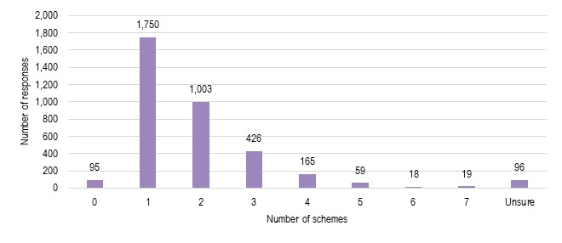
N=3,631 respondents
Source: ACIL Allen survey of ARC funding recipients

Respondents received ARC funding for 5,640 Discovery Program grants (57% of projects) and 4,226 Linkage Program grants (43%), which commenced between 2010 and 2020. Respondents could identify as being involved with both programs (see Figure 8.2).
Figure 8.2 Survey results on the Programs providing support to respondents’ projects
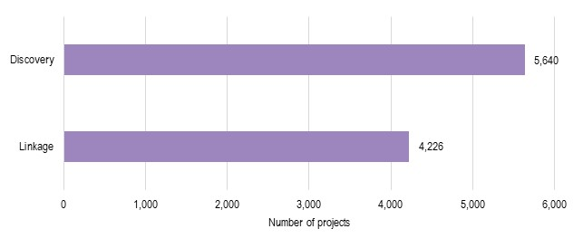
N=5,906
Note: respondents could select up to 3 schemes that they were involved in that commenced between 2010-2020.
Source: ACIL Allen survey of ARC funding recipients
Figure 8.3 shows that 72% of respondents were involved with ARC-funded projects in CI or equivalent roles, followed by PI roles (19%). Respondents of other roles include international collaborators (9), co-investigators (6), industry partners (6), external consultants (5), associate investigators (3), and other research-specific roles such as fellows, advisors, reviewers, research associates, and research partners.
Figure 8.3 Survey results on respondents’ roles on ARC-funded projects
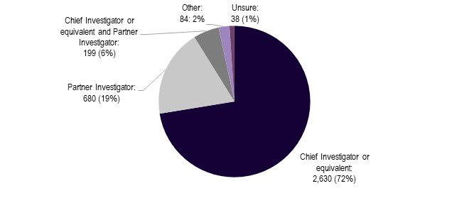
N=3,631
Source: ACIL Allen survey of ARC funding recipients
Most respondents worked at Australian organisations (86% of respondents) while participating in all/most of their ARC-funded project(s) (see Figure 8.4), specifically at Australian university/higher education provider organisations (78%). This was followed by international university/higher education provider (10%). Other organisations mostly include research institutes, museums, and other education providers.
Figure 8.4 Survey results on type of organisation respondents worked at while participating in ARC project(s)
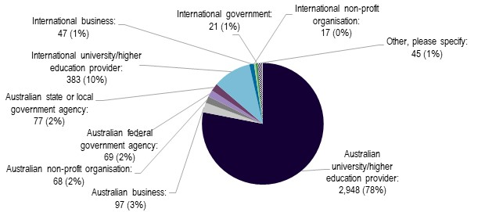
N=3,777
Source: ACIL Allen survey of ARC funding recipients
Figure 8.5 shows the Australian university/higher education providers where survey respondents are/were most commonly employed while participating in ARC-funded projects.
Figure 8.5 Survey results on their Australian university employer
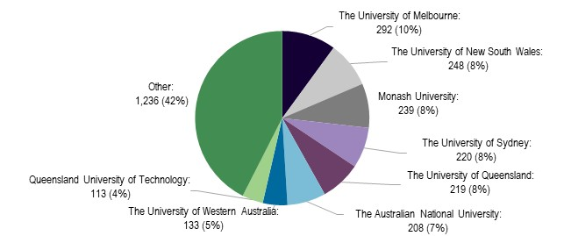
N=2,908
Source: ACIL Allen survey of ARC funding recipients
Figure 8.6 shows the distribution of respondents whose international organisations are headquartered overseas. 78% of respondents were employed by organisations headquartered in 10 countries. The United States, United Kingdom, Germany, and Australia make up more than half (noting that Australia is not an international country). The remaining 22% of Other responses is comprised of 31 countries.
Figure 8.6 Survey results on international headquarter location
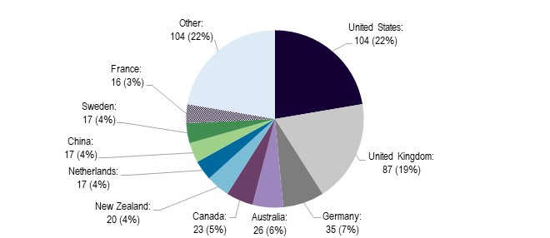
N=466
Other includes Italy, Japan, Singapore, Spain, Denmark, Switzerland, Norway, Austria, South Africa, Belgium, Israel, Poland, Indonesia, Ireland, South Korea, Finland, Philippines, India, Thailand, Greece, Saudi Arabia, Uruguay, Mexico, Algeria, Malaysia, Chile, Brazil, Hungary, Pakistan, Sri Lanka, Estonia
Source: ACIL Allen survey of ARC funding recipients
Figure 8.7 shows that during all/most of the ARC-funded projects, the Partner Investigator respondents’ worked primarily in Education and Training, which comprises 56% of ARC-funded projects, followed by Other services (11%), Professional and Scientific and Technical Services (10%). Fewer Partner Investigator respondents were associated with Health Care and Social Assistance (5%), Manufacturing (4%), Agriculture, Forestry and Fishing (3%) and Arts and Recreation Services (3%).
Figure 8.7 Survey results on the primary employment industry for Partner Investigators during all/most of the ARC-funded projects
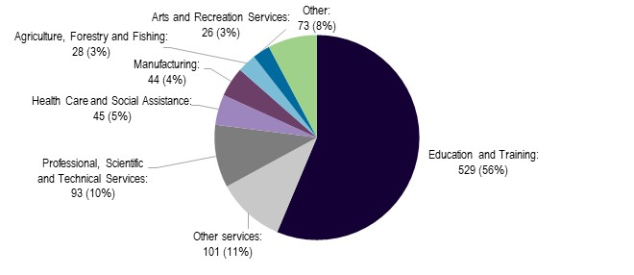
N=939
Other includes Information Media and Telecommunications, Mining, Electricity, Gas, Water and Waste Services, Public Administration and Safety, Transport, Postal and Warehousing, Construction, Finance and Insurance Services, Administrative and Support Services and Accommodation and Food Services.
Source: ACIL Allen survey of ARC funding recipients
Figure 8.8 shows the Field of Research for projects reported in the survey, noting that some respondents answered this question for multiple projects.
The largest fields in the Discovery Program were Biological Sciences and Engineering, which represented 12% and 10% of Discovery Program projects, respectively. This was followed by Studies in Human Society (9%) and Physical Sciences (8%). Agricultural and Veterinary Sciences and Philosophy and Religious Studies accounted for the fewest projects under the Discovery Program, at just over 1% of projects each.
Similarly, the largest fields in the Linkage Program were Engineering and Biological Sciences, which accounted for 13% and 9% of projects under this scheme, respectively. This was followed by Studies in Human Society, Physical and Environmental Sciences at 7% each. Economics and Philosophy and Religious Studies had the fewest projects, each representing fewer than 1% of projects in the Linkage Program.
Figure 8.8 Survey results on project Field of Research
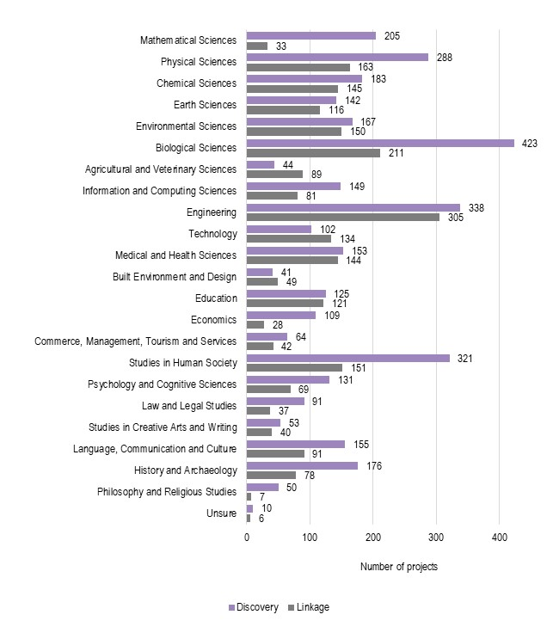
N=5,923. Each respondent could select up to 3 schemes.
Source: ACIL Allen survey of ARC funding recipients
Figure 8.9 shows the primary nature of the projects supported by ARC. In the case of the Discovery Program, 55% of respondents conducted projects that were primarily basic/fundamental/pure research, while 15% was applied research, and 29% was a combination of both. In the case of the Linkage Program, 15% of respondents conducted projects that were primarily basic/fundamental/pure research, 38% of projects were applied research and 47% were a combination of both.
Figure 8.9 Survey results on the primary nature of projects supported by ARC
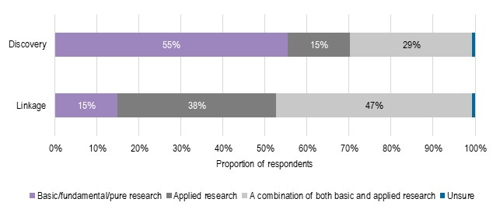
N=3,847
Source: ACIL Allen survey of ARC funding recipients
Just under half of Discovery Program respondents reported that projects supported by ARC (46%) have been completed, and 37% were mostly completed. 11% were all ongoing and 6% mostly ongoing. Similarly, respondents reported that 47% of ARC-supported Linkage Program grants had all been completed, 28% were mostly completed, 14% were all ongoing and a further 9% were mostly ongoing (see Figure 8.10).
Figure 8.10 Survey results on the status of projects supported by ARC
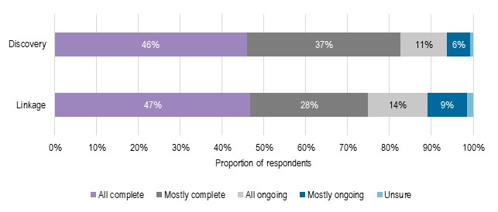
N=3,850
Source: ACIL Allen survey of ARC funding recipients

Impact by scheme
Figure 8.11 Survey data on the type of impact by scheme
Discovery Projects | Discovery Early Career Researcher Award
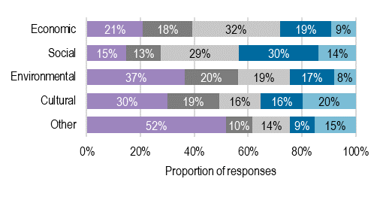 | 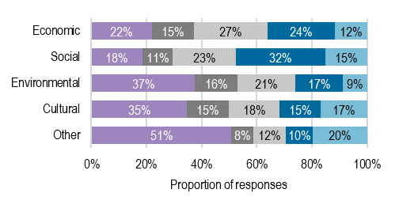
Future Fellowships | Australian Laureate Fellowships
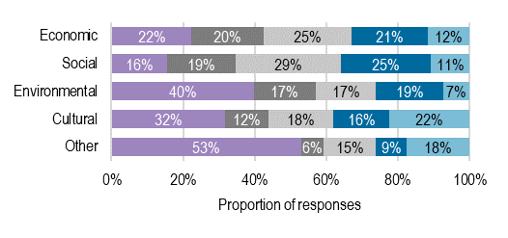 | 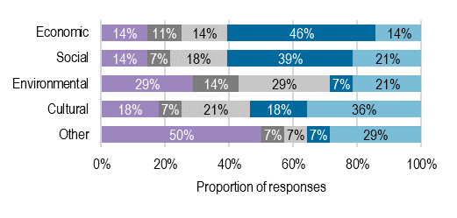
Discovery Indigenous/Discovery Indigenous Researchers Development | ARC Centres of Excellence
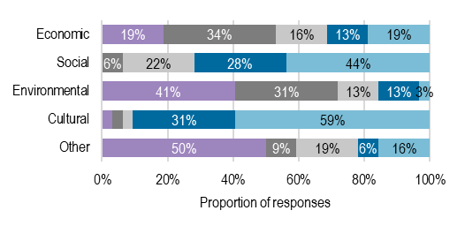 | 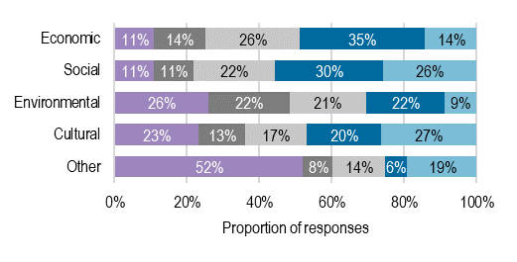
Industrial Transformation Training Centres | Industrial Transformation Research Hubs
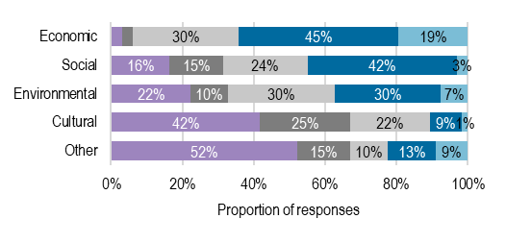 | 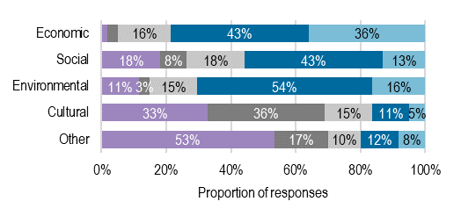
Linkage Infrastructure, Equipment and Facilities | Linkage Learned Academies Special Projects
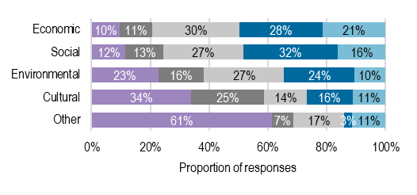 | 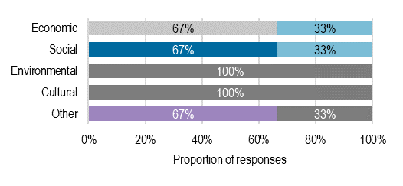
Linkage Projects | Special Research Initiatives
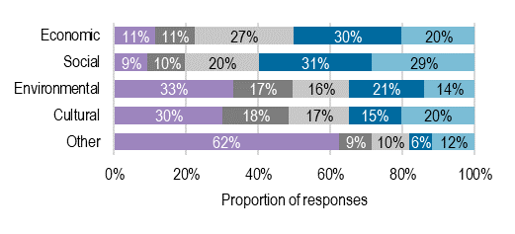 | 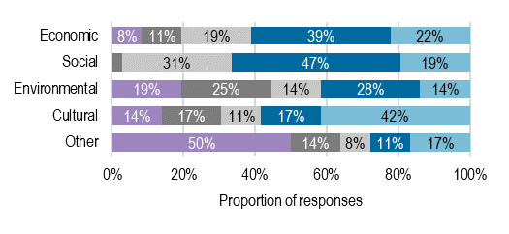
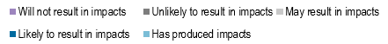
Discovery Projects N=1,825-1,828
Discovery Early Career Researcher Award N=315
Future Fellowships N=245-250
Australian Laureate Fellowships N=28
Discovery Indigenous/Discovery Indigenous Researchers Development N=32
ARC Centres of Excellence N=146-147
Industrial Transformation Training Centres N=67
Industrial Transformation Research Hubs N=60-61
Linkage Infrastructure, Equipment and Facilities N=150-155
Linkage Learned Academies Special Projects N=3
Linkage Projects N=855-862
Special Research Initiatives N=36
Note: Super Science Fellowships is not included as N=1.
Source: ACIL Allen survey of ARC funding recipients

Sentiment analysis
The sentiment analysis of all qualitative free text survey responses is graphed according to the subjectivity and polarity of each question in Figure 8.12. This shows that respondents expressed both a high degree of emotional sentiment and personal opinion in their responses to questions:
- 5 Are there any ways that the ARC could better support the realisation of impacts from the research it funds?
- 8 Why do you think it is not important for the ARC to monitor and communicate the impacts of ARC-funded research?
- 10 Do you have any other comments you would like to make before concluding the survey?
These scores likely indicate that respondents have a strong perspective and a high level of emotional investment. When analysing free text responses, long-term, short-term, and application process are words used frequently when answering these questions, highlighting the importance that respondents are placing on their feedback on these issues.
Figure 8.12 Qualitative analysis of survey results - sentiment analysis
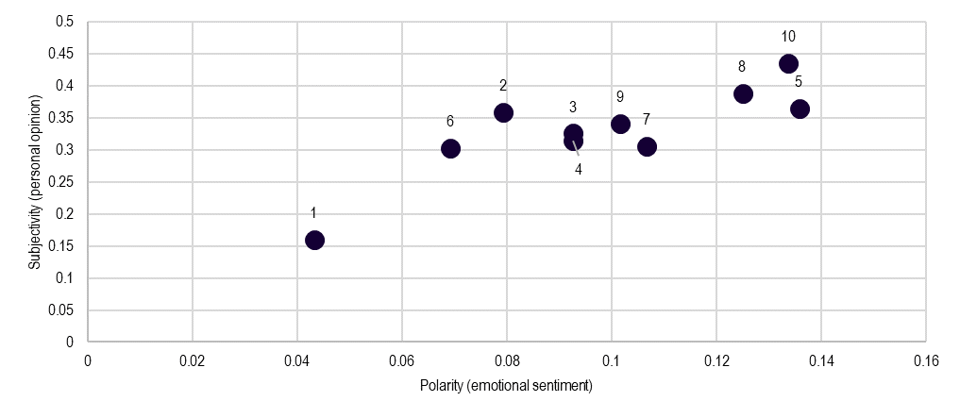
Source: ACIL Allen survey of ARC-funded recipients

Melbourne  Suite 4, Level 19, North Tower  80 Collins Street  Melbourne VIC 3000 Australia  +61 3 8650 6000  Canberra  Level 6, 54 Marcus Clarke Street  Canberra ACT 2601 Australia  +61 2 6103 8200 | Sydney  Suite 603, Level 6  309 Kent Street  Sydney NSW 2000 Australia  +61 2 8272 5100  Perth  Level 12, 28 The Esplanade  Perth WA 6000 Australia  +61 8 9449 9600 | Brisbane  Level 15, 127 Creek Street  Brisbane QLD 4000 Australia  +61 7 3009 8700  Adelaide  167 Flinders Street  Adelaide SA 5000 Australia  +61 8 8122 4965
ACIL Allen Pty Ltd
ABN 68 102 652 148
acilallen.com.au

Noting that reference to Government’s broad strategic priorities includes priorities beyond the National Science and Research Priorities, as agreed with the ARC.
Department of Industry, Innovation, Science, Research and Tertiary Education (DIISRTE) (2012). 2012 National Research Investment Plan.
National Health and Medical Research Council (NHMRC) (2010). Strategic Plan 2010-2012, p.3.
Salter, A. J., & Martin, B. R. (2001). The economic benefits of publicly funded basic research: a critical review. Research Policy, 30(3), 509–532. https://doi.org/10.1016/S00487333(00)000913. Note that where these benefits cannot be quantified, they have been considered qualitatively in the main report, see chapters 2 and 3.
European Commission (2017). The Economic Rationale for Public R&I Funding and its Impact, Brussels. Accessed October 2022: http://bookshop.europa.eu/en/the-economic-rationale-for-public-r-i-funding-and-itsimpact-pbKI0117050/.
Department of Industry, Innovation and Science (DIIS) (2016). Australian Innovation System Report 2016.
Georghiou, L. (2015). Value of Research, Policy Paper by the Research, Innovation, and Science Policy Experts. European Commission.
Department of Industry, Innovation and Science (DIIS) (2016). Op. cit.
Ibid. The private ROR is the ROR that an individual or company receives from an investment. It represents the financial benefits that the investor gets from the investment. The private ROR is typically calculated as the ratio of the profits or benefits gained from the investment to the costs of the investment. On the other hand, the social ROR represents the overall benefit to society that results from an investment. It takes into account not only the financial benefits but also the broader social benefits, such as improvements in health, education, and the environment. The social ROR is calculated as the ratio of the total benefits to society to the costs of the investment. Dyakova, M, et al. (2020). Health Evidence Network Synthesis Report 51. World Health Organization.
Martin, B. (2007). Assessing the Impact of Basic Research on Society and the Economy.
Productivity Commission (2007). Public Support for Science and Innovation. SSRN Electronic Journal. https://doi.org/10.2139/ssrn.1018883.
Allen Consulting Group (2003). A Wealth of Knowledge: The return on investment from ARC-funded research, report for the Australian Research Council.
Department of Industry, Innovation and Science (DIIS) (2016). Op. cit.
Hall, B. H., Mairesse, J., & Mohnen, P. (2009). Measuring the Returns to R&D. National Bureau of Economic Research Working Paper Series, 15622. Includes references to Griliches, 1980 and 1986; Griliches and Lichtenberg, 1984; Hanel, 1988; Leonard, 1971; Mansfield, 1980; Nadiri and Mamuneas, 1994. Accessed: https://doi.org/10.3386/w15622.
Dagg, M. (2007). Public investment in R&D in Ireland. In R. O’Toole & C. Aylward (Eds.), Perspective on Irish productivity, 330–341, Dublin, p. 331. Includes references to Gudgiev 2006.
Noting that these have been described qualitatively in the main report, see chapters 2 and 3.
Dagg, M. (2007). Public investment in R&D in Ireland. In R. O’Toole & C. Aylward (Eds.), Perspective on Irish productivity, 330–341, Dublin.
Frontier Economics (2014). Rates of return to investment in science and innovation, a report prepared for the Department for Business Innovation and Skills. BIS.
Lucking, B., Bloom, N., & Reenen, V. (2018). Have R&D Spillovers Changed? National Bureau of Economic Research Working Paper Series, No. 24622. https://doi.org/10.3386/w24622. Cited in Bloom, N., Reenen, V., & Williams, H. (2019). A Toolkit of Policies to Promote Innovation. Journal of Economic Perspectives, 33(3), 163–184. https://doi.org/10.1257/jep.33.3.163.
Sveikauskas, L. (2007). R&D and Productivity Growth: A Review of the Literature. U.S. Bureau of Labor Statistics, Working Papers. No. 408. Cited in OECD. (2015). The Impact of R&D Investment on Economic Performance: A Review of the Econometric Evidence.
Elk, R., Weel. B., Wiel, K.., Wouterse, B. (2019). Estimating the Returns to Public R&D Investments: Evidence from Production Function Models, De Economist, 167(1), 45–87.
Guellec, D. and B. van Pottelsberghe de la Potterie (2001). R&D and Productivity Growth: Panel Data Analysis of 16 OECD Countries. OECD Science, Technology and Industry Working Papers, No. 2001/03, OECD Publishing, Paris, https://doi.org/10.1787/652870318341.
Coe, D. T., & Helpman, E. (1995). International R&D spillovers. European Economic Review, 39(5), 859–887. Cited in Wynn, K., Liu, M., Cohen, J., (2022). Quantifying the economy-wide returns to innovation for Australia, Australian Economics Papers, Wiley, 591-614.
Martin, B. (2007). Op. cit.
Productivity Commission (2007). Op. cit.
The Jones and Summers approach is a macro-level approach that draws on modern innovation-based growth theory to show how average returns to innovation can be calculated by linking the total cost of innovation investments to economy-wide gains in GDP.
Wynn, K., Liu, M., & Cohen, J. (2022). Quantifying the economywide returns to innovation for Australia. Aust Econ Pap, 61(3), 591–614. https://doi.org/https://doi.org/10.1111/14678454.12262
Grant, J., & Buxton, M. J. (2018). Economic returns to medical research funding. BMJ Open, 8(9), e022131. https://doi.org/10.1136/bmjopen2018022131.
Sussex, J., Feng, Y., MestreFerrandiz, J., Pistollato, M., Hafner, M., Burridge, P., & Grant, J. (2016b). Quantifying the economic impact of government and charity funding of medical research on private research and development funding in the United Kingdom. BMC Medicine, 14(1), 32. https://doi.org/10.1186/s129160160564z.
Frontier Economics (2014). Op. cit., p. 50.
Ibid, p. 50.
Allen Consulting Group (2003). Op. cit., p. 57.
Notably, these figures reflect co-contributions reported in grant applications. ARC analysis of a sample of projects has shown that these reported contributions are close to the actual amount delivered throughout the projects.
An alternative counterfactual assumption that taxes are lowered by the amount of NCGP funding in the absence of the program would have resulted in a reduction of the deadweight losses associated with taxation and a reduction in the estimated impacts of the program. The extent of this reduction would depend on the taxes that are assumed to have been reduced.
Productivity Commission (2007). Public Support for Science and Innovation. SSRN Electronic Journal. https://doi.org/10.2139/ssrn.1018883.
Jakeman, G., Heyhoe, E., Pant, H., Woffenden, K. and Fisher, B.S. (2001). The Kyoto Protocol: economic impacts under the terms of the Bonn agreement. ABARE paper presented to the International Petroleum Industry Environmental Conservation Association conference, ‘Long Term Carbon and Energy Management - Issues and Approaches’, Cambridge, Massachusetts, 15-16 October.
Pant, H.M. (2007), GTEM: Global Trade and Environment Model, ABARE Technical Report, Canberra, June.
Hanslow, K. & Hinchy, M. (1996). The MEGABARE model: interim documentation. Canberra: ABARE.
Hertel, T. (1997). Global Trade Analysis: modelling and applications. Cambridge University Press, Cambridge.
Aguiar, A., Chepeliev, M., Corong, E., McDougall, R., & van der Mensbrugghe, D. (2019). The GTAP Data Base: Version 10. Journal of Global Economic Analysis, 4(1), 1-27. Retrieved from https://www.jgea.org/ojs/index.php/jgea/article/view/77.
Namely Hertel, T. (1997). Op. cit. and Pant, H.M. (2007). Op. cit., respectively.
The term “regional household” was devised for the GTAP model. In essence it is an agent that aggregates all incomes attributable to the residents of a given region before distributing the funds to the various types of regional consumption (including savings).
Hanslow, K. & Hinchy, M. (1996). Op. cit.
Australian Government (2008), Australia’s Low Pollution Future: the economics of climate change mitigation, Australian Government, Canberra.
For example, at the start and end of each week for this analysis. Tasman Global can be run with different steps in time, such as quarterly or bi-annually in which case the markets would clear at the start and end of these time points.
As discussed in Dixon et al (1997), a standard CES/CET function is defined in terms of effective units. Quantitatively this means that, when substituting between, say, X₁ and X₂ to form a total quantity X using a CET function a simple summation generally does not actually equal X. Use of these functions is common practice in CGE models when substituting between substantially different units (such as labour versus capital or imported versus domestic services) but was not deemed appropriate when tracking the physical number of people. Such ‘modified’ functions have long been employed in the technology bundles of Tasman Global and GTEM. The Productivity Commission have proposed alternatives to the standard CES to overcome similar and other weaknesses when applied to internationally traded commodities. See Dixon, P.B., Parmenter, B., Sutton, J., & Vincent, D. (1997), ORANI: A Multisectoral Model of the Australian Economy, Amsterdam: North Holland.
Narayanan et al. (2012).
Pant, H.M. (2007), GTEM: Global Trade and Environment Model, ABARE Technical Report, Canberra, June.
This method is a common way of calibrating the economic relationships assumed in CGE models to those observed in the economy. See for example Dixon, P.B. and Rimmer, M.T. (2002), Dynamic General Equilibrium Modelling for Forecasting and Policy. Contributions to Economic Analysis 256, Amsterdam: North Holland.
Organisation for Economic Co-operation and Development (2015). Frascati Manual 2015: Guidelines for Collecting and Reporting Data on Research and Experimental Development. Paris: OECD.
Department of Industry, Science and Resources (2020). Modern Manufacturing Initiative and National Manufacturing Priorities announced. Accessed December 2022: https://www.industry.gov.au/news/modern-manufacturing-initiative-and-national-manufacturing-priorities-announced.
Department of Industry, Science and Resources (2020). National Reconstruction Fund: diversifying and transforming Australia’s industry and economy. Accessed December 2022: https://www.industry.gov.au/news/national-reconstruction-fund-diversifying-and-transforming-australias-industry-and-economy.
UKRI (2023). Our relationship with the government. Accessed January 2023: https://www.ukri.org/about-us/how-we-are-governed/our-relationship-with-the-government/.
Department of Industry, Science and Resources (2022). Australian Government to revitalise our science and research priorities. Accessed December 2022: https://www.industry.gov.au/news/australian-government-revitalise-our-science-and-research-priorities.
Department of Industry, Science and Resources (2022). Australian Government to revitalise our science and research priorities. Accessed February 2023: https://www.industry.gov.au/news/australian-government-revitalise-our-science-and-research-priorities.
Department of Health and Aged Care (n.d.). Medical Research Future Fund. Accessed February 2023: https://www.health.gov.au/our-work/medical-research-future-fund.
Ferguson, H. (2022). University research funding: a quick guide. Accessed January 2023: https://www.aph.gov.au/About_Parliament/Parliamentary_Departments/Parliamentary_Library/pubs/rp/rp2122/Quick_Guides/UniversityResearchFunding.
Ibid.
Group of Eight Australia (2022). Essential decisions for national success Supporting Australian research. Canberra: Go8.
Australian Government Department of Education (2022). Research Block Grants. Accessed January 2023: https://www.education.gov.au/research-block-grants.
Australian Government Department of Education (2022). Trailblazer Universities Program. Accessed January 2023: https://www.education.gov.au/trailblazer-universities-program.
Australian Government Department of Education (2022). Australia’s Economic Accelerator. Accessed January 2023: https://www.education.gov.au/university-research-commercialisation-package/australias-economic-accelerator.
NSW Government Chief Scientist and Engineer (n.d.). Research and Development. Accessed January 2023: https://www.chiefscientist.nsw.gov.au/funding/research-and-development.
Breakthrough Victoria (2023). Breakthrough Victoria – University Innovation Platform. Accessed January 2023: https://breakthroughvictoria.com/stories/university-innovation-platform-launch/.
Government of South Australia Department for Industry, Innovation and Science (2023). Research and Innovation Fund. Accessed January 2023: https://www.diis.sa.gov.au/innovation/entrepreneurship-and-future-industries/funding/research-and-innovation-fund.
Group of Eight and Australian Technology Network (2012). Excellence in Innovation: Research impacting our nation’s future – assessing the benefits. Accessed January 2023: https://atn.edu.au/wp-content/uploads/2021/12/atn-go8-report-web-pdf.pdf.
Ibid.
GovHack (2023). About. Accessed January 2023: https://govhack.org/about/.
UKRI (2022). Annual Report and Accounts 2021-2022, p.12.
Note this was accurate at the time of consultation in 2022. On 7 February 2023, the department was dissolved, and its functions split into 3 new departments: the Department for Business and Trade, the Department for Energy Security and Net Zero, and the Department for Science, Innovation and Technology. See Gov.UK (2023). Making Government Deliver for the British People. Accessed February 2023: https://www.gov.uk/government/publications/making-government-deliver-for-the-british-people/making-government-deliver-for-the-british-people-html.
UKRI (2022). Our budget. Accessed December 2022: https://www.ukri.org/about-us/strategy-plans-and-data/our-budget/.
UKRI (2022). UKRI’s budget allocation explainers. Accessed December 2022: https://www.ukri.org/publications/ukri-budget-allocation-explainers/.
UKRI (2022). Strategy 2022-27. Accessed December 2022: https://www.ukri.org/publications/ukri-strategy-2022-to-2027/.
European Commission (2021). Horizon Europe strategic plan 2021-2024. Accessed December 2022: https://op.europa.eu/en/web/eu-law-and-publications/publication-detail/-/publication/3c6ffd74-8ac3-11eb-b85c-01aa75ed71a1.
Ibid.
European Commission (2021). Horizon Europe – budget. Accessed December 2022: https://op.europa.eu/en/publication-detail/-/publication/1f107d76-acbe-11eb-9767-01aa75ed71a1.
European Commission (2021). The EU Research and Innovation Programme 2021-2027. Accessed December 2022: https://research-and-innovation.ec.europa.eu/system/files/2022-06/ec_rtd_he-investing-to-shape-our-future_0.pdf.
Science Foundation Ireland (2017a). About us. Accessed December 2022: https://www.sfi.ie/about-us/.
Science Foundation Ireland (2017b). About us – history. Accessed December 2022: https://www.sfi.ie/about-us/about-sfi/history/index.xml.
Science Foundation Ireland (2022). Annual programmes plan 2022. Accessed December 2022: https://www.sfi.ie/research-news/publications/SFI-Annual-Plan-2022.pdf.
Science Foundation Ireland (2021). Annual report 2021. Accessed December 2021: https://www.sfi.ie/research-news/publications/annual-reports/SFI-Annual-Report-2021-FINAL-w-alt-text.pdf.
Science Foundation Ireland (2021). Strategic plan 2021-2025. Accessed December 2022: https://www.sfi.ie/strategy/SFI-Strategy-2025.pdf.
Science Foundation Ireland (2017a). Op. cit.
Ibid.
Ministry of Business, Innovation and Employment (2015). Strategic intentions 2021-2025. Accessed December 2022: https://www.mbie.govt.nz/assets/strategic-intentions-2021-2025.pdf.
Ministry of Business, Innovation and Employment (2015). National statement of science investment. Accessed December 2022: https://www.mbie.govt.nz/assets/2eaba48268/national-statement-science-investment-2015-2025.pdf.
Ministry of Business, Innovation and Employment (2022). Annual report 2021-2022. Accessed December 2022: https://www.mbie.govt.nz/dmsdocument/25340-mbie-annual-report-2021-22.
Ministry of Business, Innovation and Employment (2022). Endeavour Fund. Accessed December 2022: https://www.mbie.govt.nz/science-and-technology/science-and-innovation/funding-information-and-opportunities/investment-funds/endeavour-fund/.
Ministry of Business, Innovation and Employment (2022). Investment Funds. Accessed December 2022: https://www.mbie.govt.nz/science-and-technology/science-and-innovation/funding-information-and-opportunities/investment-funds/.
Ministry of Business, Innovation and Employment (2022). Annual report 2021-2022. Accessed December 2022: https://www.mbie.govt.nz/dmsdocument/25340-mbie-annual-report-2021-22.
Australian Research Council (2023). NCGP Trends: Success Rates. Accessed February 2023: https://www.arc.gov.au/funding-research/funding-outcome/grants-dataset/trend-visualisation/ncgp-trends-success-rates.
Tableau Public (2021). UKRI Competitive Funding Decisions 2020-21. Accessed January 2023: https://public.tableau.com/app/profile/uk.research.and.innovation.ukri./viz/UKRICompetitiveFundingDecisions2020-21/CompetitiveFundingDecisions.
Australian Research Council (2022). Discovery Program.
Australian Research Council (2022). Linkage Program. Accessed February 2023: https://www.arc.gov.au/funding-research/funding-schemes/linkage-program.
Science Foundation Ireland (2017a). Op. cit.
Tableau Public (2021). UKRI Competitive Funding Decisions 2020-21. Accessed January 2023: https://public.tableau.com/app/profile/uk.research.and.innovation.ukri./viz/UKRICompetitiveFundingDecisions2020-21/CompetitiveFundingDecisions.
Personal communication with Horizon Europe, as of November 2022.
Personal communication with SFI, as of November 2022.
Personal communication with MBIE, as of November 2022.
Ministry of Business, Innovation and Employment (2021). Endeavour Fund: Transforming New Zealand’s Future: Investment Plan 2022–2024. Wellington: New Zealand Government.
UK Research and Innovation (2022). Op. cit.
UKRI (2023). Our relationship with the government. Accessed January 2023: https://www.ukri.org/about-us/how-we-are-governed/our-relationship-with-the-government/.
Ministry of Business, Innovation and Employment (2021). Endeavour Fund: Transforming New Zealand’s Future: Investment Plan 2022–2024. Wellington: New Zealand Government.
UKRI (2023). Op. cit.
UKRI (2023). Evaluation reports. Accessed January 2023: https://www.ukri.org/about-us/how-we-are-doing/evaluation-reports/.
Researchfish (2023). Products. Accessed January 2023: https://researchfish.com/researchfish/.
Research Excellence Framework (2022). About the REF. Accessed January 2023: https://www.ref.ac.uk/about-the-ref/.
Adam, P., Ovseiko, P. V., Grant, J., et. Al. (2018). ISRIA statement: ten-point guidelines for an effective process of research impact assessment. Health research policy and systems, 16(1), 1-16.
European Commission (2023). Horizon Europe programme analysis. Accessed January 2023: https://research-and-innovation.ec.europa.eu/strategy/support-policy-making/shaping-eu-research-and-innovation-policy/evaluation-impact-assessment-and-monitoring/horizon-europe-programme-analysis_en#evaluating-horizon-europe.
European Commission (2023). A new horizon for Europe: Impact assessment of the 9th EU framework programme for research and innovation. EU Publications.
Ibid.
Science Foundation Ireland (n.d.). SFI Strategy 2025: Delivering Today, Preparing for Tomorrow, Science Foundation Ireland Strategy 2025. Government of Ireland.
Science Foundation Ireland (2023). Reporting Procedures. Accessed January 2023: https://www.sfi.ie/funding/award-management/reporting-procedures/.
Ibid.
Ibid.
Ibid.
Science Foundation Ireland (2022). Grant General Terms & Conditions. Science Foundation Ireland.
Ministry of Business, Innovation and Employment (2022). Te Ara Paerangi Future Pathways White Paper 2022. Wellington: New Zealand Government.
A treaty signed in 1840 that states the principles on which British Crown and representatives of the Māori peoples agreed to found a nation state and build a government in New Zealand. Ministry for Culture and Heritage (2017). The Treaty in brief. Accessed January 2023: https://nzhistory.govt.nz/politics/treaty/the-treaty-in-brief.
Ministry of Business, Innovation and Employment (2022). Contestable Investments: Annual Reporting Guidelines For the period 2021 to 2022. Wellington: New Zealand.
Ibid.
Ministry of Business, Innovation and Employment (2021). New Zealand Research Information System. Accessed January 2023: https://www.mbie.govt.nz/science-and-technology/science-and-innovation/research-and-data/nzris/.
Ministry of Business, Innovation and Employment (2018). The National Research Information System: Overview. Wellington: New Zealand Government.
Hannah, A, Davies, D, Dangerfield, C, Van der Wat, C, & Hancock, M (2022). The New Zealand Research Information System (NZRIS). Accessed January 2023: https://dspacecris.eurocris.org/handle/11366/2253.
Ministry of Business, Innovation and Employment (2018). Op. cit.
Ministry of Business, Innovation and Employment (2023). 2023 Investment Round Endeavour Fund Roadshow. Accessed January 2023: https://www.mbie.govt.nz/assets/2023-endeavour-investment-round-roadshow-presentation.pdf.
Python is a programming language that is used for data analysis of qualitative and quantitative analysis. Python supports the installation of additional modules and packages - the Natural Language Toolkit (NLTK) package was used as part of the text cleaning and splitting process, and the Textblob package was used for sentiment analysis.

