 **Research Management System**

**(RMS)**

**User Guide for Applicants – Submitting an Application**

#### Contents

Introduction 2

PART 1 – Creating a new Application in RMS 3

1.1 – Creating an Expression of Interest (EOI) 3

1.2 – Creating an application 4

1.3 – Application Form Parts 5

PART 2 – Adding participants 7

2.1 – Inviting participants 7

2.2 – Allocating full control to participants 8

2.3 – Giving access on an application to a non-participant 9

2.4 – How to accept an invitation to participate on an application 9

2.5 – Changing the order or role of participants 11

2.6 – Removing a participant 11

PART 3 – Filling out the application form 12

3.1 – Identifying if a question is mandatory 12

3.2 – Uploading a PDF 13

3.3 – Adding an Organisation to an application 13

3.4 – Adding an Organisation using an Australian Business Number 14

3.5 – Adding an International Organisation 16

3.6 – Accessing additional information against a question 16

3.7 – Accessing your personal details from within the form 17

3.8 – Generating a PDF of the application 17

3.9 – Adding information to the budget 18

3.10 – Submitting an application to your Research Office 22

3.11 – Deleting a draft application 22

3.12 – Reviving a deleted draft application 23

# Introduction

* The target audience for this user guide are users who will be submitting an Expression of Interest (EOI) and/or an application for a scheme round within the National Competitive Grants Program (NCGP).
* This is an introductory user guide for submitting EOIs and/or applications in RMS, to assist applicants with navigating and the submission of an EOI or application in RMS.
* For information on Expression of Interest (i.e. two-stage application) process for the refer to Part 1.1.
* **Important:** This user guide is not a replacement for the Instructions to Applicants that are released for each scheme round. The Instructions to Applicants can be found for the relevant scheme via GrantConnect at [https://www.grants.gov.au.](https://www.grants.gov.au/)
* You will be able to access RMS via [https://rms.arc.gov.au.](https://rms.arc.gov.au/)
* RMS will be compatible with the latest versions of Google Chrome and Microsoft Internet Explorer. Compatibility with different browsers or older versions of Google Chrome and Microsoft Internet Explorer is not guaranteed.
* If you are experiencing any technical issues or require help with navigating RMS whilst completing your application, please contact the RMS Helpdesk at ARC-Systems@arc.gov.au.

## PART 1 – Creating a new Application in RMS

* Login to RMS via the Login Homepage [https://rms.arc.gov.au](https://rms.arc.gov.au/) using your **registered account email address** and your password.
* An additional user guide for RMS is available which provides information on creating new accounts, resetting passwords, and updating your personal profile. The “RMS User Management Guide“ is available at [https://www.arc.gov.au](https://www.arc.gov.au/) > [Grants](https://www.arc.gov.au/grants) > [RMS information](https://www.arc.gov.au/manage-your-grant/research-management-system-rms-information)[.](https://www.arc.gov.au/grants/rms-information/rms-auto-population-research-outputs)

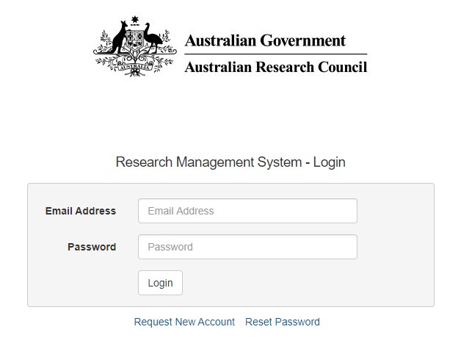

**Figure 1 – RMS Login Homepage**

* Enter your email address and your password and click on the *Login* button.
* Enter the Multi-factor Authentication (MFA) code.

### 1.1 – Creating an Expression of Interest (EOI)

* Upon login, users will be taken to the main page called the *Action Centre.*
* To create a draft EOI application, go to the *ARC Applicant Expressions of Interest* section within the *Action Centre.*

**Figure 2 – How to create an Expression of Interest application**

* Select the appropriate scheme round from the drop-down menu and then click on *Create Draft Expression of Interest* button.
* A draft EOI application will automatically be created and the user will be taken automatically to the draft EOI application.
* When a draft EOI application is created an EOI Application ID is automatically created, and this is displayed in several places in your form (see Figure 5(a)).
* For detailed information on how to complete each EOI question please consult relevant Instructions to Applicants on [Grant Connect](https://www.grants.gov.au/).
* Successful EOI applicants will be invited to submit a full application. For more information on how to create a full application please refer to **‘1.2 – Creating an application’** in the next section.

### 1.2 – Creating an application

* Upon login, users will be taken to the main page called the *Action Centre.*

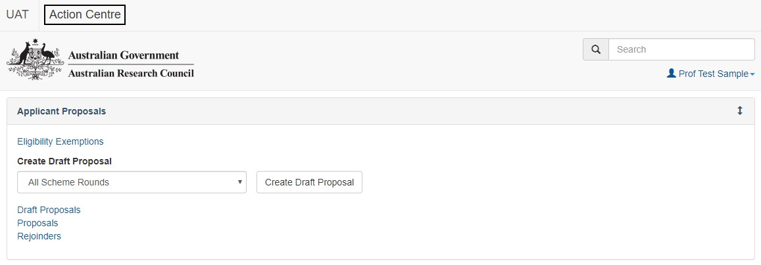

**Figure 3 - The Action Centre**

* To create a draft application, go to the *Applicant Applications* section within the *Action Centre*.
* Select the appropriate scheme round from the drop-down menu and then click on *Create Draft Application* button.

**Figure 4 – How to create a draft application**

* A draft application will automatically be created and the user will be taken automatically to the draft application.
* When a draft application is created an Application ID is automatically created and this is displayed in several places in your form (see Figure 4).

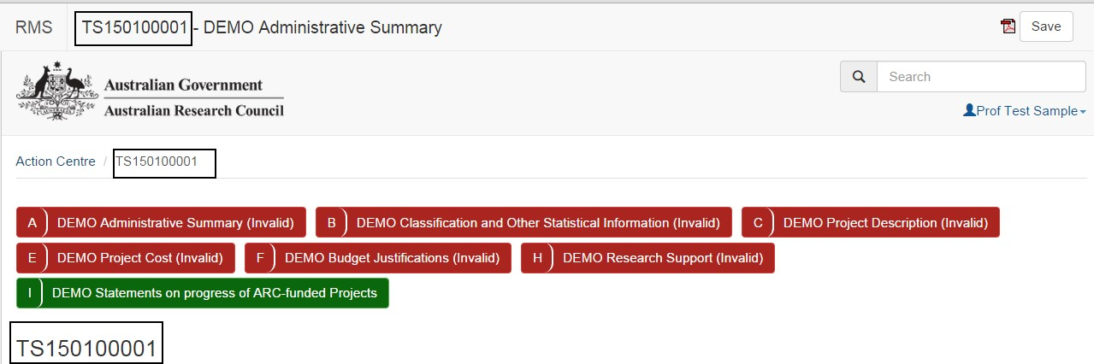

**Figure 5(a) – Draft application created showing the Application ID**

### 1.3 – Application Form Parts

**General Information:**

* The application is made up of form parts and these will be displayed at the top of the application form.
* Form parts will be either RED or GREEN in colour.
* A form part that is RED indicates that it is invalid and you cannot submit your application until all parts are validated.
* A form part that is GREEN indicates that it is valid, **but** this does not mean that all questions are answered. A form part may contain only nonmandatory questions and therefore will appear GREEN before any information has been entered.
* Applicants should check all form parts are completed and information entered before submission to their Research Office.
* To navigate between form parts simply click on the form part tab.

**Personnel and Organisation Form Parts:**

* The *Personnel* form part for each applicant will not appear until the applicant has been invited and accepted. See Part 2 for information on inviting participants.
* Each applicant can access their own section by clicking on the *Personnel* form part and then clicking on the arrow and selecting their name in the drop-down list.

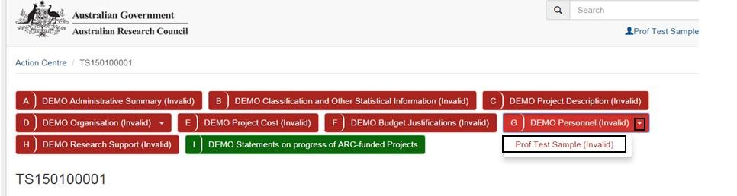

**Figure 5(b) – Accessing your Personnel form part in the Application**

* Where a scheme has a form part for *Organisations* these are accessed in the same way as personnel, by clicking on the arrow and selecting from the drop-down list.
* As you are working through the application, ensure that you save at regular intervals. The save button is located at the top of the screen.

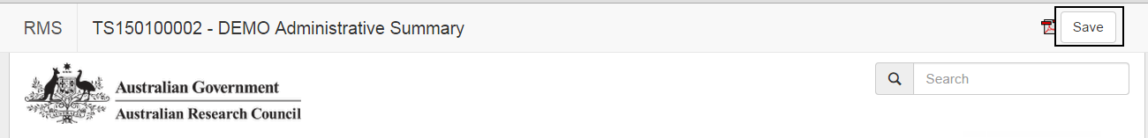

**Figure 6 – Location of the Save button**

## PART 2 – Adding participants

### 2.1 – Inviting participants

* The creator of the application will not automatically be added as a participant on the draft application. You will need to add yourself to the application if you are to be a named participant.
* Navigate to the *Administrative Summary* part of the application form to the *Person Participant Summary* question.
* Select your participating role type in the drop-down menu and enter in your email address. Your email address must be the registered account email that is stored in your personal details in RMS.
* Click Add.
* As the creator of the application, you do not need to accept an invitation you will be added automatically to the application.
* Continue to add participants by selecting their role and entering their email address.
* An invited participant will appear under the *Invited Participants* heading.
* Once an invited participant has accepted their invitation, they will appear under the Participants heading.
* **IMPORTANT:** All participants should be added to applications using their **registered account email address.** Each invited participant will receive an automated email after they have been invited to participate. If you do not have an RMS account and have been invited to participant, please use the link in the email to create an RMS account.

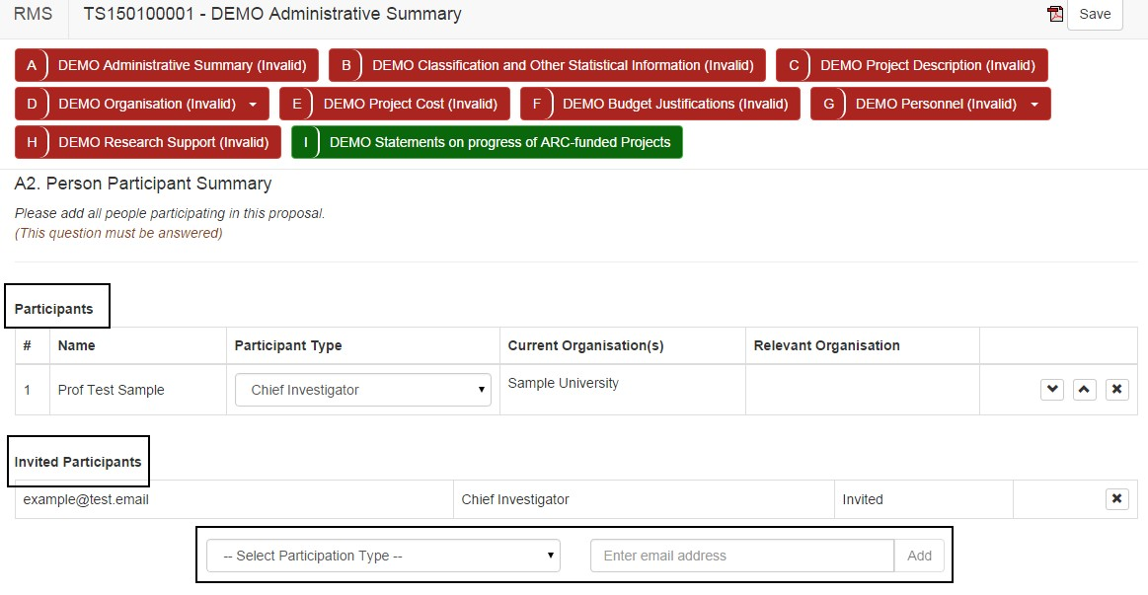

**Figure 7 – Inviting people to be participants on your application**

### 2.2 – Allocating full control to participants

* The default for each invited participant is to only be able to edit their own information in the *Personnel* form part of the application.
* For the creator of the application the default is set to full control.
* Full control means the ability to:
  + edit any part of the application
  + invite participants
  + remove participants
  + delete the draft application
  + revive a deleted draft application
  + Add/Remove Full Control from other participants
  + submit to their Research Office
* To change the default access of an applicant, click on the *Access* button under the *Applicant Application* section in the *Action Centre*. All applicants on the application will be listed in the *Access* page.

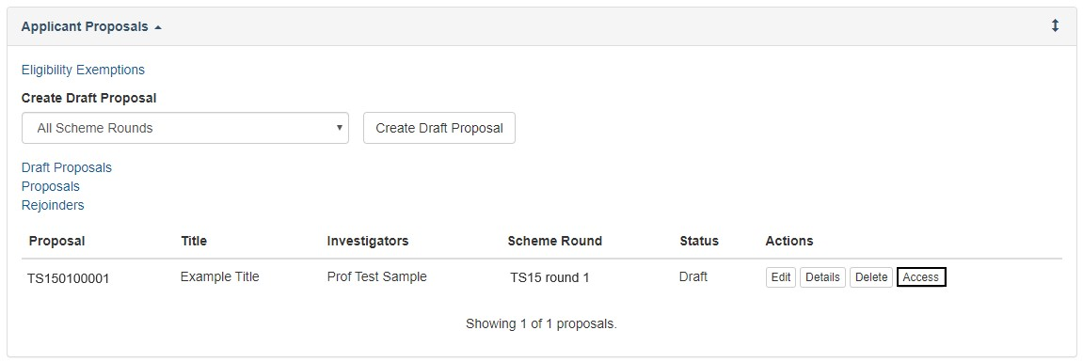

**Figure 8 – Where the Access button is located**

* Tick the check box under *Full Control* against the relevant applicant to provide them with full control.

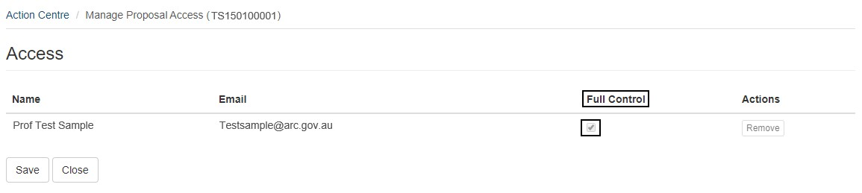

**Figure 9 – The Full Control checkbox**

* *Full Control* can also be removed by unchecking the box.
* Click *Save*.

### 2.3 – Giving access on an application to a non-participant

* Click on the *Access* button, as per Figure 8.
* Enter the non-participant’s email address in the *Email* field under *Add Access* and click on the Add button. A non-participant must have an RMS User Account in order to be given access to an application.

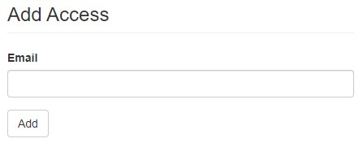

**Figure 10 – Giving access to a non-participant**

* Adding a non-participant will automatically provide them with Full Control. If you wish for them to have view only access, uncheck the Full Control checkbox, as per figure 9.

### 2.4 – How to accept an invitation to participate on an application

Each invited participant will receive an automated email as shown in Figure 11.

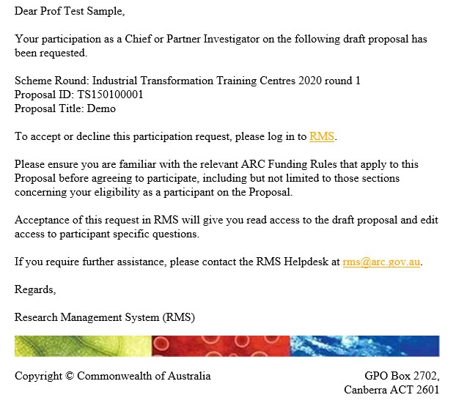

**Figure 11 – Automated email that invited participants receive**

* To accept the invitation, follow the RMS link and log in to RMS.
* Details of the application you are being asked to participate on will appear under *Invitations to Participate on Draft Applications* in the *Action Centre*.
* Click on the *Accept* or *Reject* button under *Actions*.

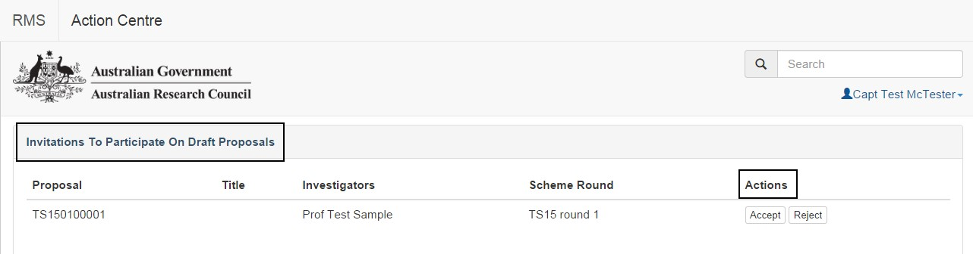

**Figure 12 – Location of the Accept/Reject buttons for an invited participant to select**

* Once accepted you can access the application in the *Applicant Applications* section by clicking on the *Edit* button under *Actions*.

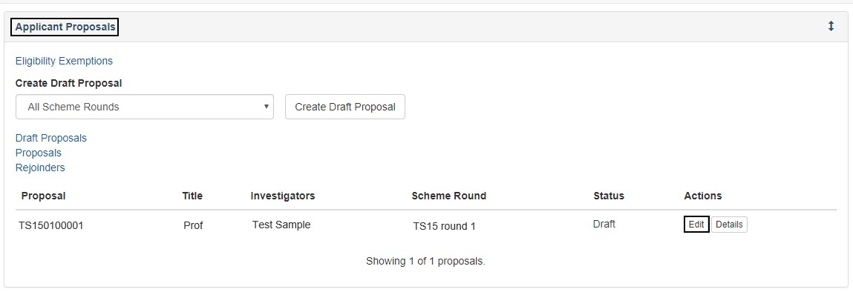

**Figure 13 – Accessing the Draft application once you have accepted an invitation to participate**

### 2.5 – Changing the order or role of participants

* To change the order of participants, click on the up/down arrows against that participant.
* To change the role of the participant, click on the drop-down menu under the *Participant Type* and select the role.

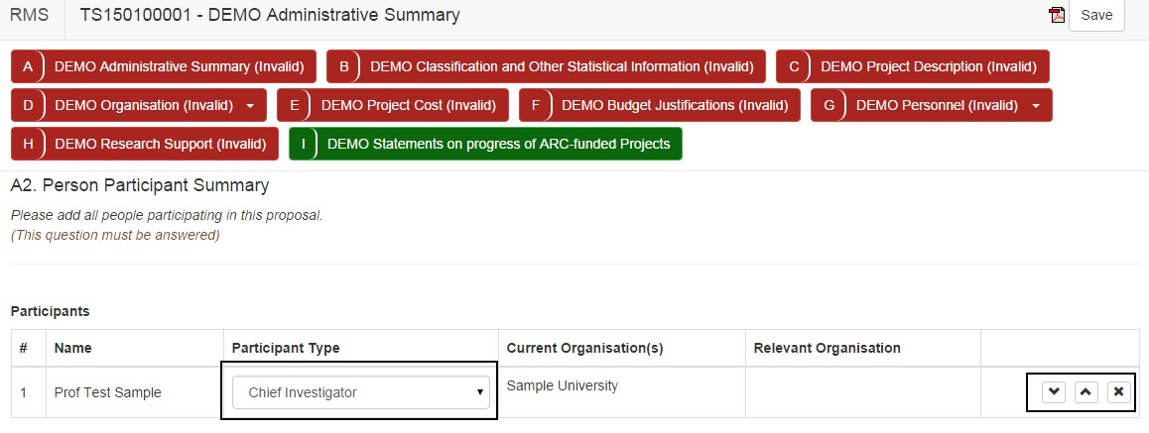

**Figure 14 – How to change a role type of a participant, move their position in the listing of participants, and remove a participant**

### 2.6 – Removing a participant

* To remove a participant from the application, click on the cross against the relevant participant.
* If a participant was removed by mistake you will need to reinvite the participant and they will need to accept the invitation again. Saved data will be repopulated and the participant will not need to re-enter this.

## PART 3 – Filling out the application form

The following will assist applicants in completing their applications and/or form parts. Applicants must still refer to the Instructions to Applicants for the relevant scheme which can be found via GrantConnect at [https://www.grants.gov.au](https://www.grants.gov.au/)

### 3.1 – Identifying if a question is mandatory

* To identify if a question is mandatory in a form you will see “(This question must be answered)” following the question text.
* A validation message will also appear for the question.

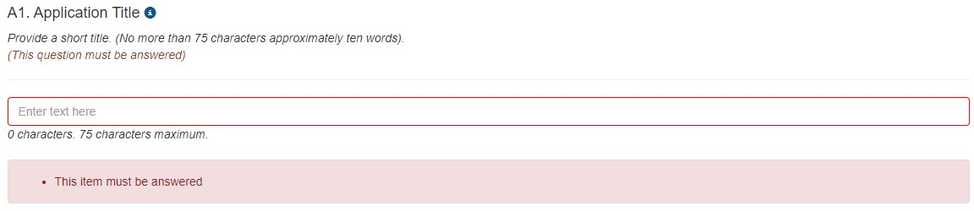

**Figure 15 – This question is mandatory and shows the validation message**

* Once a mandatory question has been answered the validation message will not appear.

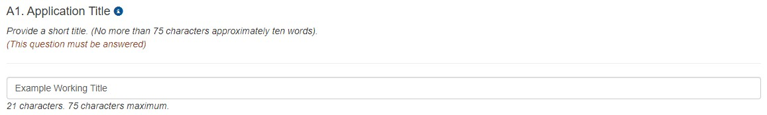

**Figure 16 – This mandatory question has been answered and the validation message no longer appears**

* Validation error messages will also appear if the question has been answered incorrectly. Figure 17 shows a validation error message because there has been more than the allowable number of characters entered. The validation message will appear until the error is corrected.

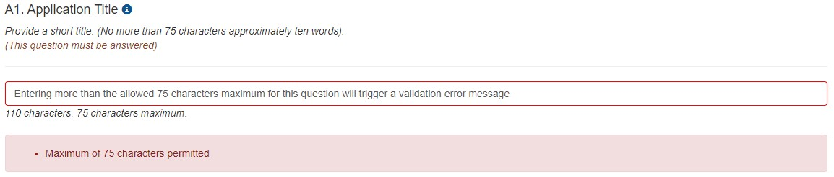

**Figure 17 – Validation error message received after too many characters being entered**

### 3.2 – Uploading a PDF

* Some questions may ask applicants to attach a PDF to the question.
* Click on the *Choose file* button, select the file and then click on the *Upload* button.
* The file name will appear underneath with the number of pages listed.
* To remove a file, click on the cross and then select *OK*.

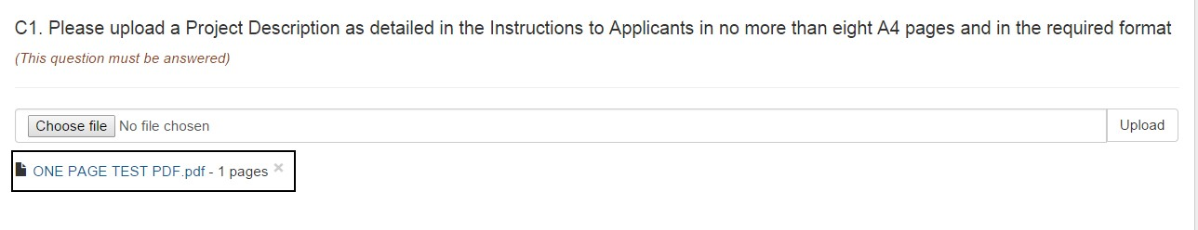

**Figure 18 – Uploading a PDF**

### 3.3 – Adding an Organisation to an application

* Go to the *Organisation Participant Summary* question in the *Administrative Summary* form part of the application.
* Select the organisation role type from the *Select Organisation Role* drop-down menu.

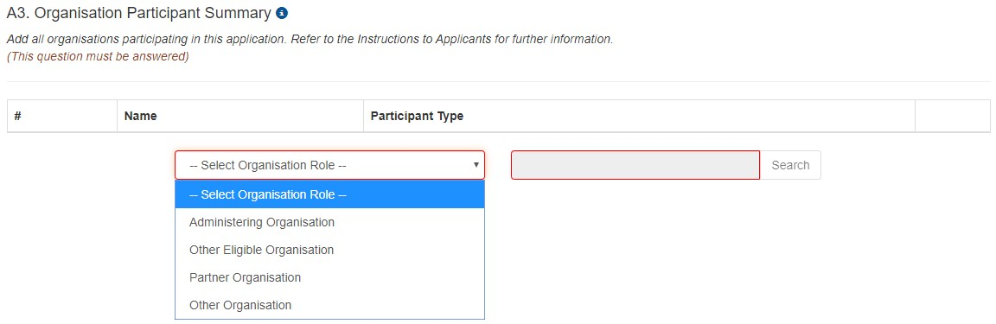

**Figure 19 – Select an Organisation Role Type**

* Enter the name of the organisation in the search field and click on the Search button.
* **Note:** This search field will work on partial name search. Some organisations may be listed with a slightly different name. Please ensure that you conduct a partial name search on an organisation before requesting the addition of a new organisation, as per Section 3.4.
* If the organisation is found using the search function, click on the *Add* button to add that organisation to an application.

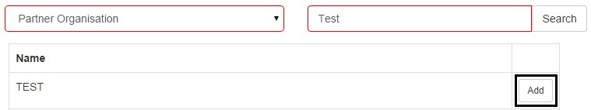

**Figure 20 – Add an organisation**

### 3.4 – Adding an Organisation using an Australian Business Number

* For the *Organisation Participant Summary* question, organisations can be added after using the search function.
* If an organisation is not appearing and you know the Australian Business Number (ABN) then click on the please *Add Organisation for use with RMS* link, which is located at the bottom of the *Organisation Participant Summary* question.
* Enter in the ABN and click the Search button. If the Search button does not become active check that the right number of digits have been entered. All ABNs consist of 11 digits.

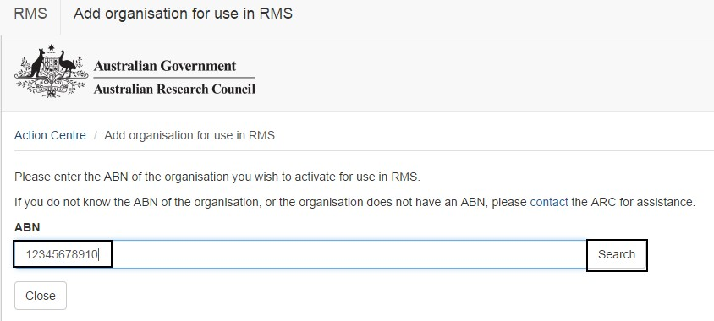

**Figure 21 – Entering in an ABN number to add an organisation for use in RMS**

* Click the *Add Organisation for use with RMS* button.

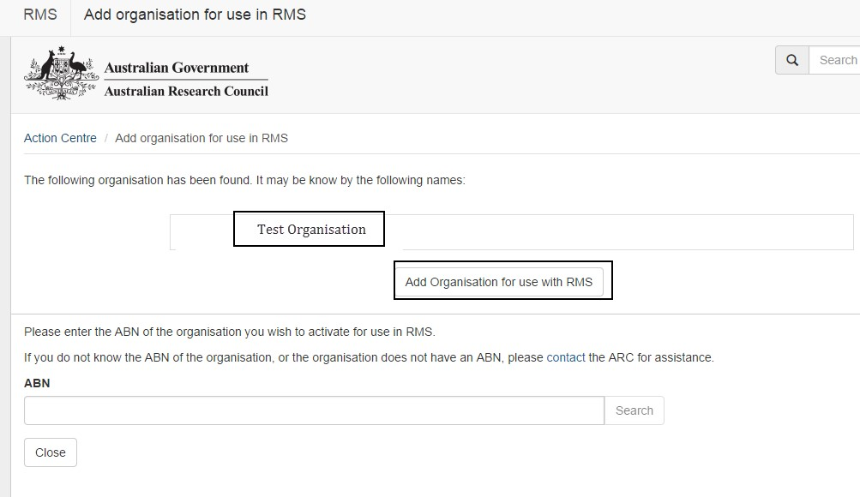

**Figure 22 – Adding the organisation for use in RMS**

* If an organisation does not have an ABN and is not available for selection via the search option, then click on the contact link for further assistance.

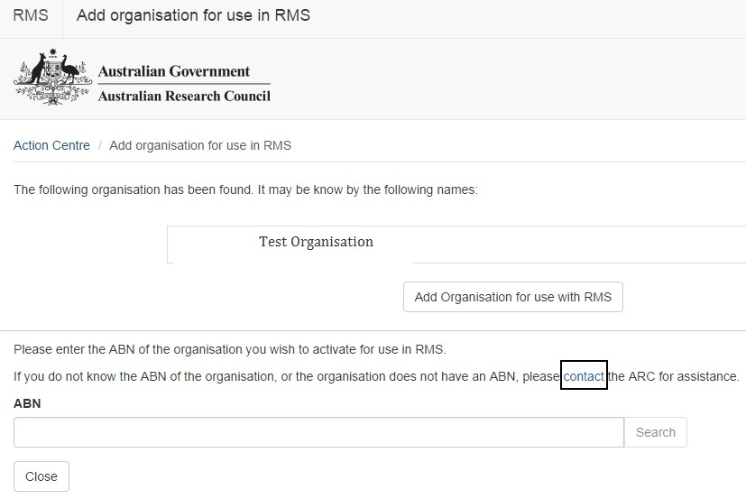

**Figure 23 – Click on the contact link for contact details to seek further assistance**

### 3.5 – Adding an International Organisation

* For the *Organisation Participant Summary* question, organisations can be added after using the search function.
* If an International Organisation is not appearing a request can be submitted to add the organisation to RMS using the request it to be created in RMS link, which is located at the bottom of the *Organisation Participant Summary* question
* Enter the organisation details and then click on the *Request* button.

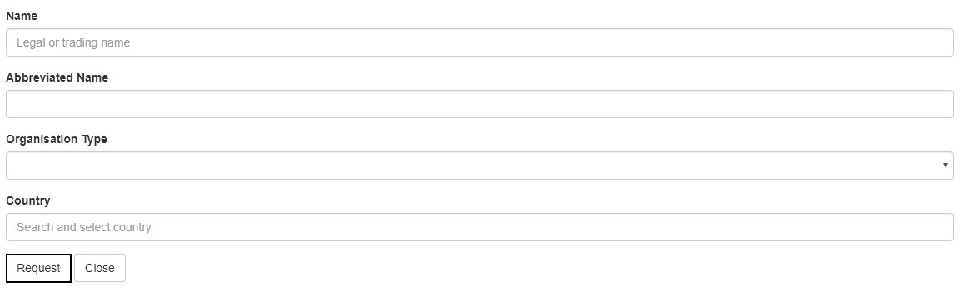

**Figure 24 – Requesting the addition of an International Organisation**

* The information will be reviewed by the RMS Helpdesk team and you will be notified when the organisation is available for use in RMS.
* For any information on pending organisation requests please contact ARCSystems@arc.gov.au.

### 3.6 – Accessing additional information against a question

* If there is additional information available for a question an information bubble will be visible next to the question title:



**Figure 25 – The information bubble icon that indicates additional information text**

* Click on the information bubble to expand the details

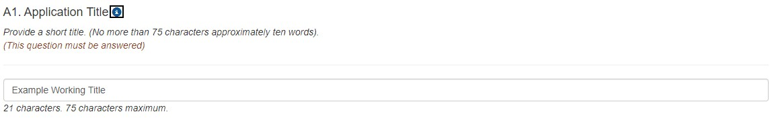

**Figure 26 – A question with an information bubble – click on the bubble to access further information**

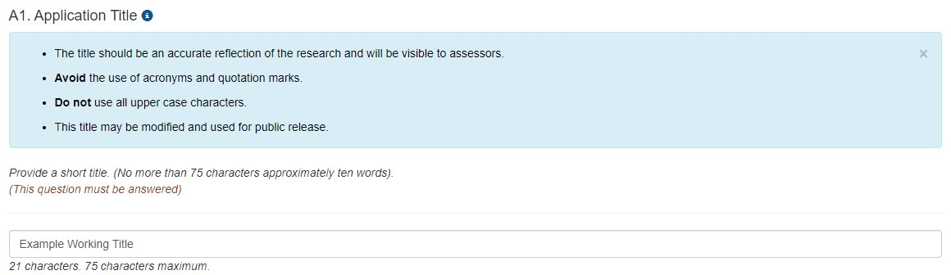

**Figure 27 – Information bubble expanded**

* Click on the cross at the top right of the information detail to close.

### 3.7 – Accessing your personal details from within the form

* Where a question auto-populates information from the personal details you have stored in RMS, a link will be available to access your personal details within your RMS profile.
* You can use the link within the application form or choose to navigate back to the Action Centre and click on the relevant link under Person Profile.
* As an example of the link within the form, the below question (*Personal Details*) contains a link entitled *Manage Personal Details*. Clicking on this link will automatically take you to your *Personal Details* page in a new tab.

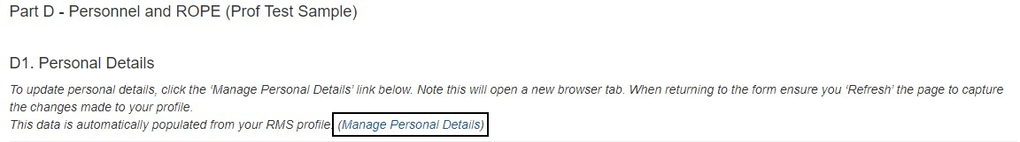

**Figure 28 – Accessing your details to update information that populates into the application**

* You can proceed to update your details and press *Save*. Close the tab and refresh your application page by clicking Save. Details that were updated will now appear.
* In addition to personal details, the *Research Output* section of the personal profile can be accessed through the application form. For more information on how to enter Research Outputs please see the ‘User Guide: Research Outputs in RMS’ located on the ARC [RMS Information](https://www.arc.gov.au/grants/rms-information) page.

### 3.8 – Generating a PDF of the application

* To generate a PDF of your application, click on the PDF icon displayed at the top right-hand corner.

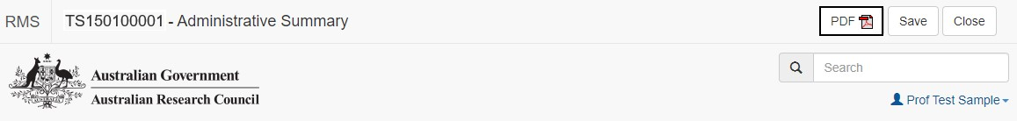

**Figure 29 – Click on the PDF icon to generate a PDF of your application**

* The PDF will generate and display in a separate tab.

### 3.9 – Adding information to the budget

**Adding budget items**

* Navigate to the *Project Cost* form part.
* The budget will automatically be set to Year 1. To access other years, click on the relevant year tab
* To enter in items, click on the plus button against the relevant budget category.

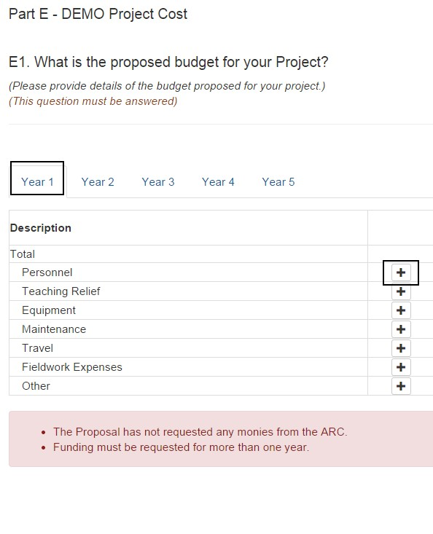

**Figure 30 – How to add an item in the budget**

* A text field box will appear for you to enter in your budget item description. Click the *OK* button to add the item to your budget.

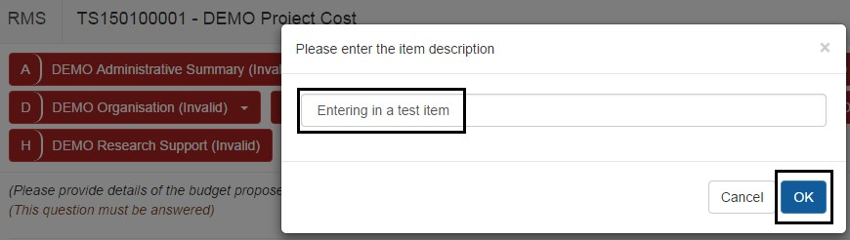

**Figure 31 – Entering a description for a budget item**

* The budget item will now appear in the budget, and you will be able to enter in a value.

To edit the budget item, click on the pencil button. To delete a budget item, click on the trashcan button.

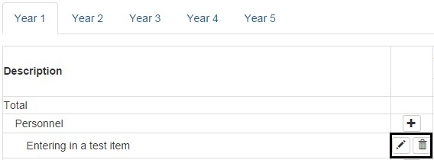

**Figure 32 – Click on the pencil icon to edit a budget item or on the trashcan icon to delete**

* Continue to fill out budget line items ensuring that you save regularly. All budget validation error messages will automatically appear at the bottom of the budget. Once these issues have been resolved, the validation messages will not appear.

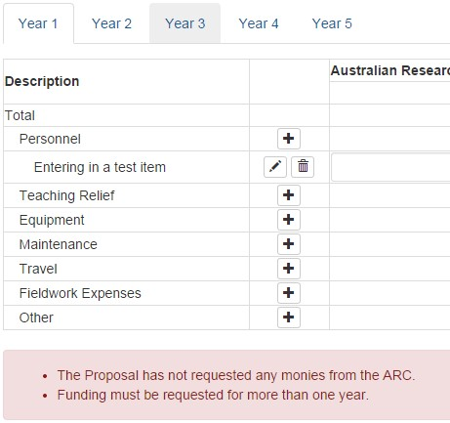

**Figure 33 – Validation error messages will appear under the budget table**

* Budget line items that are added will appear in all years.
* Values entered in against budget line items will only appear in the year that it was entered and not across all years.

Always refer to Instructions to Applicants for the specific scheme for more information on which items to add as a budget line item.

* Some budget line items are entered through the personnel section of the form, for example Teaching Relief. This information is automatically populated when the relevant Personnel question is answered. Please ensure to review the budget prior to submission to your Research Office.

**Adding a participant type to the budget (including unnamed participant types)**

* Some schemes may have additional participant type/s to add into the budget.
* To add a participant type, select from the drop-down menu under *Add Participant Type* and then click on *Add*.
* Some types will also have levels that can be selected in addition to the start year. Select the level and start year from the drop-down menu next to the selection for participant type and then click on *Add*. This will automatically populate into the budget.

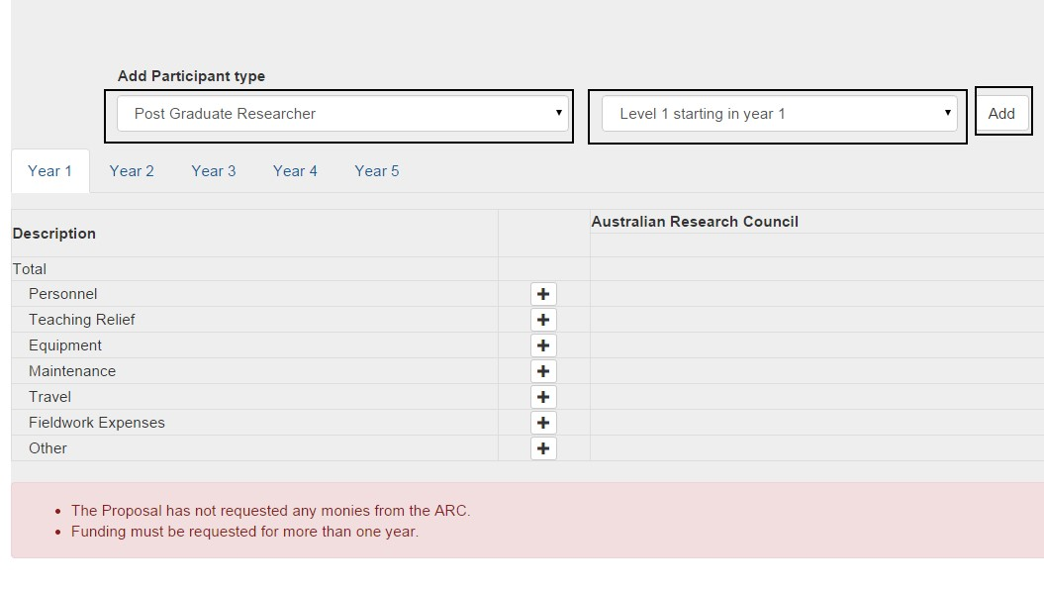

**Figure 34 – Participant types can be added by using the drop-down menu and clicking the add button**

* Note that where only a single level is available, only Level 1 starting in year 1 will be listed in the drop-down menu.
* Participant budget items will be added to the budget automatically along with an allocated value amount. Where permissible following an item being added automatically, the value can be amended.

### 3.10 – Submitting an application to your Research Office

* Once all the form parts are completed, saved and are validated (changed from red to green), the application is ready to be submitted to the Research Office.



**Figure 35 – Once all the information is added to each form part and all form parts are green, the application is ready to submit to the Research Office**

* Before submitting your application to the Research Office, the Project Leader must:
  + review all form parts to ensure the information to be submitted is accurate.
  + ensure all form parts are complete and valid; and
  + generate a PDF (Whole Application document PDF).
* Once the above has been confirmed, click on the *Submit to Research Office* button from the *Action Centre*.

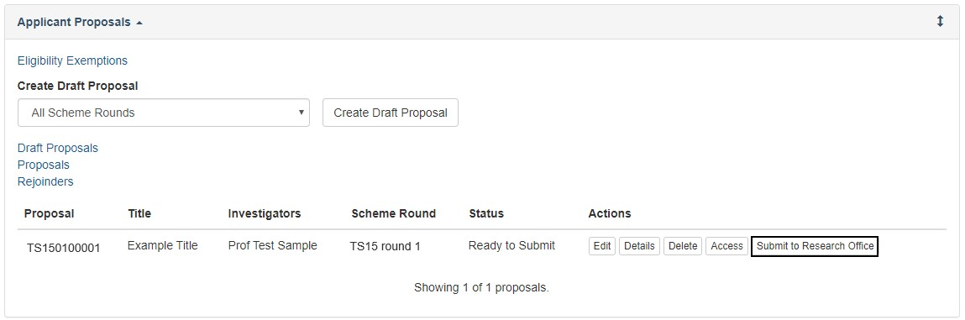

**Figure 36 – Submitting your draft application to the Research Office**

### 3.11 – Deleting a draft application

* If you have created a draft application in error and you no longer want to view the details, it can be deleted using the *Delete* button to the right of the Application ID



**Figure 37 – Click on the delete button to delete your draft application**

* Once an application is deleted it will no longer be visible in the *Action Centre*

### 3.12 – Reviving a deleted draft application

* To retrieve a deleted draft application, click on the *Draft Application* under the *Applicant Application* section.

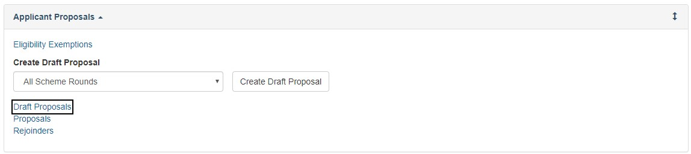

**Figure 38 – Accessing a deleted draft application**

* The deleted application will show as a *Deleted* under the *Status* heading.
* Click on the *Revive* button under *Actions*.

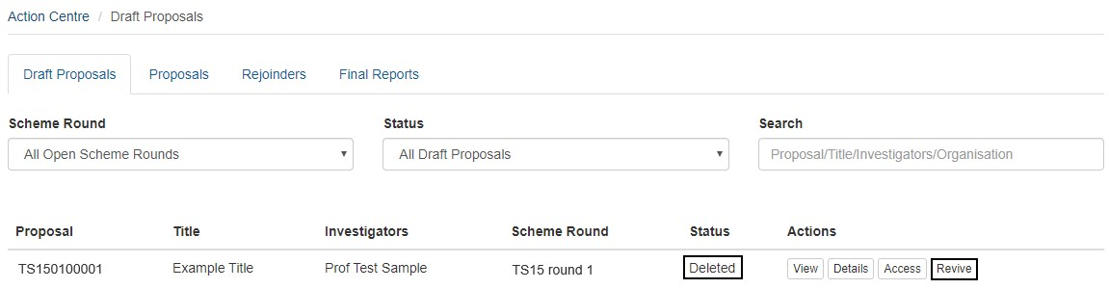

**Figure 39 – A deleted application can be revived by clicking the Revive button**

* The application will now have *Draft* under the *Status* heading and you will now be able to click on the *Edit* button to continue working on the application.

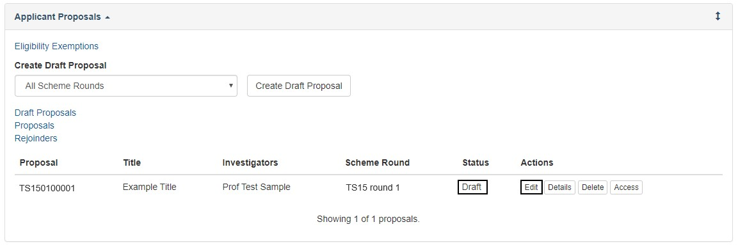

**Figure 40 – An application that was deleted and now revived will show as Draft status.**