

**Research Management System**

**(RMS)**

**User Guide for Applicants and Research Office Staff – Submitting a Rejoinder**

Contents

Introduction 2

Key Points 2

PART 1 – Individuals with Full Edit Access to an Application 3

1.1 Reviewing Assessment Text 3

1.2 Entering Rejoinder text and submitting to Research Office 4

1.3 Accessing Rejoinder text once submitted to Granting Agency 5

PART 2 – Individuals without Full Edit Access to an Application 5

2.1 Reviewing Assessment text 5

2.2 Reviewing Rejoinder text 7

2.3 Accessing Rejoinder text once submitted to Granting Agency 7

PART 3 – Research Office Rejoinder Management 8

3.1 Entering Rejoinder text on an Applicant’s behalf 8

3.2 De-submitting Rejoinder to Applicant 8

3.2 Submitting Rejoinder to Granting Agency 9

3.2.1 Individual Rejoinder Submission 9

3.2.2 Bulk Rejoinder Submission 10

3.3 Accessing Rejoinder text once submitted to Granting Agency 11

PART 4 – Contacting the ARC for additional help 12

# Introduction

The Research Management System (RMS) is a web-based application developed by the Australian Research Council (ARC) and now used by multiple agencies to manage their Grant Programs. Each agency can utilise functions such as: submissions, request not to assess, assignment and assessment, rejoinders, announcement, grant offers/acceptance, and post-award activities such as grant variations and project reporting.

More detailed information on the agencies utilising RMS is available on the [Research Grant Services](https://www.arc.gov.au/research-grants-services) page of the ARC Website.

**RMS Access**

The web address to access RMS is dependent on the agency or program that you are needing to interact with.

* ARC (NCGP) RMS instance - <https://rms.arc.gov.au>
* DESE (NCRIS) RMS instance - [https://dese.researchgrants.gov.au](https://dese.researchgrants.gov.au/)
* ONI (NISDRG) RMS instance - <https://rmsoni.researchgrants.gov.au>
* Defence (NISDRG) RMS Instance - <https://defence.researchgrants.gov.au>

**Note** - You only need one account to access RMS, regardless of agency or program you are accessing, however you will require specific roles for each version/instance of RMS.

All screenshots provided within this document have been sourced from the NCGP instance of RMS and images may differ slightly dependent on the instance you are using.

# Key Points

* + - The target audience for this user guide is scheme round participants and Research Office staff who will be submitting a Rejoinder within RMS.
    - RMS is compatible with the latest versions of Google Chrome and Microsoft Edge. The ARC cannot guarantee compatibility with other browsers or older versions of Google Chrome or Microsoft Edge.
    - Assessor comments and Rejoinders can be viewed by any individual listed on the corresponding scheme round application within RMS. Drafting rejoinder text and submission are reserved for individuals with full edit access to the corresponding scheme round application within RMS. For additional details on granting full access to individuals please see the ‘Submitting an Application’ user guide available on the [ARC website](https://www.arc.gov.au/grants/rms-information).

# PART 1 – Individuals with Full Edit Access to an Application

Individuals with full edit access to the corresponding scheme round application can view assessment text, draft rejoinder text and submit to the Research Office through the ‘Rejoinders’ link within the RMS Action Centre.

## Reviewing Assessment Text

The responses provided by external assessors can be viewed to allow applicants to respond to assessment comments prior to the final assessments conducted by the Selection Advisory Committee.

* Navigate to the RMS Action Centre.
* Select the ‘Rejoinders’ link from the Action Centre.

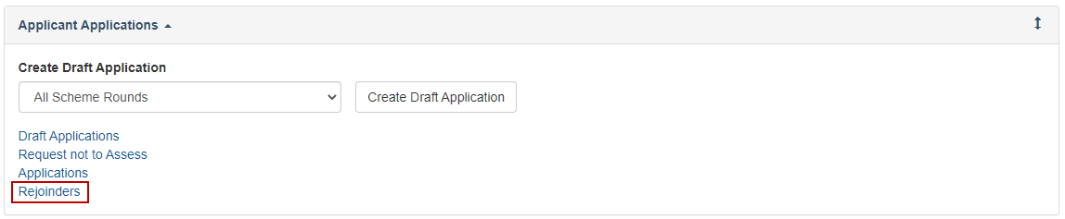  
**Figure 1 – Rejoinders link from Action Centre**

* Locate the corresponding scheme round application by selecting the Scheme Round from the available filters and select ‘Edit’ to open the application details

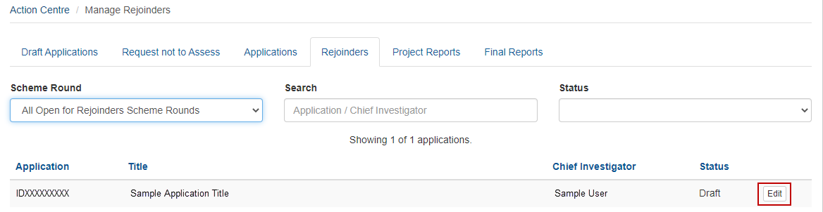**Note -** If the individual attempting to view the assessment text through the rejoinder link does not hold full edit access to the corresponding scheme round application, the application will not appear within this screen. Please continue to Part 2 of this document or request full access by following the steps outlined in the ‘Submitting an Application’ user guide available on the [ARC website](https://www.arc.gov.au/grants/rms-information).

**Figure 2 – ‘Edit’ button for associated scheme round application**

* The page will contain a summary of information on the Application and will contain de-identified assessments. To access the assessment text, click on the Assessor link.

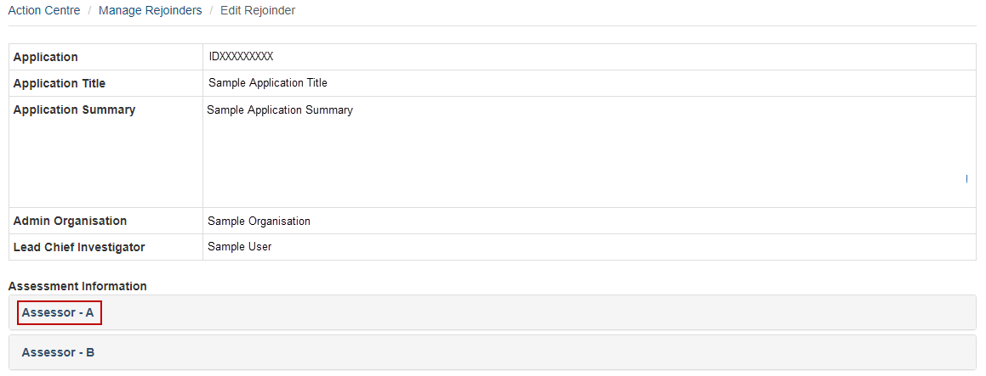  
**Figure 3 – Assessor link to open assessment detail**

* Selecting the Assessor link will open the assessment criteria text response provided by the assessor.

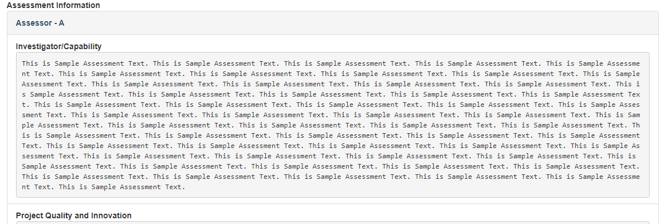  
**Figure 4 – Assessment text entered by assessor**

## Entering Rejoinder text and submitting to Research Office

Rejoinder text is entered into the ‘Rejoinder’ field, noting the maximum character limits.

* Enter text into the ‘Rejoinder’ field.

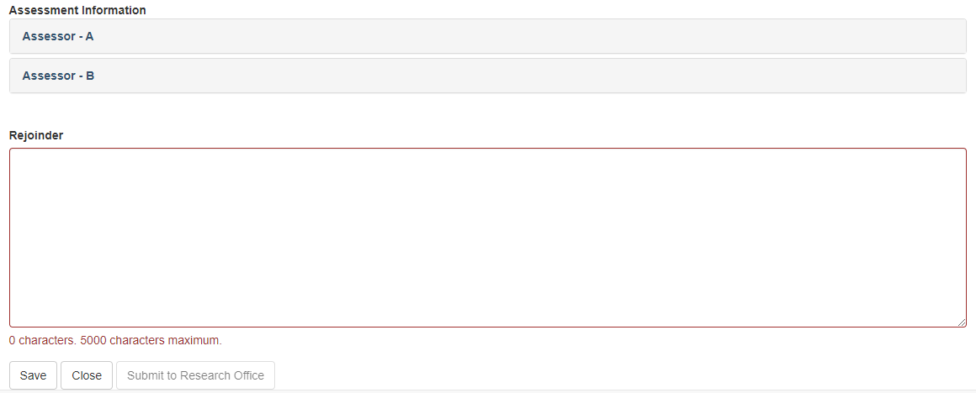  
**Figure 5 – Rejoinder entry field**

* To save the Rejoinder text select ‘Save’.

**Note** – Ensure to save regularly to avoid losing data entered due to time out.

* To close the screen and return to the ‘Manage Rejoinder’ page shown in Figure 2 select ‘Close’.
* To finalise the rejoinder and submit to the Research Office select ‘Submit to Research Office’.

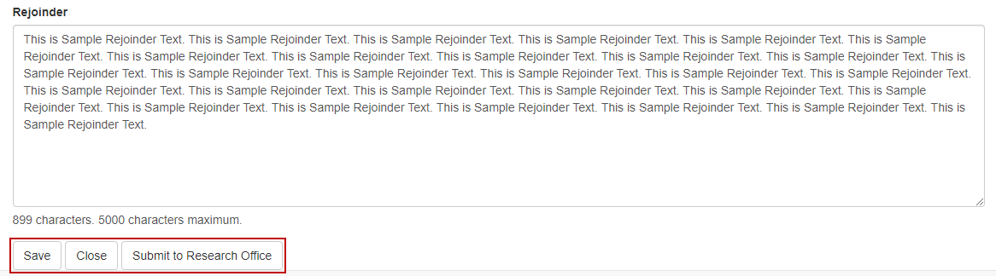  
**Figure 6 – ‘Save’, ‘Close’ and ‘Submit to RO’ button**

**Note** – Once the rejoinder has been submitted to the Research Office the rejoinder becomes locked and further amendments cannot be made. If amendments are required, please contact the Research Office and request rejoinder de-submission to return the rejoinder to a ‘Draft’ status.

## Accessing Rejoinder text once submitted to Granting Agency

Rejoinder text entered by an individual with full edit access to the corresponding scheme round application will appear in the ‘Rejoinder Text’ section of the ‘Assessment’ tab and remain accessible in RMS once submitted to the Granting Agency.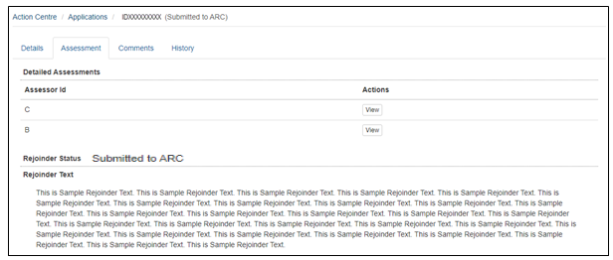

**Figure 7 – ‘Rejoinder Status’ and ‘Rejoinder Text’ once submitted to Granting Agency**

# PART 2 – Individuals without Full Edit Access to an Application

Individuals without full edit access to the corresponding scheme round application can view assessment text and completed Rejoinder text through the ‘Applications’ link within the RMS Action Centre.

## 2.1 Reviewing Assessment text

The responses provided by external assessors can be viewed to allow applicants to respond to assessment comments prior to the final assessments conducted by the Selection Advisory Committee.

* Navigate to the RMS Action Centre.
* Select the ‘Applications’ link from the Action Centre.

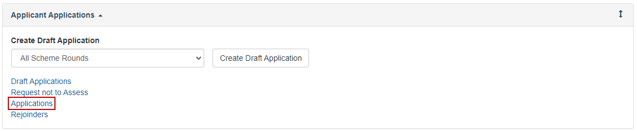  
**Figure 8 – Applications link from Action Centre**

* Locate the corresponding scheme round application by selecting the Scheme Round from the available filters and select ‘Details’ to open the application details.

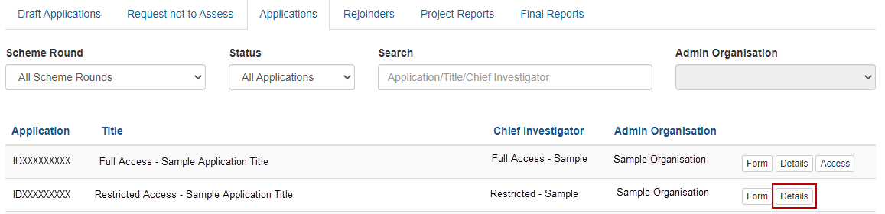  
**Figure 9 – ‘Details’ button for associated scheme round application**

* Click on the ‘Assessment’ tab to view the submitted assessments and entered rejoinder text.

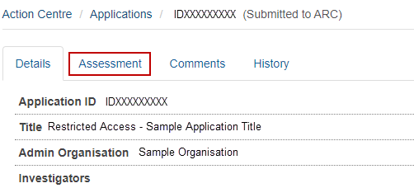  
**Figure 10 – ‘Assessment’ tab within application details**

* Click on the ‘View’ button to expand the response provided by the Assessor.

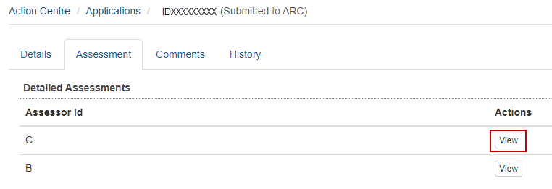  
**Figure 11 – ‘View’ button to expand assessor response**

* Click on the ‘Hide’ button to minimise the response provided by the Assessor.

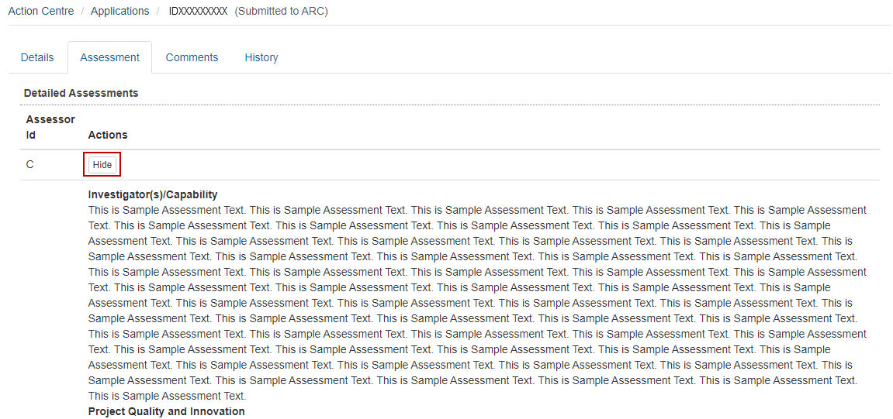  
**Figure 12 – ‘Hide’ button to minimise assessor response**

## 2.2 Reviewing Rejoinder text

Rejoinder text entered by an individual without full edit access to the corresponding scheme round application will appear in the ‘Rejoinder Text’ section of the ‘Assessment’ tab.

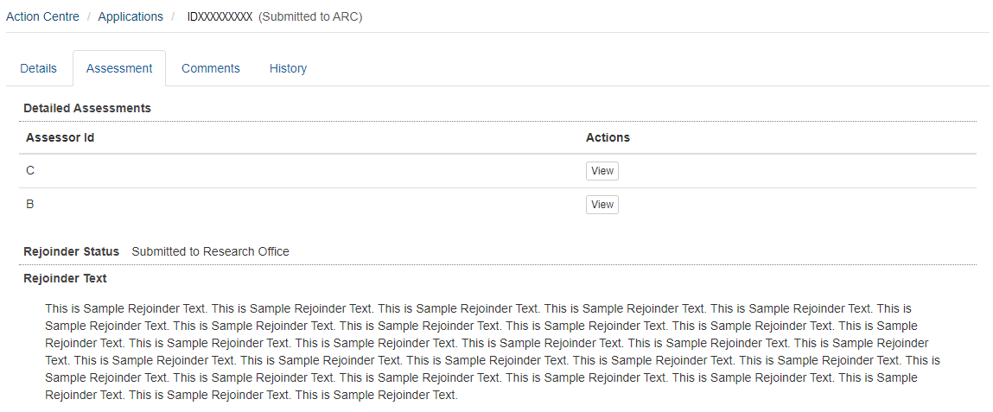  
**Figure 13 – ‘Rejoinder Status’ and ‘Rejoinder Text’**

## 2.3 Accessing Rejoinder text once submitted to Granting Agency

Rejoinder text entered by an individual without full edit access to the corresponding scheme round application will appear in the ‘Rejoinder Text’ section of the ‘Assessment’ tab and remain accessible in RMS once submitted to the Granting Agency. 

**Figure 14 – ‘Rejoinder Status’ and ‘Rejoinder Text’ once submitted to the Granting Agency**

# PART 3 – Research Office Rejoinder Management

Research Office staff can enter rejoinder text on an applicant’s behalf. In addition, Research Office staff users have the ability to de-submit rejoinders to the applicant for update or submit the rejoinder to the granting agency for review.

## 3.1 Entering Rejoinder text on an Applicant’s behalf

* Navigate to the RMS Action Centre
* Select the ‘Research Office Rejoinders’ link from the Action Centre

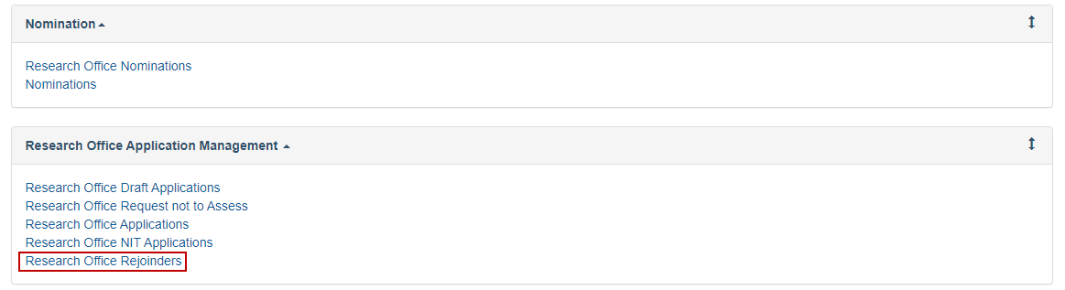  
**Figure 15 – ‘Research Office Rejoinders’ link from the Action Centre**

* Locate the corresponding scheme round application by selecting the Scheme Round from the available filters

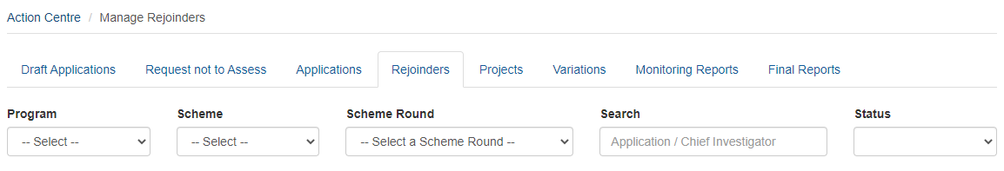  
**Figure 16 – Manage Rejoinders filter options**

* To enter rejoinder text select ‘Edit’

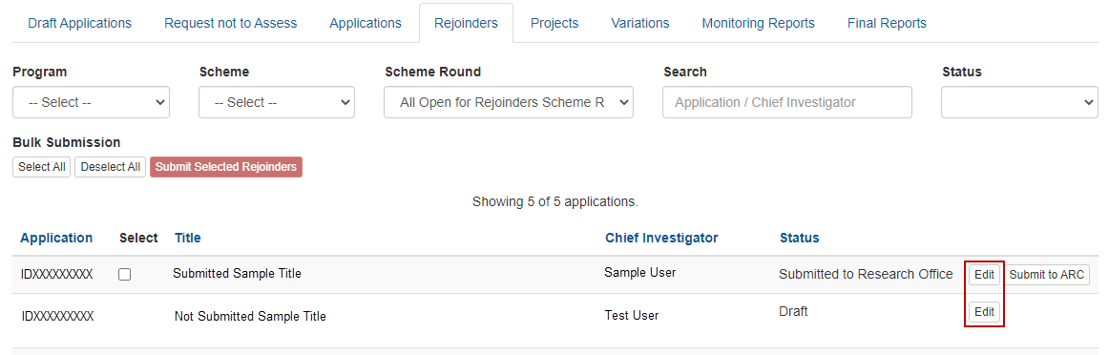  
**Figure 17 – ‘Edit’ button for associated scheme round application**

* Enter rejoinder text and submit to Research Office as per Section 1.2 of this document

## 3.2 De-submitting Rejoinder to Applicant

If the rejoinder requires additional updates by the applicant, the rejoinder must be de-submitted to allow for amendment.

* Locate relevant application and select ‘Edit’ (figure 17)
* Select ‘De-submit’ to return the rejoinder to draft status and allow for edits to be made by individuals with full edit access to the associated scheme round application

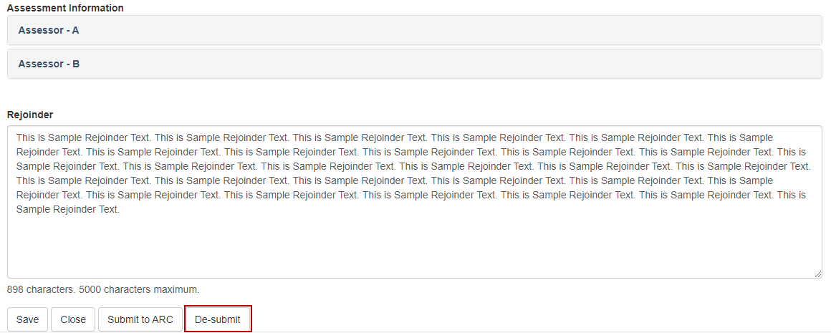  
**Figure 18 – ‘De-submit’ button for rejoinder**

## 3.2 Submitting Rejoinder to Granting Agency

The rejoinder must be submitted to the Granting Agency for review. The submission process can be completed in bulk or for each individual rejoinder.

### 3.2.1 Individual Rejoinder Submission

Individual submission will only submit the selected rejoinder, which can be submitted in two ways - from within the rejoinder edit page or the Research Office Rejoinders page.

**Option 1:**

* Navigate to ‘Research Office Rejoinders’ page within RMS
* Select the ‘Submit to ARC’ button

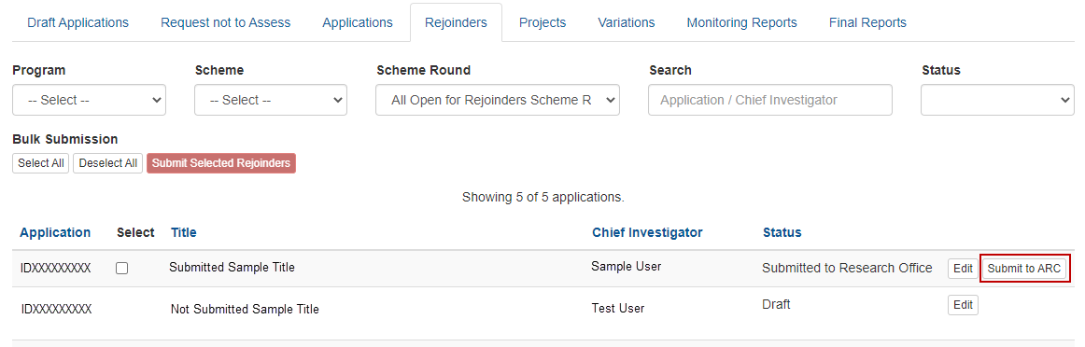  
**Figure 19 – ‘Submit to ARC’ button located on the Research Office Rejoinders page**

**Option 2:**

* Navigate to the individual rejoinder by selecting ‘edit’ from the Research Office Rejoinders page
* Select the ‘Submit to ARC’ button

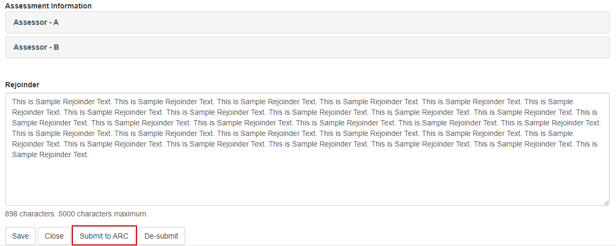  
**Figure 20 – ‘Submit’ button located on the rejoinder edit page**

### 3.2.2 Bulk Rejoinder Submission

Bulk submission allows the Research Office to select all rejoinders currently in the status ‘Submitted to Research Office’ and submit all selected rejoinders to the Granting Agency at once

* Navigate to ‘Research Office Rejoinders’ page within RMS
* Click the ‘Select All’ button to select all rejoinders currently in the status of ‘Submitted to Research Office’

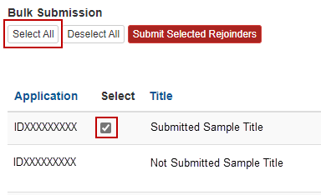  
**Figure 21 – ‘Select All’ button and selected tick box flag**

* If an individual rejoinder is to be removed from the bulk submission process the tick box next to the relevant application can be de-selected (Figure 18)
* If the selection was made in error all selected rejoinders can be removed from the bulk submission process by clicking the ‘Deselect All’ button.

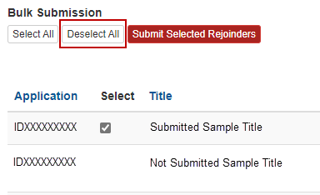  
**Figure 22 – ‘Deselect All’ button**

* Once the selection has been reviewed and all selected rejoinders are to be submitted to the Granting Agency click the ‘Submit Selected Rejoinders’ button

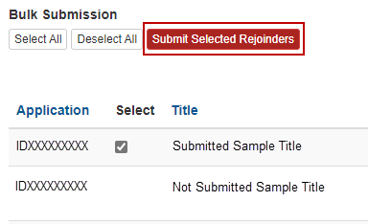  
**Figure 23 – ‘Submit Selected Rejoinders’ button**

**Note** – Once the rejoinder has been submitted to the Granting Agency the rejoinder becomes locked and further amendments cannot be made. If amendments are required, please contact the Granting Agency and request rejoinder de-submission to return the rejoinder to a ‘Submitted to Research Office’ status.

## 3.3 Accessing Rejoinder text once submitted to Granting Agency

Once the Rejoinder has been submitted to the Granting Agency, Research Office staff users are able to download the bulk Rejoinder Extract from RMS.

* Return to the RMS Action Centre
* Select the ‘Research Office Staff Reports’ link from the Action Centre

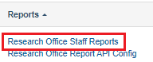

**Figure 24 – Select the ‘Research Office Staff Reports’**

* Select the ‘Rejoinder Extract’ from the drop-down list under ‘Report’

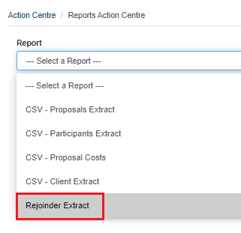

**Figure 25 – Select the ‘Rejoinder Extract’**

* Select ‘Scheme Round’ from the drop-down list

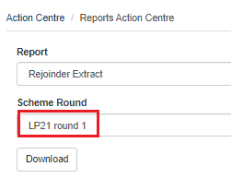

**Figure 26 – Select the ‘Scheme Round’**

* Select ‘Download’ button

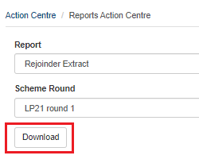

**Figure 27 – Select the ‘Download’ button**

**Note** – The Rejoinder Extract will not be accessible after the outcomes are announced**.**

# PART 4 – Contacting the ARC for additional help

If you are experiencing any technical issues or require help with navigating RMS whilst completing your Rejoinder, please contact the RMS Support team at [RMSSupport@ARC.gov.au](mailto:RMSSupport@ARC.gov.au).