

**Research Management System**

**(RMS)**

**User Guide for Applicants and Research Office Staff – Submitting a Request Not to Assess**

Contents

Introduction 2

Key Points 2

PART 1 – Creation and Deletion of a Request Not to Assess 3

1.1 – Creating a Request Not to Assess 3

1.2 – Returning to a Previously Created Request Not to Assess 4

1.3 – Deleting a Previously Created Request Not to Assess 4

PART 2 – Completing the Request Not to Assess form 5

2.1 – College of Experts Member Request Not to Assess Entry 6

2.2 – Non-College of Experts Member Request Not to Assess Entry 8

PART 3 – Submitting the Request Not to Assess to the Research Office 10

PART 4 – Research Office Request Not to Assess Submission 10

PART 5 – Contacting the ARC for additional help 12

# Introduction

The Research Management System (RMS) is a web-based application developed by the Australian Research Council (ARC) and now used by multiple agencies to manage their Grant Programs. Each agency can utilise functions such as: submissions, request not to assess, assignment and assessment, rejoinders, announcement, grant offers/acceptance, and post-award activities such as grant variations and project reporting.

More detailed information on the agencies utilising RMS is available on the [Research Grant Services](https://www.arc.gov.au/research-grants-services) page of the ARC Website.

**RMS Access**

The web address to access RMS is dependent on the agency or program that you are needing to interact with.

* ARC (NCGP) RMS instance - <https://rms.arc.gov.au>
* DESE (NCRIS) RMS instance - [https://dese.researchgrants.gov.au](https://dese.researchgrants.gov.au/)
* ONI (NISDRG) RMS instance - <https://rmsoni.researchgrants.gov.au>
* Defence (NISDRG) RMS Instance - <https://defence.researchgrants.gov.au>

**Note** - You only need one account to access RMS, regardless of agency or program you are accessing, however you will require specific roles for each version/instance of RMS.

All screenshots provided within this document have been sourced from the NCGP instance of RMS and images may differ slightly dependent on the instance you are using.

# Key Points

* + - The target audience for this user guide is scheme round participants and Research Office staff who will be submitting a Request Not to Assess (RNTA) within RMS.
    - RMS is compatible with the latest versions of Google Chrome and Microsoft Edge. The ARC cannot guarantee compatibility with other browsers or older versions of Google Chrome or Microsoft Edge.
    - RNTAs can only be created or edited by individuals who have full edit access to the corresponding scheme round application within RMS. For additional details on granting full access to individuals please see the ‘Submitting an Application’ user guide available on the [ARC website](https://www.arc.gov.au/grants/rms-information).
    - An RNTA will only become available once the scheme round application has information contained in the Application Title, Application Summary, Administering Organisation detail and at least 1 Chief Investigator listed. For further information on how to complete these details please refer to the scheme specific Instructions to Applicants available on the Grant Opportunity located on [GrantConnect](https://www.grants.gov.au/Go/List).
    - A total of three individuals can be added to an RNTA. This limit is enforced at the application level and does not increase based on the number of listed participants. Additional justification will be required for requests for College of Experts.

# PART 1 – Creation and Deletion of a Request Not to Assess

Requests Not to Assess (RNTA) are associated by application ID. To create the RNTA, ensure that the application form has been created and the below details have been completed within the application form.

* Application Title
* Application Summary
* Administering Organisation
* Lead Investigator

**Note** – Only individuals with full edit access to the application form will be able to create or edit the RNTA. For further information on granting full access to individuals please see the ‘Submitting an Application’ user guide available on the [ARC website](https://www.arc.gov.au/grants/rms-information).

## 1.1 – Creating a Request Not to Assess

Once the application form has the required information entered the below steps can be completed to create the RNTA.

* Return to the RMS Action Centre.
* Select the ‘Request not to Assess’ link from the Action Centre.

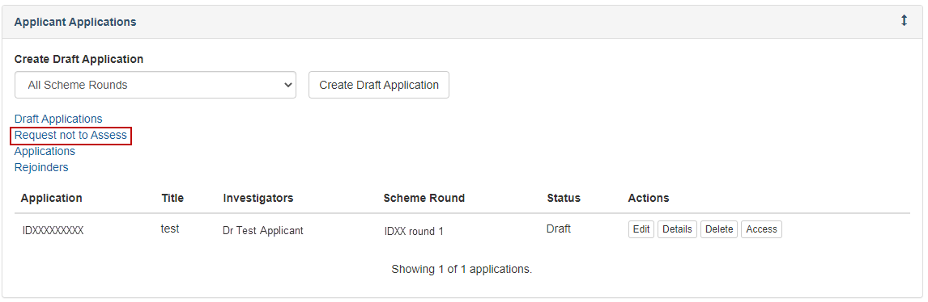

**Figure 1 – Request not to Assess link from Action Centre**

* Locate the corresponding scheme round application by selecting the Scheme Round from the filter.

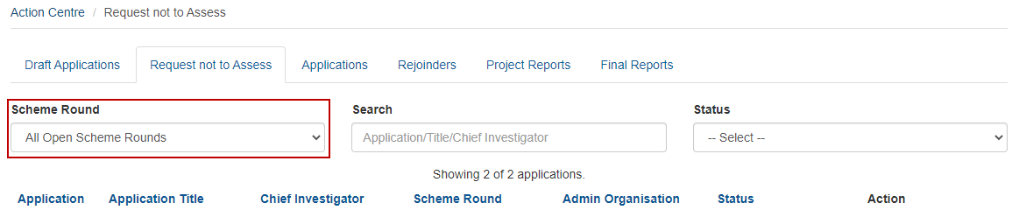

**Figure 2 – Scheme Round filter menu**

* Select the ‘Create’ button with the associated scheme round application.

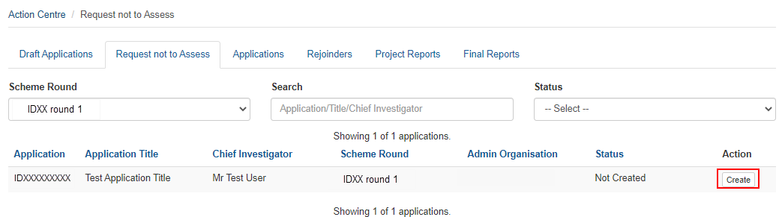

**Figure 3 – Create button with association scheme round application**

* Confirm you wish to create an RNTA for an application.

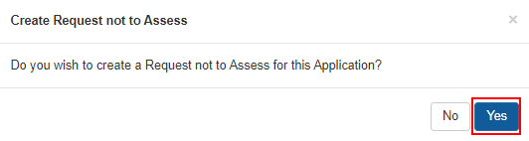  
**Figure 4 – Confirming RNTA creation**

## 1.2 – Returning to a Previously Created Request Not to Assess

Once the RNTA form has been created within RMS you can save changes and resume editing at anytime prior to the RNTA closure date.

* Select the ‘Request not to Assess’ link from the Action Centre (Figure 1).
* Locate the relevant RNTA from the available list.
* Select the ‘Edit’ button to resume editing a created RNTA.

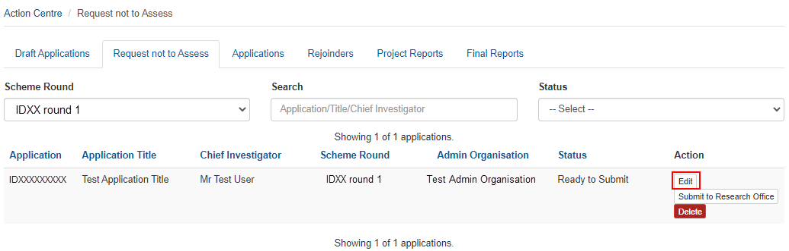  
**Figure 5 – ‘Edit’ button within RNTA page**

## 1.3 – Deleting a Previously Created Request Not to Assess

If an RNTA has been created in error, it can be deleted within RMS prior to submission to the Research Office. If you wish to delete a request after Research Office submission, please contact the application Administering Organisation who can delete the RNTA on your behalf.

* Select the ‘Request not to Assess’ link from the Action Centre (Figure 1).
* Locate the relevant RNTA from the available list.
* Select the ‘Delete’ button to remove the RNTA .

**Note** – Deleting an RNTA will revert the status to ‘Not Created’ and if an RNTA is required at a later stage Step 1.1 must be repeated.

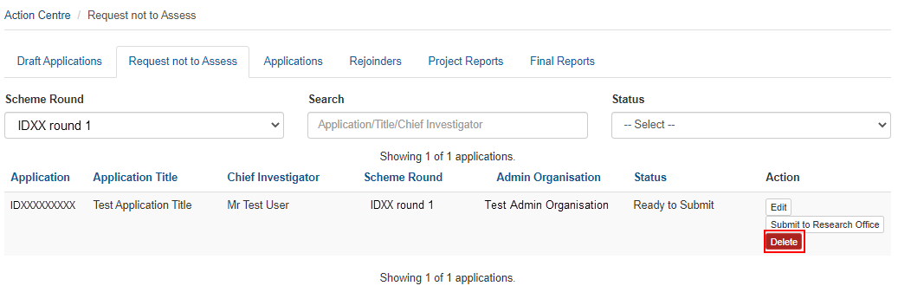**Figure 6 – Deleting an RNTA**

# PART 2 – Completing the Request Not to Assess form

Once the ‘Create’ button has been selected an RNTA form becomes available for completion. This form displays application details including the Application, Title, Summary, Administering Organisation and the name of the Lead Investigator.

* To begin entering details of the individual select the ‘Add Assessor’ button located at the bottom of the form.

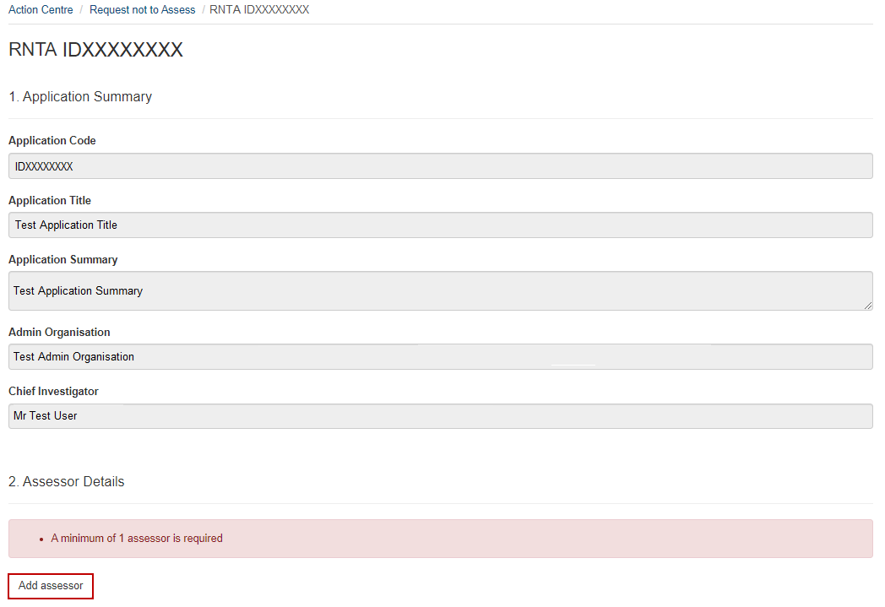**Figure 7 – ‘Add Assessor’ button at the bottom of the RNTA form**

* Once the ‘Add Assessor’ button is selected a Yes/No question will display requesting if the individual is currently recognised as an ARC College of Experts member.
* If the answer is no, select No from the dropdown menu and continue to Section 2.2 of this document.
* If the answer is yes, additional questions will appear in the drop down as shown in Section 2.1 of this document.

**Note** – If you are unsure if the individual is currently serving as a College of Experts member the list is available on the [ARC website](https://www.arc.gov.au/about-arc/arc-profile/arc-committees/arc-college-experts), alternatively a list of active members can be located within the RNTA form after selecting ‘Yes’ to the college member question (further details on locating this list can be found in Section 2.1 of this document).

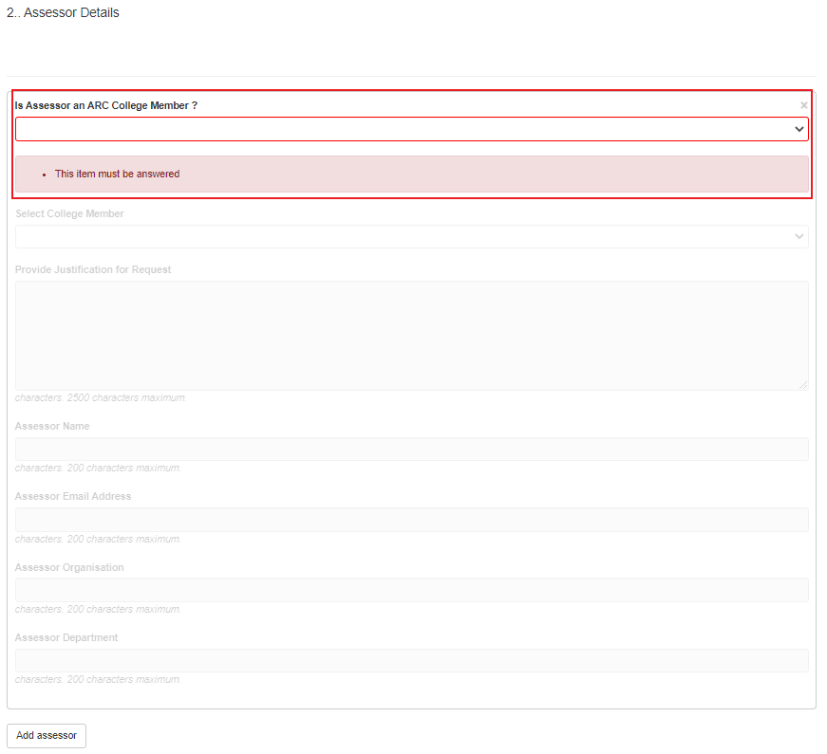**Figure 8 – ‘Is Assessor an ARC College Member’ dropdown question**

* If an individual is entered in error the Assessor section can be removed by selecting the ‘X’ on the top right of the individual information box.

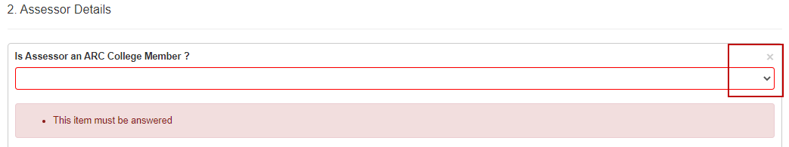**Figure 9 – ‘X’ to remove assessor from RNTA**

## 2.1 – College of Experts Member Request Not to Assess Entry

If the individual is currently serving as an ARC College of Expert member the name can be selected from the available dropdown list, and additional justification is required prior to submission of the RNTA form.

* Once ‘Yes’ is selected to the college member dropdown two additional mandatory fields will display within the form.

**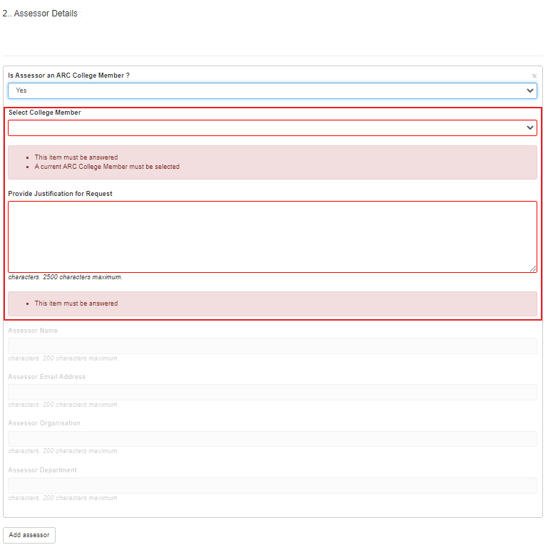  
Figure 10 – ARC College Member mandatory fields**

* Please select the ARC College Member from the drop-down list and provide justification for this request.
* When all the mandatory fields have been filled out, press the ‘Save’ button on the top right of the page.

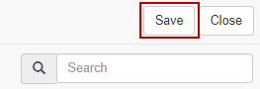  
**Figure 11 – ‘Save’ Button in top right**

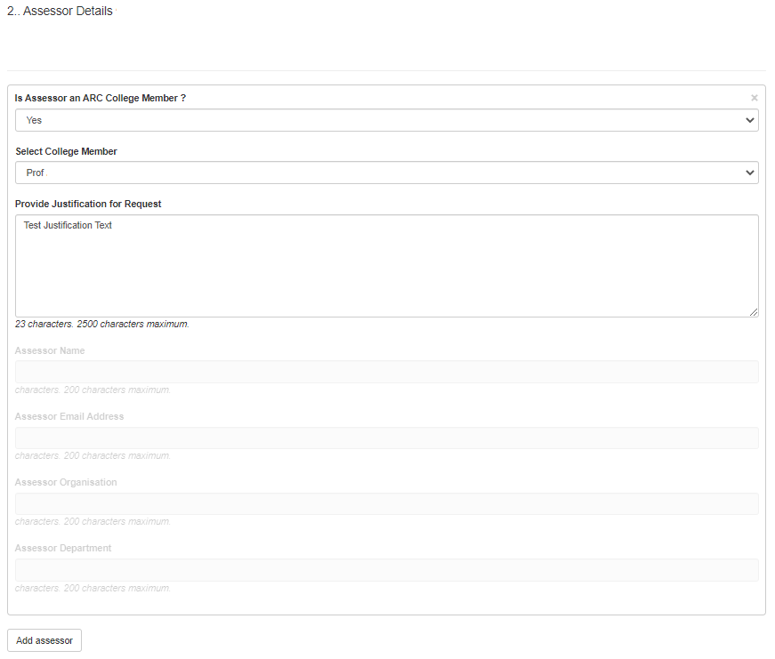 **Figure 12 – Completed College Member RNTA form**

* Any additional individuals can then be added to the RNTA by selecting the ‘Add Assessor’ button.
* For any additional ARC College of Expert member, please repeat the steps outlined in section 2.1 of this document.
* For individuals who are not currently recognised as a College member please continue to section 2.2 of this document.

**Note:** There is alimit of three individuals can be requested per application.

## 2.2 – Non-College of Experts Member Request Not to Assess Entry

Individuals who are not an ARC College member do not require additional justification within the RNTA form. To ensure the RNTA can be processed information regarding the individual is requested.

* Once ‘No’ is selected to the college member dropdown additional fields display, including the individuals name, email address, organisation, and department.

**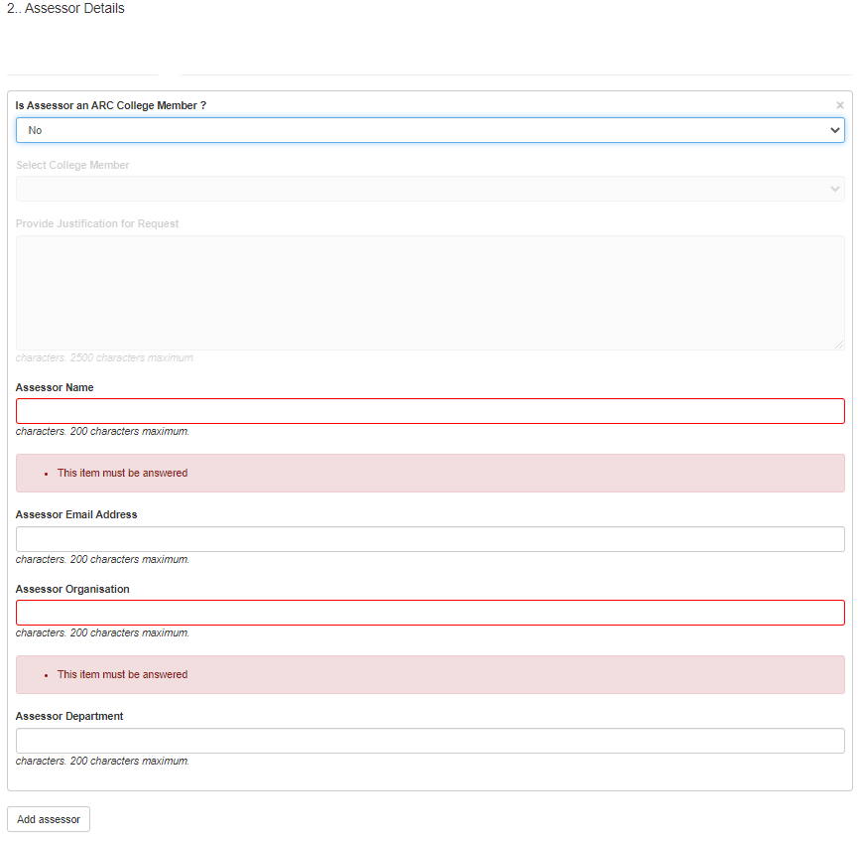  
Figure 13 – Non-ARC College Member additional information fields**

* The Assessor name and Organisation are mandatory fields and must be completed prior to RNTA submission.

**Note** – to assist in the identification of current assessors please complete as many fields as possible

* When all known fields have been filled out, press the ‘Save’ button on the top right of the page.

  
**Figure 14 – ‘Save’ Button in top right**

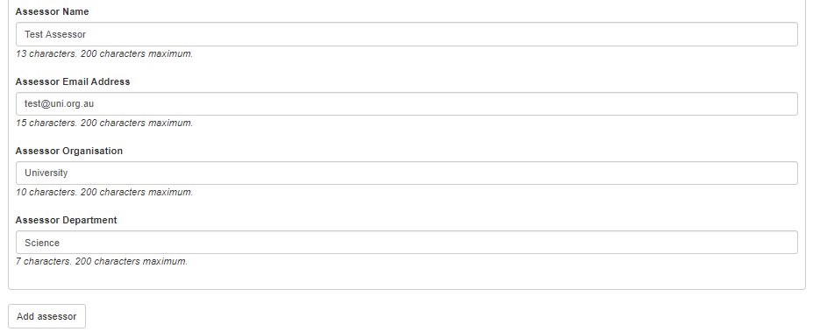 **Figure 15 – Completed Non-College Member RNTA form**

# PART 3 – Submitting the Request Not to Assess to the Research Office

All RNTAs must be reviewed by the application Administering Organisation’s Research Office prior to submission.

* Before submitting your RNTA to the Research Office, the Chief Investigator must:
  + review the form to ensure the information to be submitted is accurate; and
  + ensure the form is complete and valid.
* Once the above has been confirmed, click on the ‘Submit to Research Office’ button from the Request Not to Assess Page.

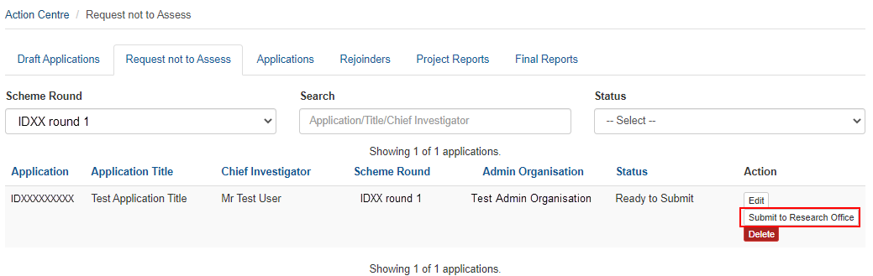

**Figure 16 – Submitting to the Research Office**

* A message will appear requesting confirmation to submit to the Research Office. To finalise submission, select ‘Yes’. To exit submission and continue editing the RNTA select ‘No’.

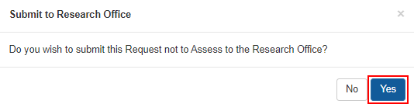

**Figure 17 – Message confirming RNTA submission to Research Office**

# PART 4 – Research Office Request Not to Assess Submission

RNTAs are submitted by participants to the Research Office for review prior to final submission.

* To view RNTAs, select the ‘Research Office Request not to Assess’ link from the Action Centre.

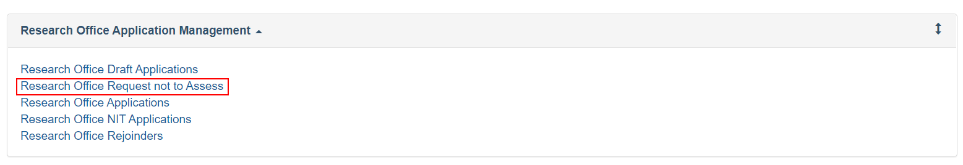

**Figure 18 – RO Navigating to Request Not to Assess forms**

* Select the relevant details from the dropdown filters to display RNTA.

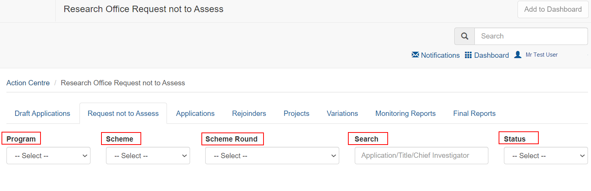

**Figure 19 – Choosing the relevant scheme round**

* + - To review or edit an RNTA select the ‘Edit’ button to the right of the relevant application. This will display the form as completed by the participant. Additional details can be completed as outlined in Part 2 of this document.

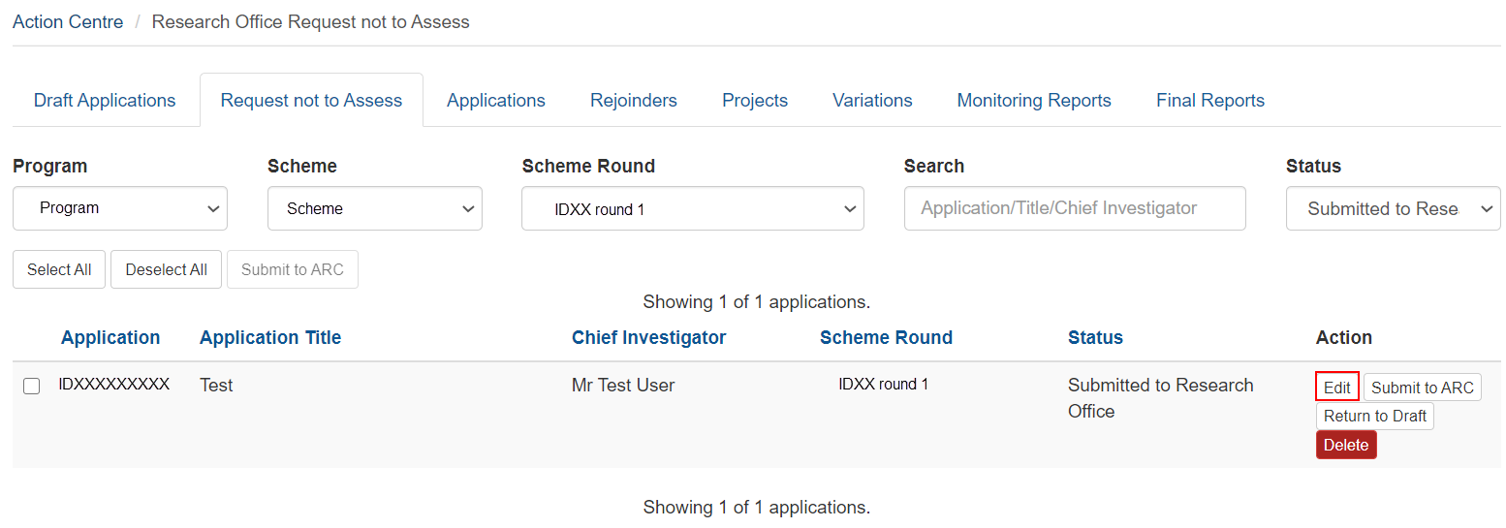

**Figure 20 – ‘Edit’ button within RO RNTA screen**

* + - If amendments are required to the RNTA, the RNTA can be returned to the participant by selecting ‘Return to Draft’ to the right of the relevant application. This will return the RNTA to the participant who can then make amendments and re-submit to the Research Office.

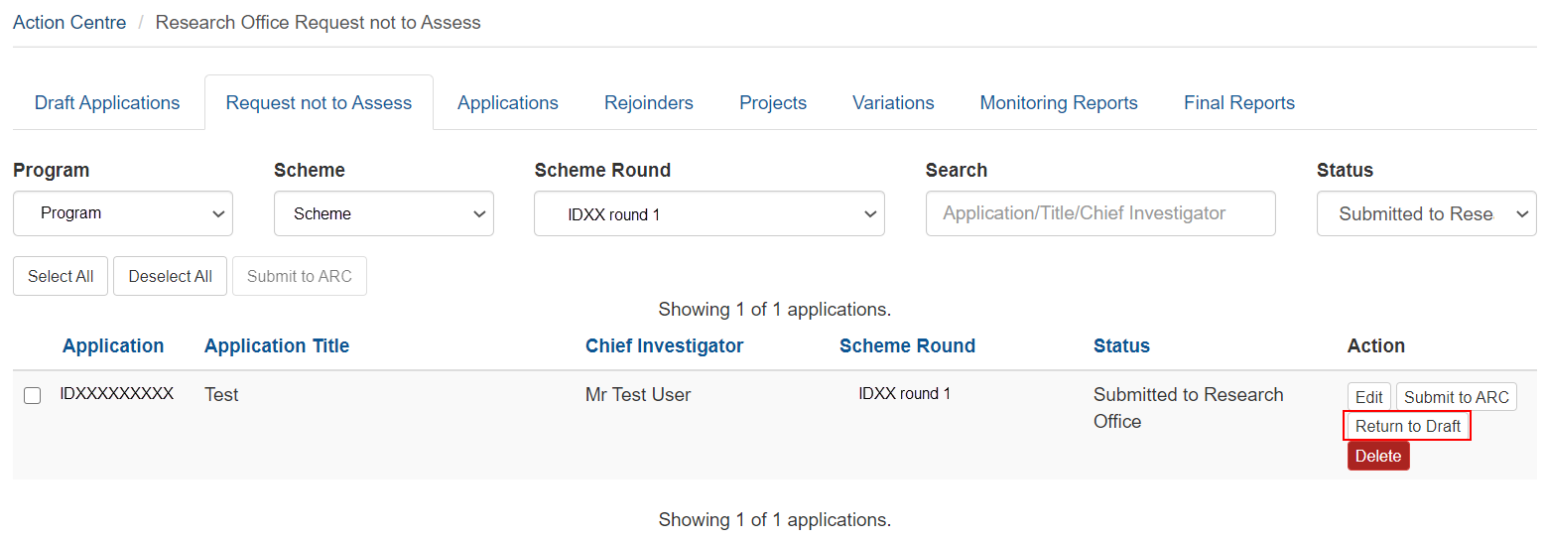

**Figure 21 – ‘Return to Draft’ Button within RO RNTA screen**

* + - Once the RNTA details have been confirmed the RNTA can be submitted using the ‘Submit to ARC’ button to the right of the relevant application.

**Note** – Further editing or de-submission to the applicant is not possible once the RNTA is submitted. If you require the RNTA to be returned, please contact the relevant contact details outlined in the Instructions to Applicants for the scheme.

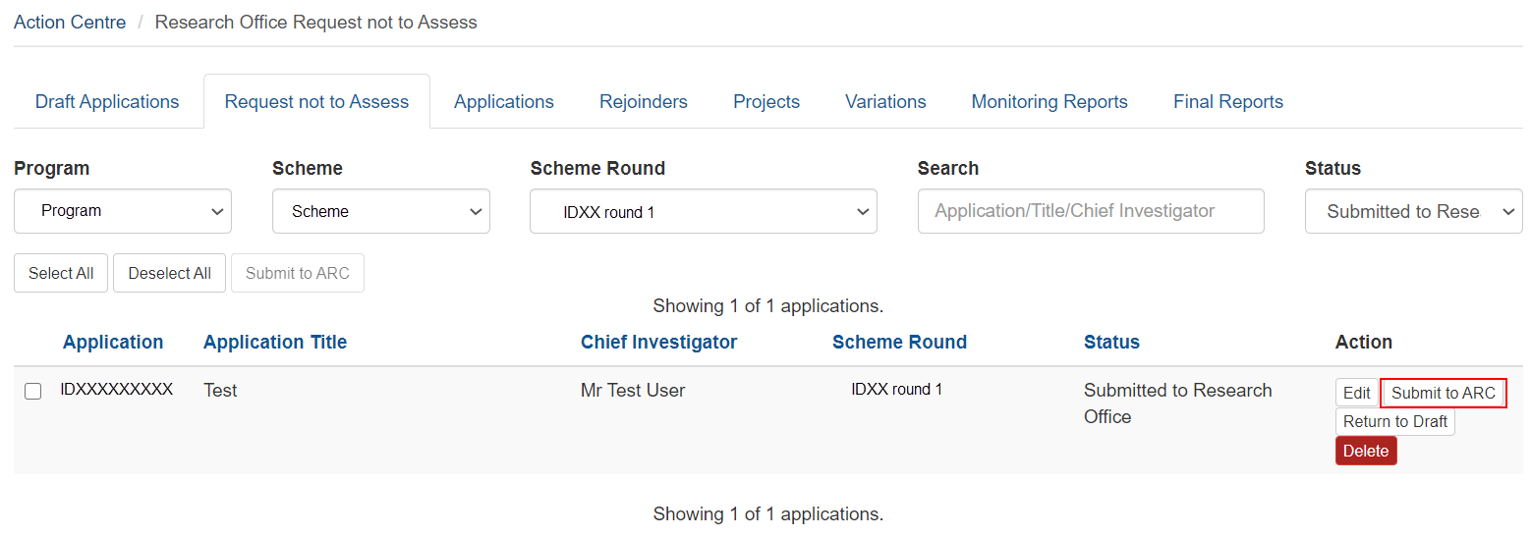

**Figure 22 – ‘Submit’ Button within RO RNTA screen**

* + - A message will appear requesting confirmation of submission. To finalise submission, select ‘Yes’. To exit submission and continue editing the RNTA select ‘No’.

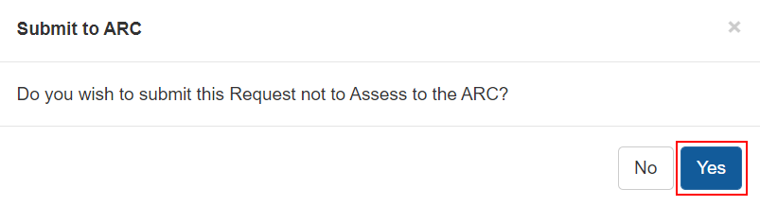

**Figure 23 – Confirming Submission Message**

# PART 5 – Contacting the ARC for additional help

* + - If you are experiencing any technical issues or require help with navigating RMS whilst completing your Request Not To Assess, please contact the RMS Helpdesk at [RMSSupport@ARC.gov.au](mailto:RMSSupport@ARC.gov.au).