# **SEER University User Guide Higher Education Research (HERDC)_2024 Data Collection**

Contents

**SEER University User Guide Higher Education Research (HERDC)_2024 Data Collection** 1

HERDC Supporting materials 2

**Introduction** 3

Purpose of the 2024 HERDC University User Guide 3

**Section 1** 4

Completing the HERDC Form 4

Input Part A. Contact Details 5

Input Part B. Research Income 6

Input Part C. Audit Report 7

Part C. Lodgement 7

Submit to Certifier 8

**Section 2** 9

Vice Chancellor Certification 9

Instructions for Certifying the HERDC return form in SEER 9

Final submission step 10

HERDC Certifier Role for Acting Vice Chancellors 11

**Section 3** 11

View form, status and comments (all users) 11

Collection Reports 11

SEER University User Guide Higher Education Research Data Collection (HERDC)_2024

The ARC administers the collection of research income data on behalf of Department of Education (DE) for the Higher Education Research Data Collection (HERDC). The tool used to collect this information is hosted on the SEER platform, owned by the ARC.

Higher Education Research Offices HERDC staff are responsible for completing the HERDC Form in SEER and submitting to the ARC, the certified HERDC Collection Form to the ARC

This User Guide contains three sections.

* Section 1 – Purpose of the SEER University User Guide HERDC_2024
* Section 2 – Vice Chancellor Certification
* Section 3 - View form, status and comments (all users)

## HERDC Supporting materials

* The  [Higher Education Research Data Collection – Frequently asked questions - Department of Education, Australian Government](https://aus01.safelinks.protection.outlook.com/?url=https%3A%2F%2Fwww.education.gov.au%2Fresearch-block-grants%2Fhigher-education-research-data-collection%2Fhigher-education-research-data-collection-frequently-asked-questions&data=05%7C02%7CKay.Booth%40arc.gov.au%7C09468dddb85c41eba55d08dd66a27f4a%7Cc75dbeeca1a549b48a3ac54972b1ce77%7C0%7C0%7C638779570611530743%7CUnknown%7CTWFpbGZsb3d8eyJFbXB0eU1hcGkiOnRydWUsIlYiOiIwLjAuMDAwMCIsIlAiOiJXaW4zMiIsIkFOIjoiTWFpbCIsIldUIjoyfQ%3D%3D%7C0%7C%7C%7C&sdata=98PiObTTfKhSFtC1xqmOgvCgYys26g9Q3wD0c11Pd9c%3D&reserved=0) are designed to provide information to assist HEPs to complete their annual HERDC returns.
* [SEER User Guide](https://www.arc.gov.au/evaluating-research/excellence-research-australia/seer-user-guide)
* Department of Education’s Higher Education Research Data Collection specifications [Higher Education Research Data Collection - Department of Education, Australian Government](https://www.education.gov.au/research-block-grants/higher-education-research-data-collection#toc-draft-herdc-specifications-for-the-collection-of-2024-data)

# **Introduction**

# Purpose of the 2024 HERDC University User Guide

The purpose of theHigher Education Research Data Collection (HERDC) University User Guide is to provide a reference for Research Office HERDC staff in HEPs and auditors on how to prepare and submit their return of the 2024 research and experimental development (R&D) income data.

You are asked to read the Department of Education’s Higher Education Research Data Collection specifications for the collection of 2024 data prior to embarking on entering your data in the SEER Form.

The HERDC SEER User Guide for Universities is to guide HEPs to provide the following information in the 2024 Collection Form

* an accurate R&D income return
* a Vice-Chancellor certification statement and
* an audit report

The SEER - HERDC Data submission workflow

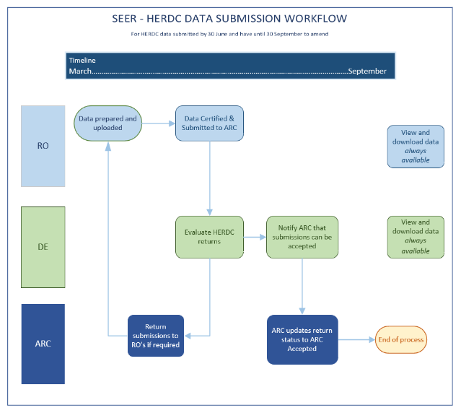

* users seeking to create a new SEER account or experiencing issues in accessing current accounts refer to the [SEER User Guide](https://www.arc.gov.au/evaluating-research/excellence-research-australia/seer-user-guide) - New Users – Requesting an Account

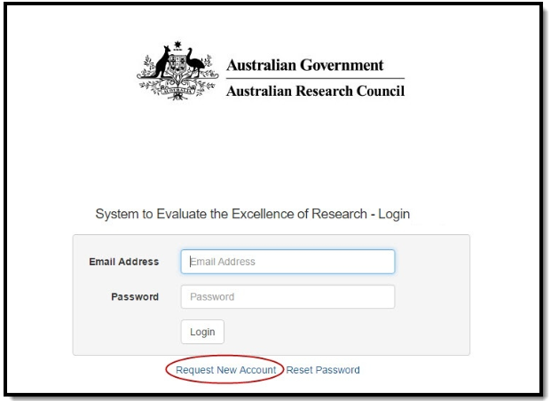

# **Section 1**

## Completing the HERDC Form

Log into SEER using your email and password. Ensure you have the **Research Office HERDC staff member role assigned to your profile**. You can check this by contacting the “HERDC Research Officer Delegate” within your university. If you have any issues with your user account, please contact the SEER helpdesk on (02) 6287 6789 during Canberra business hours or email [arc-systems@arc.gov.au](mailto:arc-systems@arc.gov.au)

* The SEER home page is called the Action Centre
* There are a range of options within the Action Centre

1. Navigate to the Research Office Data Collection Management function
2. Locate the Collection Reports option and
3. Select “Higher Education Research Data Collection for 2024 data year
4. Click on the “Form” button next to the 2024 Collection Round

## Input Part A. Contact Details

1. Enter the Higher Education Provider and the contact details of the administrator responsible for completing the form



***Press ‘save’ in SEER once you have completed this part of the form to ensure the entered data is not lost.***

## Input Part B. Research Income

1. Enter the eligible research income for each sub-category of Categories 1, 2, 3 and 4 in accordance with the HERDC specifications and any supplementary advice issued by the department. The form does not accept decimals places. Income for each sub-category should therefore be rounded to the nearest dollar.

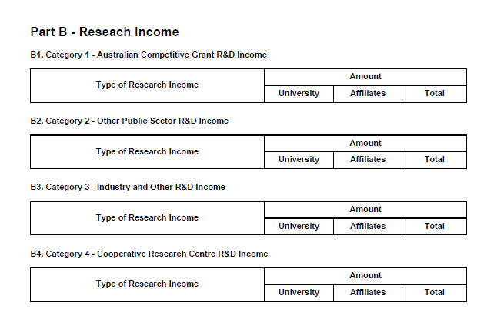

* *Please note: Category totals are automatically calculated.*

1. A response is required to the question in Part B.5 **Explanations for any negative values.**

*Question:* If the HEP is reporting any negative values, please provide information to explain the negative value(s). If this question is not applicable, please answer N/A.



***Press ‘save’ in SEER once you have completed this part of the form to ensure the entered data is not lost.***

## Input Part C. Audit Report

Each HEP must arrange for an audit of the Category 1, 2, 3 and 4 R&D income in their respective R&D income return and provide the department with a Special Purpose Audit Report under the Auditing and Assurance Standard Board’s Auditing Standard ASA800, which clearly certifies that the R&D income recorded is correct.

In addition to ensuring that the R&D income reported by a HEP under its R&D income return is correct, the department expects that the audit also ensures that R&D income is:

* attributed to activities that comply with the definition of R&D (**section 3**)
* attributed to the correct category of R&D income
* identified by transparent and explicit transactions.

The audit of HERDC returns should be conducted by an independent, external, and qualified auditor. HEPs may choose to use the auditors that undertake the audit of their financial statements.

***Press ‘save’ in SEER once you have completed this part of the form to ensure the entered data is not lost.***

## Part C. Lodgement

1. Enter all the details as required for the submission, undertake a quality assurance review of the entered data, then upload the audit report.

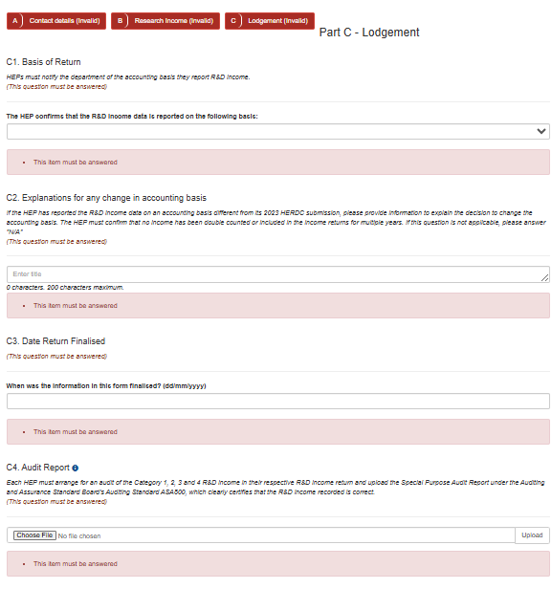

1. Once the research income data and other required information is entered correctly, all parts (A, B, C) will be coloured green. This indicates that the form is valid. **Remember to save the form.**

***Press ‘save’ in SEER once you have completed this part of the form to ensure the entered data is not lost.***

1. Once the form has been saved. Select the PDF button to export a report of the draft form to confirm details.

## Submit to Certifier

1. Return to action centre and select Submit to Certifier.

***Note: this action does not send an automatically generated email notification to the HERDC Certifier.***

# **Section 2**

# Vice Chancellor Certification

Vice-Chancellors (or equivalent) must certify that their HEP’s R&D income return is correct and has been compiled in accordance with the specification document. This certification is completed in SEER. A separate certification statement is not required.

## Instructions for Certifying the HERDC return form in SEER

Log into SEER using your email and password (generic email accounts are not accepted). Ensure you have the HERDC Certifier role assigned to your profile. You can check this by contacting the “HERDC Research Officer Delegate” within your university.

*If you have any issues with your user account, please contact the SEER helpdesk on (02) 6287 6789 during Canberra business hours or email arc-systems@arc.gov.au.*

1. Navigate to the Research Office Data Collection Management function
2. Locate the Collection Reports option and
3. Select “Higher Education Research Data Collection for 2024 data year”

1. This will take you to the completed form to review the details. You can view the data on the screen navigating through each part of the form or use the PDF export to view the entire form at once.
2. If the data is ready to certify, select certify.

1. If the data requires modification, return to the action centre and select de-submit. This will return the form to a draft status and the Research Office HERDC Staff user can then log in and make changes to the form and re-submit for certification.

1. A pop-up box will appear with specific certification text *(similar to the sample text below) that* must be accepted. This text, along with the time and date of the certification will appear in the downloadable PDF.
2. Before this action can be performed the following certification must be accepted.

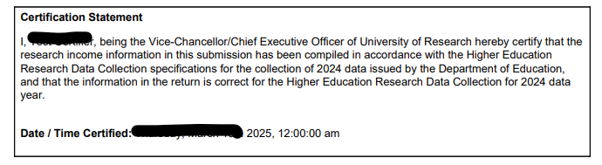

1. Once accepted, there will be one final option to certify or cancel.

# Final submission step

1. Once the form has been Certified by the Vice Chancellor, the Research Office HERDC Staff user is to log into SEER and return to the Action centre and select the and Submit to ARC action.
2. The Certification Statement **is not viewable in SEER,** to view a copy of your universities completed PDF form including the Certification Statement, select the PDF download option.

***Note: this action does not send an automatically generated email notification to the Research Office HERDC Staff.***

***The formal HERDC submission process is considered complete once the ‘Certified Form’ is updated to the workflow status of ‘Submit to ARC’ by selecting ‘Submit to ARC’ in ‘Actions’.***

## HERDC Certifier Role for Acting Vice Chancellors

In the event that there is an Acting Vice Chancellor during the collection round, Research Officers are asked to email [HERDC@arc.gov.au](mailto:HERDC@arc.gov.au) requesting the assignment of the HERDC Certifier role in SEER and include the acting Vice Chancellor’s name and the timeframe that the person will be acting Vice Chancellor.

***Where there is a temporary interim acting arrangement, the role should be removed when the arrangement is scheduled to end.***

# **Section 3**

# View form, status and comments (all users)

## Collection Reports

To view the form and download the PDF at any time, select collection reports.

1. Select the relevant round and phase to view your submission, its status and select form to view the data and export the PDF.

***Note: the phase will either be main or corrections. Unless the Department of Education is notified in writing, the corrections phase will reflect a copy of the original submission.***

1. Any comments made by the ARC against a university submission will also appear here. Select feedback to view the comment.

1. This will allow you to view the time, date, and text in the comment. Click view for further details.

1. A pop-up box will appear with the full comment.

