Research Management System

**Dashboard and Notifications in RMS**

(User guide)

Target Audience –Research Office Staff

Updated January 2021

Contents

Introduction 3

Key Points 3

Overview 3

PART 1 – Dashboard 4

1.1 - Accessing the Dashboard 4

1.2 - Editing the Dashboard screen 5

1.3 - How to create a new selection for the Dashboard: 5

1.4 - Accessing the data from the Dashboard 7

Part 2 - Notifications 8

2.1 - How to subscribe to a Notification 8

2.2 - Receiving Notifications 9

2.2.1 - In RMS Notifications 9

2.2.2 - Email Notifications 10

2.3 - Unsubscribing to Notifications 11

Part 3 – Frequently Asked Questions 11

PART 4 – Contacting the ARC for additional help 11

# Introduction

The Research Management System (RMS) is a web-based application developed by the ARC and now used by multiple agencies to manage their Grant Programs. Each agency can utilise functions such as: submissions, request not to assess, assignment and assessment, rejoinders, announcement, grant offers/acceptance, and post-award activities such as grant variations and project reporting.

More detailed information on the agencies utilising RMS is available on the [Research Grant Services](mailto:RMSSupport@ARC.gov.au) page of the ARC Website.

RMS Access

The web address to access RMS is dependent on the agency or program that you are needing to interact with.

* ARC (NCGP) RMS instance - [https://rms.arc.gov.au](https://dese.researchgrants.gov.au/)
* DESE (NCRIS) RMS instance - [https://dese.researchgrants.gov.au](https://rmsoni.researchgrants.gov.au)
* ONI (NISDRG) RMS instance - [https://rmsoni.researchgrants.gov.au](https://defence.researchgrants.gov.au)
* Defence (NISDRG) RMS Instance - [https://defence.researchgrants.gov.au](https://www.arc.gov.au/research-grants-services)

**NOTE:** - You only need one account to access RMS, regardless of agency or program you are accessing, however you will require specific roles for each version/instance of RMS.

All screenshots provided within this document have been sourced from the NCGP instance of RMS and images and processes may differ slightly dependent on the instance you are using.

# Key Points

* + - The target audience for this user guide is Research Office Staff who manage the Pre and Post-award processes for applications processed within RMS.
    - RMS is compatible with the latest versions of Google Chrome and Microsoft Edge. The Australian Research Council (ARC) cannot guarantee compatibility with other browsers or older versions of Google Chrome or Microsoft Edge.
    - In December 2020 the ability to add Pre-award processes to both notifications and dashboards within RMS, with more options to be released in the future.
    - If a Research Office staff member has previously configured custom tiles within the Dashboard the Pre-award default tiles will not be accessible without resetting the dashboard to default.

# Overview

Functionality within the Research Management System (RMS) has been developed to allow Research Office staff to set up an easy access dashboard to access pre-selected data and receive notifications to assist with the management of Pre and Post-award activities.

# PART 1 – Dashboard

The Dashboard in RMS provides Research Office staff the ability to pre-select search criteria in RMS, for easy accessibility to proposal and project data. Users can personalise the dashboard to suit their own requirements and only show information they are interested in.

## 1.1 - Accessing the Dashboard

Click the ‘Dashboard’ link in the top right hand corner of the Action Centre to access the dashboard page in RMS.



**Figure 1 – Dashboard link from within the Action Centre**

Once in the dashboard seven default tiles will appear

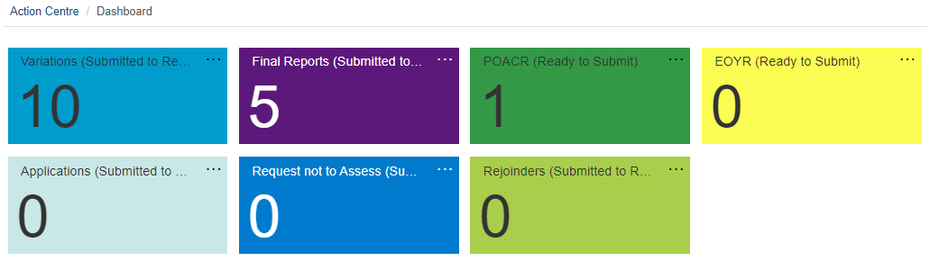  
**Figure 2 – Default Dashboard**

Each tile has defaulted selections to show the following default settings:

| Variations | Variations received by the Research Office in the last 30 Days and has the ‘Submitted to RO’ status |
| --- | --- |
| Final Reports | Final Reports received by the Research Office in the last 30 Days and has the ‘Submitted to RO Valid’ status |
| POACR | POACRs received by the Research Office in the last 30 Days and has the ‘Ready to Submit’ status |
| EOYR | EOYRs received by the Research Office in the last 30 Days and has the ‘Ready to Submit’ status |
| Applications | Applications received by the Research Office for all scheme rounds currently accepting applications |
| RNTA | RNTAs received by the Research Office for all scheme rounds currently accepting RNTAs |
| Rejoinders | Rejoinders received by the Research Office for all scheme rounds currently accepting rejoinders |

## 1.2 - Editing the Dashboard screen

RMS allows users to customise the dashboard to display user’s preferences.

To edit the existing tiles select the … on the top right hand corner of each tile. This will provide the ability to edit, move or remove the individual tile.

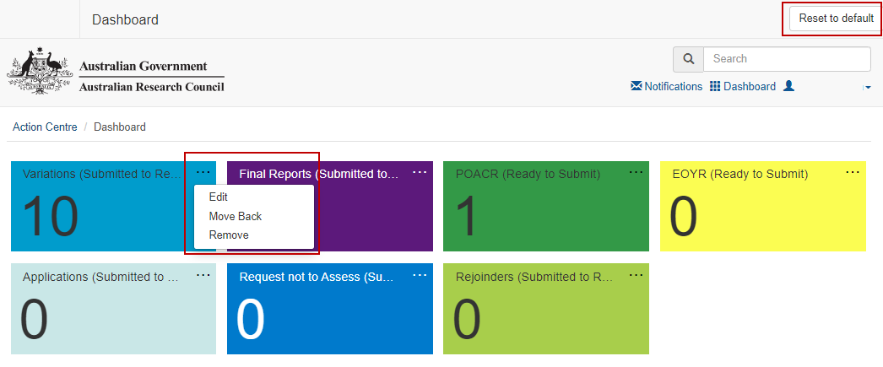  
**Figure 3 – Reset to default and Edit existing tiles**

* Edit – provides the ability to re-name and/or re-colour the tile
* Move Forward/Back - changes where on the screen the tile is displayed
* Remove - will delete the tile

If users wish to return the dashboard to the original settings, this can be done by selecting the ‘Reset to default’ in the top right-hand corner of the screen. This will return the dashboard to the default tiles.

**Note** – if a Research Office staff had customised their personal dashboard prior to the release of Pre-Award functionality in December 2020 the ‘Reset to default’ button will need to be selected in order to receive the default Pre-award tiles. Alternatively, they can be configured using the steps outlines in steps 1.3.

## 1.3 - How to create a new selection for the Dashboard:

Users can create multiple new dashboard tiles to suit their personal preferences. There is no limit on the amount of tiles that can be created or edited. Tiles can be created by doing the following steps:

* open to the relevant Pre or Post-award tab that holds the required data (Draft Applications, Request not to Assess, Rejoinders, Variations, Project Reports or Final Reports)
* select the options from each of the relevant dropdown lists
* once all selections are made, click the ‘Add to Dashboard’ button in the top right-hand corner of the screen

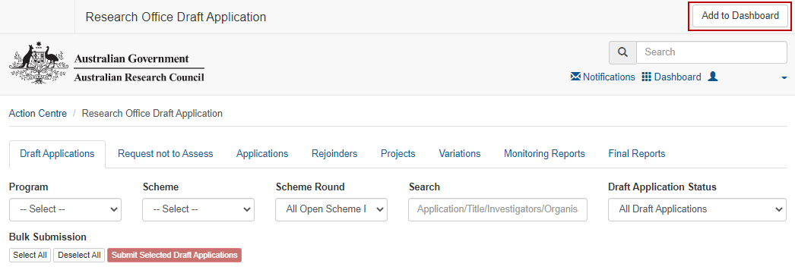  
**Figure 4 – Draft Applications - Add to Dashboard button in top right**

A new screen will appear and a default name of the original tab will appear. The name can then be edited and a colour selected as per user’s preference, as only the user will see it. Save the selection once it is made.

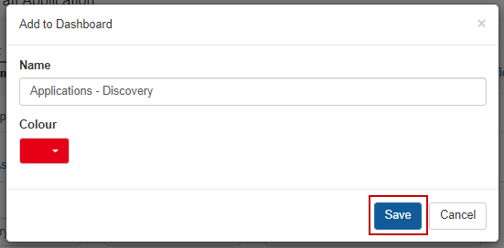  
**Figure 5 – Save dashboard tile customisation**

The new tile will then appear in the dashboard and is ready to be selected.

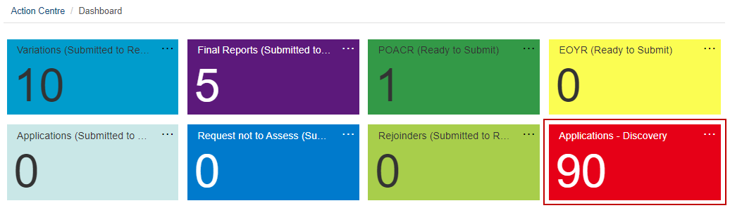  
**Figure 6 – Customised dashboard tile**

## 1.4 - Accessing the data from the Dashboard

To access any of the data from the dashboard click any of the coloured tiles that appear on the dashboard. RMS will then take you to the relevant page in RMS and display the information that has been pre-selected to appear. The variations/reports can then be actioned/viewed from this page.

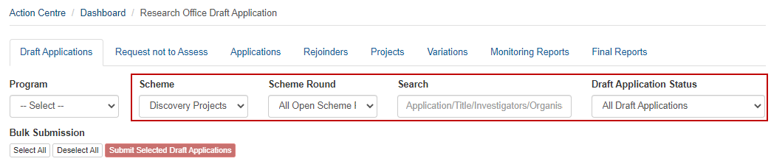  
**Figure 7 – Customised dashboard tile filter view**

# Part 2 - Notifications

RMS has a subscription service that allows users to be notified when an action has been performed in RMS. Users can select to receive notifications either via email or within RMS and must be set up by each individual user.

## 2.1 - How to subscribe to a Notification

To access the notifications screen, select the ‘Notifications’ link in the top right-hand corner of the Action Centre.

  
**Figure 8 – Notifications link from Action Centre**

The first-time notifications are created, the screen will appear with the statement ‘*You have no notifications’*. To create a notification, select the ‘Manage Notifications’ button in the top right hand side of the screen.

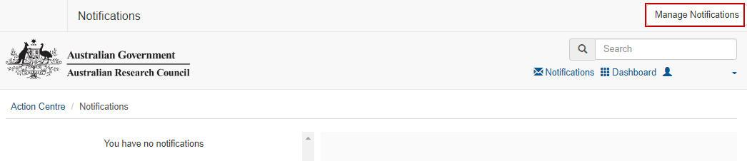  
**Figure 9 – Manage Notifications button in top right**

The ‘Add subscription’ page in RMS will appear and allow users to create a subscription. Multiple subscriptions can be made at any stage and can be created using the following steps.

To activate a subscription the following criteria must be completed:

* **RECEIVE**: the method to receive the notifications - this can be via email or RMS, or both. (This can be edited again after the subscription is created.)
* **TYPE**: the notification type that is being subscribed to from the dropdown list.
* **STATE**: the state of the subscription type such as submitted to Research Office or accepted by ARC. If 'All States' is selected, a notification will be sent for every status change for the subscription type selected
* **FOR**: the funding program that the subscription type relates to. For NCGP notifications the program can be narrowed down to ‘Discovery’ or ‘Linkage’, which would result in only the schemes that fall under these programs appearing on the scheme list. Alternatively ‘All Programs’ will show both programs and all schemes under both programs

To refine the selections even further, additional non-mandatory selections can also be selected:

* **SCHEME**: (based on the program selected) a specific scheme can be selected or ‘All Schemes’ can be selected
* **SCHEME ROUND**: (based on the previous program/scheme selections) a specific scheme round can be selected or ‘All Scheme Rounds’ can be selected

Once the relevant criteria has been selected, click the ‘Subscribe’ button. The subscription will then appear in the ‘Current subscriptions’ list on the bottom of the page.

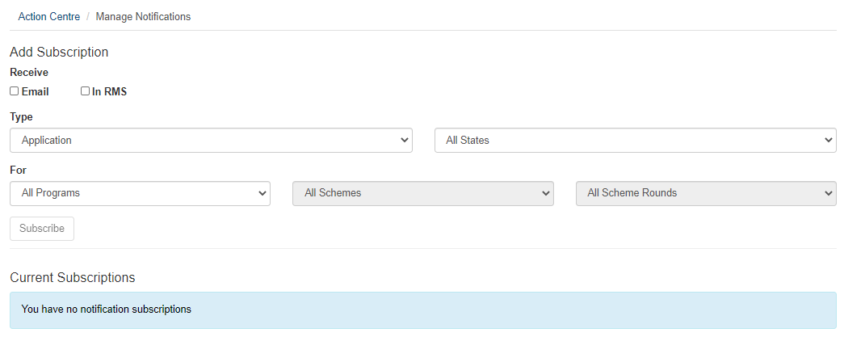  
**Figure 10 – Notification subscription filters**

**Note:** Although the method of receiving subscriptions can be adjusted once created using the 'email' and 'In RMS' buttons, the details of the subscription cannot be edited. Subscriptions will have to be unsubscribed and re-added if changes are required.

## 2.2 - Receiving Notifications

Depending on the selections made within each subscription, notifications will be received via one or both of the following methods.

### 2.2.1 - In RMS Notifications

If subscriptions are set up to receive notifications via ‘In RMS’ any new notifications will appear in RMS as a red badge against the notifications link and display the number of unread notifications.

  
**Figure 11 – ‘In RMS’ Notification badge**

Select the notifications link to open the notifications page. All notifications will then appear on the left-hand side of the screen. Once a notification is selected, the details of the notification will be displayed on the right-hand side of the screen. Each notification will inform the user of the Project or Application ID and details of the status change of the subscription type.

Notifications can then be marked as read or deleted by clicking on the 'X' button in the top right-hand corner. Notifications can also be marked as read or deleted in bulk by selecting the 'Mark all as read' or 'Delete All' buttons.

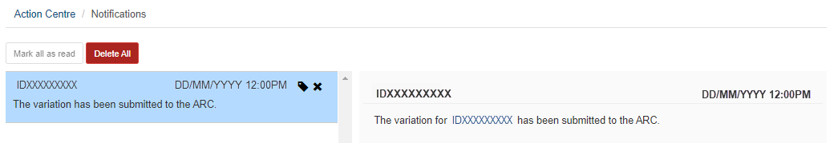  
**Figure 12 – ‘In RMS’ Notification example**

### 2.2.2 - Email Notifications

If subscriptions are set up to receive notifications via email, the notifications will be sent to the email address attached to the RMS account. Each notification will inform the user of the Project or Application ID and details of the status change of the subscription type.

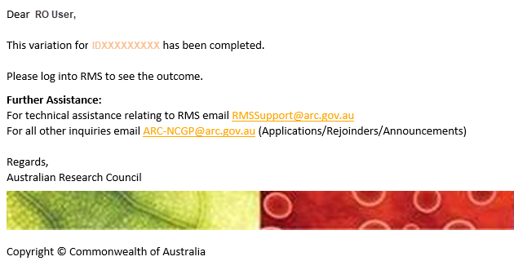  
**Figure 13 – Email Notification example**

## 2.3 - Unsubscribing to Notifications

Notifications can be unsubscribed, so they are no longer received. Once unsubscribed emails and RMS notifications will cease.

To unsubscribe to a specific subscription, select the ‘Unsubscribe’ button on the right-hand side of the relevant subscription.

To unsubscribe to all subscriptions, select the ‘Unsubscribe All’ button on the right-hand side of the screen above the 'Current Subscriptions' list.

Alternatively, if the subscription is to be kept but the method of receiving the subscription needs to be changed, then they can be adjusted by selecting the 'Email' and 'In RMS' buttons on the left side of the relevant subscriptions

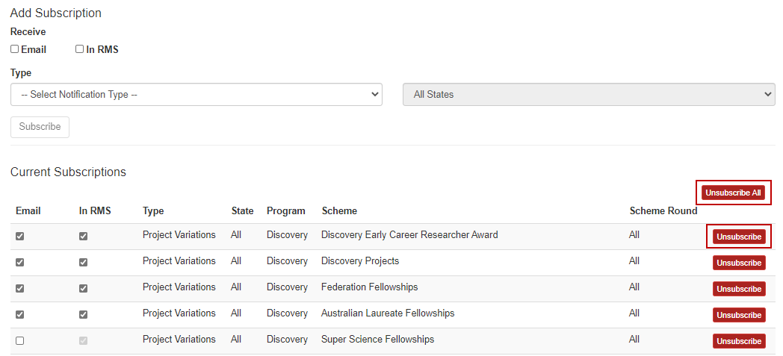  
**Figure 14 – Unsubscribe button to left of screen**

# Part 3 – Frequently Asked Questions

**If I move to another Administering Organisation, will I lose all my customised dashboards and notifications?**Yes, moving to another Administering Organisation, will wipe all customised dashboards and notifications.

**Can I set up my notifications to go to another email address?**No, email notifications are only sent to the email address attached to your RMS account.

**Why can I see scheme rounds that have no Post-award data?**This functionality has been built to provide RMS data both now and in the future. This may result in RMS displaying rounds currently under assessment.

# PART 4 – Contacting the ARC for additional help

If you are experiencing any technical issues or require help with navigating RMS please contact the RMS Support team at [RMSSupport@ARC.gov.au](https://rms.arc.gov.au)